University size and equity participation

ACSES Data Insights Series

Acknowledgements
This report was prepared by the Data Program of the Australian Centre for Student Equity and Success (ACSES) at Curtin University.
The authors would like to acknowledge the staff at ACSES for their comments and assistance in the production of this publication and extend thanks to the Australian Government Department of Education for the provision of student equity data.
The report may be cited as: ACSES Data Program. (2026). University size and equity participation. Australian Centre for Student Equity and Success (ACSES), Perth: Curtin University.
This report examines the relationship between institution size (domestic undergraduate headcount) and equity student participation rates across Australian universities. For further information on retention, participation, success, and six- and nine-year cohort completion, please refer to the ACSES student equity data Interactive Tool: www.acses.edu.au/data/interactive-tool/.
Copyright ownership of this material resides with Curtin University.
ISBN 978-1-7648267-8-5

The Australian Centre for Student Equity and Success Data Insights Series
The Australian Centre for Student Equity and Success (ACSES) is an evidence-based research and public policy centre based at Curtin University and funded by the Australian Government Department of Education. ACSES is committed to providing the higher education sector with tangible proof of what works to improve the quality and impact of student equity practices in higher education.
The ACSES Data Insights Series reports on equity student participation and outcomes in Australian higher education. It focuses on trends among identified equity groups in domestic undergraduate enrolments in Australia, including, but not limited to:
- low socio-economic status (SES) students
- students with disability
- First Nations (Aboriginal and Torres Strait Islander) Australian students
- regional students
- remote students.
For further information on ACSES, please visit www.acses.edu.au.

Overview
This report examines the relationship between institution size (domestic undergraduate headcount) and equity student participation rates across Australian universities.
Larger universities may have access to more resources which could be used to increase equity student participation share. Conversely, smaller universities could have dedicated mission statements with more bespoke focuses on equity students. Examining the relationship between university size and equity student participation provides a way to explore how these factors manifest across the sector, particularly whether participation rates vary systemically with institutional size.
In this report, correlations (“R”) are used to assess the direction and strength of association between size and participation. R values closer to one indicate a more positive relationship between university size and equity student participation, while values closer to negative one indicate a more negative relationship.
Correlations are descriptive measures and should not be interpreted as targets in themselves. In a setting where equity participation is driven primarily by institution-specific factors rather than sector-wide dynamics, we might expect participation rates to vary independently of university size, resulting in correlations close to zero. Observed correlations may indicate the presence of broader structural or systemic influences operating across the sector. The direction of these relationships is not, in itself, diagnostic: for example, a negative correlation may reflect lower participation among larger universities, but it may equally reflect comparatively higher participation among smaller institutions.
This analysis enables an assessment of whether university size is systemically related to variation in equity student participation across the sector. While no causal inference is made, the presence of strong correlations suggests that size may be connected to underlying features of the systems that influence accessibility.
For consistency, we use the following rule of thumb as a guide for correlation strength:
- |R| < 0.2 → negligible, indicating little to no evidence of a relationship
- 0.2 to 0.4 → weak, indicating some evidence of a relationship
- 0.4 to 0.6 → moderate, indicating clear evidence of a relationship
- 0.6+ → strong, indicating a clear and substantial relationship.
Results are presented for the year 2024, followed by trends over time (2017–2024).

Data explanatory notes
All student data reported in this document are sourced from a customised request to the Australian Government Department of Education.
For this report:
- Analysis includes Table A and Table B universities (as defined under the Higher Education Support Act 2003), with segmentation based on their institutional groupings. Table B universities are included in the “non-aligned” grouping.
- Universities and their institutional grouping memberships are reported as they were in 2024—the most recent year of data being reported.
- The identification of students from low SES, regional, and remote backgrounds is based on their first address.
- “Equity students” or “all equity students” refers to students who belong to at least one of the four key equity groups presented in this report, namely, students with disability, First Nations Australian students, students from low SES areas, and students from regional and remote areas.
- “Non-equity students” refers to students who do not belong to any of the equity groups described above.
- “Students with disability” changed its definition in 2020 to include “mental health conditions”.
- We also report on students who are the first in their family to attend university; students from non-English speaking backgrounds (NESB); and women in non-traditional areas (WINTA) of study, that is, female students enrolled in “non-traditional” disciplines.

All equity students
Figure 1 shows the relationship between university size and participation for all equity students across each university. A moderate negative correlation is observed, indicating that larger universities have lower participation shares of equity students. There is a distinct threshold cut-off at roughly 23,000 students where equity participation drops off sharply, ranging from 20% to just over 40%, while below 23,000 equity participation ranges from 20% to well over 80%.
Figure 1: Domestic undergraduate enrolments vs overall equity student participation rate in 2024
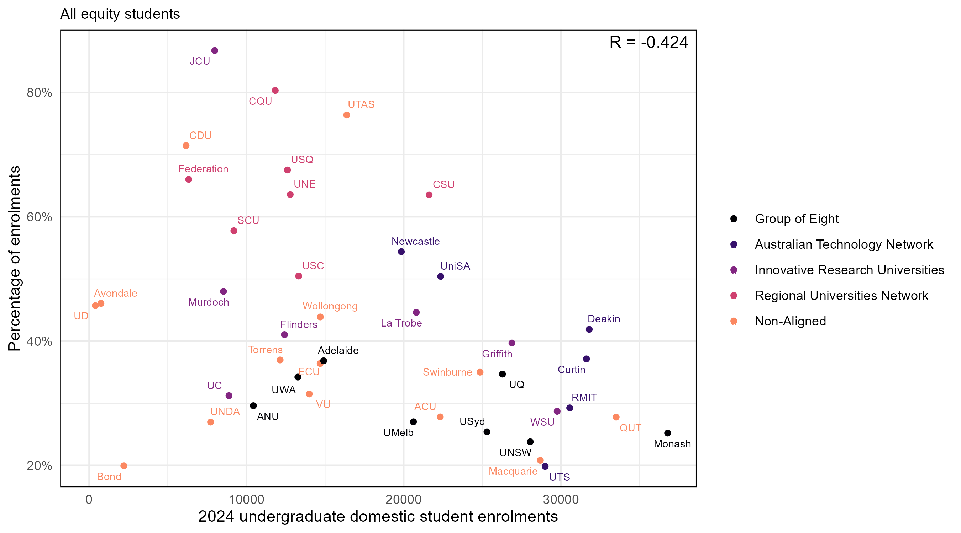

Students with disability
Figure 2 shows the relationship between university size and participation for students with disability across each university. No clear relationship is observed at the sector level, indicating that participation share for students with disability is broadly independent of university size.
Figure 2: Domestic undergraduate enrolments vs participation rate for students with disability in 2024
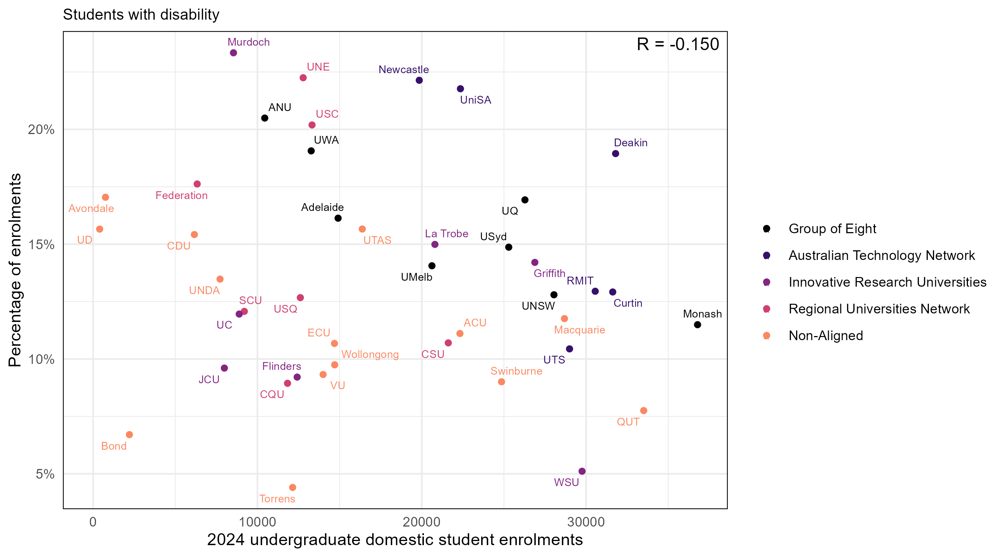

Students from regional and remote areas
Figure 3 shows the relationship between university size and participation for students from regional and remote areas across each university. A weak negative correlation is observed between university size and regional/remote participation share across the sector.
Figure 3: Domestic undergraduate enrolments vs participation rate for students from regional and remote areas in 2024
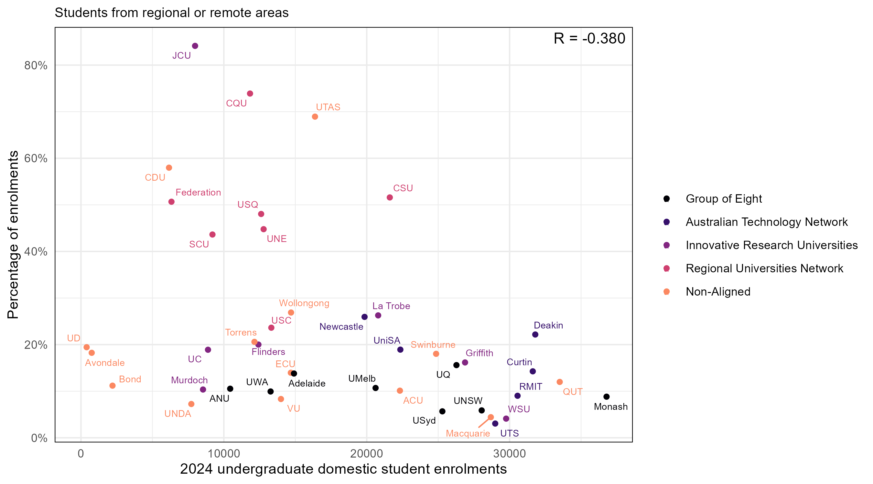

First Nations Australian students
Figure 4 shows the relationship between university size and participation for First Nations Australian students across each university. A weak to moderate negative correlation is observed between institution size and participation for First Nations Australian students, indicating a negative association between university size and participation share.
Figure 4: Domestic undergraduate enrolments vs participation rate for First Nations Australian students in 2024
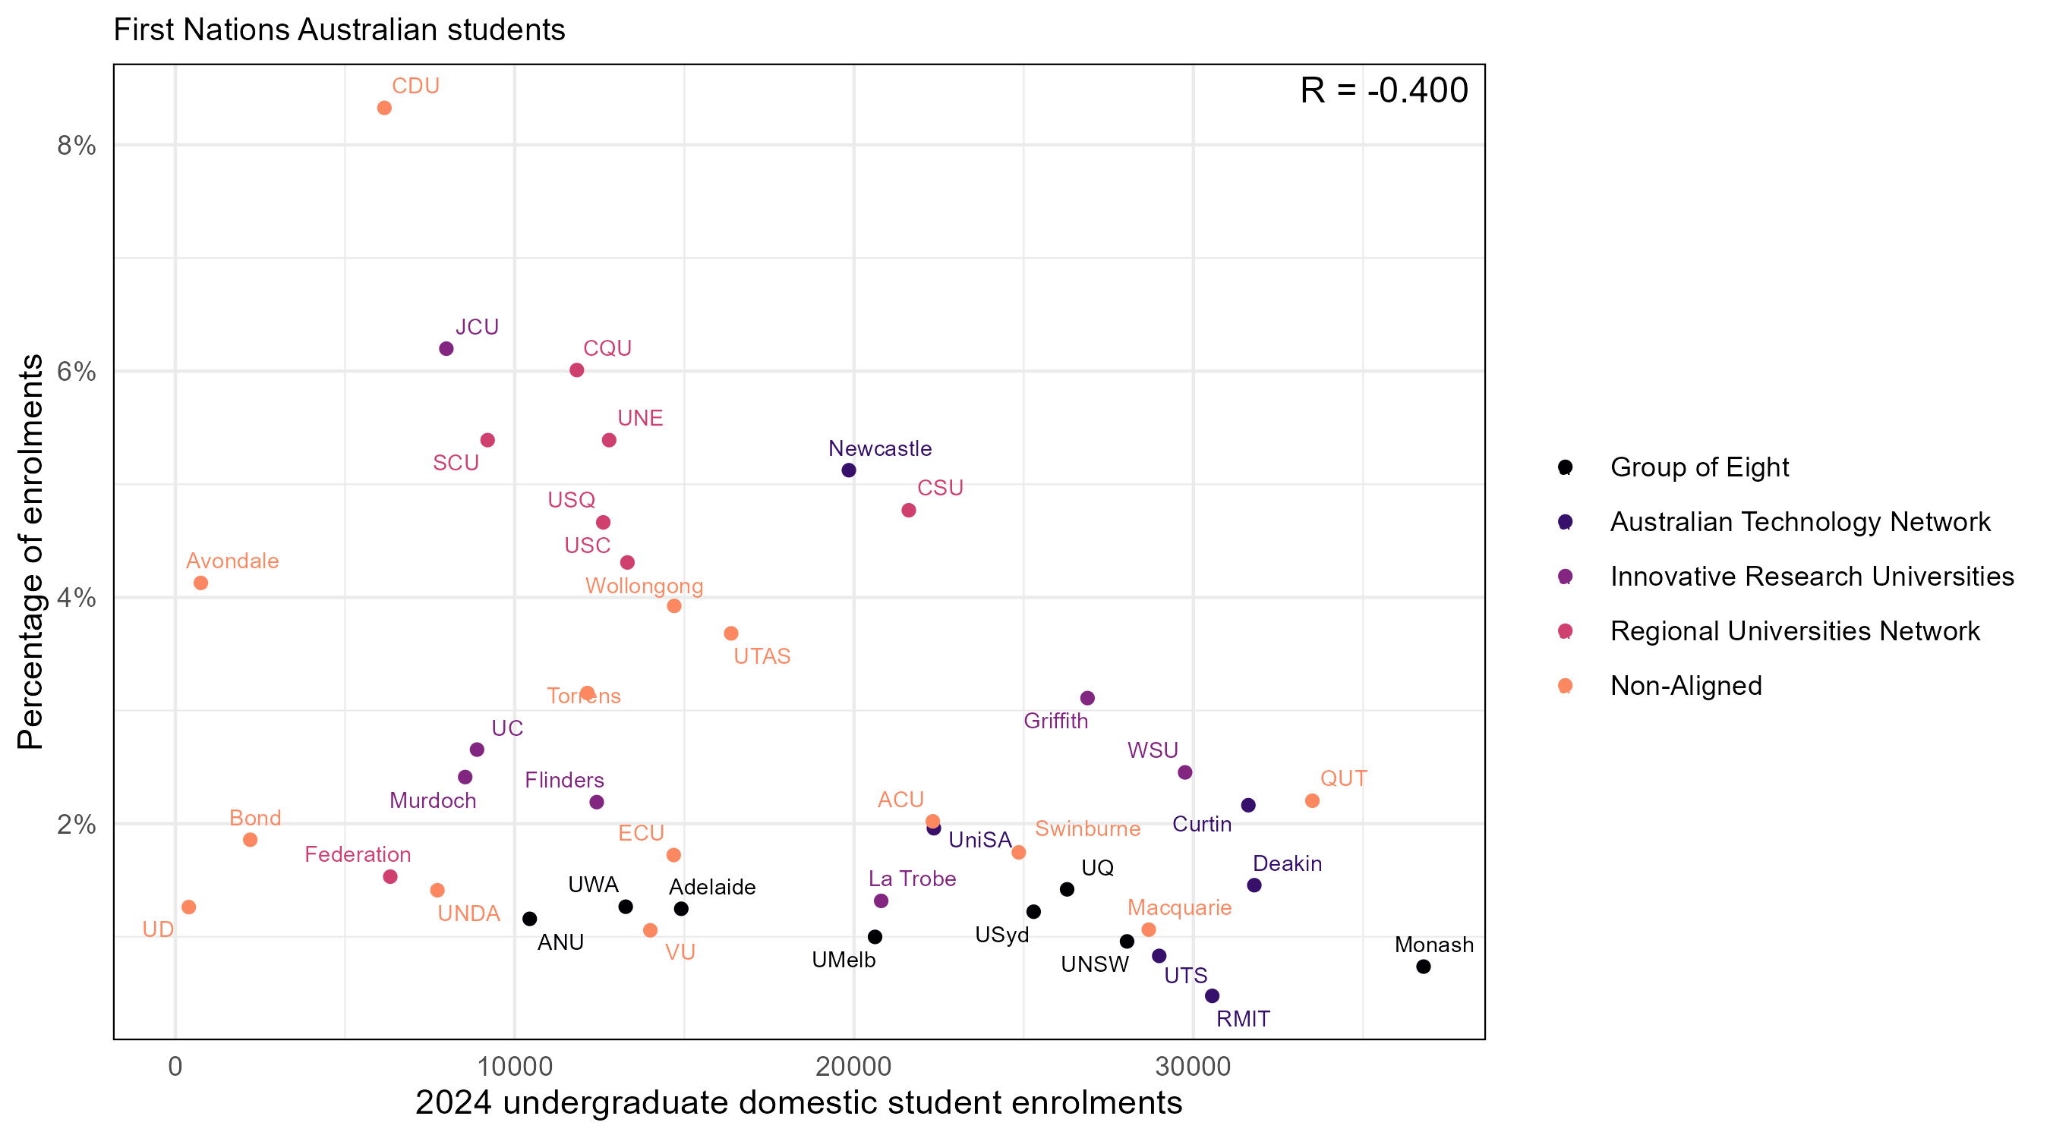

Students from low SES areas
Figure 5 shows the relationship between university size and participation for students from low SES areas across each university. A weak negative correlation is observed between institution size and participation for students from low SES areas.
Figure 5: Domestic undergraduate enrolments vs participation rate for students from low SES areas in 2024
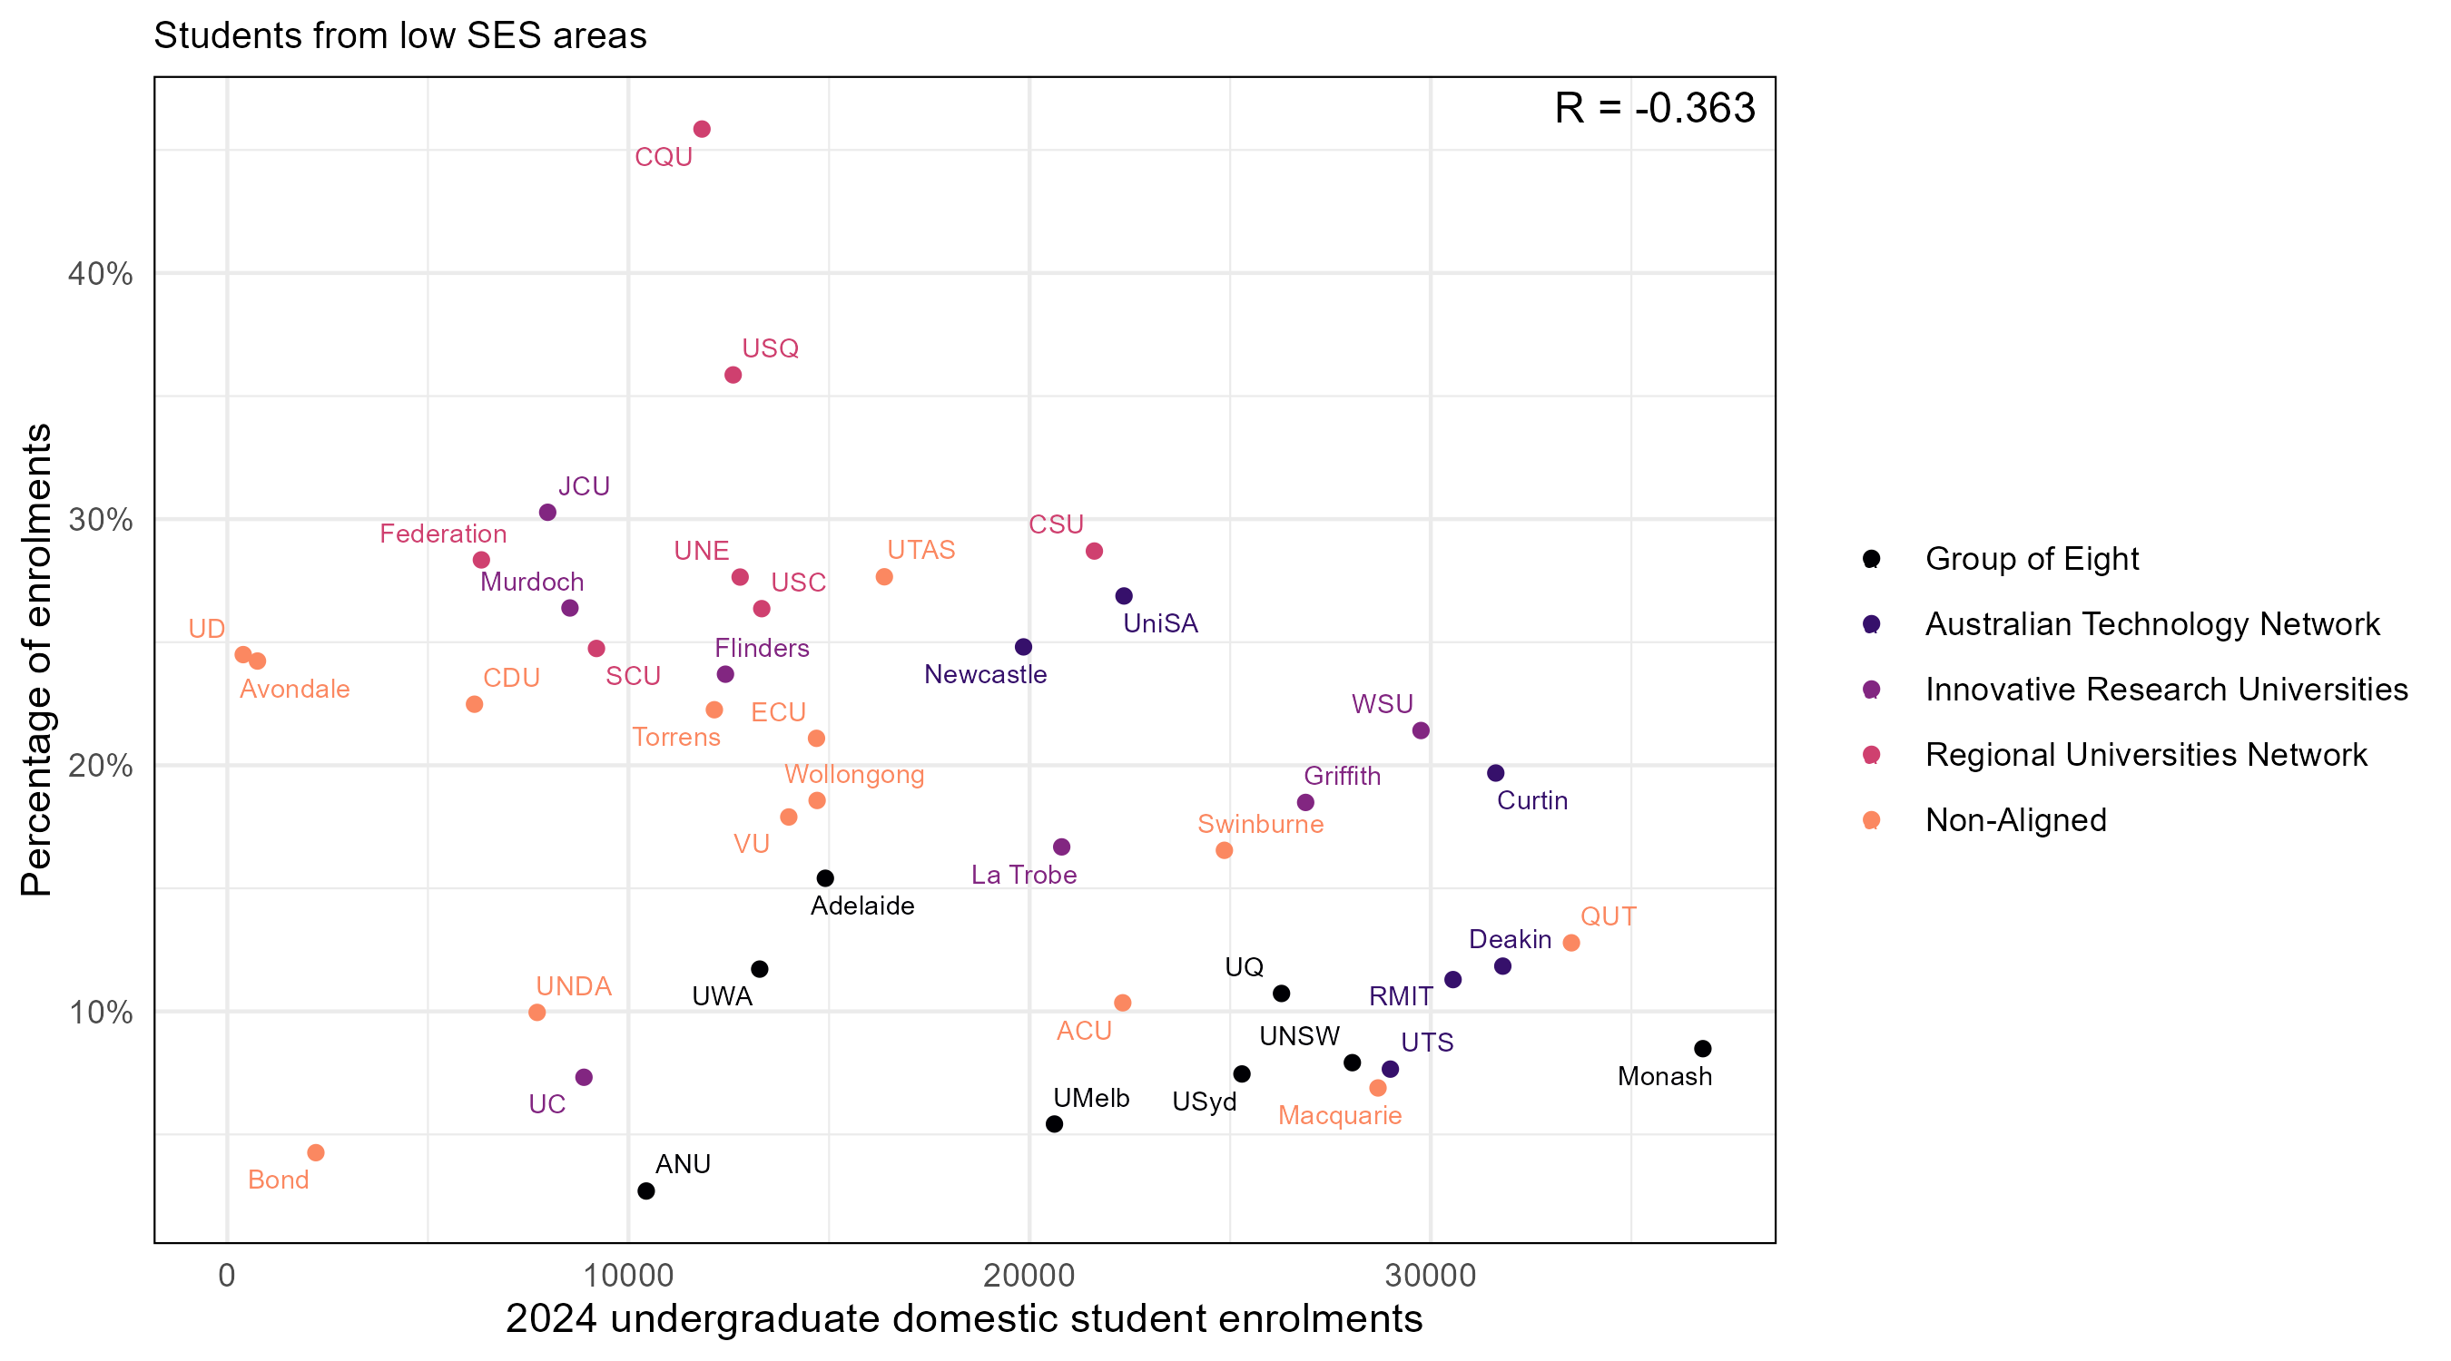

Students who are first in family
Figure 6 shows the relationship between university size and participation for first-in-family students across each university. No clear relationship is observed at the sector level, indicating that participation share for first-in-family students is broadly independent of university size.
Figure 6: Domestic undergraduate enrolments vs participation rate for first-in-family students in 2024
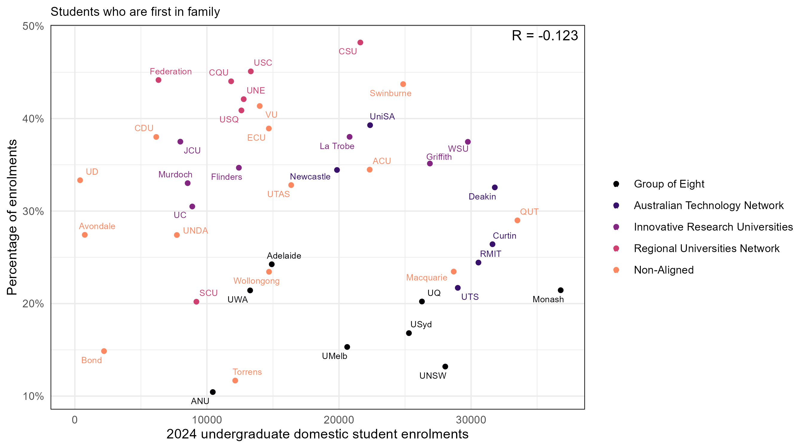

Students from a non-English speaking background
Figure 7 shows the relationship between university size and participation for students from non-English speaking backgrounds across each university. A weak positive correlation is observed between institution size and participation for students from non-English speaking backgrounds.
Figure 7: Domestic undergraduate enrolments vs participation rate for students from non-English speaking backgrounds in 2024
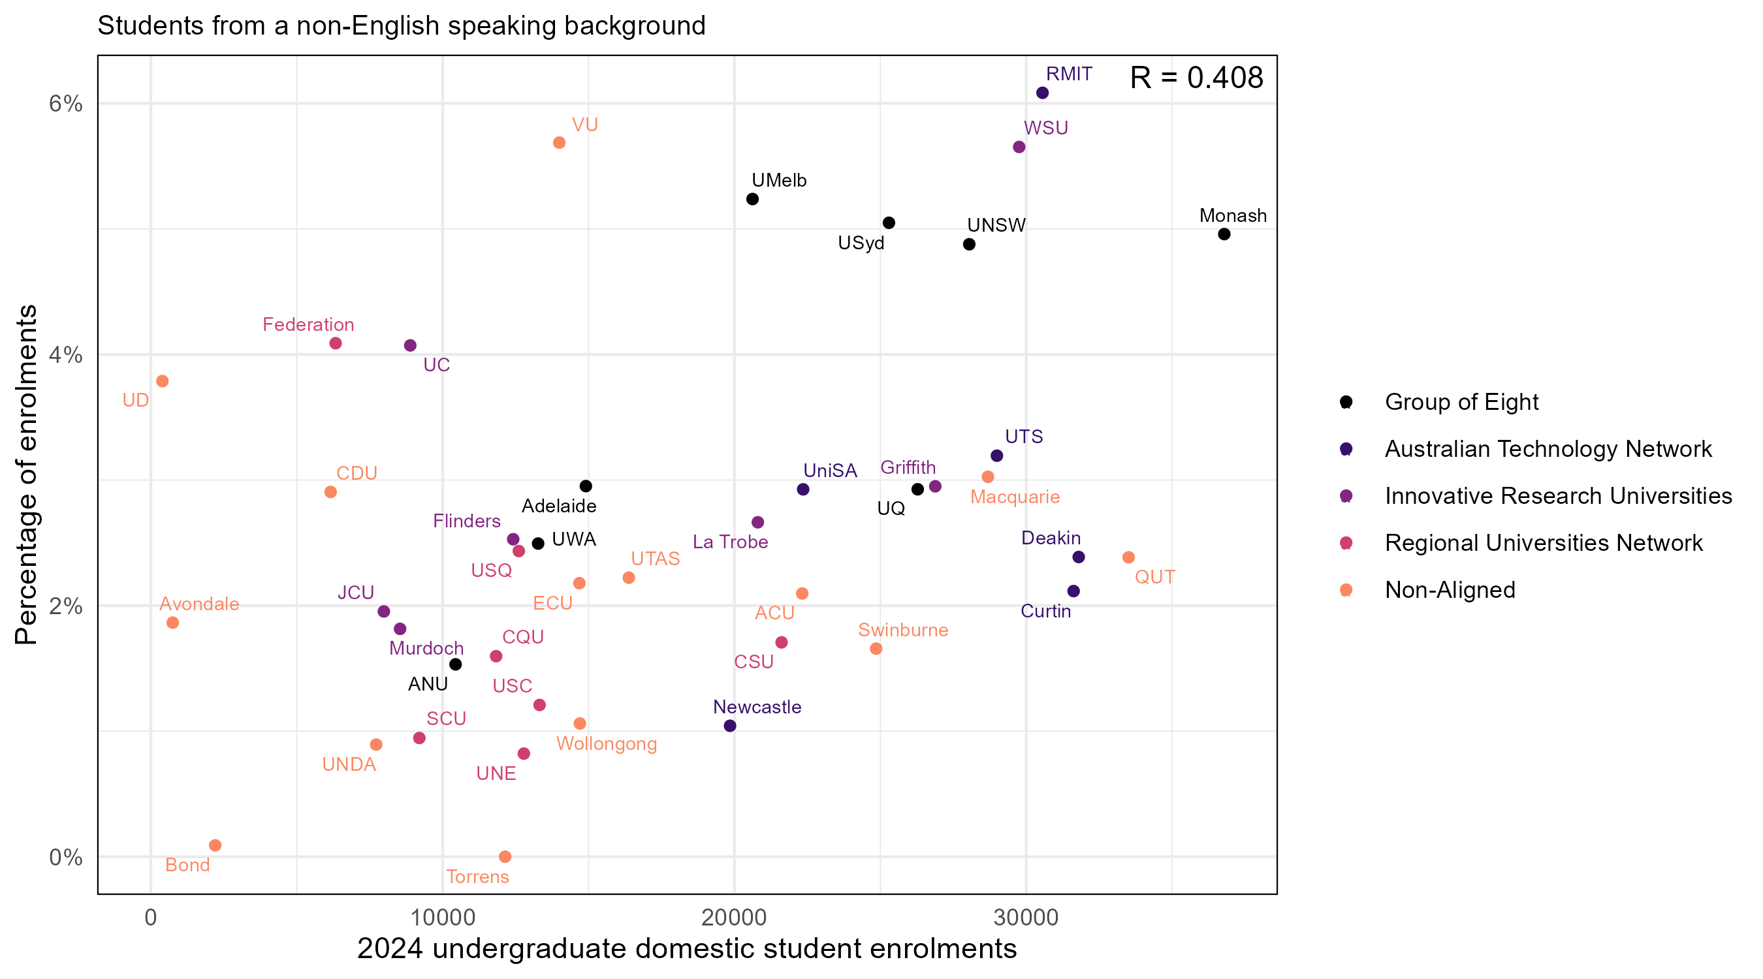

Women in non-traditional areas of study
Figure 8 shows the relationship between university size and participation for women in non-traditional areas of study across each university. A weak positive correlation is observed between institution size and participation for women in non-traditional areas of study.
Figure 8: Domestic undergraduate enrolments vs participation rate for women in non-traditional areas of study in 2024
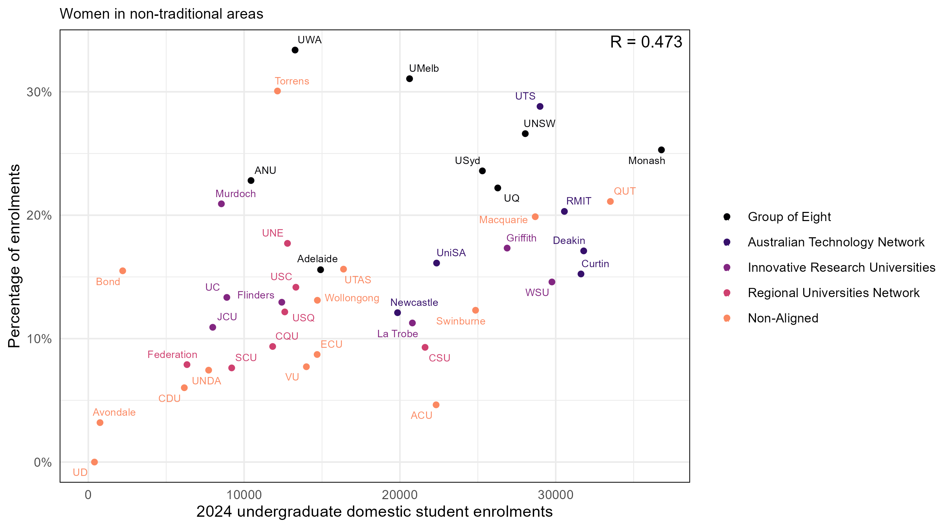

Correlations across institutional groupings
Weak correlations at the sector level can coexist with stronger relationships within institutional groupings. Table 1 shows the correlations between university size and participation for each equity group across institutional groupings in 2024. Note that correlations for non-equity students are the inverse of those for all equity students.
Table 1: Correlations for domestic undergraduate enrolments vs participation rate for equity students by institutional grouping in 2024
Equity group | All universities | Group of Eight | Australian Technology Network | Innovative Research Universities | Regional Universities Network | Non-aligned
All equity students | -0.424 | -0.580 | -0.691 | -0.495 | -0.069 | -0.292
Students with disability | -0.150 | -0.861 | -0.727 | -0.354 | -0.247 | -0.382
First Nations Australians | -0.400 | -0.560 | -0.745 | -0.349 | 0.410 | -0.282
Regional/remote | -0.380 | -0.309 | -0.513 | -0.461 | -0.018 | -0.179
Low SES | -0.363 | -0.014 | -0.754 | -0.165 | 0.009 | -0.328
First in family | -0.123 | 0.152 | -0.667 | 0.507 | 0.443 | 0.183
NESB | 0.408 | 0.739 | 0.429 | 0.605 | -0.396 | 0.115
WINTA | 0.473 | 0.024 | 0.421 | 0.057 | 0.194 | 0.479

Equity participation and institution size correlations over time
Figure 9 shows the correlations between university size and participation shares for all students belonging to the four key equity groups over time. The correlations for students with disability jumped from weakly negative to negligible, coinciding with the change in definition of “students with disability” (to include “mental health conditions”) introduced in 2020.
Figure 9: Correlation between institution size and participation rate by equity group, 2017–2024
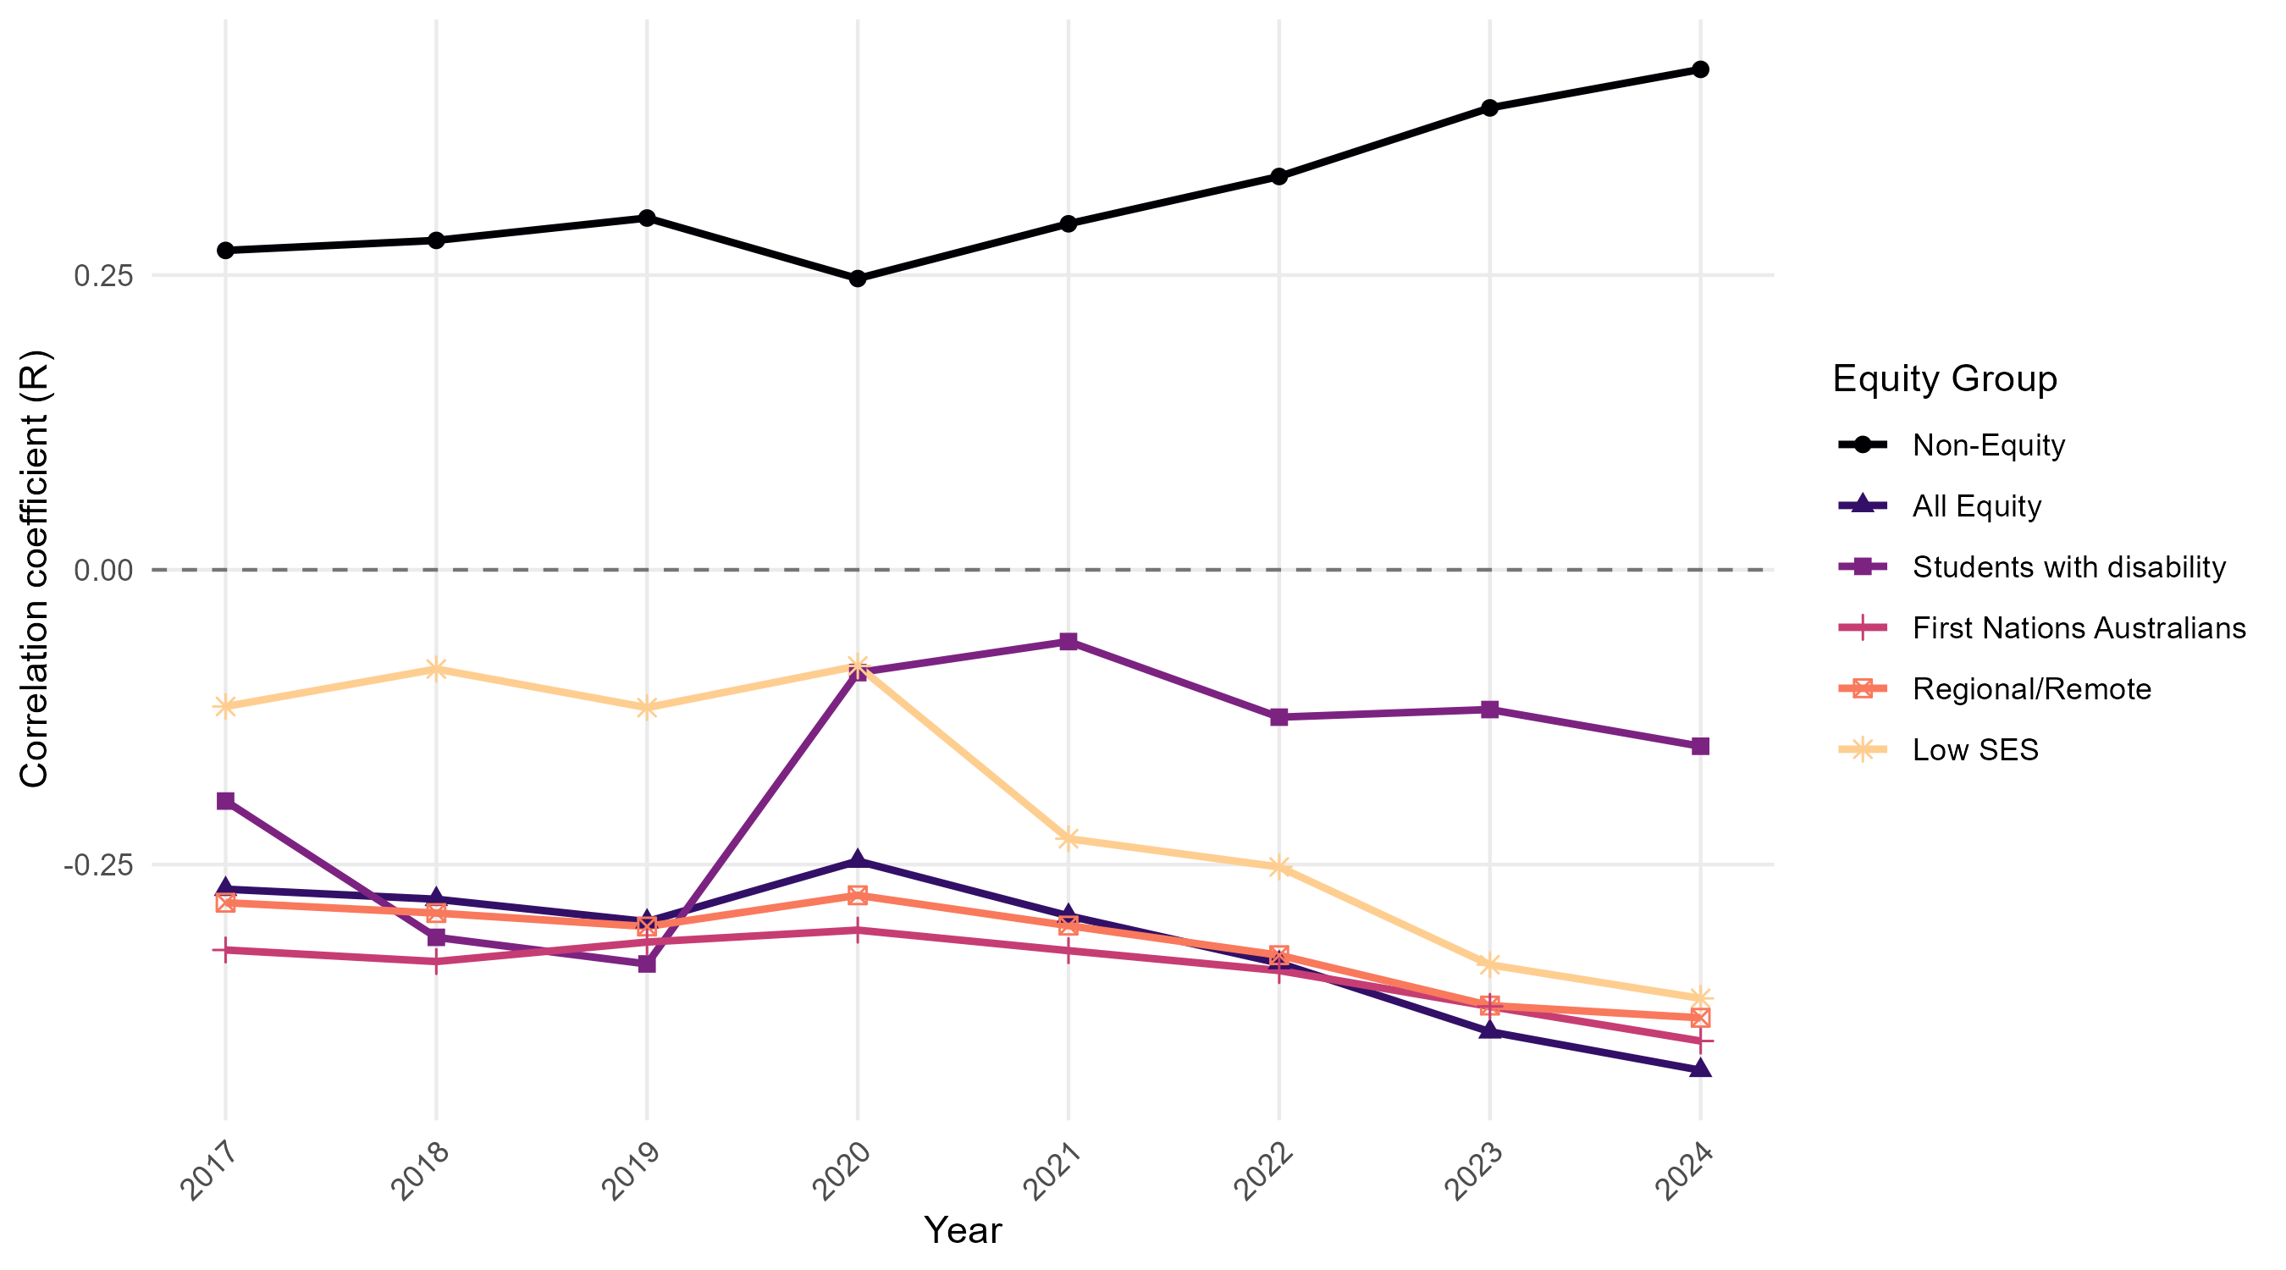

Australian Government Department of Education. (2025). Higher Education Statistics, Private Request (September 2025). Canberra: Department of Education.
These include: natural and physical sciences; information technology; engineering and related technologies; architecture and building; agriculture, environmental, and related studies; management and commerce; and economics and econometrics (a narrow field of education in society and culture).

