Equity participation targets and sector growth: How are we tracking between 2021 and 2024?

ACSES Data Insights Series

Acknowledgements
This report was prepared by the Data Program of the Australian Centre for Student Equity and Success (ACSES) at Curtin University.
The authors would like to acknowledge the staff at ACSES for their comments and assistance in the production of this publication and extend thanks to the Australian Government Department of Education for the provision of student equity data.
The report may be cited as: ACSES Data Program. (2026). Equity participation targets and sector growth: how are we tracking between 2021 and 2024? Australian Centre for Student Equity and Success (ACSES), Perth: Curtin University.
This report examines changes in the enrolment headcount of domestic undergraduate students between 2021 and 2024, with a focus on progress towards 2050 equity parity targets. For further information on retention, participation, success, six- and nine-year cohort completion, please refer to the ACSES student equity data Interactive Tool: https://www.acses.edu.au/data/interactive-tool/
Copyright ownership of this material resides with Curtin University.
ISBN 978-1-7648267-4-7

The Australian Centre for Student Equity and Success Data Insights Series
The Australian Centre for Student Equity and Success (ACSES) is an evidence-based research and public policy centre based at Curtin University and funded by the Australian Government Department of Education. ACSES is committed to providing the higher education sector with tangible proof of what works to improve the quality and impact of student equity practices in higher education.
The ACSES Data Insights Series reports on equity student participation and outcomes in Australian higher education. It focuses on trends among identified equity groups in domestic undergraduate enrolments in Australia, including, but not limited to:
- low socio-economic status (SES) students
- students with disability
- First Nations (Aboriginal and Torres Strait Islander) Australian students
- regional students
- remote students.
For further information on ACSES, please visit www.acses.edu.au.

Data explanatory notes
All student data reported in this document are sourced from a customised request to the Australian Government Department of Education.
For this report:
- Analysis was restricted to domestic, onshore, undergraduate students from Table A institutions (as defined under the Higher Education Support Act 2003).
- The identification of students from low SES, regional, and remote backgrounds is based on their first address.
- “Non-equity students” refers to students who do not belong to any of the key equity groups presented in this report, namely, students with disability, First Nations Australian students, and students from low SES, regional, and remote areas.
- Parity targets for 2050 were drawn from the ACSES report Equity Policy Options: Parity Targets, Final Report. Since the release of that report, updates to Department data and reporting, alongside the Australian Universities Accord Final Report, have informed the approach to parity targets for students with disability. In the Accord, the objective for students with disability was to maintain current levels of participation. Accordingly, in this report, the 2050 target for students with disability is set at the 2024 participation share.

Equity parity targets and enrolment growth
Since the release of the Australian Universities Accord Final Report in February 2024, a key question for the higher education sector has been how progress towards its two central ambitions is tracking: the expansion of around one million additional students by 2050 and the achievement of equity parity by 2050. Importantly, these objectives are not necessarily dependent on one another—growth in overall enrolments does not automatically translate into equitable representation across equity groups.
In this report, we build on earlier ACSES work examining options for achieving equity participation parity by 2050 to ask: where are we now? Using the most recent available data, we examine changes in enrolment headcount and equity participation between 2021 and 2024 and assess progress towards 2050 parity targets.

Domestic undergraduate enrolments declined by 56,000 between 2021 and 2024
Domestic undergraduate enrolments fell from 798,084 in 2021 to 742,289 in 2024, a decline of 55,795 students over this period.
This decline was widespread, with only five universities recording increases in enrolments (ranging from 325 to 3,430), while the remaining 33 experienced declines (ranging from 61 to 7,374 students) (Figure 1).
Figure 1: Changes in total headcount enrolment between 2021 and 2024 for Table A universities
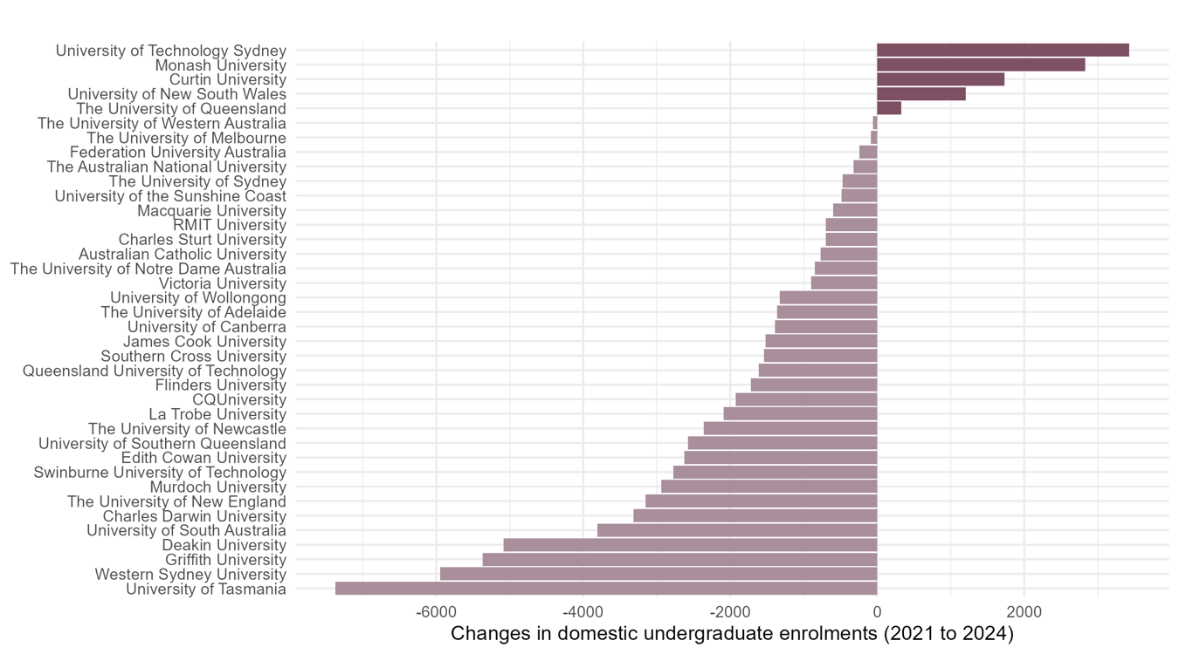

Equity enrolments have declined for all groups, except for students with disability
Between 2021 and 2024, enrolments fell markedly for students from low SES areas and regional and remote areas, with declines of around 9% (Table 1).
Enrolments for First Nations Australian students remained broadly stable, while enrolments for students with disability increased by around 21%.
Table 1: Headcount enrolment for 2021 and 2024, both overall and for each equity group
Group | 2021 headcount | 2024 headcount | Change in enrolment between 2021 and 2024 | Percentage change (%)
Students from low SES areas | 135,269 | 123,007 | -12,262 | -9.1
Students from regional/remote areas | 159,620 | 144,125 | -15,495 | -9.7
First Nations Australian students | 16,737 | 16,718 | -19 | -0.1
Students with disability | 81,529 | 98,934 | 17,405 | 21.3
Equity students | 296,499 | 286,331 | -10,168 | -3.4
Non-equity students | 501,585 | 455,958 | -45,627 | -9.1
Domestic undergraduates | 798,084 | 742,289 | -55,795 | -7.0
Note: Students may belong to more than one equity group, therefore changes observed within individual equity groups will not sum to the total change for all domestic undergraduates.

Participation parity target tracking
Recent participation trends indicate mixed progress towards student equity parity. Participation shares for students with disability have increased markedly since 2021, while shares for students from low SES areas and regional and remote areas have declined. Participation among First Nations Australian students has increased steadily and appears to be on track towards 2050 parity targets, despite a slight decline in overall enrolments over the same period.
Figure 2: Progress towards 2050 equity targets for each of the four priority equity groups. The dotted line indicates a uniform trajectory from 2021 to achieving the 2050 target.
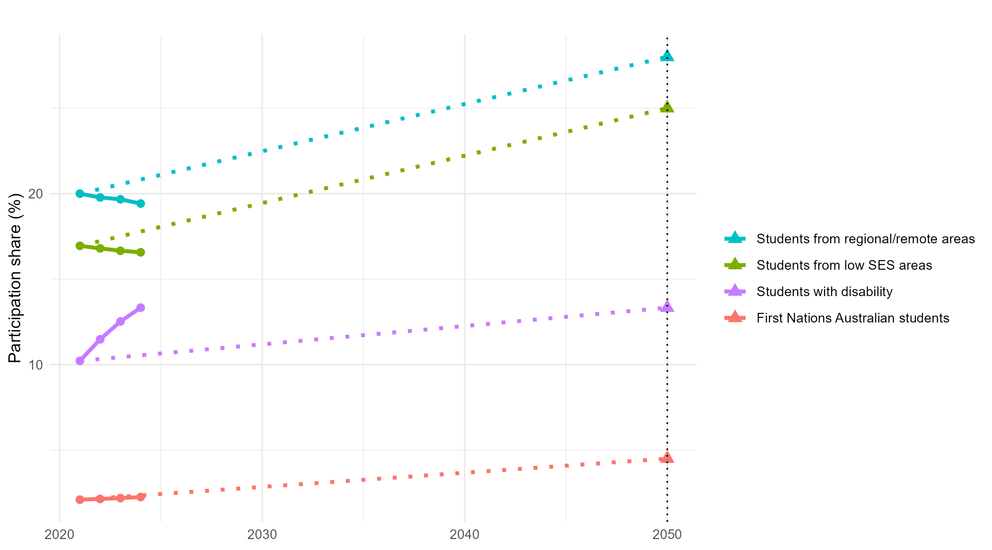

Relationship between changes in participation share and enrolment headcount for equity student groups
Figures 3 to 8 show the relationship between changes in participation share and enrolment headcount from 2021 to 2024 for each of the five equity groups and equity students overall.
Within each plot, four quadrants are labelled. These are:
- ↑ Headcount & ↑ Share: An increase in both enrolment headcount and equity participation share—indicating increased representation and growth in student numbers.
- ↑ Headcount & ↓ Share: An increase in headcount but a decline in equity participation share—indicating that equity representation is reducing despite an overall growth of student numbers.
- ↓ Headcount & ↑ Share: A decline in enrolment headcount alongside an increase in equity participation share—indicating improved equity representation despite declining enrolments.
- ↓ Headcount & ↓ Share: A decline in both headcount and equity participation share—indicating both contraction and reduced equity representation.

Figure 3: Students from low SES areas: Relationship between changes in headcount and participation shares between 2021 and 2024
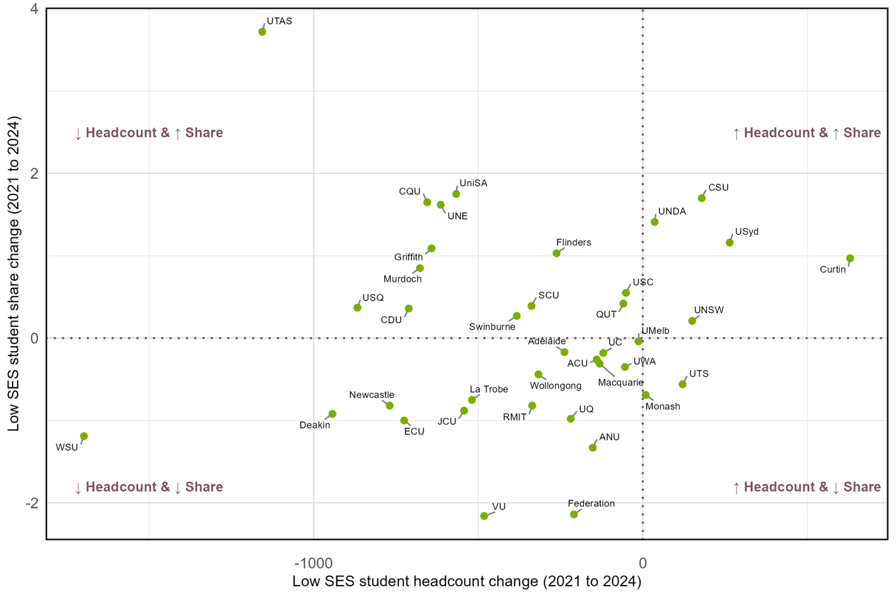

Figure 4: Students from regional areas: Relationship between changes in headcount and participation shares between 2021 and 2024
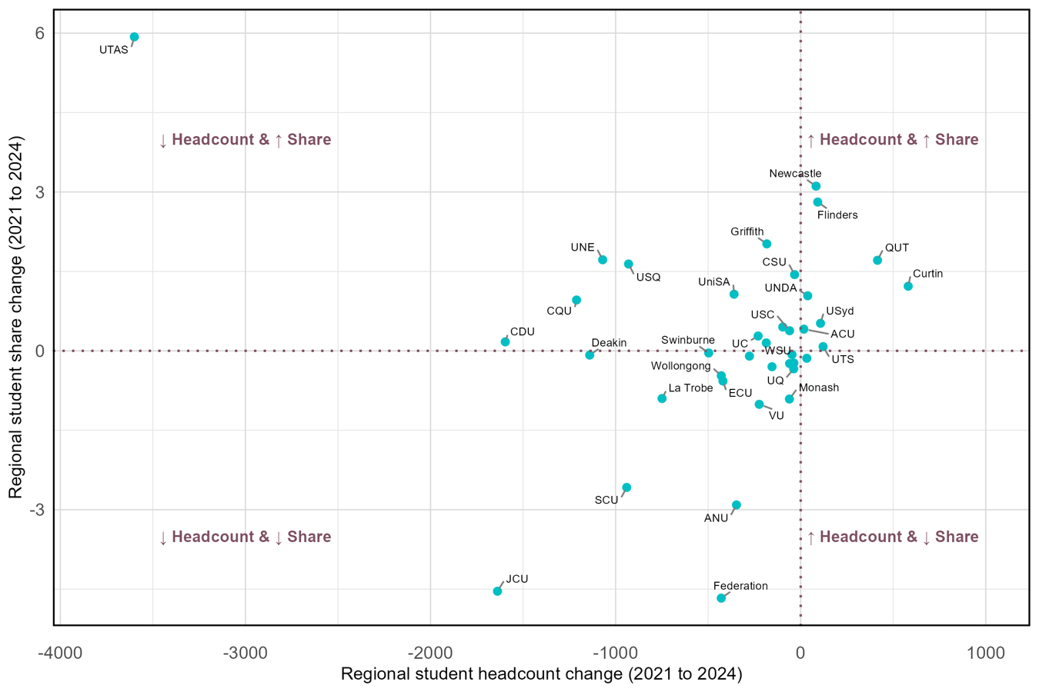

Figure 5: Students from remote areas: Relationship between changes in headcount and participation shares between 2021 and 2024
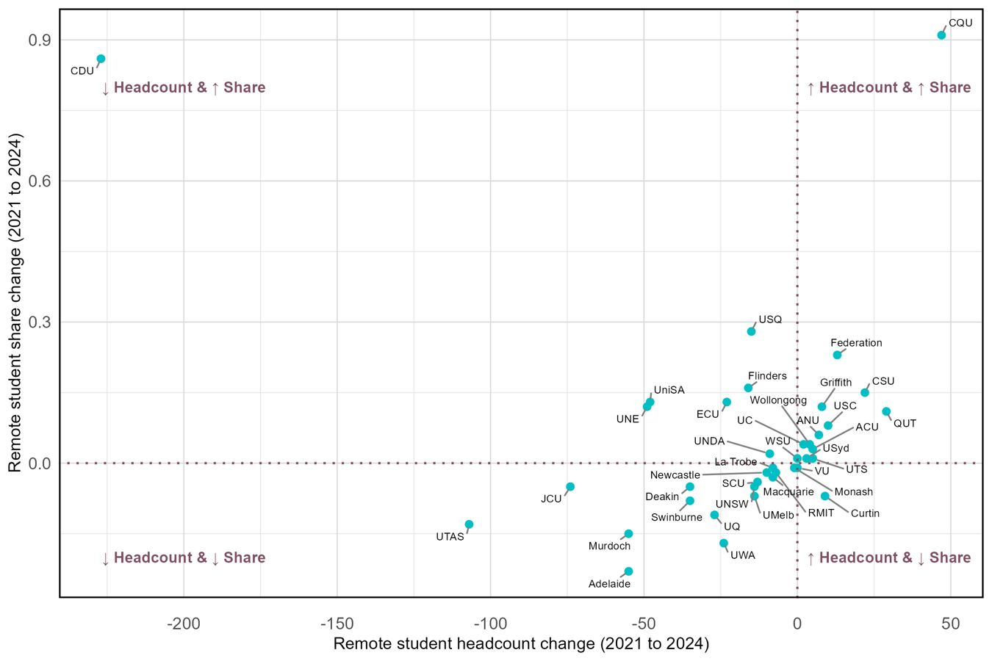

Figure 6: First Nations Australian students: Relationship between changes in headcount and participation shares between 2021 and 2024
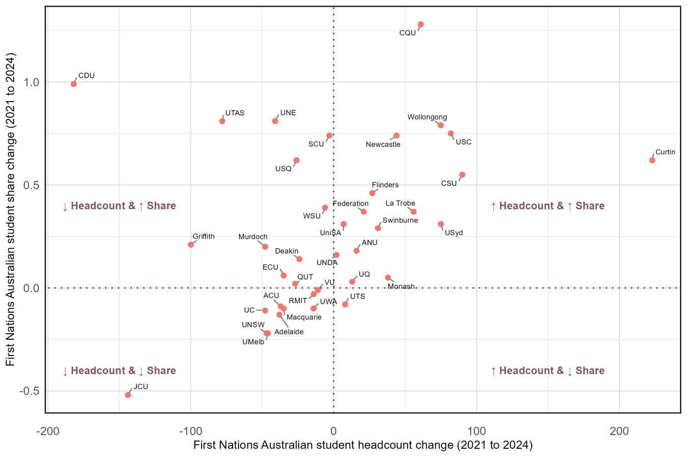
Figure 7: Students with disability: Relationship between changes in headcount and participation shares between 2021 and 2024
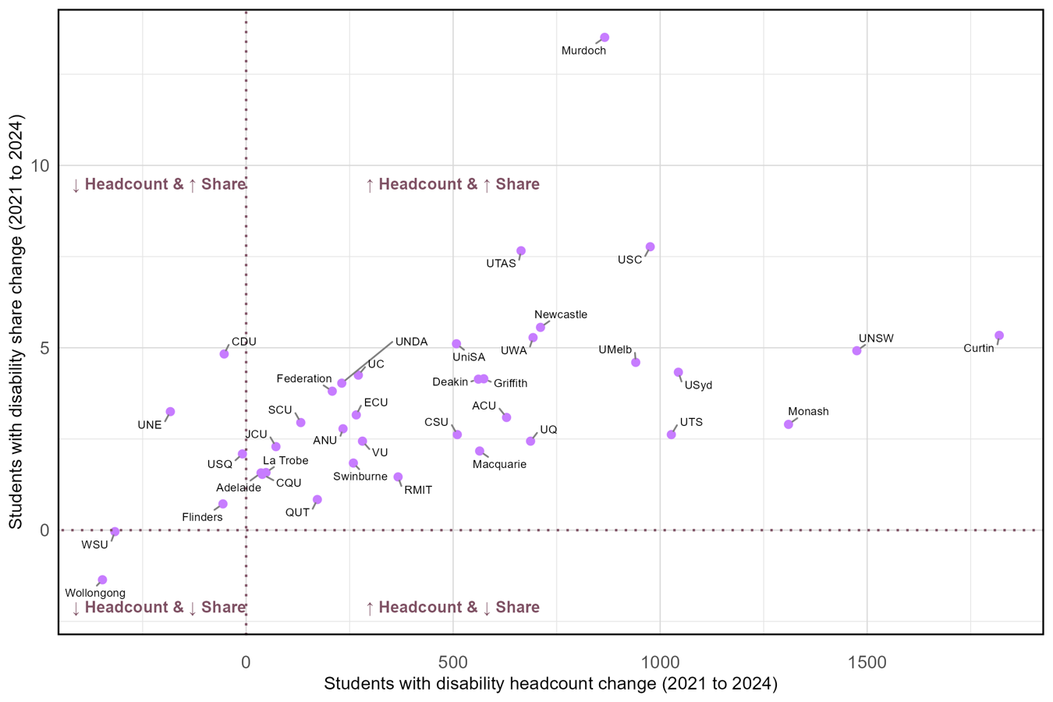

Figure 8: Equity students: Relationship between changes in headcount and participation shares between 2021 and 2024
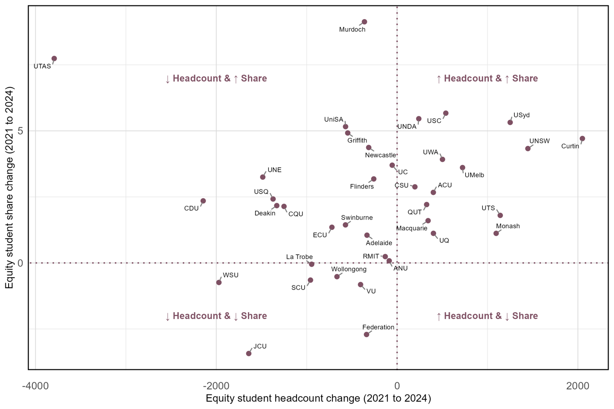

Table 2 summarises the distribution of universities across quadrants for each equity group, providing an overview of the patterns shown in Figures 3 to 8. Across low SES and regional groups, the largest number of universities fall in the ↓ Headcount & ↓ Share quadrant, indicating that declines in enrolment are being accompanied by declining representation. In contrast, students with disability are overwhelmingly in the ↑ Headcount & ↑ Share quadrant, suggesting consistent sector-wide gains.
Table 2: Summary of the number of universities by direction of change in headcount enrolment and participation share, 2021 to 2024, by equity group
Group | ↑ Headcount  & ↑ Share | ↓ Headcount  & ↑ Share | ↓ Headcount  & ↓ Share | ↑ Headcount  & ↓ Share
Students from low SES areas | 5 | 13 | 18 | 2
Students from regional areas | 8 | 12 | 17 | 1
Students from remote areas | 13 | 7 | 16 | 2
First Nations Australian students | 16 | 11 | 10 | 1
Students with disability | 32 | 4 | 2 | 0
Equity students | 14 | 17 | 7 | 0

Table 3 summarises whether universities increased both headcount enrolment and participation share for each equity group between 2021 and 2024, with “Yes” indicating that both measures increased over the period. Only one university was able to increase its headcount enrolment and participation share for all equity groups between 2021 and 2024, while three universities increased headcount and participation share for four of the five groups.
Table 3: Universities showing increases (“Yes”) in both equity group headcount enrolment and participation share (↑ Headcount & ↑ Share) from 2021 to 2024
University Name | Low SES students | Regional students | Remote students |  | First Nations Australian students | Students with disability | Yes Total
Australian Catholic University | No | Yes |  | Yes | No | Yes | 3
CQUniversity | No | No |  | Yes | Yes | Yes | 3
Charles Darwin University | No | No |  | No | No | No | 0
Charles Sturt University | Yes | No |  | Yes | Yes | Yes | 4
Curtin University | Yes | Yes |  | No | Yes | Yes | 4
Deakin University | No | No |  | No | No | Yes | 1
Edith Cowan University | No | No |  | No | No | Yes | 1
Federation University Australia | No | No |  | Yes | Yes | Yes | 3
Flinders University | No | Yes |  | No | Yes | No | 2
Griffith University | No | No |  | Yes | No | Yes | 2
James Cook University | No | No |  | No | No | Yes | 1
La Trobe University | No | No |  | No | Yes | Yes | 2
Macquarie University | No | No |  | No | No | Yes | 1
Monash University | No | No |  | No | Yes | Yes | 2
Murdoch University | No | No |  | No | No | Yes | 1
Queensland University of Technology | No | Yes |  | Yes | No | Yes | 3
RMIT University | No | No |  | No | No | Yes | 1
Southern Cross University | No | No |  | No | No | Yes | 1
Swinburne University of Technology | No | No |  | No | Yes | Yes | 2
The Australian National University | No | No |  | Yes | Yes | Yes | 3
The University of Adelaide | No | No |  | No | No | Yes | 1
The University of Melbourne | No | No |  | No | No | Yes | 1
The University of New England | No | No |  | No | No | No | 0
The University of Newcastle | No | Yes |  | No | Yes | Yes | 3
The University of Notre Dame Australia | Yes | Yes |  | No | Yes | Yes | 4
The University of Queensland | No | No |  | No | Yes | Yes | 2
The University of Sydney | Yes | Yes |  | Yes | Yes | Yes | 5
The University of Western Australia | No | No |  | No | No | Yes | 1
University of Canberra | No | No |  | Yes | No | Yes | 2
University of New South Wales | Yes | No |  | No | No | Yes | 2
University of South Australia | No | No |  | No | Yes | Yes | 2
University of Southern Queensland | No | No |  | No | No | No | 0
University of Tasmania | No | No |  | No | No | Yes | 1
University of Technology Sydney | No | Yes |  | Yes | No | Yes | 3
University of Wollongong | No | No |  | Yes | Yes | No | 2
University of the Sunshine Coast | No | No |  | Yes | Yes | Yes | 3
Victoria University | No | No |  | No | No | Yes | 1
Western Sydney University | No | No |  | Yes | No | No | 1
Yes Total | 5 | 8 |  | 13 | 16 | 32 | 74

Summary and future directions
The findings in this report highlight a dual challenge for the sector. Between 2021 and 2024, domestic undergraduate enrolments fell by nearly 56,000 students, and this decline has not been experienced equally. Students from low SES backgrounds and regional and remote areas saw larger proportional declines (around 9–10%) than the sector overall (7%), indicating that existing participation gaps may be widening, rather than closing.
Nonetheless, the performance of some institutions demonstrates that it is possible to increase enrolments whilst maintaining or even improving equity participation rates.
Looking ahead, reversing the overall decline in enrolments will be important, but it will not be enough on its own. Future growth will need to be actively directed towards underrepresented groups, particularly students from low SES and regional and remote backgrounds, who have experienced the largest declines. Without this focus, progress towards equity parity by 2050 is likely to slow further, and for some groups the gap may continue to widen. In addition, it is important to consider other performance measures such as retention and attainment, as gains in enrolment need to be matched by successful progression and completion, to support meaningful equity outcomes.

Australian Government Department of Education. (2025). Equity Group Statistics, Private Request (November 2025). Canberra: Department of Education.
Australian Centre for Student Equity and Success. (2024). Equity Policy Options: Parity Targets, Final Report. https://www.acses.edu.au/publication/equity-policy-options-parity-targets-final-report/
Department of Education. (2024). Australian Universities Accord Final Report. https://www.education.gov.au/australian-universities-accord

