Enabling programs in Australian higher education

ACSES Data Insights Series

Acknowledgements

This report was prepared by the Data Program of the Australian Centre for Student Equity and Success (ACSES) at Curtin University.
The authors would like to acknowledge the staff at ACSES for their comments and assistance in the production of this publication and extend thanks to the Australian Government Department of Education for the provision of student equity data.
The report may be cited as: ACSES Data Program. (2026). Enabling programs in Australian higher education. Australian Centre for Student Equity and Success (ACSES), Perth: Curtin University.
This report focuses on changes in participation rates in enabling programs from 2014 to 2023, retention rates from 2021 and 2022, and success rates from 2021 to 2023. For further information on retention, participation, success, and six- and nine-year cohort completion, please refer to the ACSES student equity data Interactive Tool: www.acses.edu.au/data/interactive-tool.
Copyright ownership of this material resides with Curtin University.
ISBN - 978-1-7645328-8-4

The Australian Centre for Student Equity and Success Data Insights Series

The Australian Centre for Student Equity and Success (ACSES) is an evidence-based research and public policy centre based at Curtin University and funded by the Australian Government Department of Education. ACSES is committed to providing the higher education sector with tangible proof of what works to improve the quality and impact of student equity practices in higher education.
The ACSES Data Insights Series reports on equity student participation and outcomes in Australian higher education. It focuses on trends among identified equity groups in domestic undergraduate enrolments in Australia, including, but not limited to:
- low socio-economic status (SES) students
- students with disability
- First Nations (Aboriginal and Torres Strait Islander) Australian students
- regional students
- remote students.
For further information on ACSES, please visit www.acses.edu.au.

Data explanatory notes

All student data reported in this document are sourced from a customised request to the Australian Government Department of Education.
For this report:
- Some longitudinal analysis is provided, but the focus is on the most recent data available, which is for 2023.
- For the purposes of aggregation and presentation of results, cell counts of less than five have been excluded from presentation. For retention rates, this suppresses institutions with headcounts less than five, while for success rates, it suppresses institutions with fewer than five Equivalent Full-Time Student Loads (EFTSL). This means this report may suppress success rates for institutions whose retention rates are otherwise included.
- Analysis includes only Table A universities (as defined under the Higher Education Support Act 2003).
- The identification of students from low SES, regional, and remote backgrounds is based on their first address.
- “Equity students” or “all equity students” refers to students who belong to at least one of the four key equity groups presented in this report, namely, students with disability, First Nations Australian students, students from low SES areas, and students from regional and remote areas.
- “Non-equity students” refers to students who do not belong to any of the key equity groups described above.
- “First-in-family” refers to students whose parents or guardians have not completed a bachelor’s degree (AQF Level 7) or higher. We are including first-in-family status as a complementary equity lens. At present, first-in-family students are not recognised as an official national equity group and are not included in “all equity students” numbers.
- The definition of “students with disability” was changed in 2020 to include “mental health conditions”. This change in definition has driven much of the increase in participation by equity students in enabling programs.
- The participation rate for an equity group refers to the percentage of students within the enabling program who are part of the specified equity group. The participation rate measures participation in a university enabling program, not university participation for students from enabling programs.
- The success and retention rates are for commencing onshore domestic university students who entered university through enabling programs or via Australian Tertiary Admission Rank (ATAR) pathways. Success rate measures performance at university, not performance within the enabling program used to gain admission to university. Retention rate measures retention of university students within the university sector, not retention in an enabling program.
- The retention rate used is the Sector Retention Rate (New Adjusted Retention Rate), which counts students who switch institutions in the previous year as being retained within the higher education system.
- Retention rate is a lagging indicator. This means that data labelled “2022” refers to students from 2022 who returned to higher education in 2023.
- Success rate measures the proportion of subject load passed by undergraduate students in their first year at university. The success rate is equal to the EFTSL passed by students in a selected group as a percentage of EFTSL certified (EFTSL passed, failed, or withdrawn) among all students in the group.
- “Enabling program students” refers to domestic undergraduate students at university whose main basis of admission was through enabling program pathways. “ATAR students” refers to domestic undergraduate students whose main basis of admission was through their ATAR.

Enabling programs in Australian higher education

An enabling program (or enabling course) is a course of instruction that enables a person to undertake a course leading to a higher education award but does not itself offer an award (Higher Education Support Act, 2003). As of 2024, there were 48 enabling programs across Australia (NAEEA, 2024).
Enabling programs are a key mechanism for widening participation in Australian higher education, particularly for equity students. Some enabling programs are designed for specific equity groups, including 15 that are explicitly for First Nations students (NAEEA, 2024). Enabling programs also attract substantial participation from students in regional and remote areas, highlighting their role as an alternative entry pathway for students who may face geographic and structural barriers to direct entry.
This report presents enabling program participation rates, as well as retention and success rates for university students whose main basis of admission to university was via an enabling program. Retention and success rates are presented across two comparative dimensions: (1) equity students entering via enabling programs compared with non-equity students entering via enabling programs; and (2) equity students entering via enabling programs compared with equity students entering via ATAR.
These two comparison dimensions are intended to support meaningful benchmarking and interpretation of equity outcomes. Comparing equity and non-equity students provides a within-cohort reference point that helps quantify equity gaps and identify where outcomes diverge, consistent with ACSES guidance on the importance of comparative data for understanding equity performance and improvement priorities. Comparing equity students entering via enabling programs with equity students entering via ATAR provides a pathway benchmark that helps understand how enabling programs perform for specific equity groups.
Enabling programs are not delivered in a uniform institutional context. At some universities, enabling programs are delivered wholly or partly within secondary school settings (“in‑school enabling programs”), often through partnerships between universities and schools, and are targeted at students while they are still enrolled in Year 11 or 12. These delivery arrangements are not differentiated in Department of Education administrative data, which record enabling programs as a single category regardless of whether delivery occurs on‑campus or within schools, limiting the capacity to disaggregate participation and outcomes by delivery context.
Further reading on enabling programs:
- National Association of Enabling Educators of Australia (NAEEA). (2024). Enabling Education Across Australia.
- National Association of Enabling Educators of Australia (NAEEA). (2023). Report on Benchmarking of Enabling Programs across Australia to the National Association of Enabling Educators of Australia (NAEEA).
- National Centre for Student Equity in Higher Education (NCSEHE). (2016). Pathways to Higher Education: The Efficacy of Enabling and Sub-Bachelor Pathways for Disadvantaged Students.

Enabling program enrolments and participation rates

From 2014 to 2023, enrolments in enabling programs declined overall. Over the same period, enabling programs were increasingly comprised of equity students, with the disparity between equity and non-equity enrolments widening over time.
Figure 1: Enrolments and participation rates of domestic students enrolled in enabling programs between 2014 and 2023
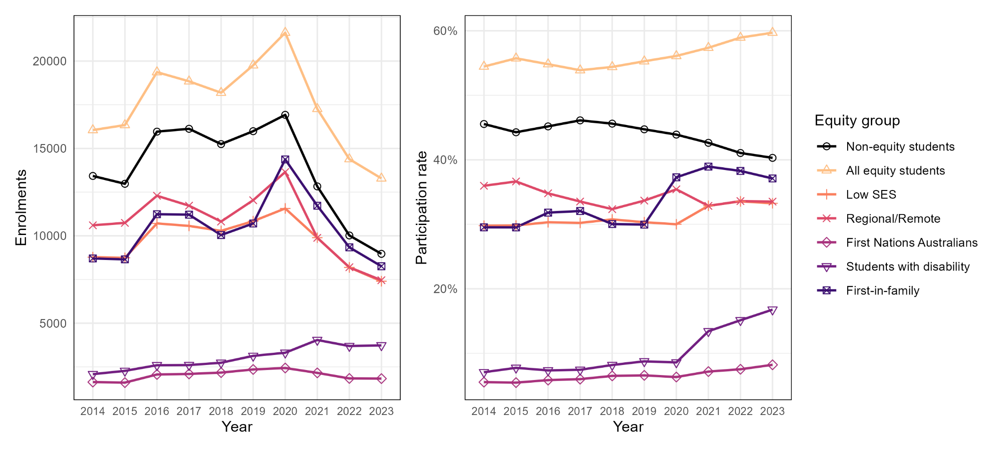

Enabling program enrolments and participation rates at Group of Eight universities

From 2014 to 2023, enrolment in enabling programs at Group of Eight universities halved. As of 2023, the share of students in enabling programs had reached approximate parity.
Figure 2: Enrolments and participation rates of domestic students enrolled in enabling programs between 2014 and 2023 at Group of Eight universities
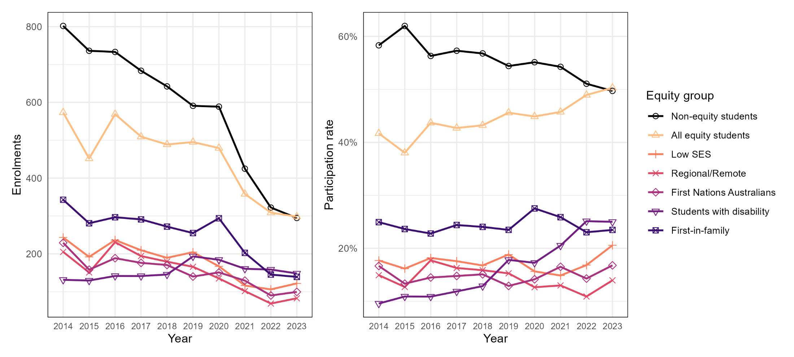

Enabling program enrolments and participation rates at Australian Technology Network universities

From 2014 to 2023, enrolments from equity students in enabling programs at Australian Technology Network universities increased, while overall enrolments decreased. As of 2021, the share of students in enabling programs had become dominated by equity students.
Figure 3: Enrolments and participation rates of domestic students enrolled in enabling programs between 2014 and 2023 at Australian Technology Network universities
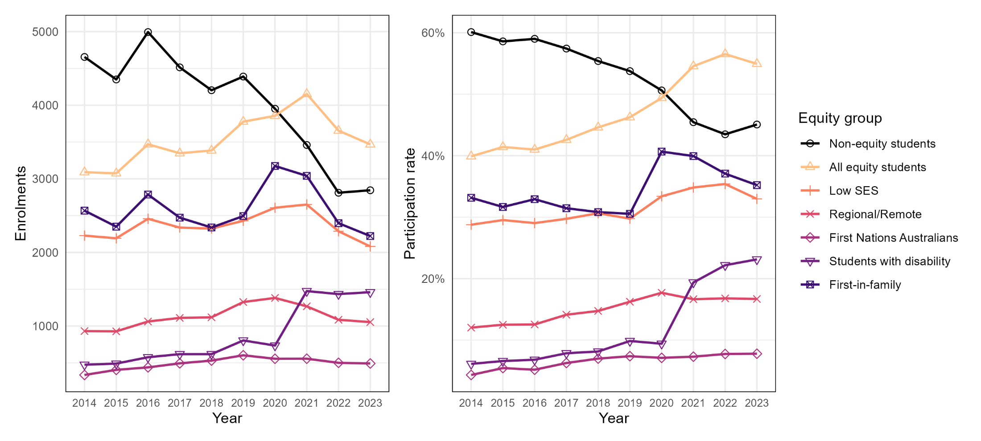

Enabling program enrolments and participation rates at Innovative Research Universities

Enrolments of students in enabling programs at Innovative Research Universities peaked before 2020 and have been on the decline since. As of 2023, the share of students in enabling programs belonging to an equity group had increased to almost 50%.
Figure 4: Enrolments and participation rates of domestic students enrolled in enabling programs between 2014 and 2023 at Innovative Research Universities
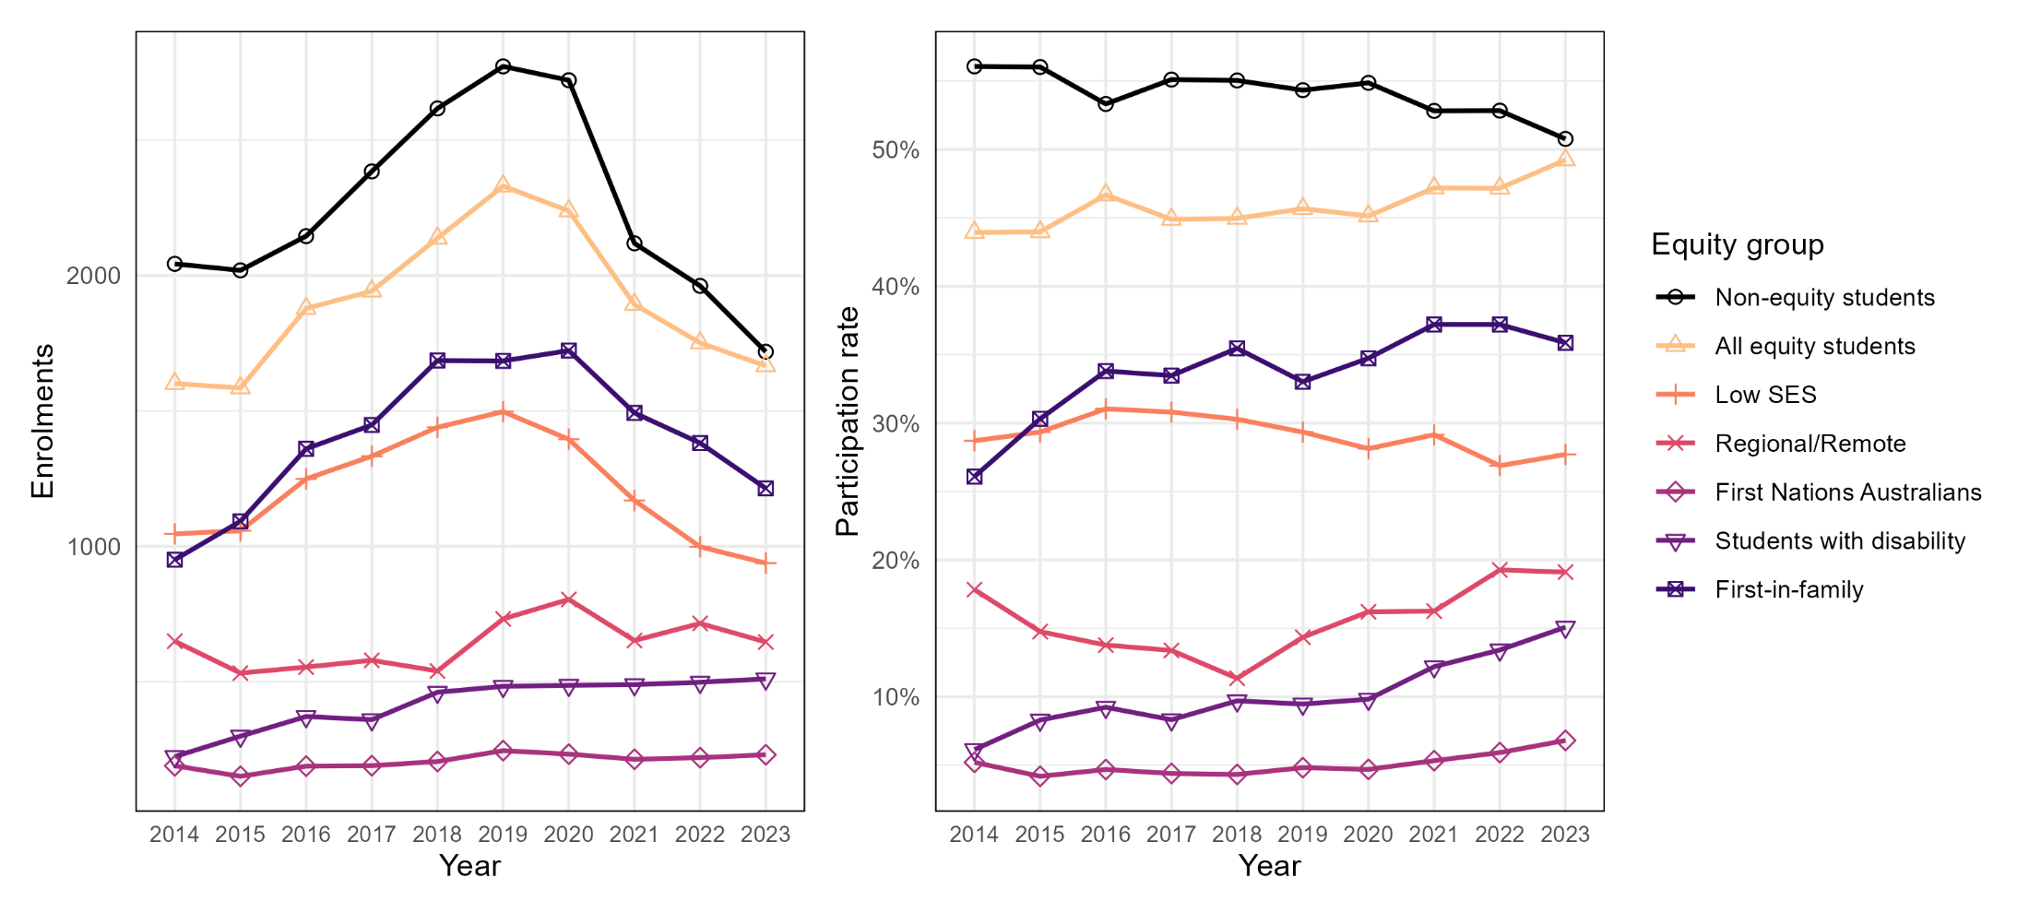

Enabling program enrolments and participation rates at Regional Universities Network universities

Enrolments of students in enabling programs at Regional Universities Network universities have been declining since 2020. Between 2014 and 2023, the share of students in enabling programs was dominated by regional and remote students.
Figure 5: Enrolments and participation rates of domestic students enrolled in enabling programs between 2014 and 2023 within the Regional Universities Network
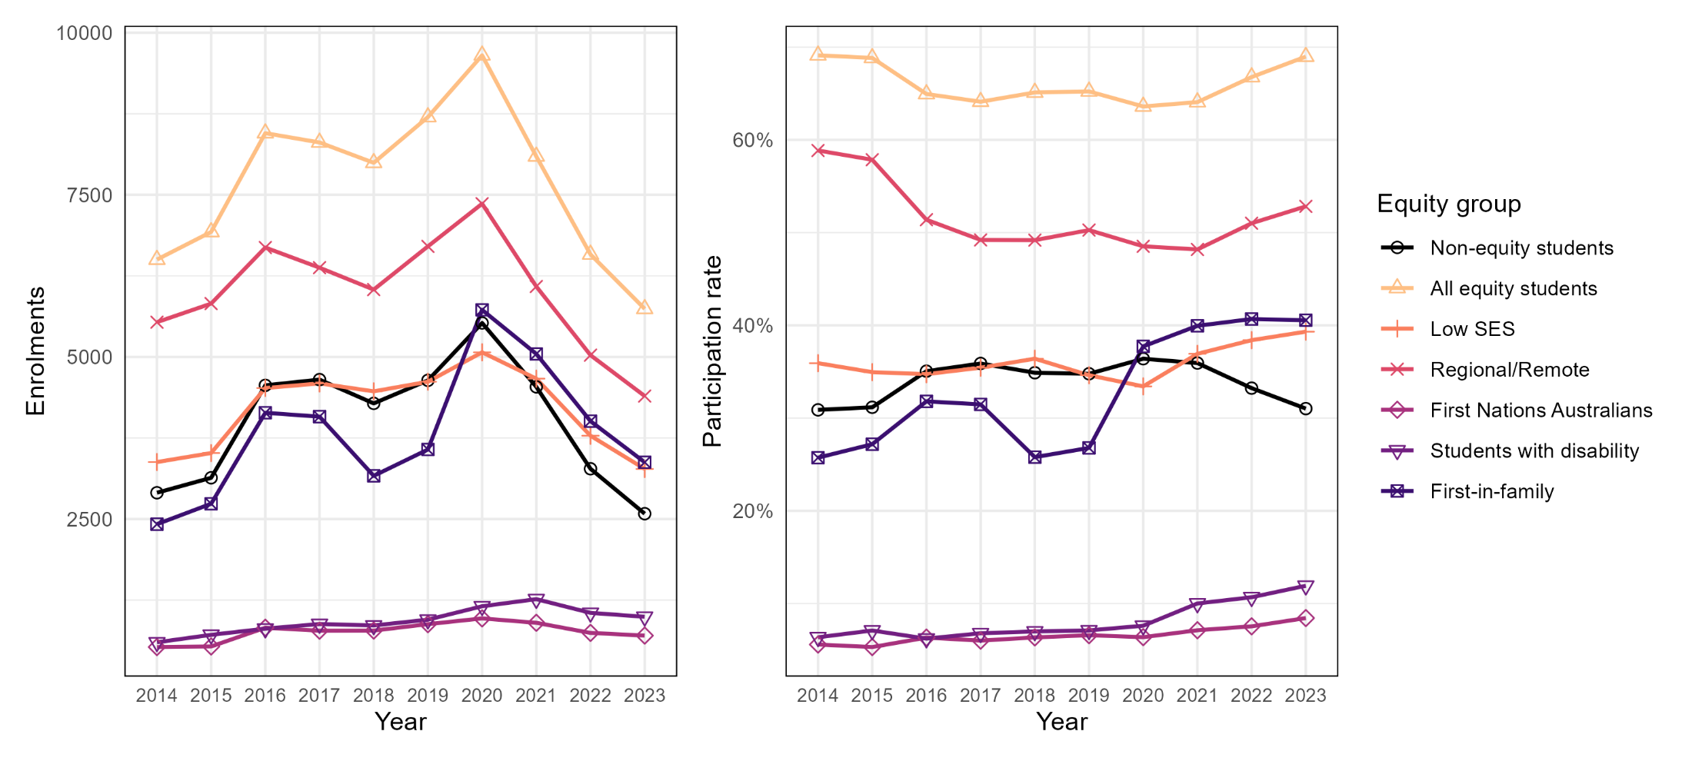

Enabling program enrolments and participation rates at non-aligned universities

Enrolments of students in enabling programs at non-aligned universities have been on a sharp decline since 2020. During this time, the share of students in enabling programs has been dominated by equity students.
Figure 6: Enrolments and participation rates of domestic students enrolled in enabling programs between 2014 and 2023 at non-aligned universities
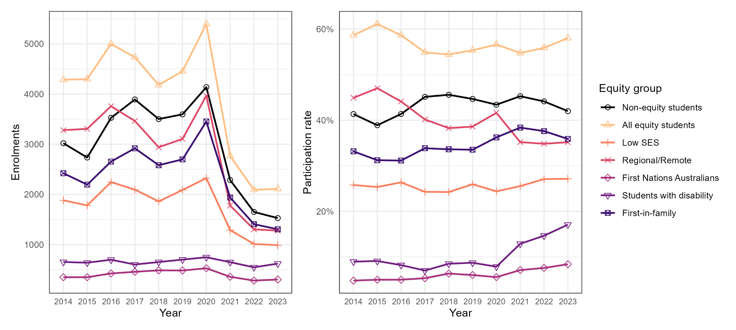

Sector-wide 2023 participation rates mask substantial variation across institutions

Figure 7: Participation rate of domestic undergraduate students enrolled in enabling programs in 2023, by equity group. Each dot represents a Table A institution with enrolments from enabling program students in 2023.
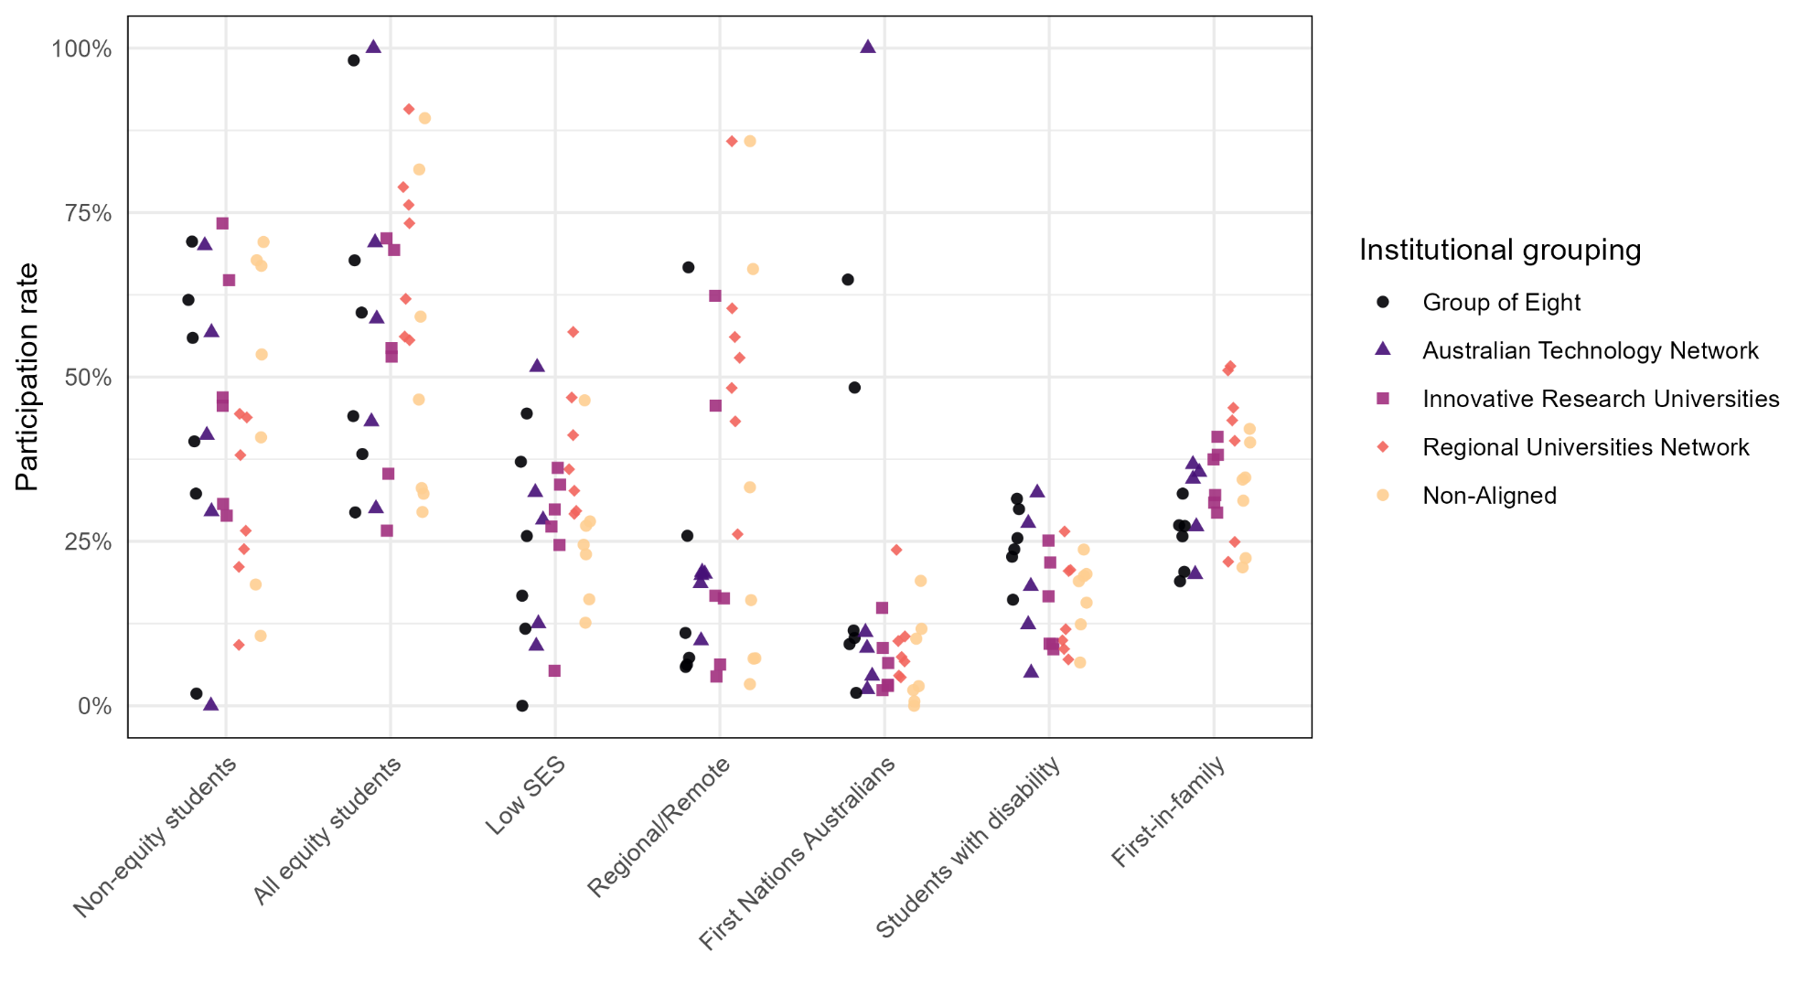

Enabling program participation in 2023

Table 1: Enabling program participation for Table A universities in 2023. Equity group headcounts have been estimated based on their percentages and rounded to the nearest whole number. Counts fewer than five are suppressed and shown as “<5”; associated percentages are upper bounds based on four students.

Institution | Headcount | Low SES | Regional/Remote | First Nations  Australians | Students with  disability | All equity students | First-in-family
CQUniversity | 1555 | 884 (56.9%) | 1335 (85.8%) | 164 (10.6%) | 181 (11.6%) | 1411 (90.7%) | 793 (51%)
Charles Darwin University | 1063 | 291 (27.4%) | 706 (66.4%) | 202 (19%) | 213 (20%) | 867 (81.6%) | 369 (34.7%)
Charles Sturt University | 2287 | 667 (29.2%) | 989 (43.2%) | 105 (4.6%) | 161 (7%) | 1272 (55.6%) | 1181 (51.7%)
Curtin University | 2035 | 576 (28.3%) | 202 (9.9%) | 92 (4.5%) | 252 (12.4%) | 880 (43.2%) | 702 (34.5%)
Edith Cowan University | 1474 | 413 (28%) | 237 (16.1%) | 44 (3%) | 231 (15.7%) | 686 (46.6%) | 590 (40%)
Federation University Australia | 278 | 100 (36%) | 156 (56.1%) | 12 (4.3%) | 57 (20.5%) | 204 (73.4%) | 126 (45.3%)
Flinders University | 691 | 250 (36.2%) | 116 (16.7%) | 22 (3.2%) | 115 (16.6%) | 367 (53.1%) | 259 (37.5%)
James Cook University | 467 | 127 (27.2%) | 291 (62.4%) | 41 (8.8%) | 44 (9.4%) | 324 (69.3%) | 144 (30.9%)
La Trobe University | 211 | 63 (29.9%) | 96 (45.6%) | 5 (2.4%) | 46 (21.8%) | 150 (71.1%) | 62 (29.4%)
Macquarie University | 99 | 13 (12.6%) | <5 (4%) | 0 (0%) | 19 (19%) | 29 (29.5%) | 21 (21%)
Monash University | 31 | 8 (25.8%) | 8 (25.9%) | 15 (48.4%) | 5 (16.1%) | 21 (67.7%) | 10 (32.3%)
Murdoch University | 753 | 253 (33.6%) | 47 (6.3%) | 112 (14.9%) | 189 (25.1%) | 410 (54.4%) | 241 (32%)
RMIT University | 40 | 5 (12.5%) | 8 (20.1%) | <5 (10%) | <5 (10%) | 12 (30%) | 8 (20%)
Southern Cross University | 956 | 283 (29.6%) | 462 (48.3%) | 71 (7.4%) | 95 (9.9%) | 592 (61.9%) | 238 (24.9%)
The University of Adelaide | 98 | 36 (37.1%) | 11 (11.1%) | 10 (10.3%) | 29 (29.9%) | 59 (59.8%) | 25 (25.8%)
The University of Melbourne | 51 | 0 (0%) | <5 (7.8%) | <5 (7.8%) | 13 (25.5%) | 15 (29.4%) | 14 (27.4%)
The University of New England | 466 | 192 (41.2%) | 282 (60.4%) | 110 (23.7%) | 124 (26.5%) | 368 (78.9%) | 188 (40.3%)
The University of Newcastle | 3555 | 1154 (32.5%) | 705 (19.8%) | 312 (8.8%) | 987 (27.8%) | 2092 (58.9%) | 1263 (35.5%)
The University of Notre Dame Australia | 420 | 68 (16.2%) | 30 (7.2%) | 10 (2.4%) | 52 (12.4%) | 139 (33.1%) | 131 (31.2%)
The University of Queensland | 130 | 15 (11.7%) | 8 (6.2%) | 12 (9.4%) | 29 (22.7%) | 50 (38.3%) | 36 (27.3%)
The University of Western Australia | 54 | 24 (44.4%) | 36 (66.7%) | 35 (64.8%) | 17 (31.5%) | 53 (98.2%) | 11 (20.4%)
University of Canberra | 338 | 18 (5.3%) | 55 (16.3%) | 22 (6.5%) | 29 (8.6%) | 90 (26.6%) | 129 (38.2%)
University of New South Wales | 229 | 38 (16.7%) | 17 (7.3%) | 26 (11.4%) | 54 (23.8%) | 101 (44%) | 43 (18.9%)
University of South Australia | 671 | 345 (51.5%) | 136 (20.3%) | 75 (11.2%) | 217 (32.4%) | 473 (70.4%) | 246 (36.7%)
University of Southern Queensland | 1668 | 782 (46.9%) | 883 (52.9%) | 164 (9.8%) | 144 (8.6%) | 1271 (76.2%) | 365 (21.9%)
University of Tasmania | 283 | 131 (46.5%) | 243 (85.9%) | 33 (11.7%) | 67 (23.8%) | 253 (89.4%) | 97 (34.4%)
University of Technology Sydney | 11 | <5 (36.4%) | <5 (36.4%) | 11 (100%) | <5 (36.4%) | 11 (100%) | <5 (36.4%)
University of Wollongong | 148 | 36 (24.5%) | 49 (33.2%) | 15 (10.2%) | 29 (19.7%) | 88 (59.2%) | 33 (22.4%)
University of the Sunshine Coast | 1113 | 364 (32.7%) | 290 (26.1%) | 75 (6.7%) | 230 (20.7%) | 625 (56.1%) | 483 (43.4%)
Victoria University | 152 | 35 (23%) | 11 (7.2%) | <5 (2.6%) | 10 (6.6%) | 49 (32.2%) | 64 (42.1%)
Western Sydney University | 925 | 226 (24.5%) | 41 (4.5%) | 28 (3%) | 87 (9.4%) | 326 (35.3%) | 378 (40.9%)

Retention rates in undergraduate study in 2022 for students who entered university via enabling programs

Figure 8: Retention rates of domestic undergraduate students admitted to university through enabling programs in 2022 (who returned to study in 2023). Each dot represents a Table A institution with enrolments from enabling program pathway students in 2022.
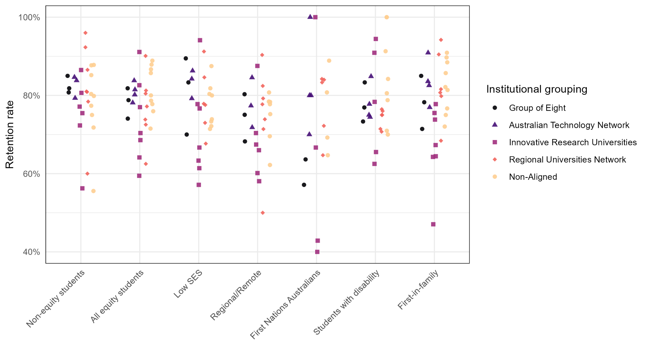

Undergraduate retention rates of all equity students from enabling program pathways in 2022

Figure 9: Undergraduate retention rates of enabling program pathway equity students in 2022 (who returned to study in 2023)
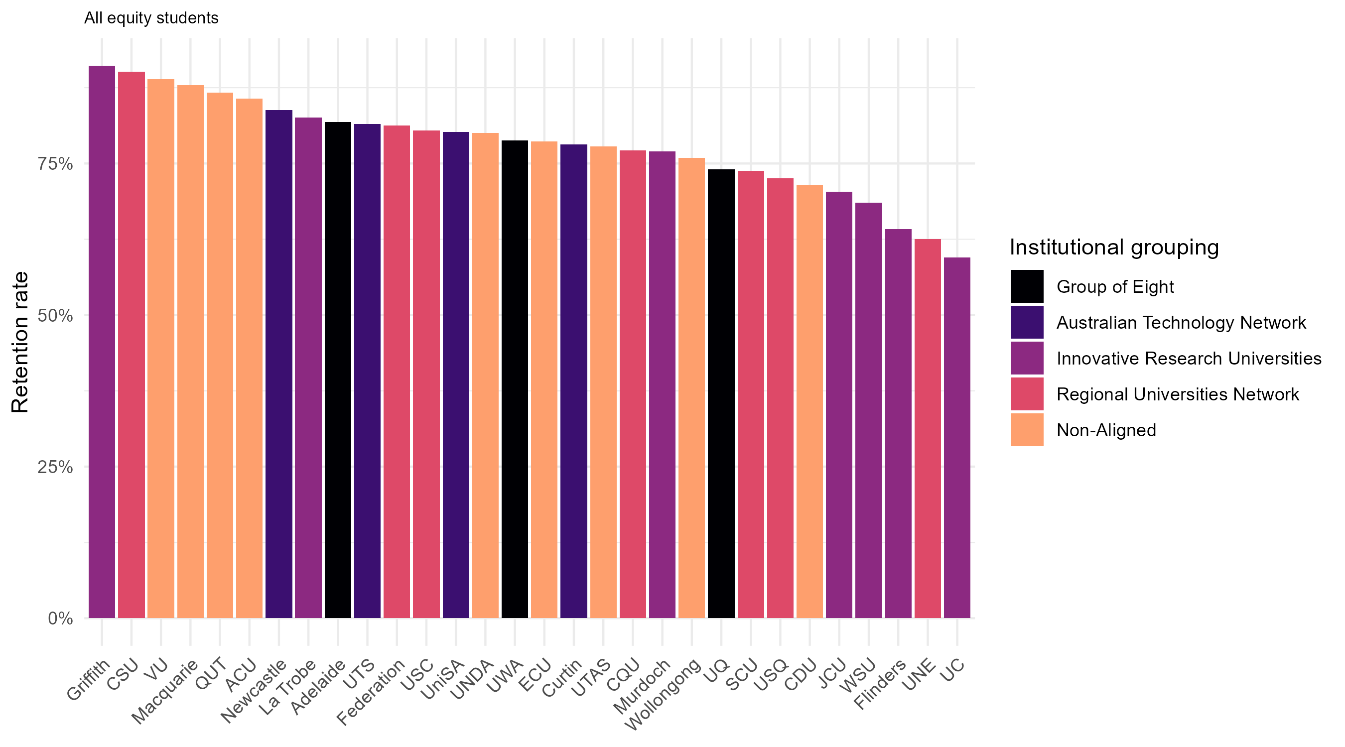

Undergraduate retention rates of enabling program pathway students from low SES areas in 2022

Figure 10: Undergraduate retention rates of enabling program pathway students from low SES areas in 2022 (who returned to study in 2023)
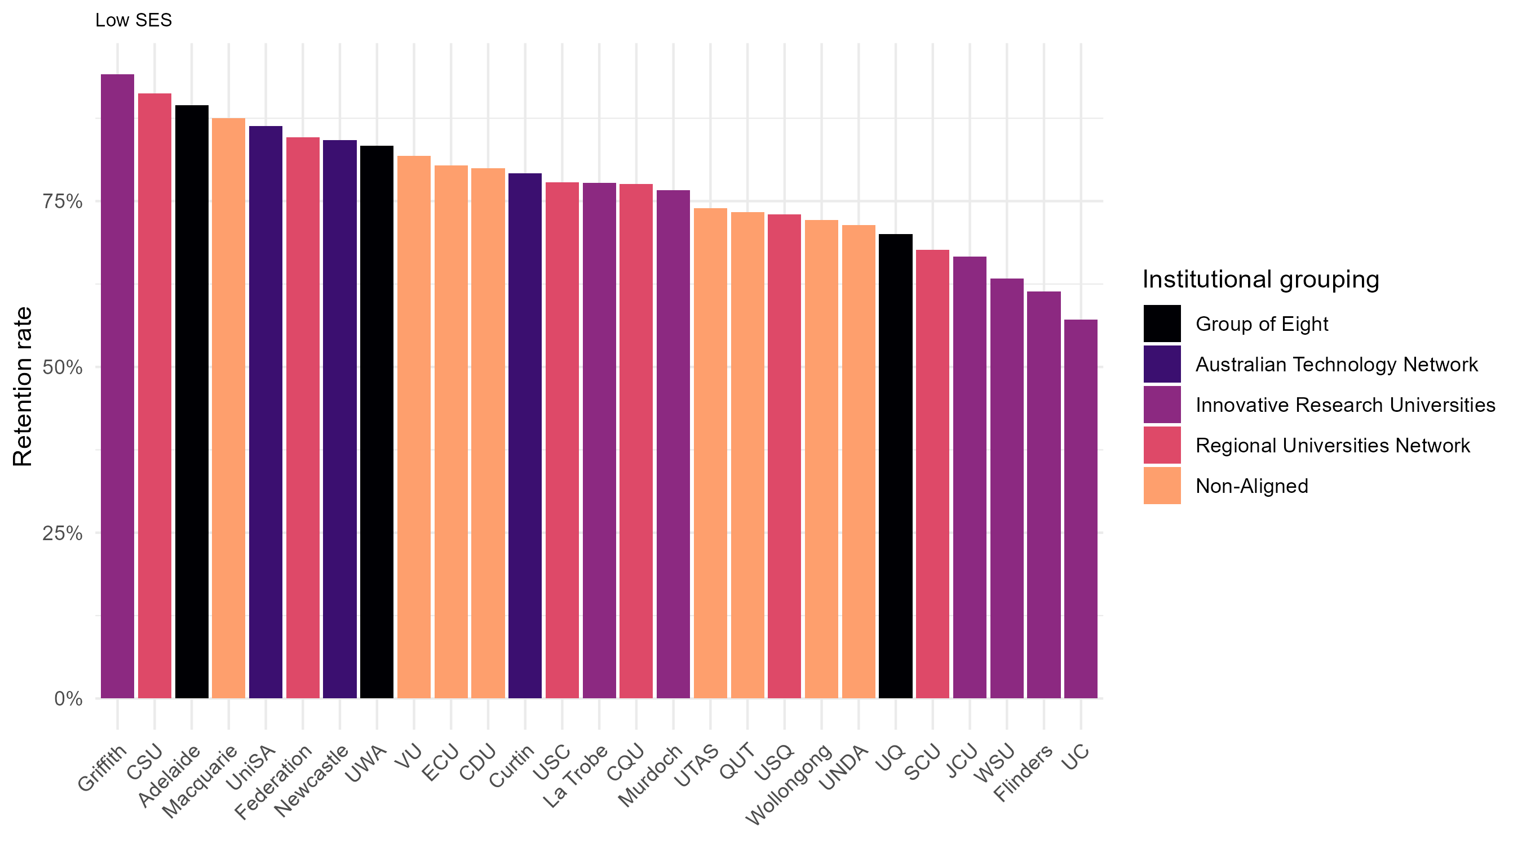

Undergraduate retention rates of enabling program pathway students from regional and remote areas in 2022

Figure 11: Undergraduate retention rates of enabling program pathway regional/remote students in 2022 (who returned to study in 2023)
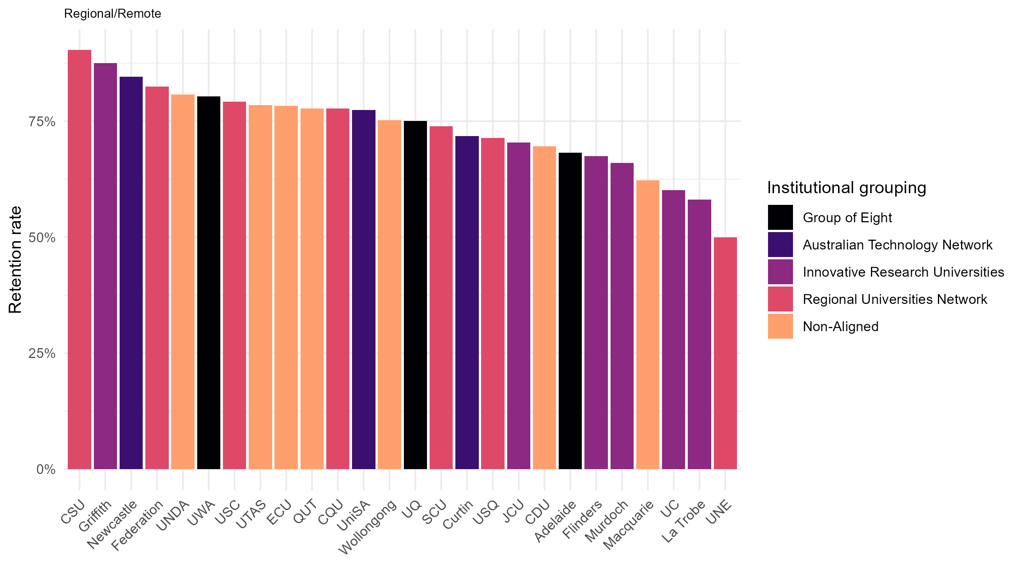

Undergraduate retention rates of enabling program pathway First Nations Australians students in 2022

Figure 12: Undergraduate retention rates of enabling program pathway First Nations Australians students in 2022 (who returned to study in 2023)
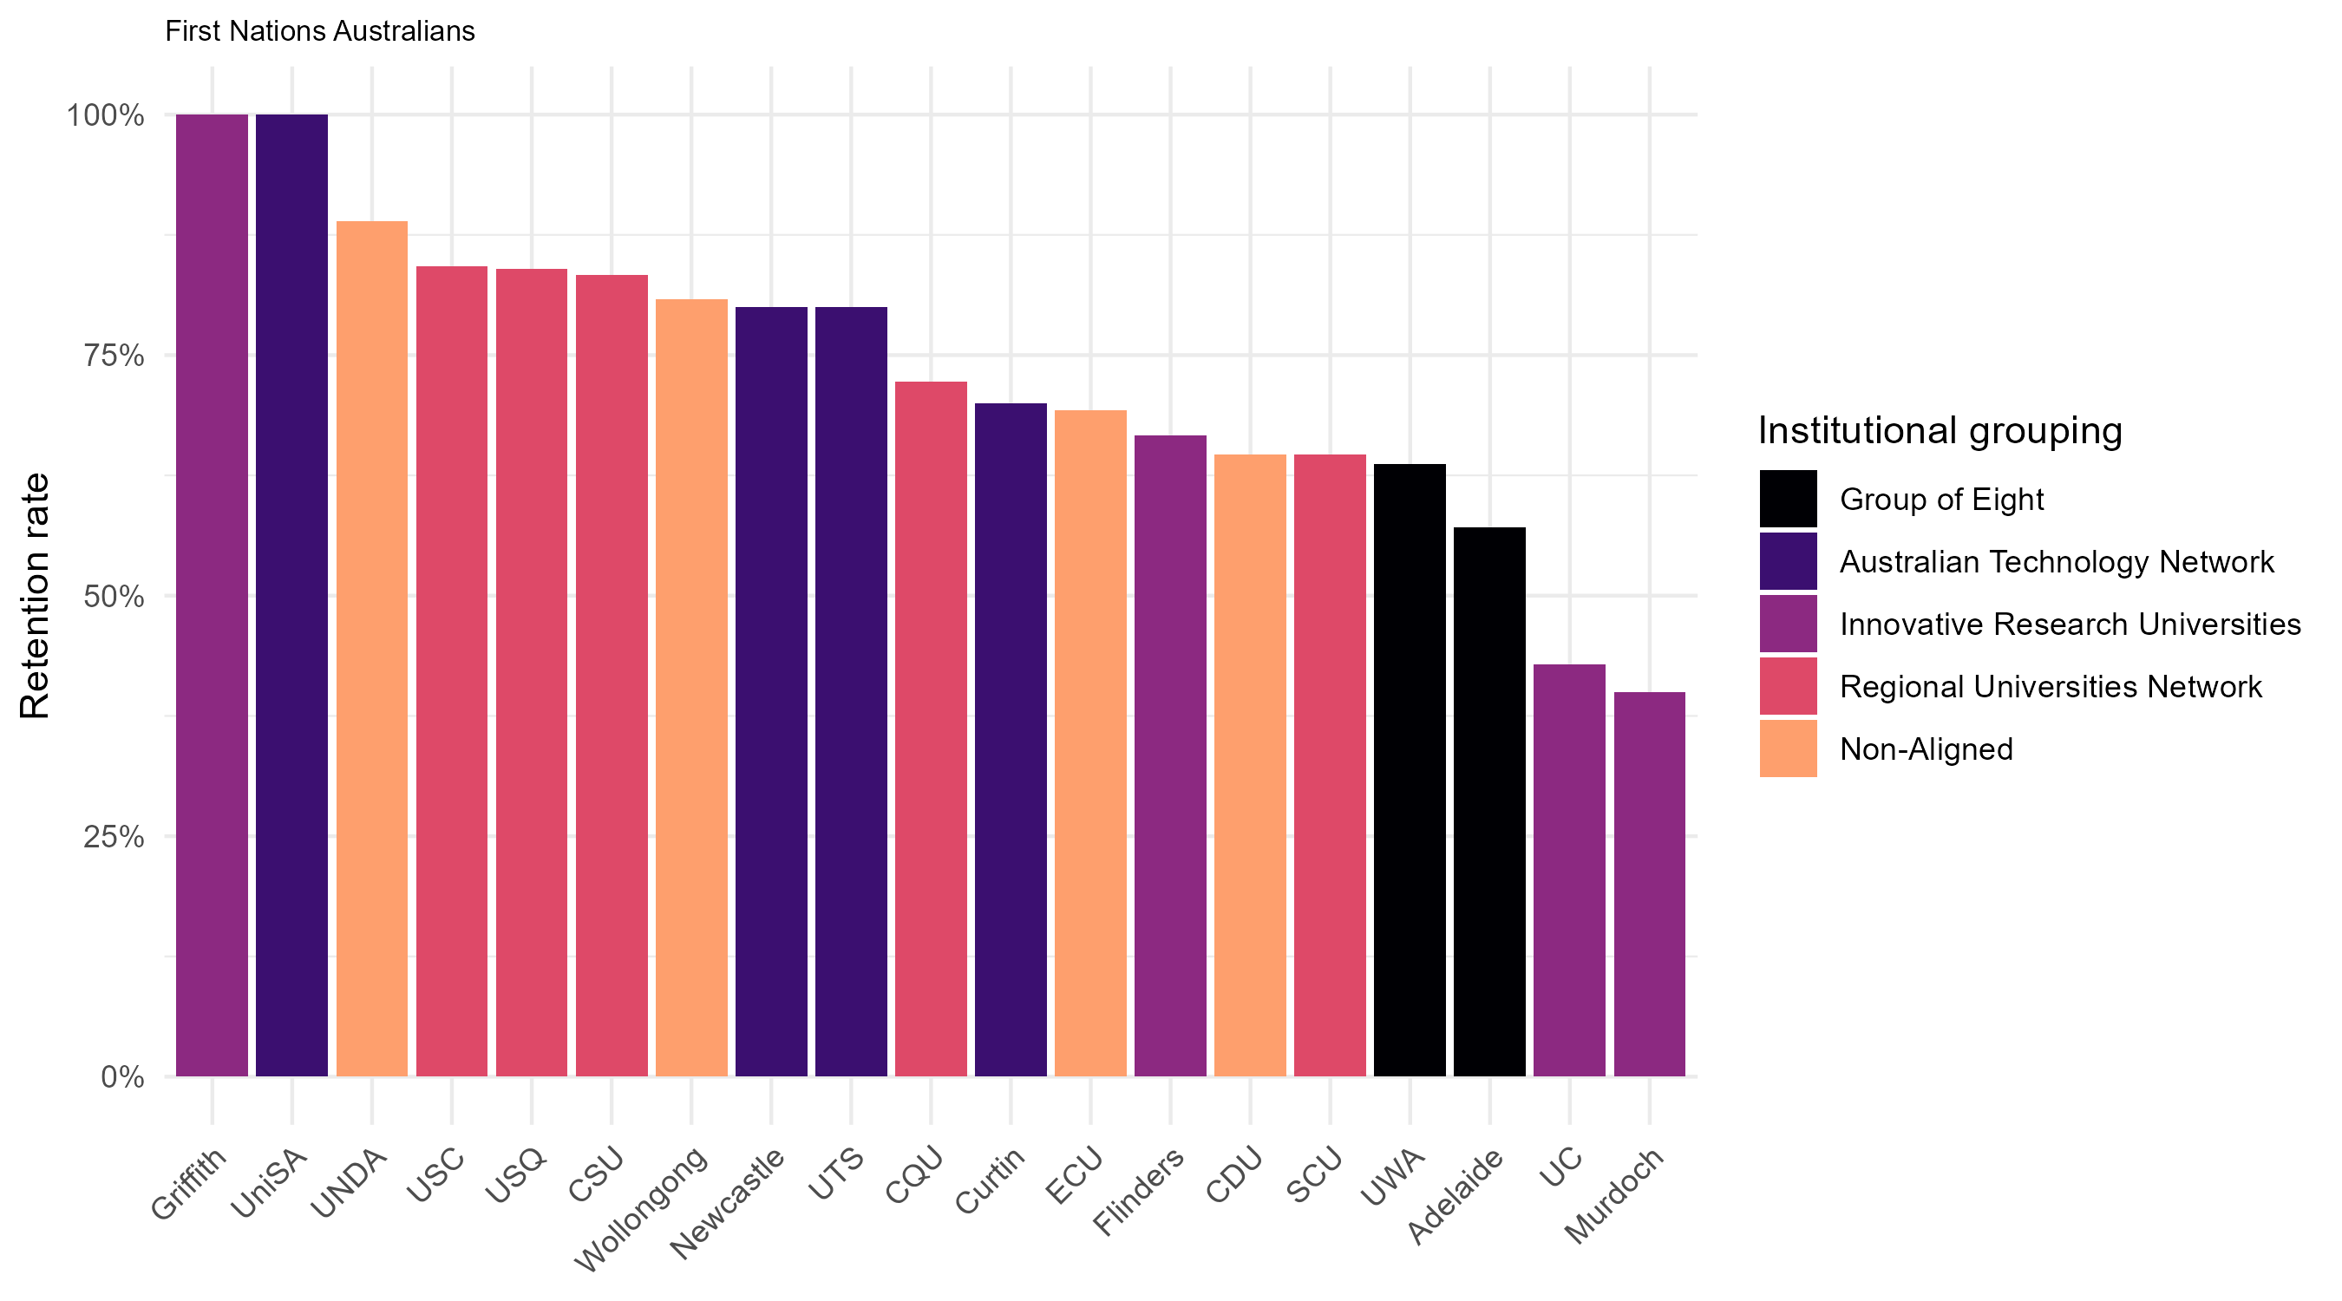

Undergraduate retention rates of enabling program pathway students with disability in 2022

Figure 13: Undergraduate retention rates of enabling program pathway students with disability in 2022 (who returned to study in 2023)
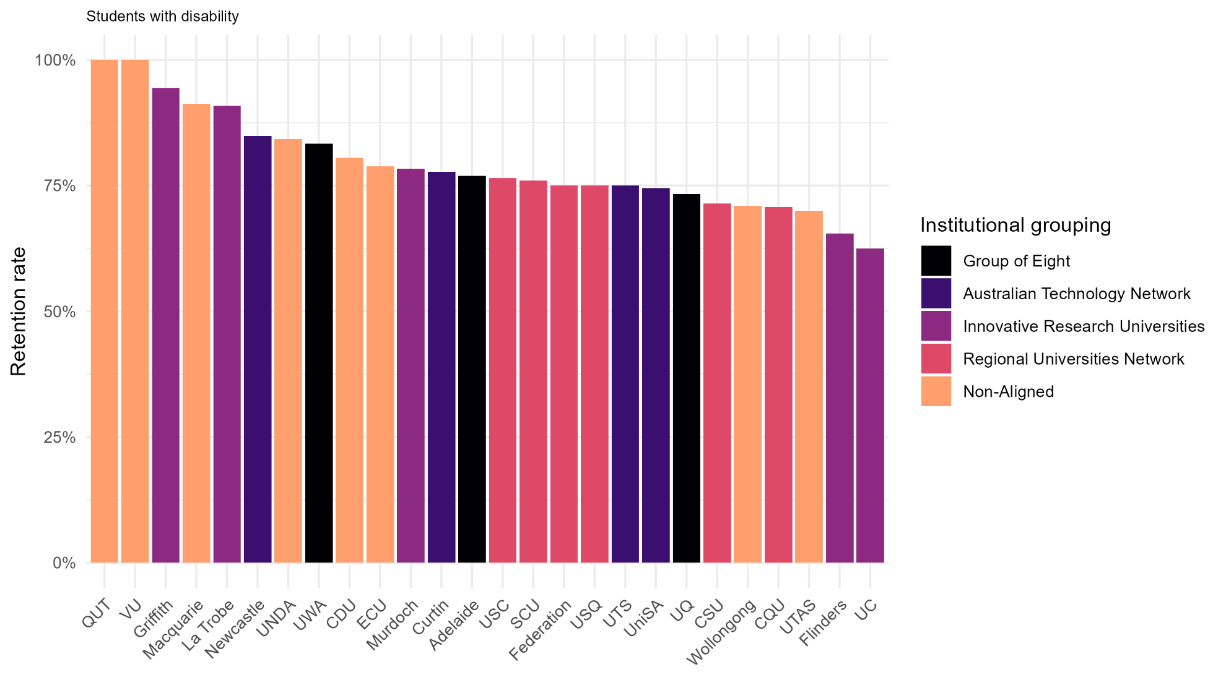

Undergraduate retention rates of enabling program pathway first-in-family students in 2022

Figure 14: Undergraduate retention rates of enabling program pathway first-in-family students in 2022 (who returned to study in 2023)
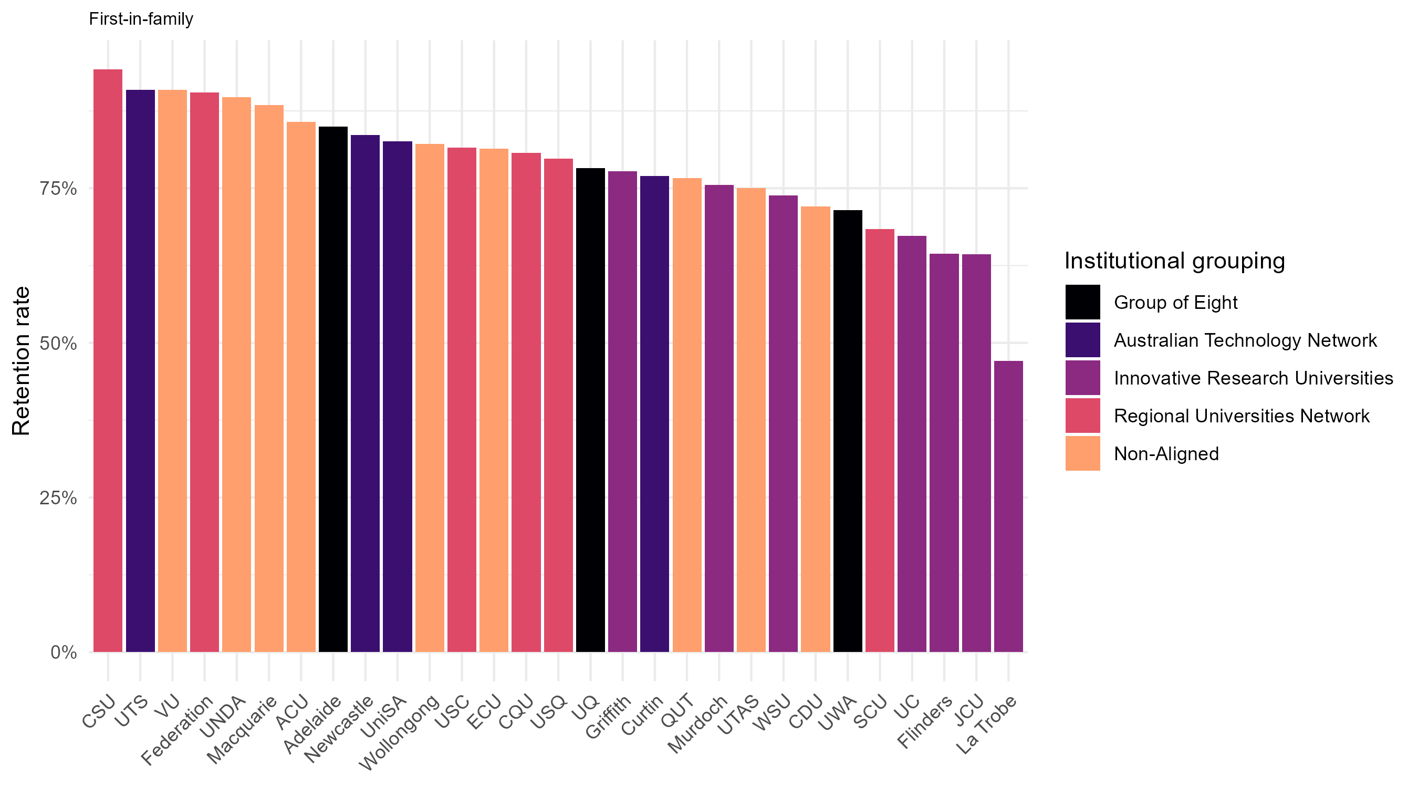

Undergraduate retention rates nationally

Retention rates for equity students from enabling program pathways showed distinct downward trends between 2021 and 2022, while remaining relatively stable for non-equity students.
Figure 15: Retention rates of domestic undergraduate students admitted to university through enabling programs for 2021 and 2022
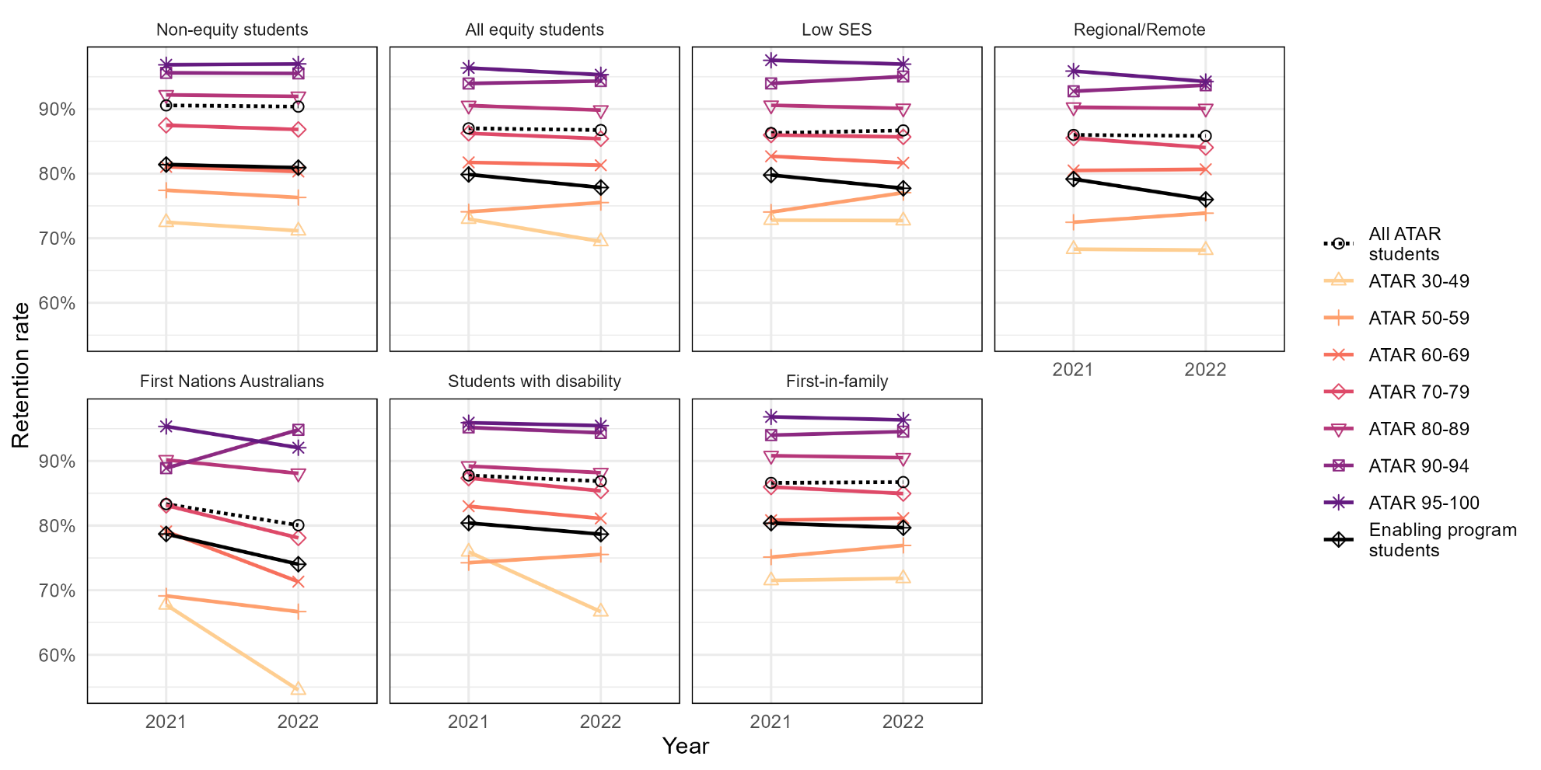

Undergraduate retention rates at Group of Eight universities

Retention rates for both equity and non-equity enabling program pathway students took a sharp dive between 2021 and 2022, while overall retention rates for ATAR pathway students remained stable.
Figure 16: Retention rates of domestic undergraduate students admitted to university through enabling programs for 2021 and 2022 at Group of Eight universities
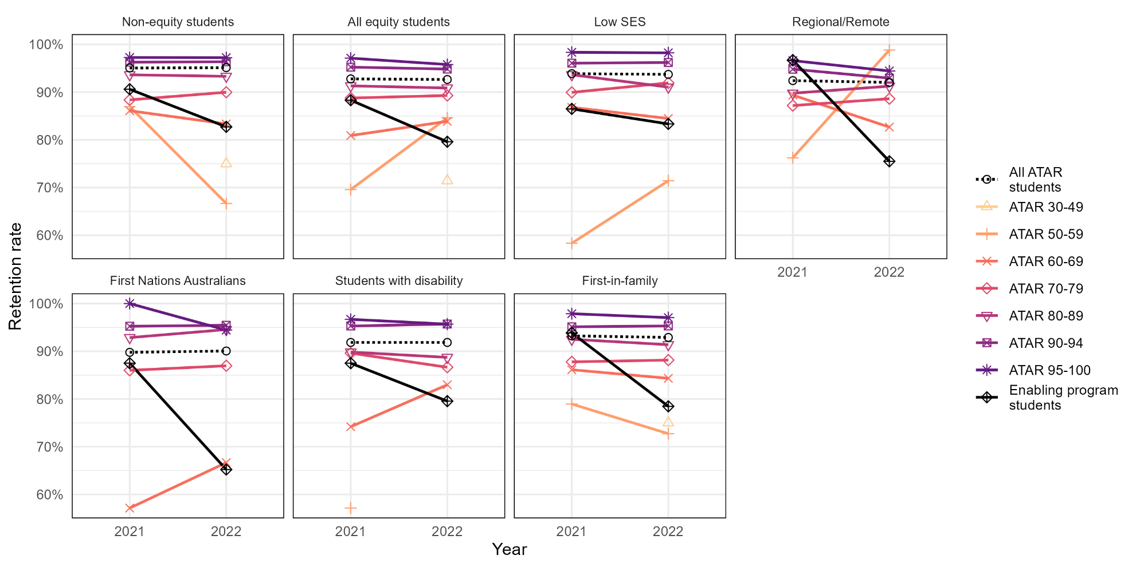

Undergraduate retention rates at Australian Technology Network universities

The only enabling program pathway equity group to have higher retention rates than all ATAR pathway students across 2021 and 2022 was First Nations Australian students in 2021.
Figure 17: Retention rates of domestic undergraduate students admitted to university through enabling programs for 2021 and 2022 at Australian Technology Network universities
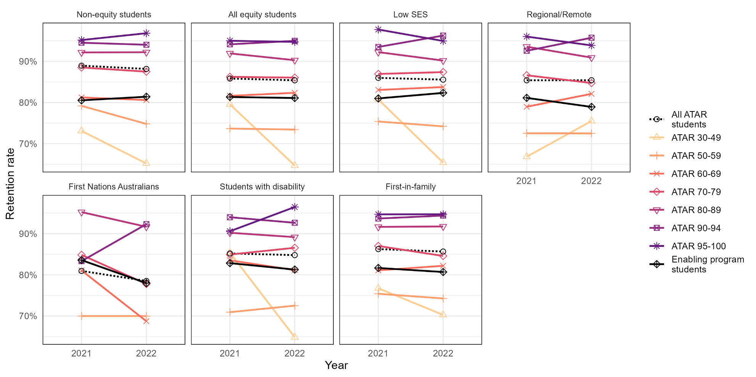

Undergraduate retention rates at Innovative Research Universities

The only enabling program pathway equity group to have higher retention rates than all ATAR pathway students across 2021 and 2022 was First Nations Australian students in 2021.
Figure 18: Retention rates of domestic undergraduate students admitted to university through enabling programs for 2021 and 2022 at Innovative Research Universities
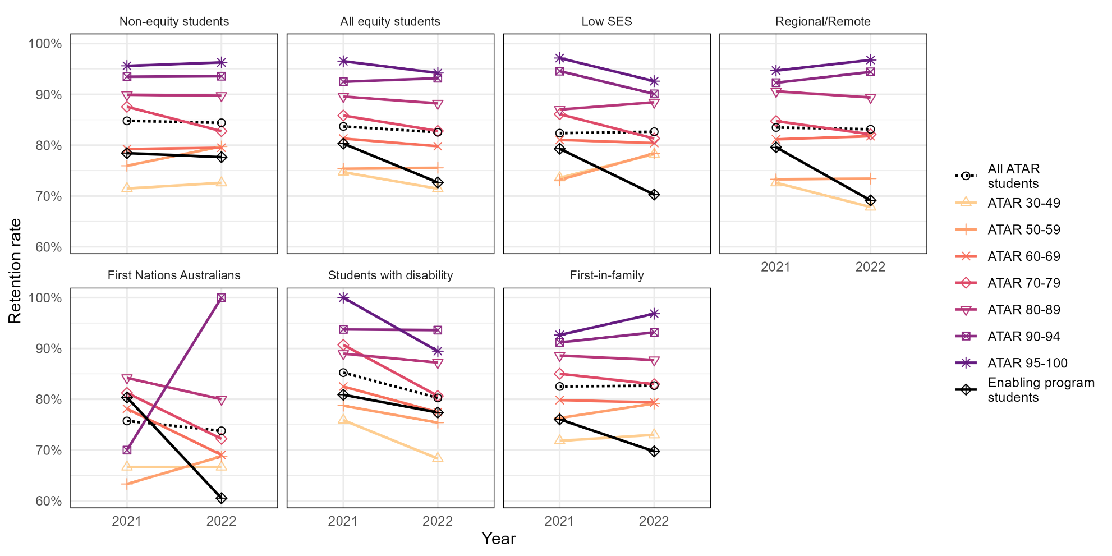

Undergraduate retention rates at Regional Universities Network universities

Equity students from enabling programs had overall lower retention rates than ATAR equity students, but non-equity students from enabling programs had higher retention rates than ATAR non-equity students between 2021 and 2022.
Figure 19: Retention rates of domestic undergraduate students admitted to university through enabling programs for 2021 and 2022 within the Regional Universities Network
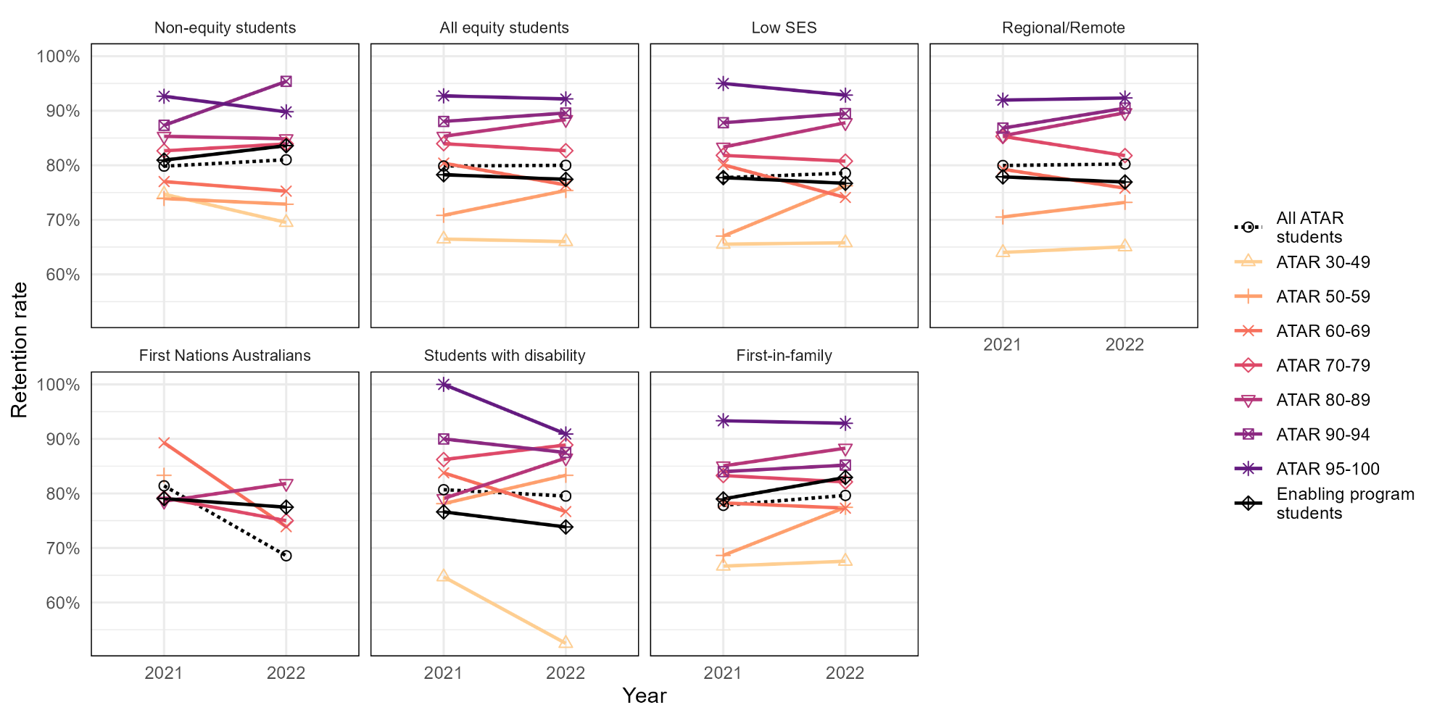

Undergraduate retention rates at non-aligned universities

Both equity and non-equity students from enabling programs had significantly lower retention rates than ATAR pathway students in 2021 and 2022.
Figure 20: Retention rates of domestic undergraduate students admitted to university through enabling programs for 2021 and 2022 at non-aligned universities
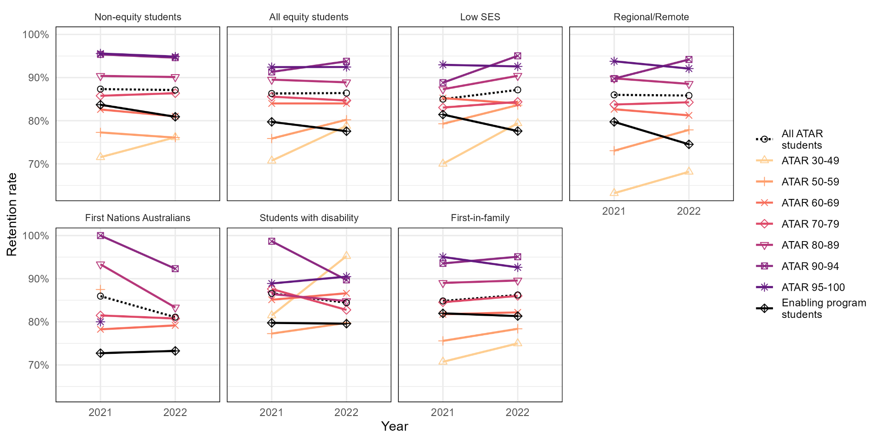

Within-institution ATAR vs enabling program retention rates

To identify differences in retention for equity students admitted to university through enabling programs versus ATAR within each institution, their retention rates can be compared.
In the following series of plots, the vertical (y-) axis represents the retention rates for university students who entered via enabling programs, and the horizontal (x-) axis represents the retention rates for students whose main basis for admission was their ATAR. The 45-degree dotted line represents equality in the compared rates.
For Figures 14–19, if retention rates are equal for both groups within an institution, its data point will lie on the 45-degree line. If retention rates at an institution are higher for enabling program students, the dot will lie above the 45-degree line, and if retention rates are lower for enabling program students, the dot will be below the 45-degree line.
For Figure 20, institutions falling on the 45-degree line have the same retention rate in both student groups. Institutions falling above the dotted line have higher retention rates for equity students compared to non-equity students.
Each dot represents a Table A institution with at least five enabling program students enrolled. If an institution is missing from the plot, it means they had fewer than five students enrolled within the particular group.
Each plot represents comparisons for one equity group.

Undergraduate retention rates of all equity students from ATAR vs enabling program pathways in 2022

Figure 21: Relationship between the undergraduate retention rates of ATAR and enabling program pathway equity students in 2022 (who returned to study in 2023)
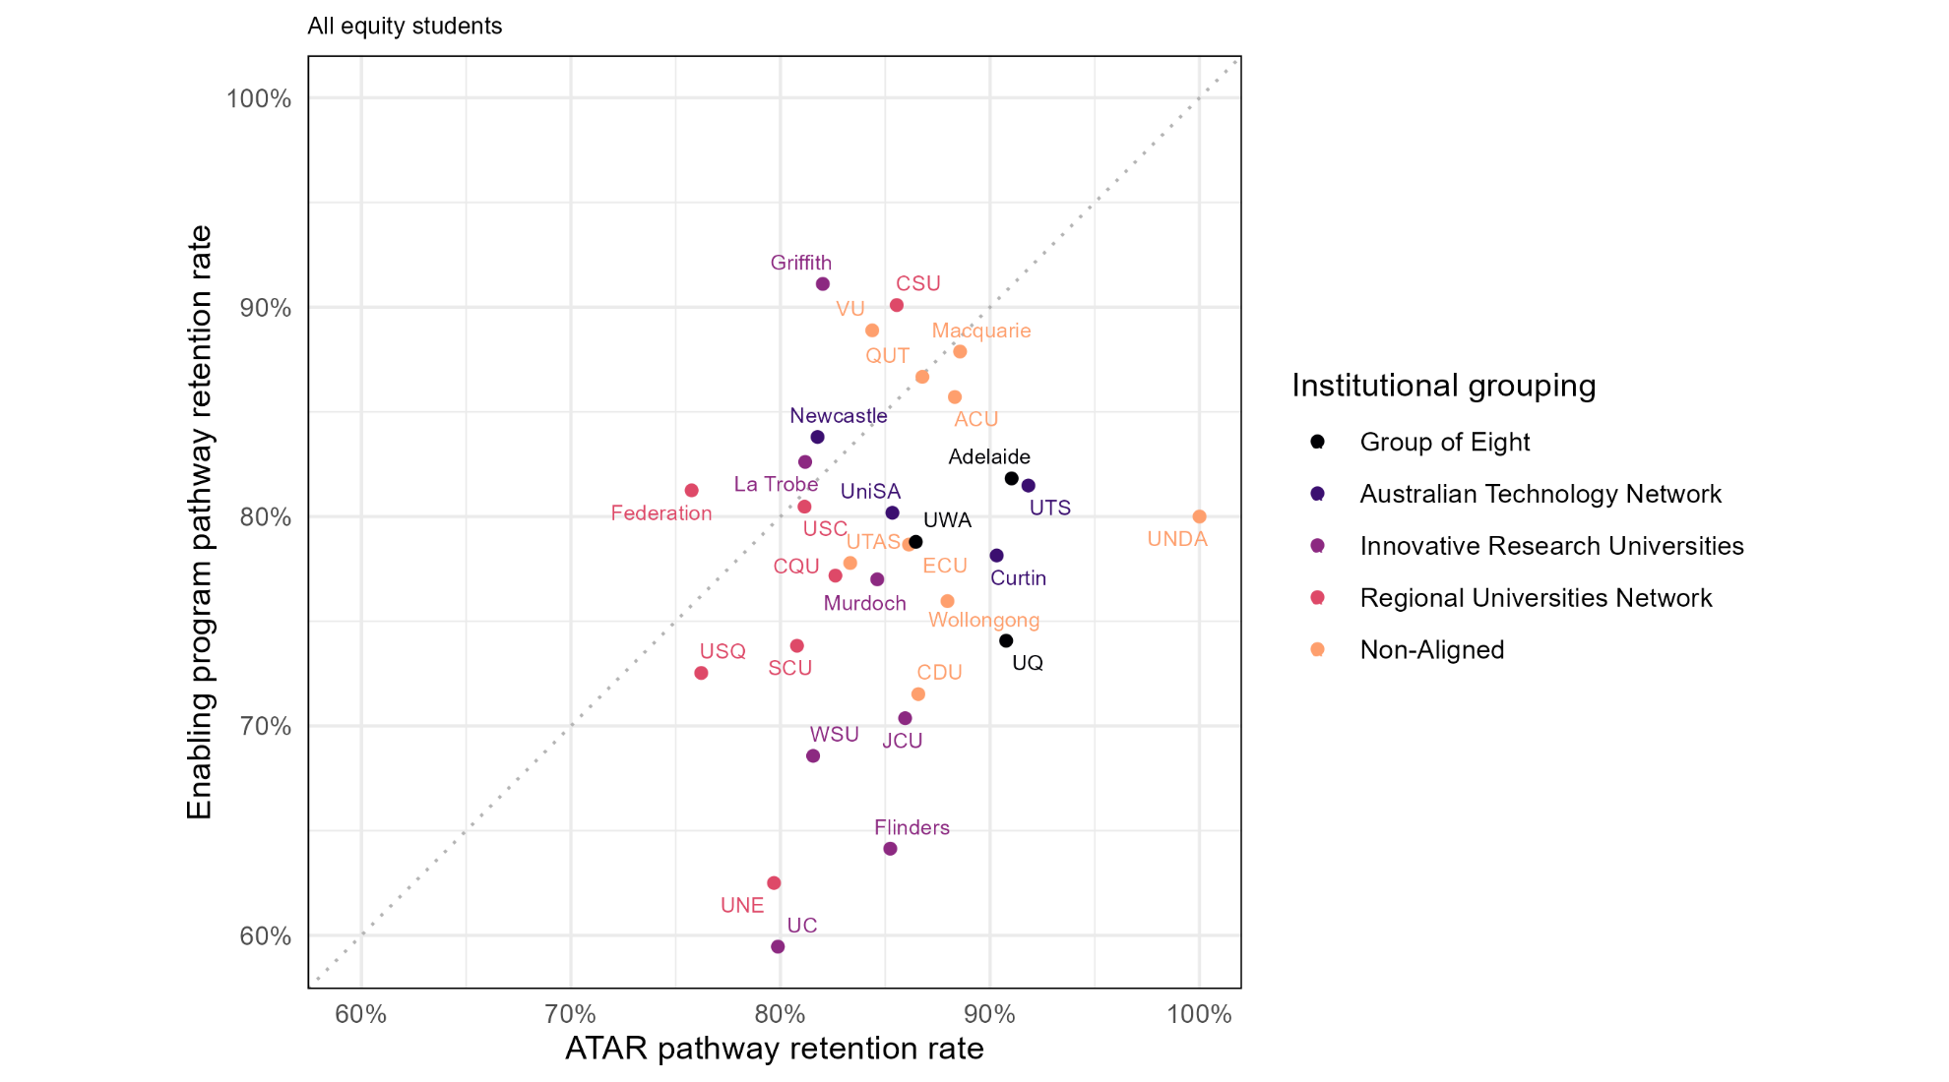

Undergraduate retention rates of students from low SES areas from ATAR vs enabling program pathways in 2022

Figure 22: Relationship between the undergraduate retention rates of ATAR and enabling program pathway students from low SES areas in 2022 (who returned to study in 2023)
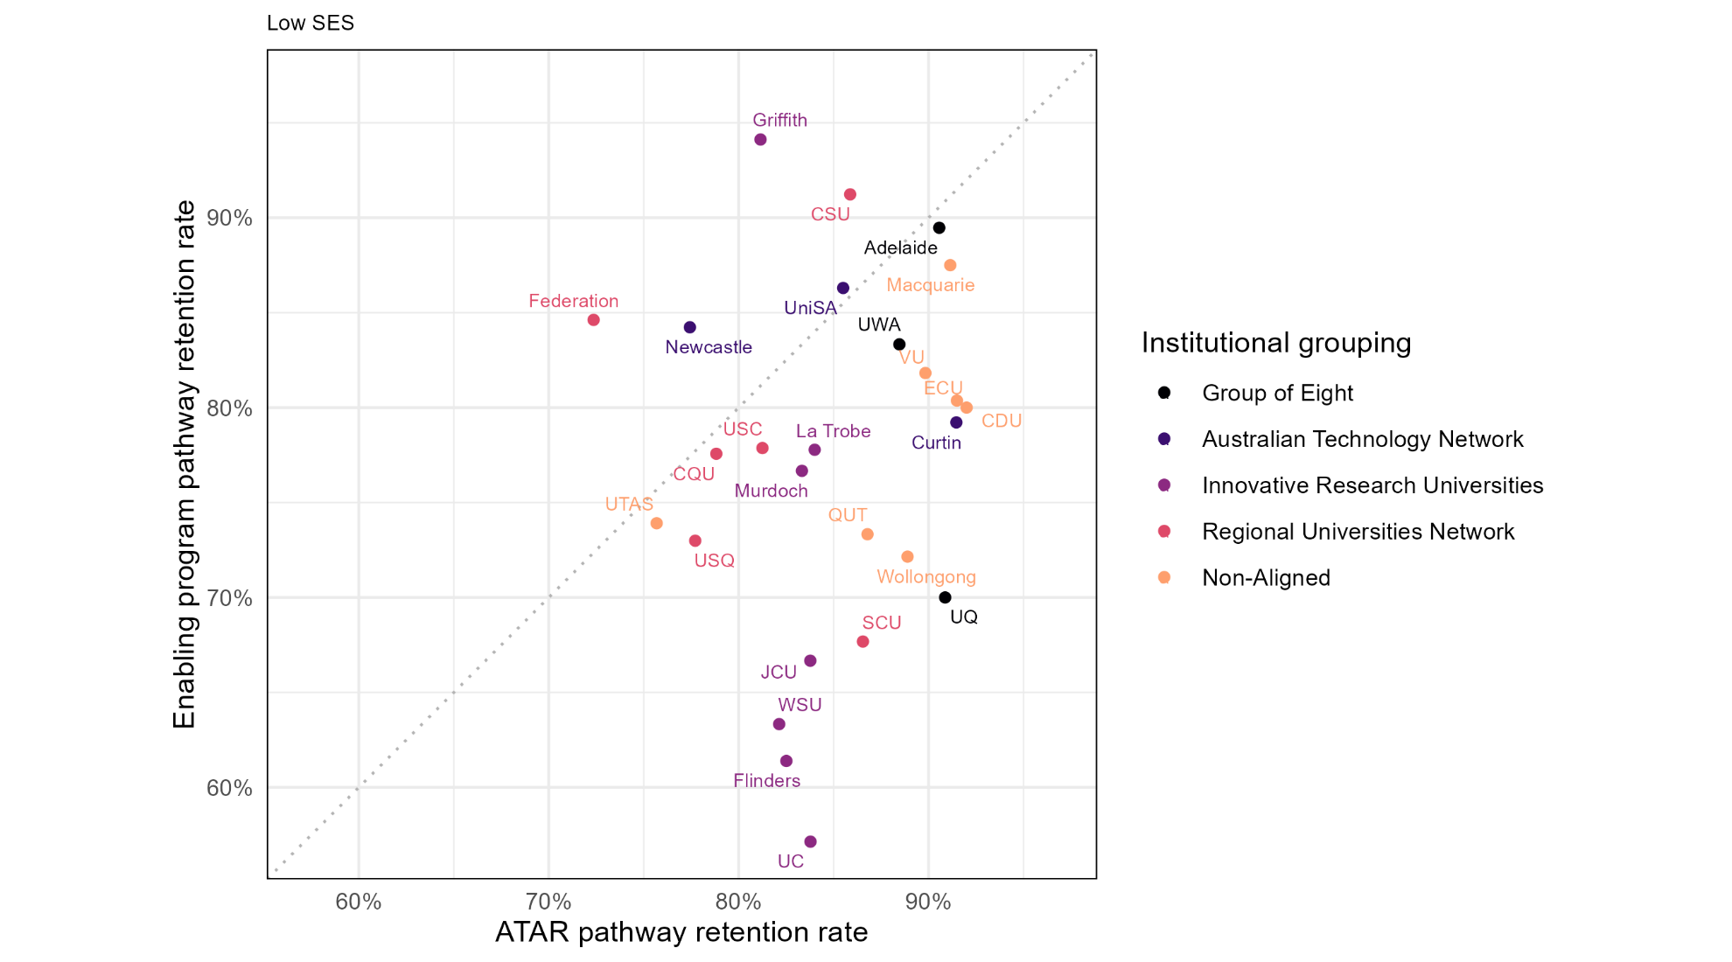

Undergraduate retention rates of students from regional and remote areas from ATAR vs enabling program pathways in 2022

Figure 23: Relationship between the undergraduate retention rates of ATAR and enabling program pathway regional/remote students in 2022 (who returned to study in 2023)
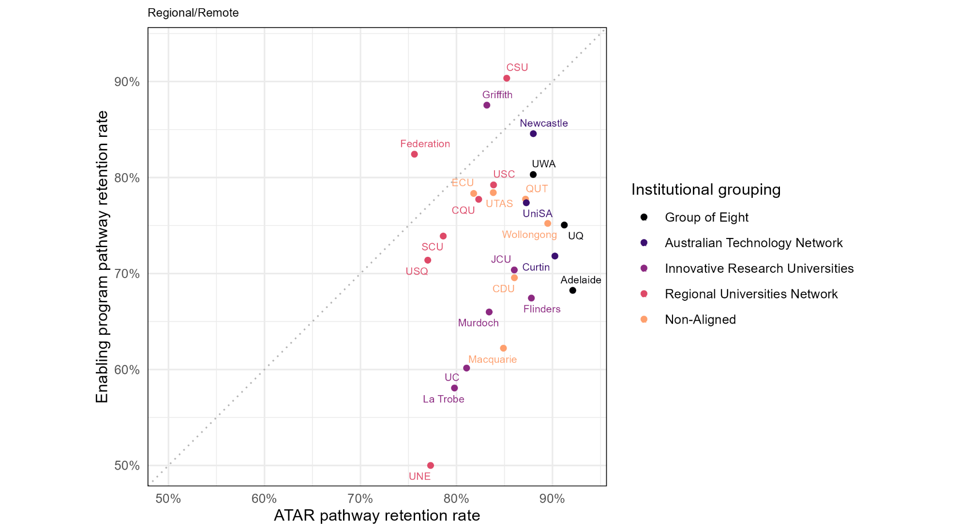

Undergraduate retention rates of First Nations Australians students from ATAR vs enabling program pathways in 2022

Figure 24: Relationship between the undergraduate retention rates of ATAR and enabling program pathway First Nations Australians students in 2022 (who returned to study in 2023)
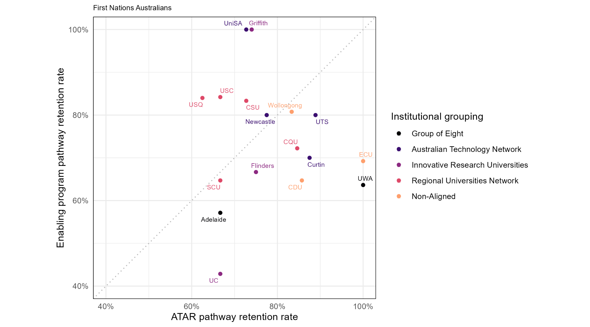

Undergraduate retention rates of students with disability from ATAR vs enabling program pathways in 2022

Figure 25: Relationship between the undergraduate retention rates of ATAR and enabling program pathway students with disability in 2022 (who returned to study in 2023)
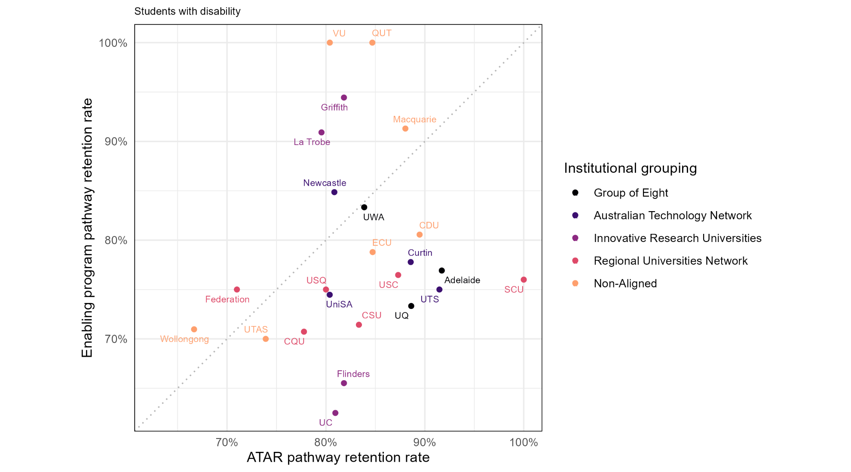

Undergraduate retention rates of first-in-family students from ATAR vs enabling program pathways in 2022

Figure 26: Relationship between the undergraduate retention rates of ATAR and enabling program pathway first-in-family students in 2022 (who returned to study in 2023)
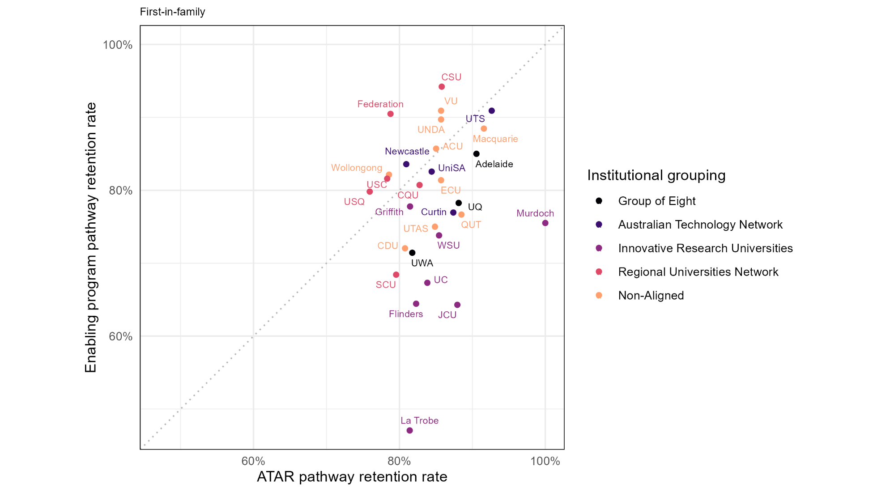

Undergraduate retention rates of equity and non-equity enabling program pathway students at university in 2022

Figure 27: Relationship between the retention rate of equity and non-equity students in 2022, whose main basis of admission into university was enabling programs
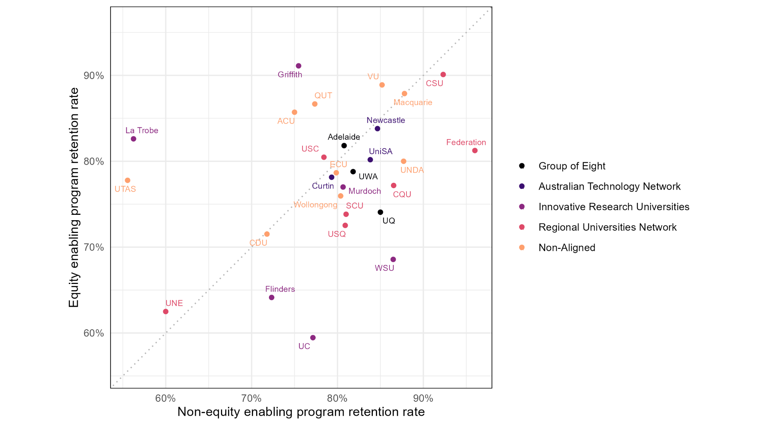

Success rates of enabling program pathway students at university in 2023

Figure 28: Success rates of first-year domestic undergraduate students admitted to university through enabling programs for 2023. Each dot represents a Table A institution with enrolments of students from enabling programs in 2023.
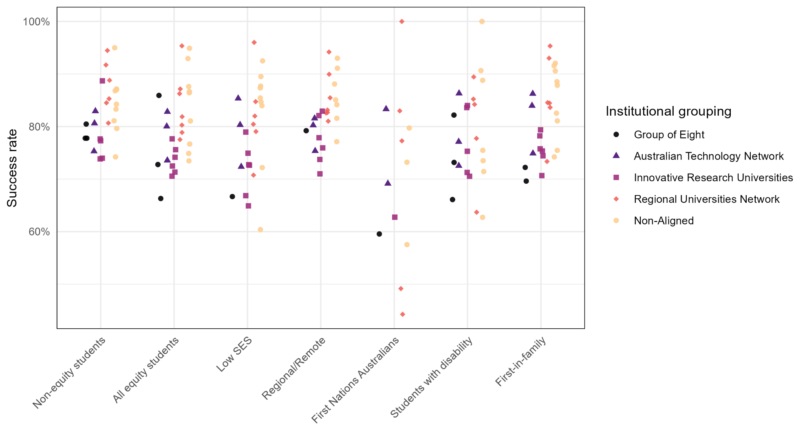

Undergraduate success rates of all equity students from enabling program pathways in 2023

Figure 29: Undergraduate success rates of enabling program pathway equity students in 2023
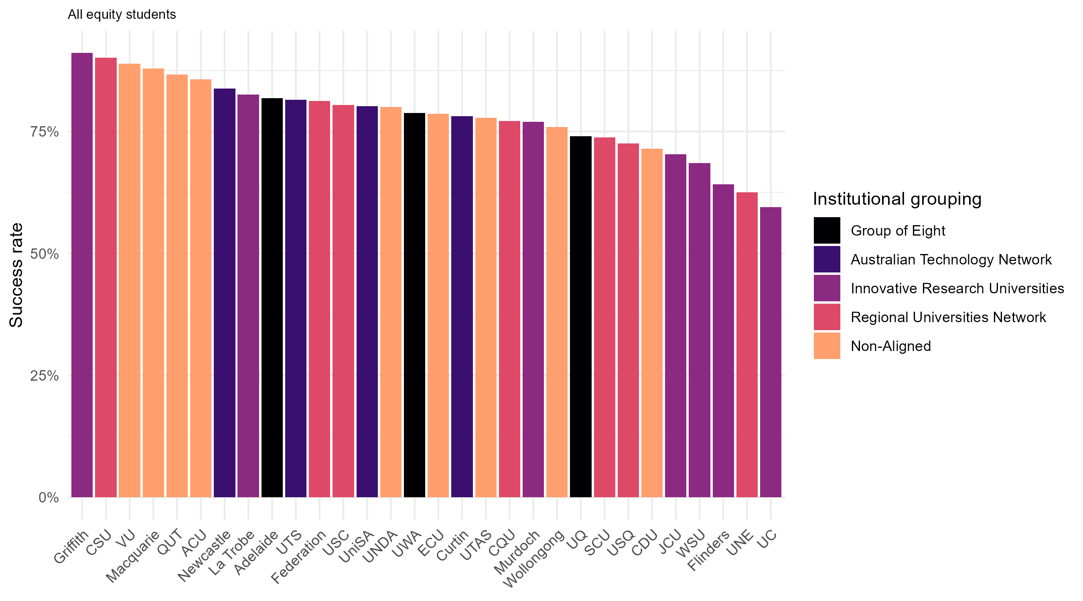

Undergraduate success rates of enabling program pathway students from low SES areas in 2023

Figure 30: Undergraduate success rates of enabling program pathway students from low SES areas in 2023
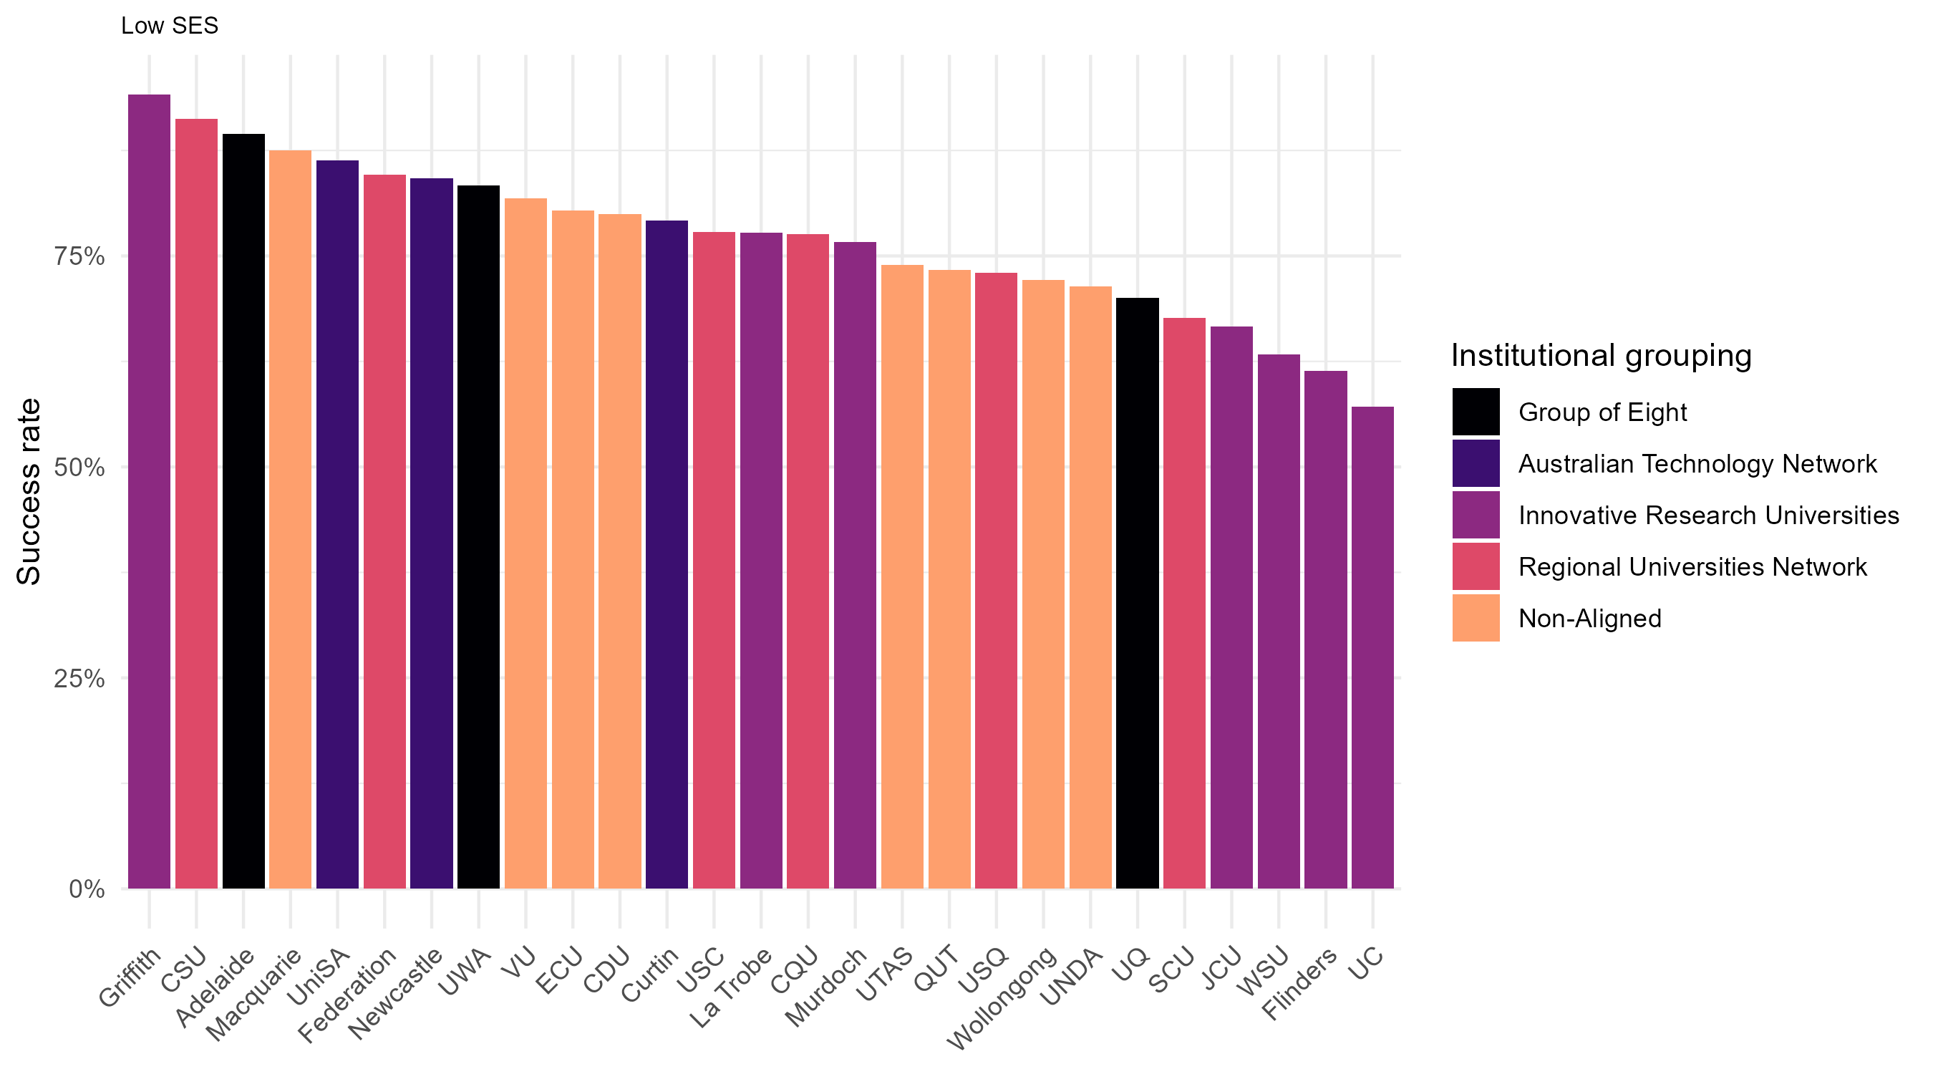

Undergraduate success rates of enabling program pathway students from regional and remote areas in 2023

Figure 31: Undergraduate success rates of enabling program pathway regional/remote students in 2023
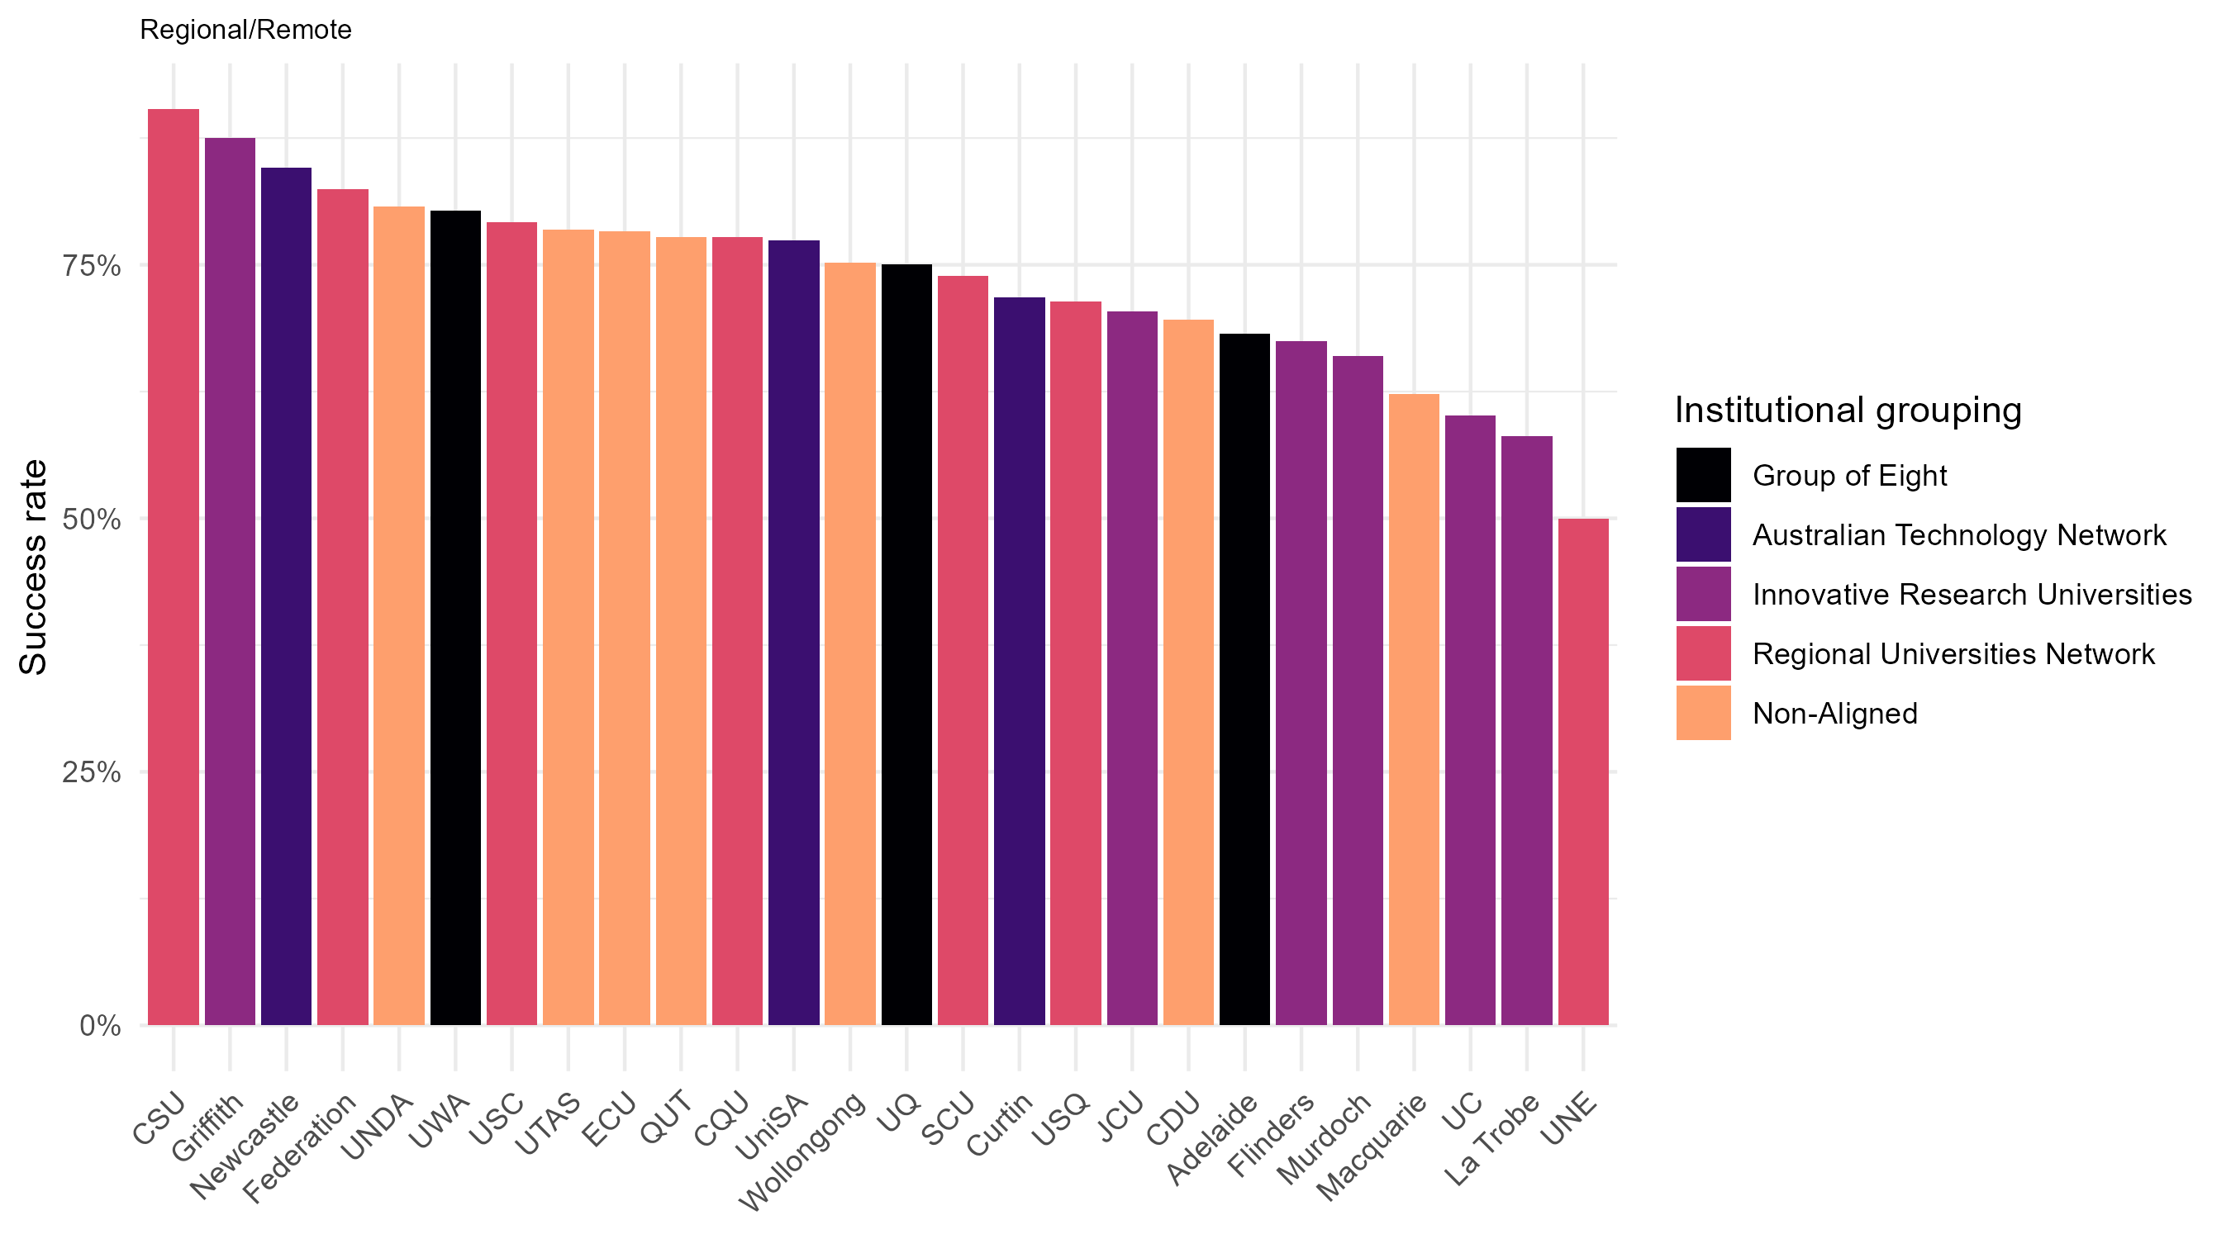

Undergraduate success rates of enabling program pathway First Nations Australians students in 2023

Figure 32: Undergraduate success rates of enabling program pathway First Nations Australians students in 2023
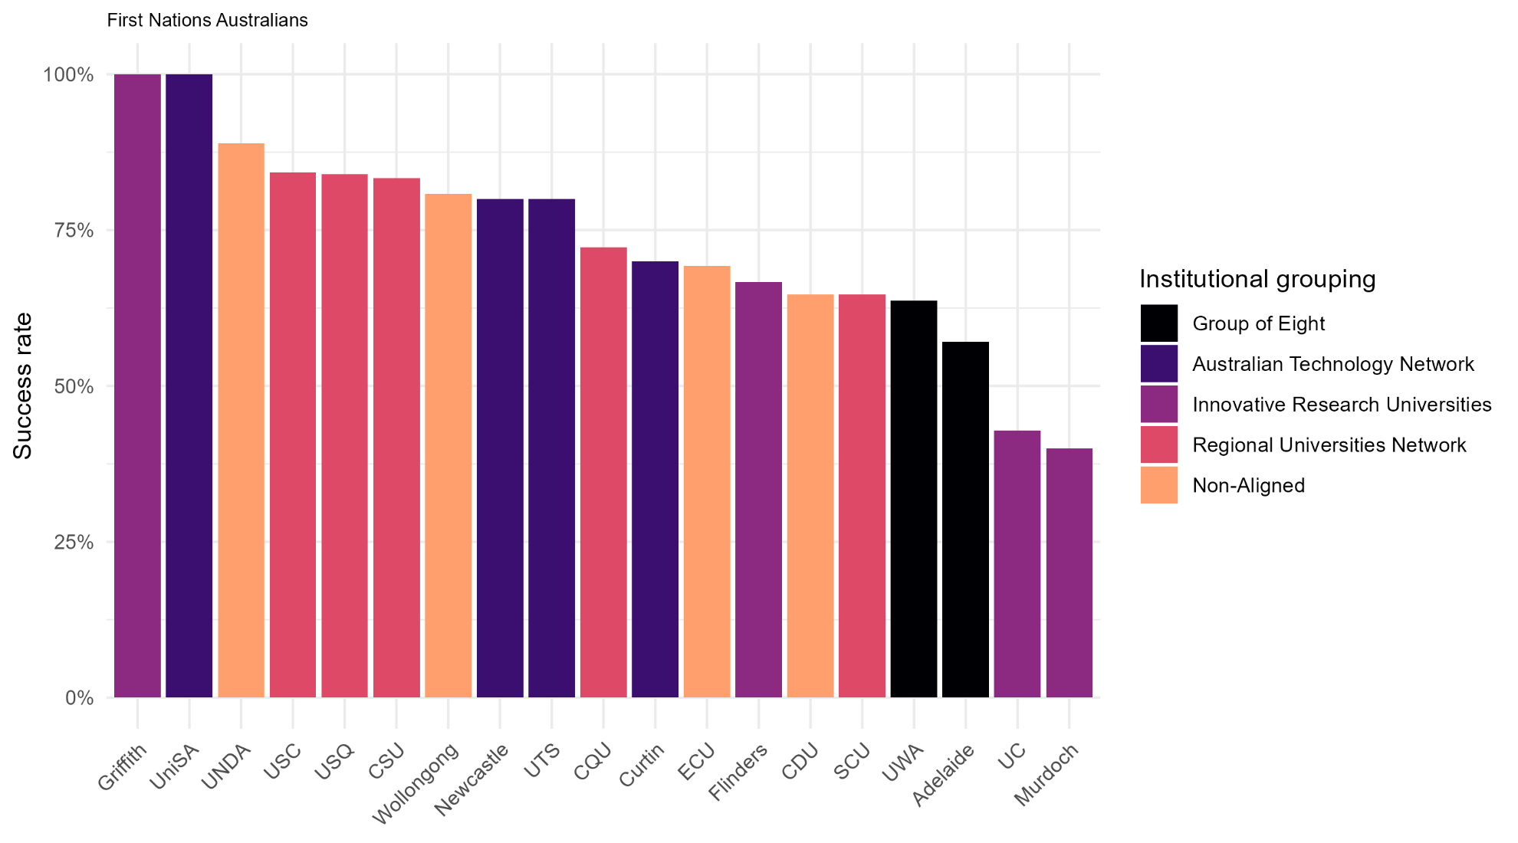

Undergraduate success rates of enabling program pathway students with disability in 2023

Figure 33: Undergraduate success rates of enabling program pathway students with disability in 2023
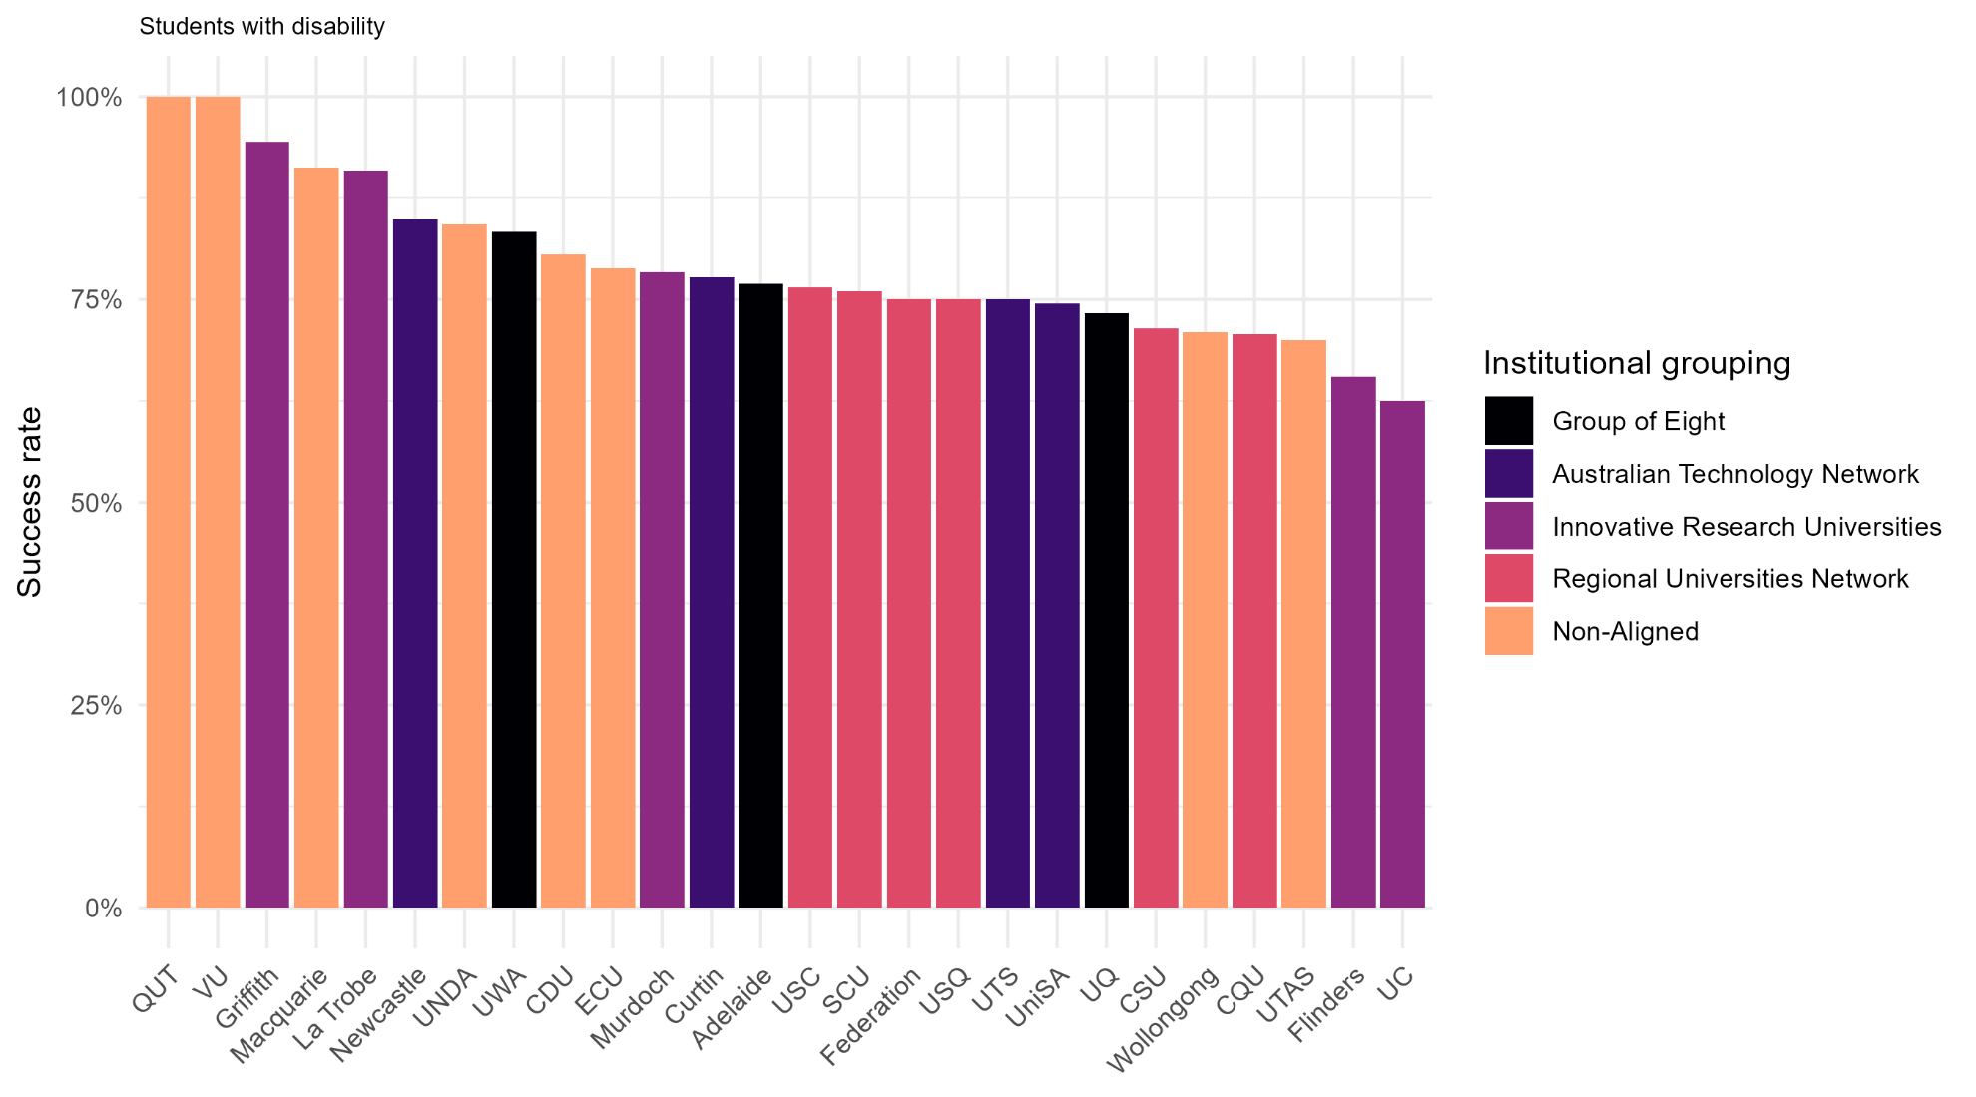

Undergraduate success rates of enabling program pathway first-in-family students in 2023

Figure 34: Undergraduate success rates of enabling program pathway first-in-family students in 2023
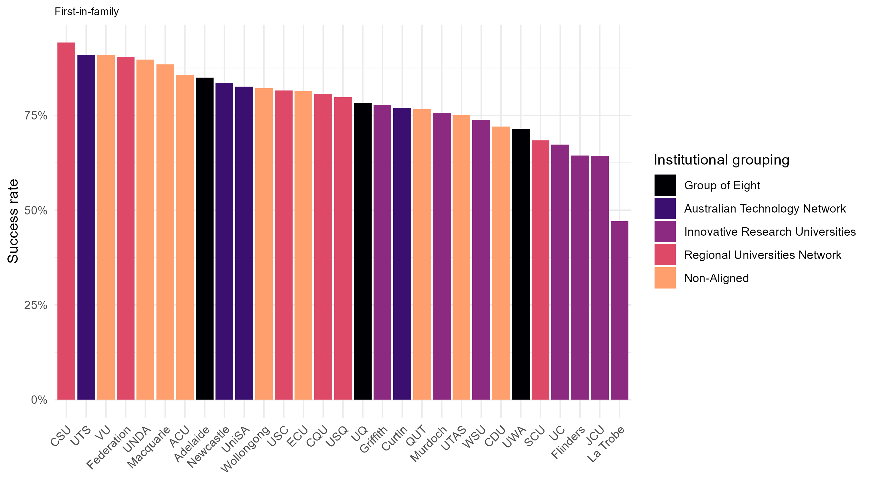

Undergraduate success rates nationally

Success rates for both equity and non-equity students from enabling program pathways showed distinct upward trends in 2023.
Figure 35: Success rates of domestic undergraduate students admitted to university through enabling programs from 2021 to 2023
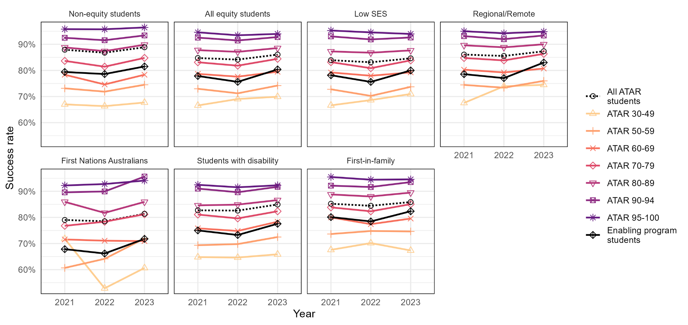

First-year success rates at Group of Eight universities

Non-equity students from enabling programs had success rates comparable to those of ATAR 70–79 non-equity students, while equity students from enabling programs consistently had success rates more comparable to those of ATAR 60–69 equity students.
Figure 36: Success rates of domestic undergraduate students admitted to university through enabling programs from 2021 to 2023 at Group of Eight universities
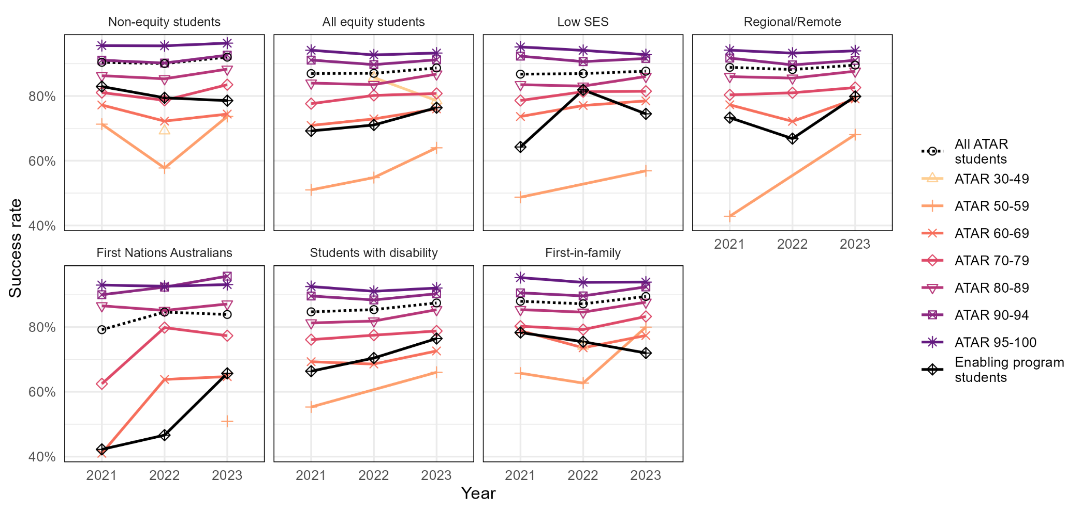

First-year success rates at Australian Technology Network universities

Non-equity students from enabling programs had success rates comparable to those of ATAR 60–69 non-equity students, while equity students from enabling programs consistently had success rates between ATAR 50–59 and ATAR 60–69 equity students.
Figure 37: Success rates of domestic undergraduate students admitted to university through enabling programs from 2021 to 2023 at Australian Technology Network universities
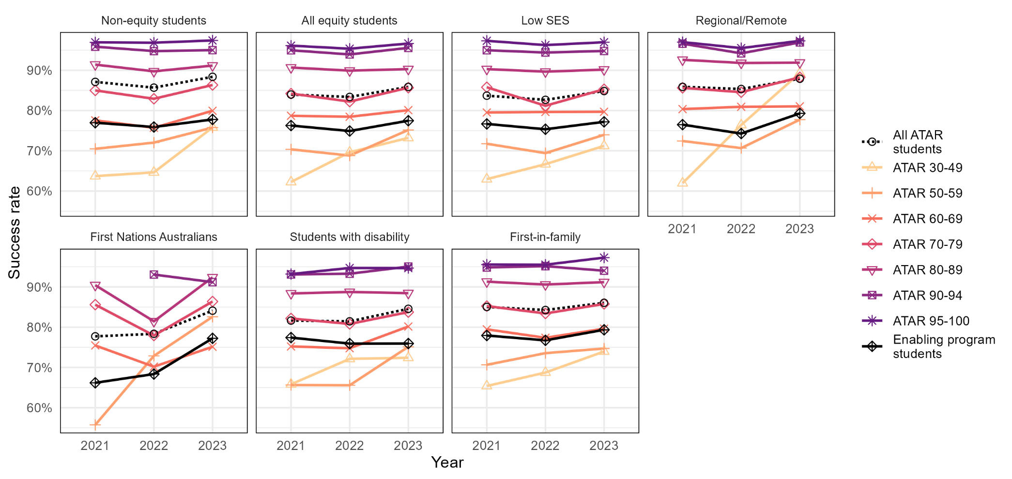

First-year success rates at Innovative Research Universities

Both non-equity and equity students from enabling programs had success rates comparable to those of ATAR 50–59 non-equity students, though all students from enabling programs were consistently below ATAR pathway students overall.
Figure 38: Success rates of domestic undergraduate students admitted to university through enabling programs from 2021 to 2023 at Innovative Research Universities
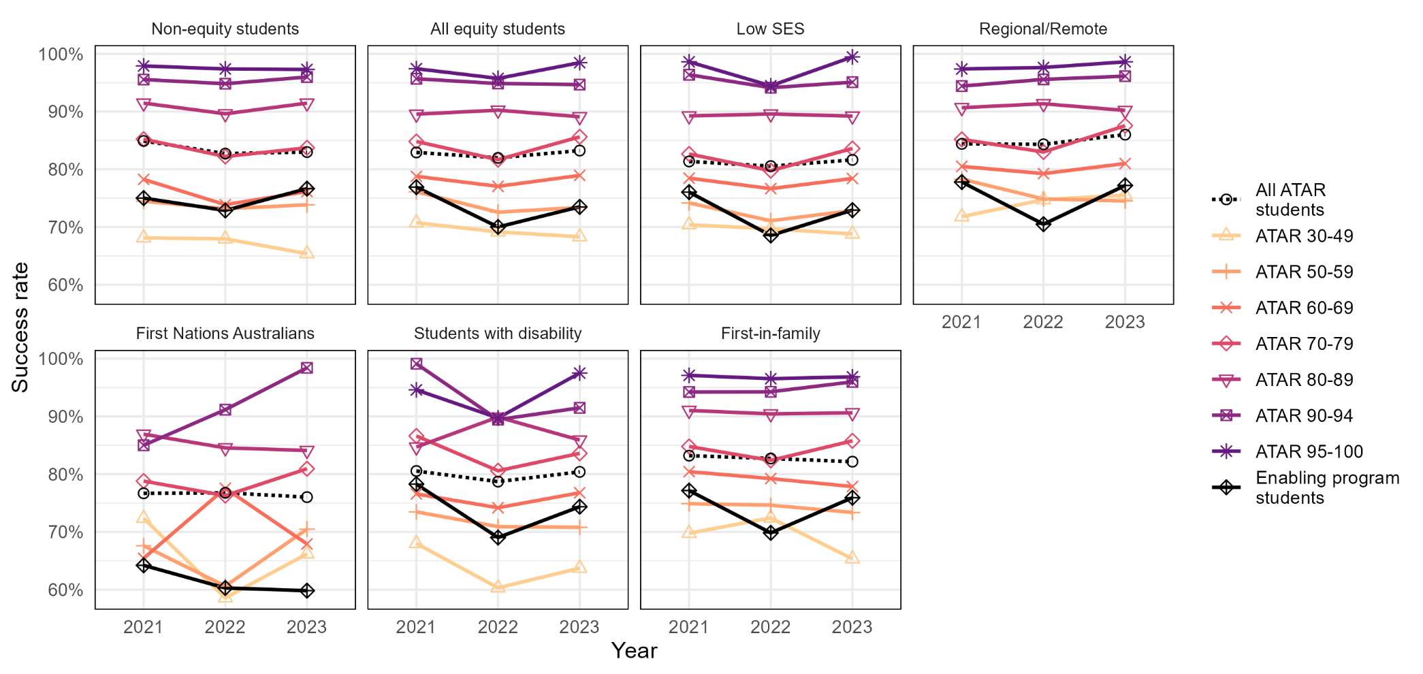

First-year success rates at Regional Universities Network universities

Non-equity students from enabling programs had success rates comparable to ATAR 70–79 non-equity students—above the average for ATAR pathway students. Equity students from enabling programs had success rates generally between ATAR 60–69 and ATAR 70–79 equity students.
Figure 39: Success rates of domestic undergraduate students admitted to university through enabling programs from 2021 to 2023 within the Regional Universities Network
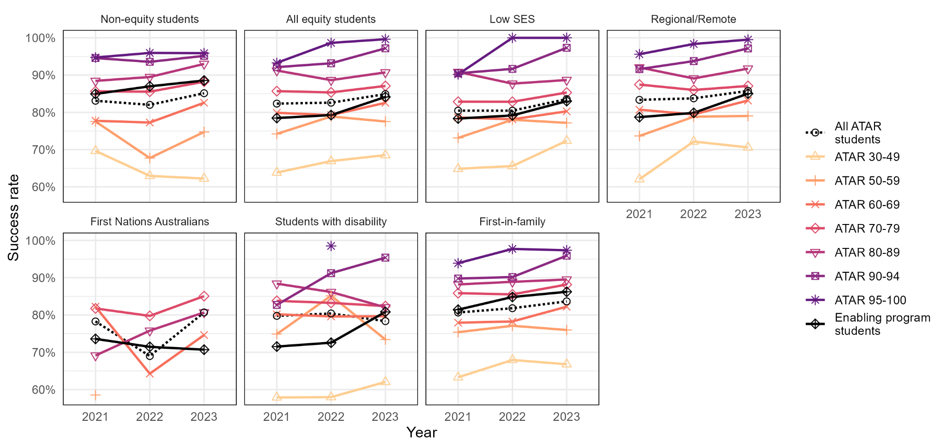

First-year success rates at non-aligned universities

Non-equity students from enabling programs had success rates comparable to ATAR 70–79 non-equity students. Equity students from enabling programs saw success rates jump from comparable to ATAR 60–69 equity students in 2022, to comparable to ATAR 70–79 equity students in 2023.
Figure 40: Success rates of domestic undergraduate students admitted to university through enabling programs from 2021 to 2023 at non-aligned universities
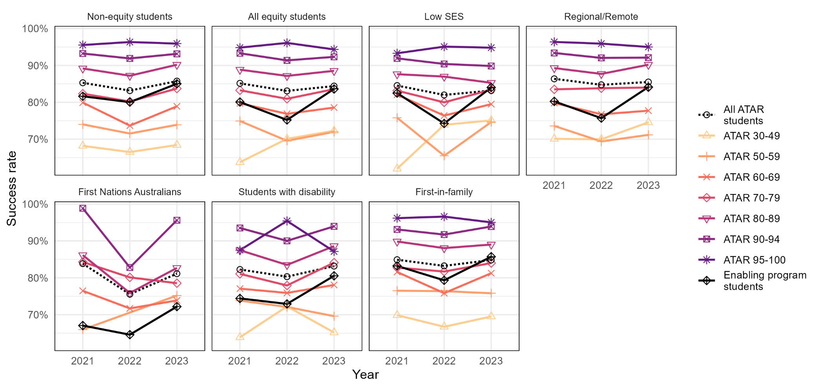

Within-institution ATAR vs enabling program pathway success rates

To identify differences in success for equity students admitted to university through enabling programs versus ATAR within each institution, their success rates can be compared.
In the following series of plots, the vertical (y-) axis represents the success rates for university students who entered via enabling programs, and the horizontal (x-) axis represents the success rates for students whose main basis for admission was their ATAR. The 45-degree dotted line represents equality in the compared rates.
For figures 27–32, we have plotted success rates of all ATAR students versus students from enabling programs for each equity group. Each plot represents comparisons for one equity group. If success rates are equal for both groups within an institution, its data point will lie on the 45-degree line. If success rates at an institution are higher for students from enabling programs, the dot will lie above the 45-degree line, and if success rates are lower for students from enabling programs, the dot will be below the 45-degree line.
For Figure 33, institutions falling on the 45-degree line have the same success rate in both student groups. Institutions falling above the dotted line have higher success rates for equity students compared to non-equity students.
Each dot represents a Table A institution with at least five EFTSL of students from enabling programs. If an institution is missing from the plot, it means they had fewer than five EFTSL of students within the particular group.

Success rates of all equity students from ATAR vs enabling program pathways in 2023

Figure 41: Relationship between the undergraduate success rates of ATAR pathway and enabling program pathway students in 2023 for all equity students
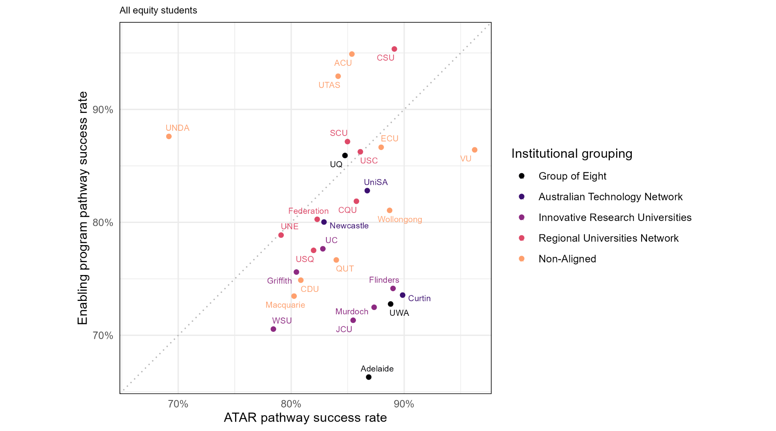

Success rates of students from low SES areas from ATAR vs enabling program pathways in 2023

Figure 42: Relationship between the undergraduate success rates of ATAR pathway and enabling program pathway students from low SES areas in 2023
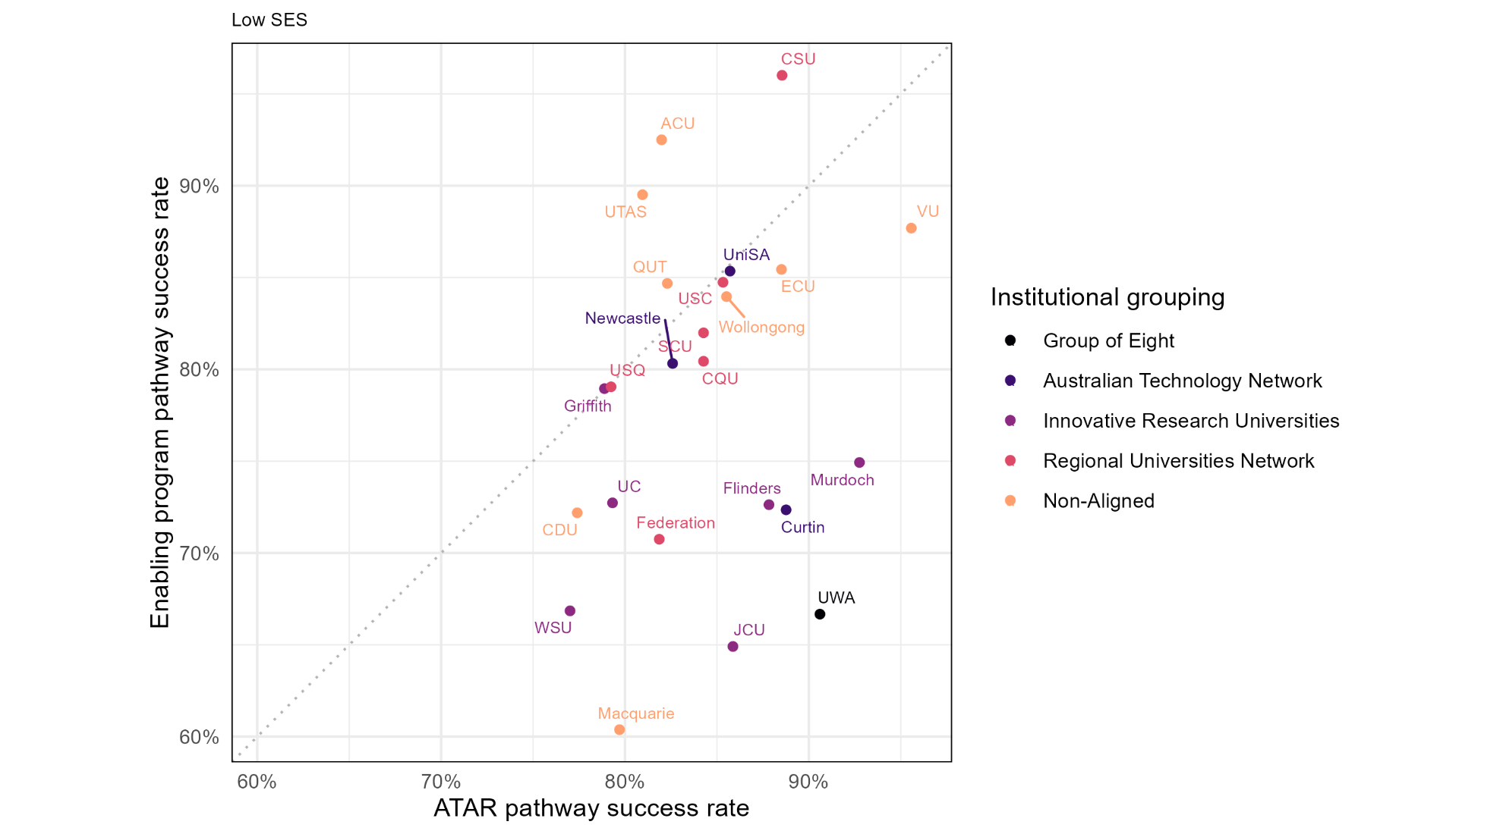

Success rates of students from regional and remote areas from ATAR vs enabling program pathways in 2023

Figure 43: Relationship between the undergraduate success rates of ATAR pathway and enabling program pathway students from regional/remote areas in 2023
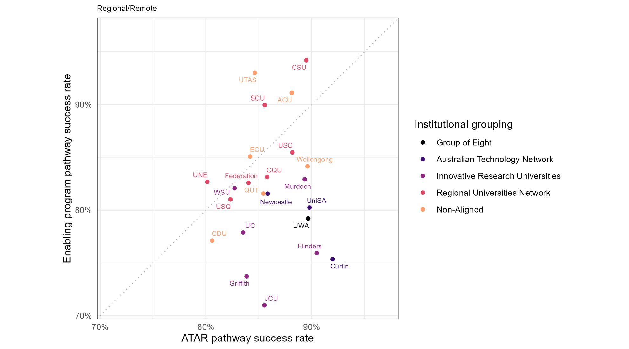

Success rates of First Nations Australian students from ATAR vs enabling program pathways in 2023

Figure 44: Relationship between the undergraduate success rates of ATAR pathway and enabling program pathway First Nations Australian students in 2023
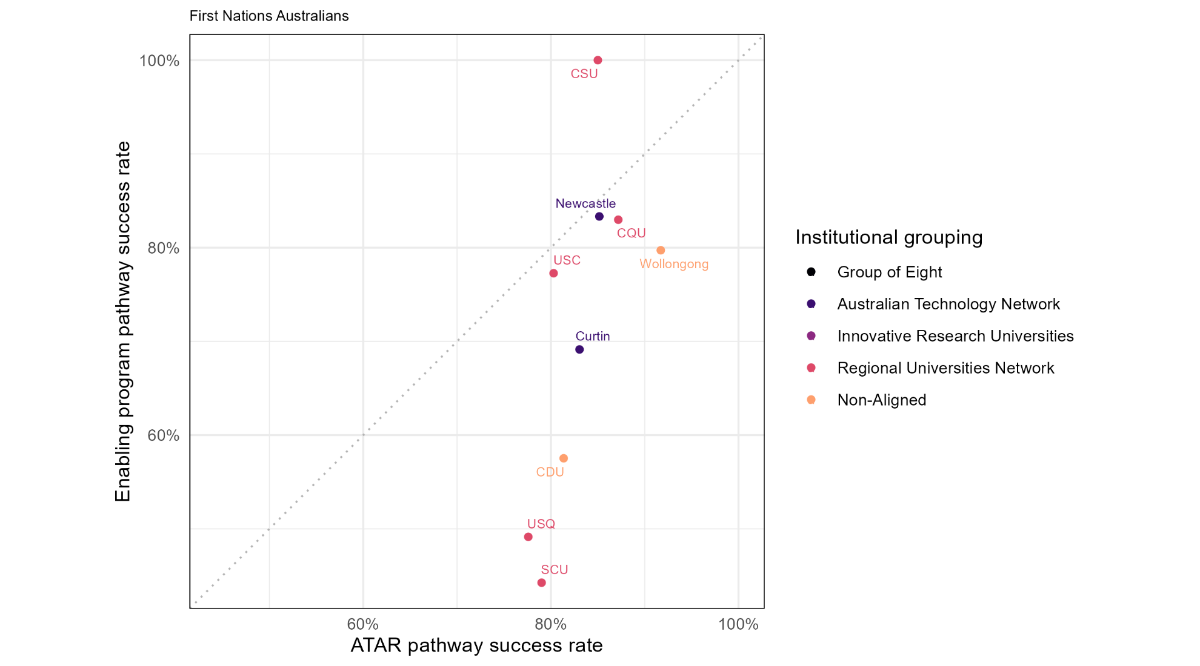

Success rates of students with disability from ATAR vs enabling program pathways in 2023

Figure 45: Relationship between the undergraduate success rates of ATAR pathway and enabling program pathway students with disability in 2023
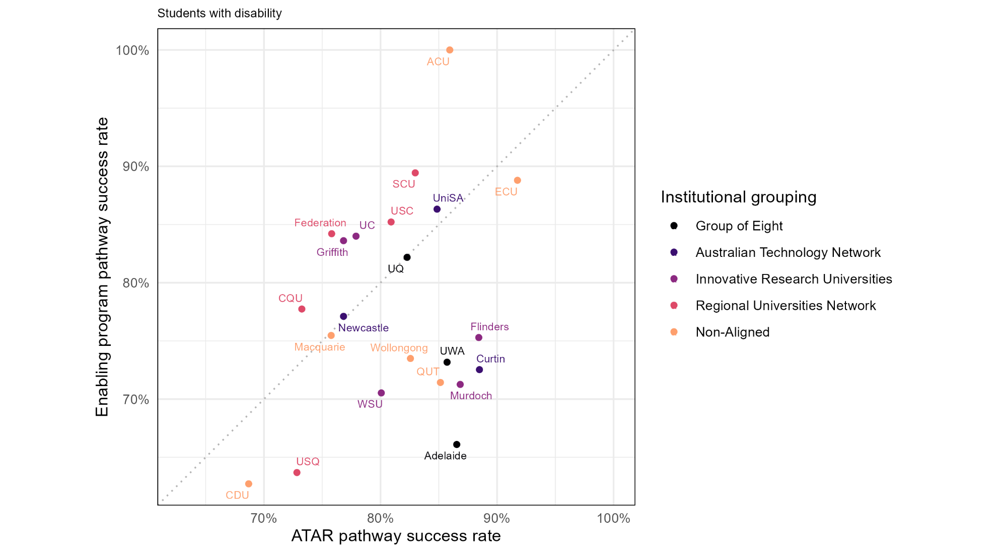

Success rates of first-in-family students from ATAR vs enabling program pathways in 2023

Figure 46: Relationship between the undergraduate success rates of ATAR pathway and enabling program pathway first-in-family students in 2023
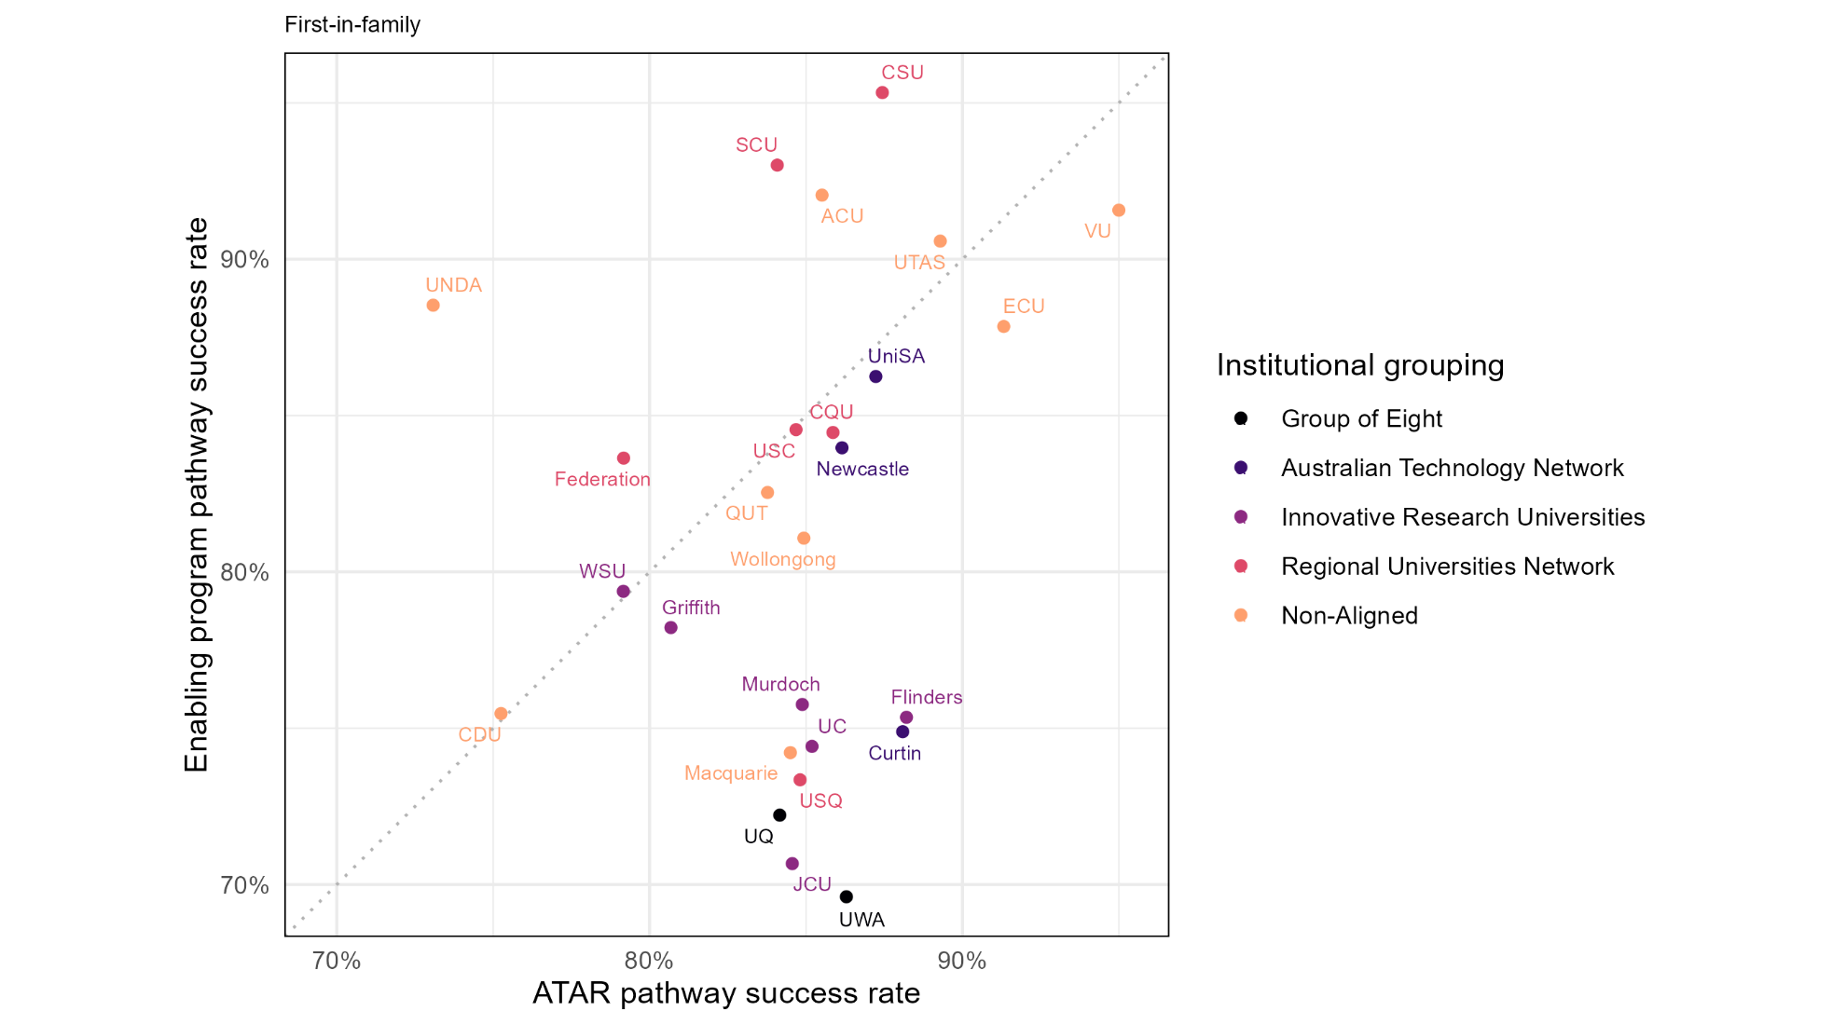

Success rates of equity and non-equity enabling program pathway students at university in 2023

Figure 47: Relationship between the undergraduate success rates of equity and non-equity enabling program pathway students in 2023
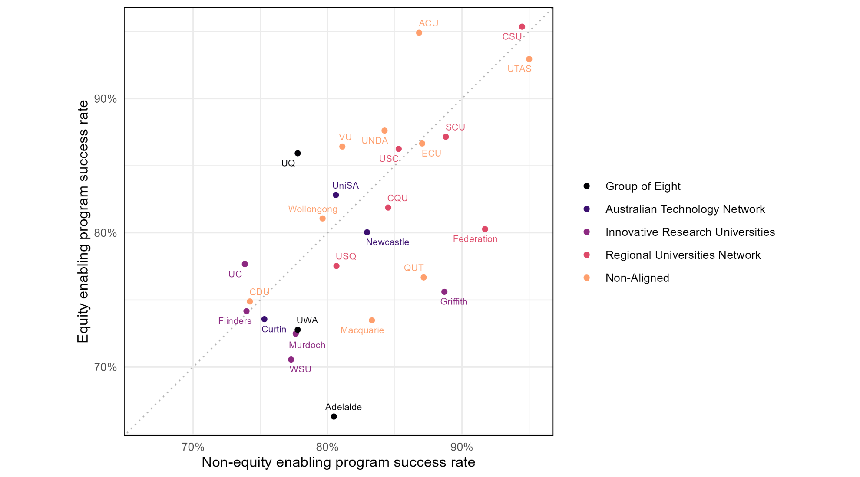

Correlations between retention and success rates

Examining the correlation between first-year success rates and subsequent retention rates across institutions helps indicate whether universities with stronger academic outcomes for a given group also tend to see higher rates of continuation in the higher education sector. A stronger correlation suggests that institutional differences in success and continuation move together. A weaker correlation indicates that the two outcomes vary more independently and suggests academic success alone may not translate into continuation. This provides context for understanding how closely academic performance and sector-wide persistence are aligned across different student cohorts.
Figures 48–54 on the following pages show plots of retention versus success rates for students from enabling program pathways for each of the equity groups.
Table 2 below shows the correlation coefficients for enabling program and ATAR pathway students. The correlations between the two pathways are very similar—moderate for each of the specific equity groups, and strong for non-equity students. However, the correlation is much weaker for “all equity students” from enabling program pathways than from ATAR pathways.
Table 2: Pairwise correlation coefficients between retention and success rates for first-year domestic undergraduate students from enabling programs at Table A institutions in 2022

Equity group | Enabling program pathway | ATAR pathway
Non-equity students | 0.77 | 0.71
All equity students | 0.35 | 0.61
Low SES | 0.54 | 0.48
Regional/Remote | 0.53 | 0.49
First Nations Australians | 0.59 | 0.54
Students with disability | 0.48 | 0.57
First-in-family | 0.63 | 0.56

Correlation between 2022 university retention and success rates for non-equity students

Figure 48: Relationship between the undergraduate retention and success rates of enabling program pathway non-equity students in 2022
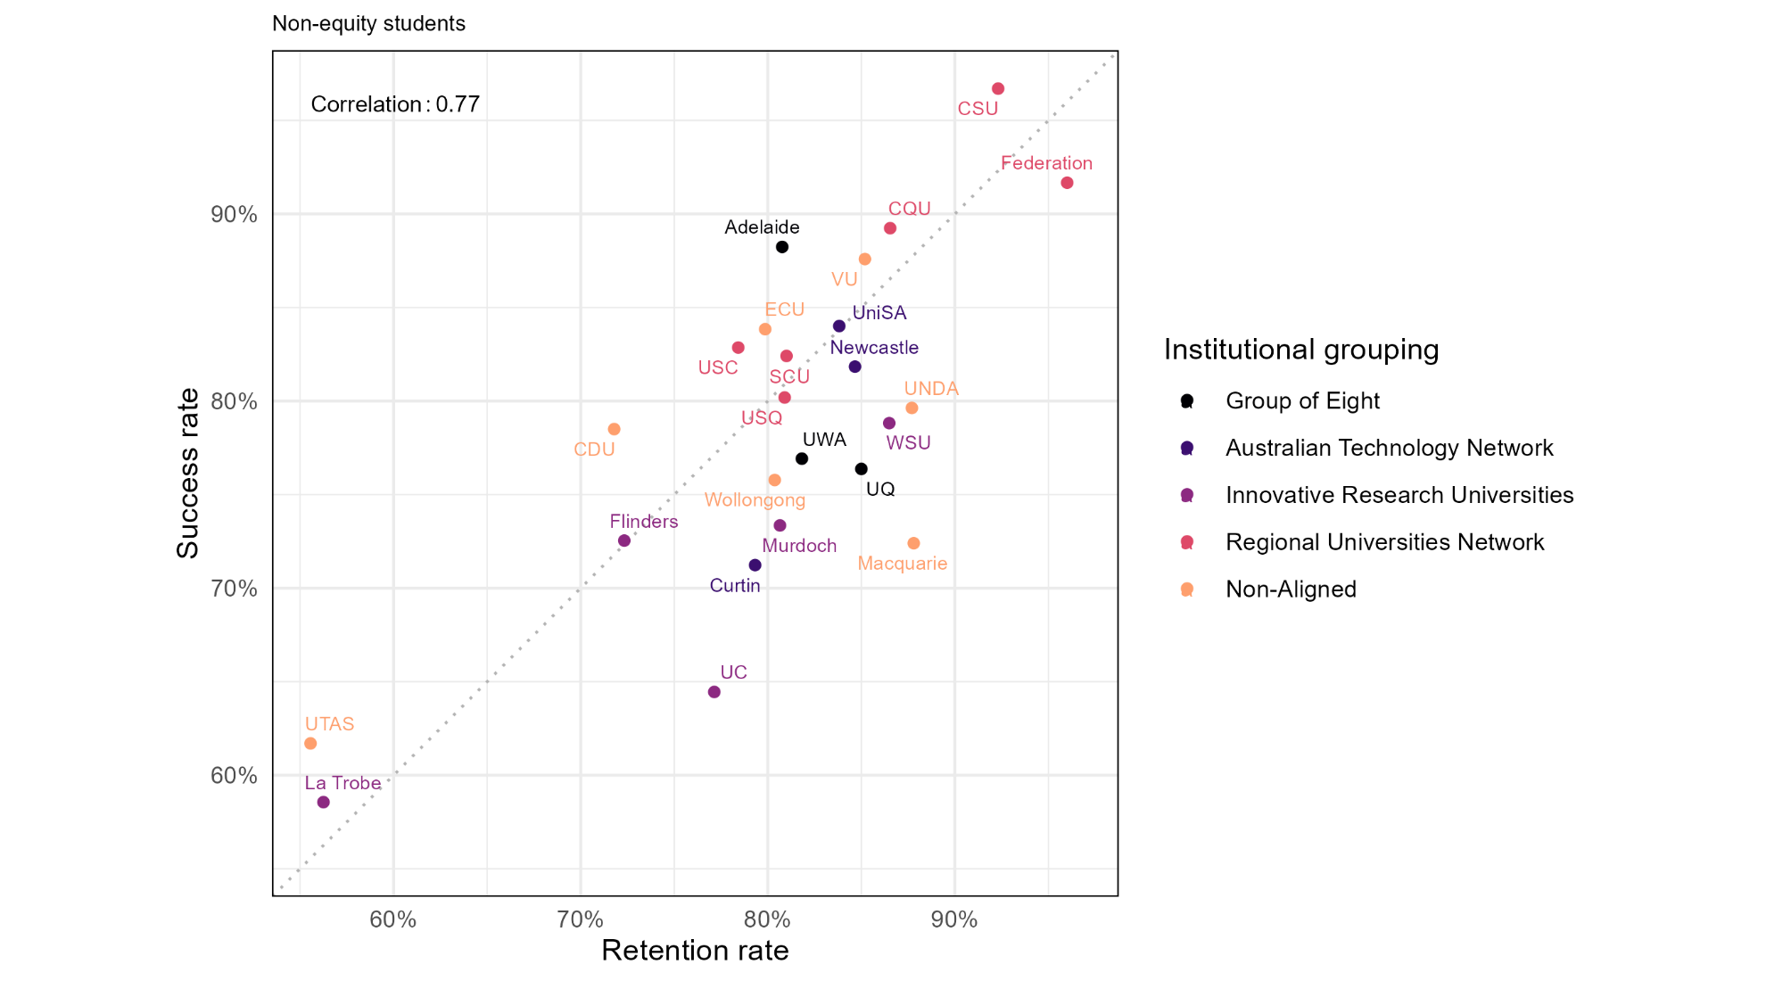

Correlation between 2022 university retention and success rates for all equity students

Figure 49: Relationship between the undergraduate retention and success rates of enabling program pathway equity students in 2022
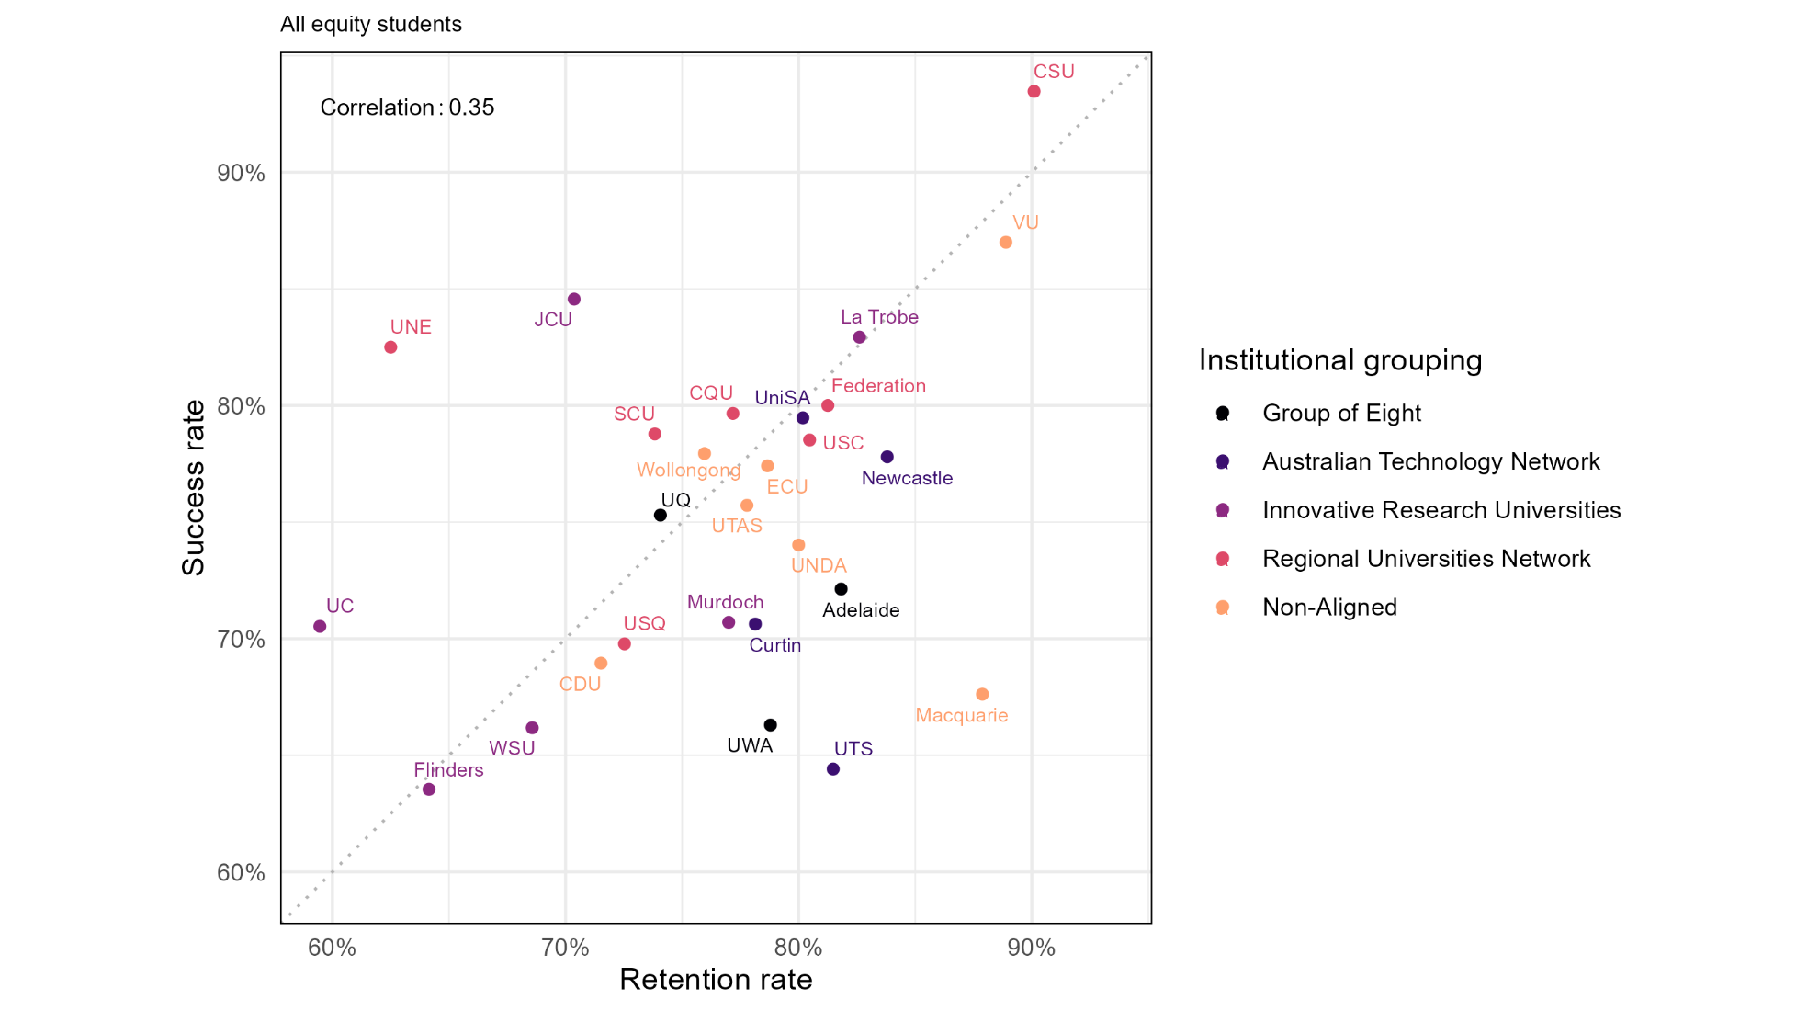

Correlation between 2022 university retention and success rates for low SES students

Figure 50: Relationship between the undergraduate retention and success rates of enabling program pathway students from low SES areas in 2022
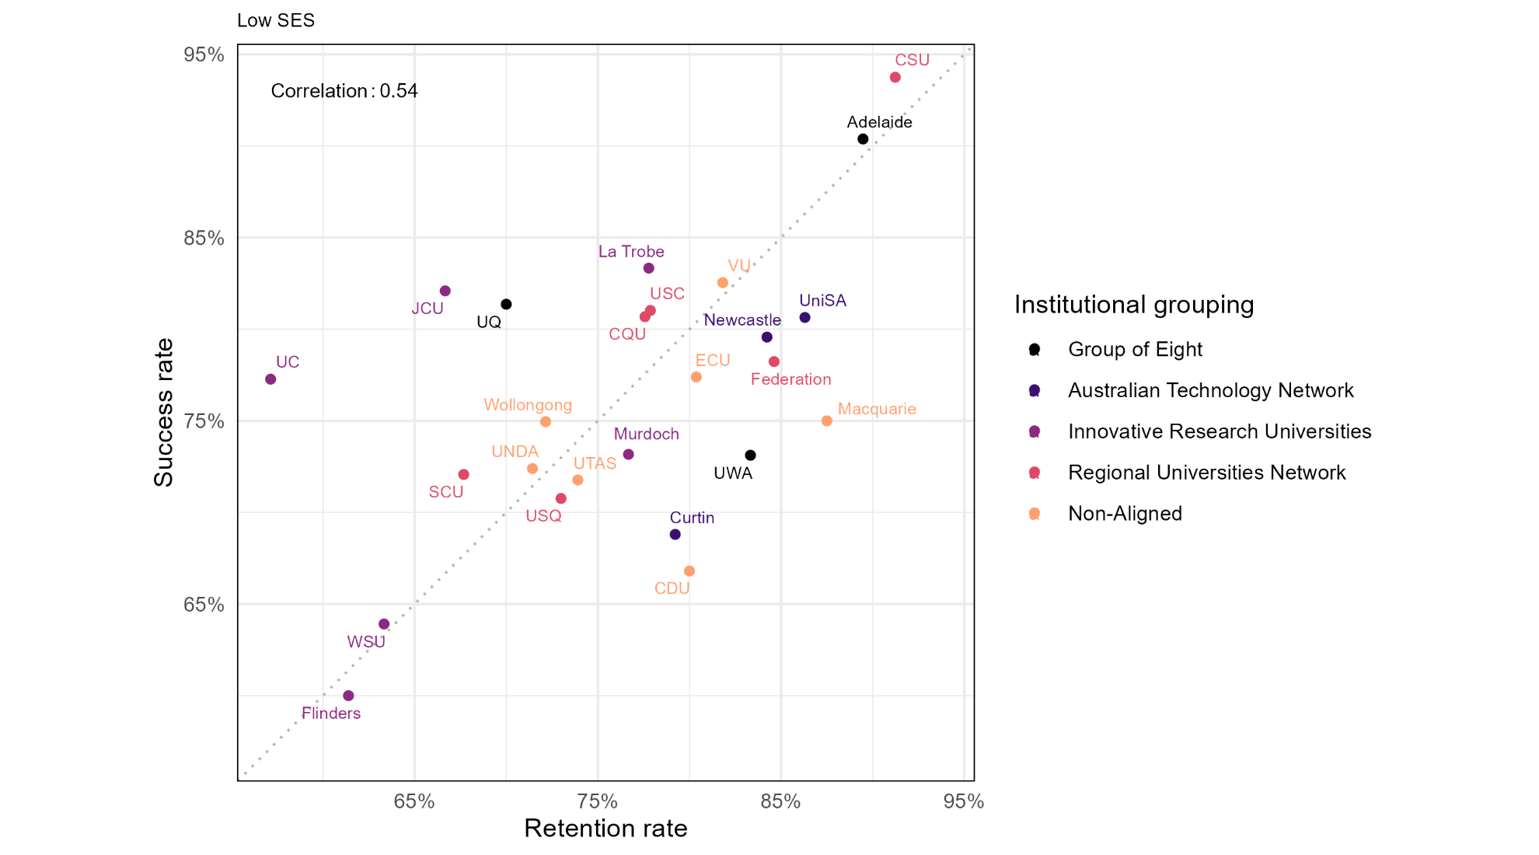

Correlation between 2022 university retention and success rates for regional and remote students

Figure 51: Relationship between the undergraduate retention and success rates of enabling program pathway students from regional/remote areas in 2022
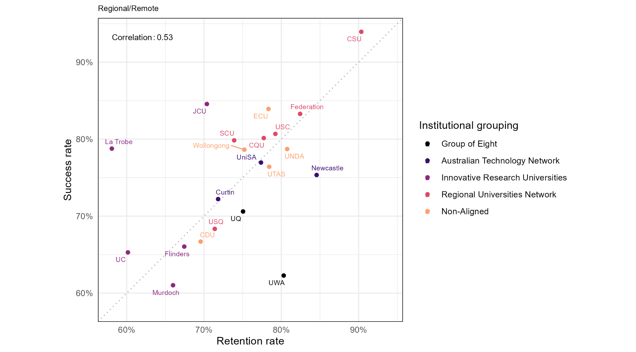

Correlation between 2022 university retention and success rates for First Nations Australians students

Figure 52: Relationship between the undergraduate retention and success rates of enabling program pathway First Nations Australian students in 2022
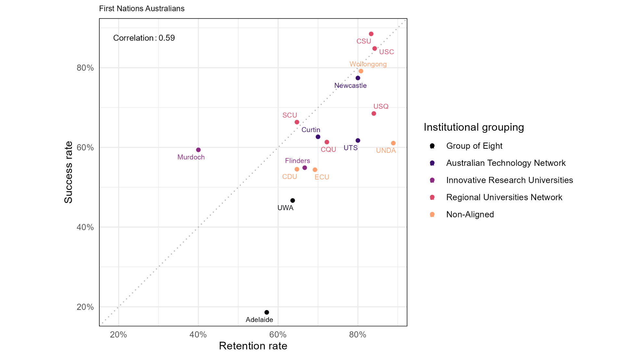

Correlation between 2022 university retention and success rates for students with disability

Figure 53: Relationship between the undergraduate retention and success rates of enabling program pathway students with disability in 2022
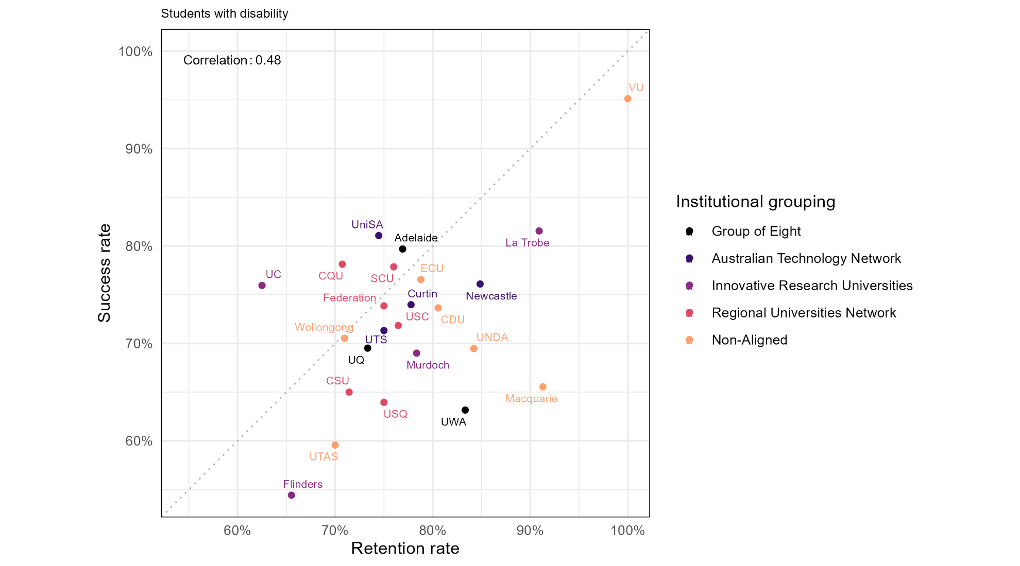

Correlation between 2022 university retention and success rates for first-in-family students

Figure 54: Relationship between the undergraduate retention and success rates of enabling program pathway first-in-family students in 2022
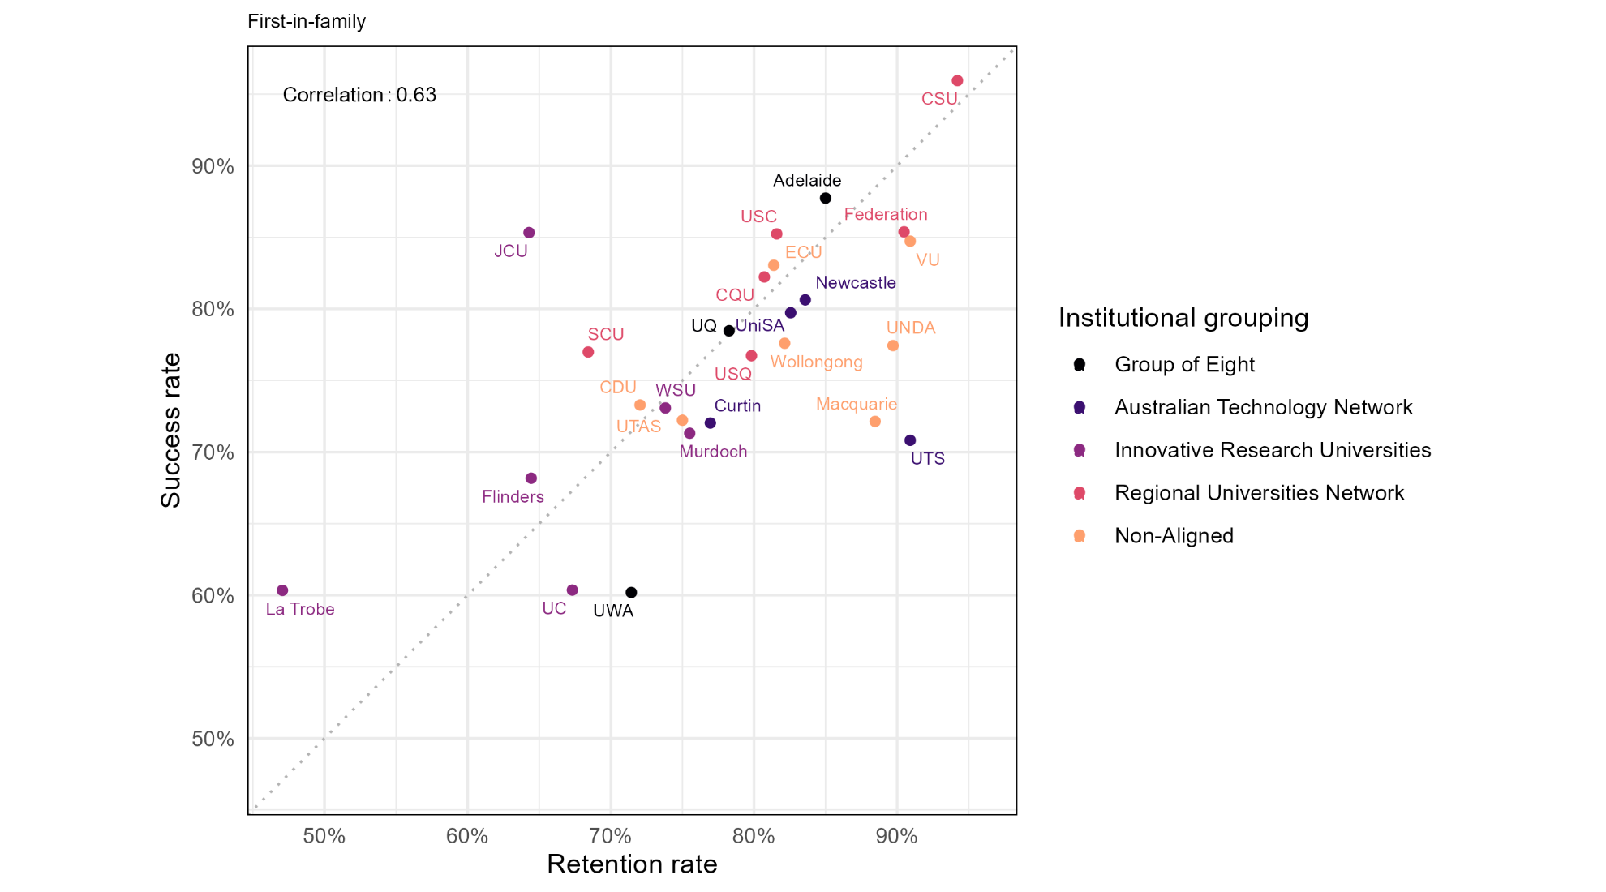

Please see Student Equity Data Guide: Defining Equity Groups for further information.
Australian Government Department of Education (2025). Enabling Program Statistics, Private Request (2025). Canberra: Department of Education.
For further discussion on first-in-family and equity, see: www.acses.edu.au/why-first-in-family-status-matters.
https://www.tcsisupport.gov.au/glossary/glossaryterm/retention-rate
https://www.tcsisupport.gov.au/node/8013
Please see Student Equity Data Guide: Challenges in Comparing Student Outcomes Across Higher Education Institutions for further information.
Please see In-school enabling programs in the landscape of university pathways for secondary students in Australia: a scoping review for discussion of in-school enabling programs.

