
SMALL GRANTS RESEARCH PROGRAM REPORT

Pathway programs and Indigenous student completion: Building the evidence

Bronwyn Fredericks, Katelyn Barney,
Tracey Bunda, Ashley Moor, Kirsten Hausia, Scott Parlett, Nisa Richy, and
Daniel Taylor-Griffiths
2026

Pathway programs and Indigenous student completion: Building the evidence

28 January 2026
Bronwyn Fredericks, The University of Queensland
Katelyn Barney, The University of Queensland
Tracey Bunda, The University of Queensland
Ashley Moor, UQ College
Kirsten Hausia, The University of Melbourne
Scott Parlett, University of New South Wales
Nisa Richy, The University of Queensland
Daniel Taylor-Griffiths, The University of Queensland

Suggested citation: Fredericks, B., Barney, K., Bunda, T., Moor, A., Hausia, K., Parlett, S., Richy, N., & Taylor-Griffiths, D. (2026). Pathway programs and Indigenous student completion: Building the evidence (Small Grants Research Program final report). Australian Centre for Student Equity and Success, Curtin University.

Australian Centre for Student Equity and Success
Tel: +61 8 9266 1573
Email: acses@curtin.edu.au
Web: www.acses.edu.au
Building 100
Curtin University
Kent St, Bentley WA 6102 | GPO Box U1987, Perth WA 6845

DISCLAIMER
Information in this publication is correct at the time of release but may be subject to change. This material does not purport to constitute legal or professional advice.
Curtin accepts no responsibility for and makes no representations, whether express or implied, as to the accuracy or reliability in any respect of any material in this publication. Except to the extent mandated otherwise by legislation, Curtin University does not accept responsibility for the consequences of any reliance which may be placed on this material by any person. Curtin will not be liable to you or to any other person for any loss or damage (including direct, consequential or economic loss or damage) however caused and whether by negligence or otherwise which may result directly or indirectly from the use of this publication.
COPYRIGHT
© Curtin University 2026
Except as permitted by the Copyright Act 1968, and unless otherwise stated, this material may not be reproduced, stored or transmitted without the permission of the copyright owner. All enquiries must be directed to Curtin University.
CRICOS Provider Code 00301J
ISBN 978-1-7644511-1-6

Acknowledgement of Country
The Australian Centre for Student Equity and Success acknowledges Indigenous peoples across Australia as the Traditional Owners of the lands on which the nation’s campuses are situated. With a history spanning more than 60,000 years as the original educators, Indigenous peoples hold a unique place in our nation. We recognise the importance of their knowledge and culture, and reflect the principles of participation, equity, and cultural respect in our work. We pay our respects to Elders past, present, and future, and consider it an honour to learn from our Indigenous colleagues, partners, and friends.

At a glance
What we did
Pathway/enabling programs are central to preparing and transitioning Indigenous students into university. This project identified and analysed the strategies used in three Group of Eight university pathway programs to support Indigenous students to successfully transition into and through university. Qualitative data was collected from Indigenous graduates and university students who had previously participated in a pathway program, and current students in pathway programs. The project additionally involved interviews with Indigenous and non-Indigenous staff who teach or support Indigenous students in pathway programs. A total of 50 interviews were undertaken. Quantitative data was obtained from the Department of Education, with specific emphasis on application, enrolment, and student outcome data.
What we found
- Peer-to-peer connections are key for Indigenous students within pathway programs.
- Indigenous centres are crucial for building a sense of connection and community.
- Student–staff connections are important within pathway programs to ensure Indigenous students successfully complete the programs, and these connections are often continued through students’ university degrees.
- Indigenous Tutorial Assistance Scheme assists students to complete their degrees.
- More Indigenous perspectives are needed within the curriculum of pathway programs.
- More professional staff development is needed, both in relation to building cultural competency and in relation to Indigenising curriculum.
- Stronger data gathering is needed to track Indigenous student pathways.
- The “basis of admission” proportions varied between institutions, providing evidence of the diverse and complex pathways into studies taken by Indigenous students.
What we recommend
- Pathway program leaders need to ensure cultural competency training opportunities for teachers and support staff in pathway programs.
- Pathway program teaching staff should work with Indigenous academics and community members to embed Indigenous perspectives in course curricula.
- Leadership and Indigenous centre staff should work together to ensure strong supports are in place for Indigenous students.
- Teachers and support staff and Indigenous centre/unit staff should continue to build a sense of belonging and connection for Indigenous pathway program students.
- Leadership should ensure there are mentoring opportunities for Indigenous students in pathway programs.
- Leadership should work with university IT services and the Indigenous centre to develop better data gathering so that student pathways can be tracked and timely support is provided to Indigenous students.
- The Australian Government Department of Education could pilot amendments to data collection practices to facilitate more granular analysis of the student lifecycle.
- The Department could pilot including a separate analysis of the national Indigenous student population in the annual cohort analysis of higher education students.

Acknowledgements
The project would not have been possible without the support of the Australian Centre for Student Equity and Success (ACSES) who have funded this research. We sincerely thank the members of the Aboriginal and Torres Strait Islander reference group for their feedback and guidance throughout the project:
- Danielle Amour, The University of Queensland
- Inala Cooper, The University of Melbourne
- Katrina Thorpe, University of New South Wales
Many thanks to the Department of Education’s Higher Education Statistics team for providing quantitative data. We sincerely thank all of the Aboriginal and Torres Strait Islander graduates and students, and the staff who work with Aboriginal and Torres Strait Islander students in pathway programs, for being interviewed for the project. The Aboriginal and Torres Strait Islander Studies Unit within the Indigenous Engagement Division at The University of Queensland provided a supportive environment to undertake the project.

Table of contents

Acknowledgement of Country iii
Acknowledgements v
Table of contents vi
List of tables viii
List of figures viii
Abbreviations ix
1. Executive summary 1
1.1 Background 1
1.2 Methods 1
1.3 Key findings 2
1.4 Outputs 2
2. Recommendations 3
2.1 Key stakeholder recommendations 3
2.2 Australian Government recommendations 3
3. Introduction 4
3.1 Positioning of the project team 6
3.2 Collaboration with an expert Indigenous reference group 7
4. Background 8
4.1 Indigenous students and pathway programs 9
4.2 Indigenous student “success” more broadly 10
4.3 Importance of Indigenous centres/units, Indigenised curriculum, and ITAS to support university completion 11
5. Methods 12
5.1 Phase 1: Establishing the research project 13
5.2 Phase 2: Undertaking multi-site data collection 13
5.3 Phase 3: Developing strategies and resources 13
5.4 Phase 4: Sharing results and embedding outcomes 14
5.5 Qualitative data collection: Interviews 15
5.6 Qualitative data analysis 16
5.7 Quantitative data analysis and collation 16
5.8 Limitations 17
6. Findings 18
6.1 About the programs 18
6.2 Examples of student pathways 19
6.3 Qualitative interview findings 20
6.3.1 Graduate and student interviews 20
6.3.2 Staff interviews 26
6.4 Quantitative findings 30
6.4.1 Progression through application, offer, enrolment, and retention 30
6.4.2 Applications, offers, and offer rates 32
6.4.3 Basis of admission into undergraduate degrees 34
6.4.4 Success rates 36
7. Discussion 38
7.1 Student characteristics: Persistence and determination 38
7.2 Benefits of pathway programs and potential links to university completion 39
7.3 Long and non-linear pathways 40
7.4 The importance of an Indigenised curriculum 40
7.5 The important role of Indigenous centres/units, peer-to-peer connections, and ITAS 42
7.6 Importance of mentoring between beginning pathway program students and current university students/graduates 43
8. Conclusion 45
8.1 Strategies to strengthen pathway programs for Indigenous students 47
8.2 Future research opportunities 48
8.3 Recommendations 48
8.3.1 Key stakeholder recommendations 48
8.3.2 Australian Government recommendations 49
9. References 50
10. Appendices 56
Appendix 1: Photos from national symposium 56

List of tables
Table 1: Timeline of project 12
Table 2: Participant type and number of interviews 16
Table 3: Participant type and number of interviews per university 16
Table 4: The programs 18
Table 5: Department of Education descriptors 34

List of figures
Figure 1: Word cloud activity 14
Figure 2: University A Student 4’s pathway into university 19
Figure 3: University B Graduate 1’s pathway into university 20
Figure 4: Collation of numbers of Indigenous applications, offers, enrolled students, and retained students, University A, 2010–2018 31
Figure 5: Collation of numbers of Indigenous applications, offers, enrolled students, and retained students, University B, 2010–2018 31
Figure 6: Collation of numbers of Indigenous applications, offers, enrolled students, and retained students, University C, 2010–2018 32
Figure 7: Indigenous applications to selected universities, 2010–2021 32
Figure 8: Offers to Indigenous students from selected universities, 2010–2021 33
Figure 9: Ratio of offers to applications, expressed as a percentage, at selected universities and a national average, 2010–2021 33
Figure 10: EFTSL by basis of admission, University A 35
Figure 11: EFTSL by basis of admission, University B 35
Figure 12: EFTSL by basis of admission, University C 36
Figure 13: Success rates by basis of admission 37

Abbreviations
ACSES Australian Centre for Student Equity and Success
ATAR Australian Tertiary Admission Rank
EFTSL Equivalent full-time student load
Go8 Group of Eight
GPA Grade Point Average
HE Higher education
ITAR Indigenous Tutorial Assistance and Retention Program
ITAS Indigenous Tutorial Assistance Scheme
RA Research assistant
SES Socio-economic status
TAFE Technical and Further Education
UA Universities Australia
UQ The University of Queensland

Executive summary

Background
This research project has focused on success factors of pathway programs for Aboriginal and Torres Strait Islander students and potential correlations to university completion. While the number of Indigenous students participating in higher education continues to grow, university completion rates for Indigenous students remain significantly lower than for non-Indigenous students (Universities Australia [UA], 2023). The national data indicates that, while Indigenous students typically can take longer to graduate, the nine-year completion rates for Indigenous students remain around 50%—significantly below the 74% for non-Indigenous students (UA, 2023). In this context, university “completion” refers to the successful completion of all the academic requirements of a course of study. Pathway/enabling programs are central to preparing and transitioning Indigenous students into university and are the primary strategies for improving the readiness of prospective Indigenous students (Nakata & Nakata, 2023). However, high-quality, research-based evidence of how these programs affect university completion is limited. While pathway programs are diverse in their structure, format, and length, for the purposes of this project, the focus was on programs that have coursework to develop students’ core academic foundational skills required for undergraduate study.

Methods
Centred on Indigenous data sovereignty and governance principles, the project involved a mixed-methods approach (combining qualitative and quantitative methods) to identify and analyse the multifaceted dimensions and range of strategies used in three Group of Eight (Go8) university pathway programs (referred to as programs A, B, and C in this report) to support Indigenous students to successfully transition into and through university. In compliance with ethical clearance, the data related to each university has been de-identified within this report. The three universities were chosen because of their high completion rates compared to the national average. Through collaboration with an expert Indigenous reference group and staff at universities, the project involved documenting evidence to demonstrate success factors that support Indigenous students in pathway programs at these three universities and to highlight areas to strengthen pathway programs to better support Indigenous students to transition into and through university to completion. Qualitative data was collected from Indigenous graduates and university students who had previously participated in a pathway program, and current students in pathway programs. The project additionally involved interviews with Indigenous and non-Indigenous staff who teach or support Indigenous students in pathway programs to explore their perspectives on success factors and what can be improved to support Indigenous students within pathway programs to then transition into and through university to completion. A total of 50 interviews were undertaken. Quantitative data was obtained through direct request to the Department of Education, with specific emphasis on application, enrolment, and student outcome data from the three selected universities.

Key findings
Key findings from the project were:
- Peer-to-peer connections are key for Indigenous students within pathway programs and are an important factor for their university completion.
- Indigenous centres/units at universities are crucial spaces for building a sense of connection and community for Indigenous students.
- Student–staff connections are important within pathway programs to ensure Indigenous students successfully complete the programs, and these connections are often continued through students’ university degrees.
- The Indigenous Tutorial Assistance Scheme (ITAS) is a strategy to assist Indigenous students within pathway programs and in their university studies to support students to complete their degrees.
- More Indigenous perspectives are needed within the curriculum of pathway programs to affirm Indigenous student connections to the content and to their own cultural identities.
- More professional development, both in relation to building staff cultural competency and in relation to Indigenising curriculum, is needed for staff to ensure Indigenous perspectives are strongly and appropriately embedded in the curriculum of pathway programs.
- Stronger data gathering is needed to be able to track Indigenous student pathways, transition, success, and university completion so that student progress can be monitored and mentoring opportunities between current Indigenous pathway program students and university students/graduates could be developed.
- Compared to the sector, the selected institutions offered places to a smaller proportion of their applicants into undergraduate degrees. The proportions of “basis of admission” varied between institutions, providing evidence of the diverse and complex pathways into studies taken by Indigenous students.

Outputs
An output of the project was a national symposium, online and in person, to share the findings from the project and receive feedback on the proposed strategies. The project findings have also established suggested strategies that can be adopted by all pathway programs across Australia to strengthen and improve pathway programs for Indigenous students.

Recommendations
The findings of this project inform eight high-level recommendations under two broad categories:
- key stakeholder recommendations
- Australian Government recommendations.

Key stakeholder recommendations
- Pathway program leaders need to ensure cultural competency training opportunities for teachers and support staff in pathway programs.
- Pathway program teaching staff should work collaboratively with Indigenous academics and community members to ensure Indigenous perspectives are strongly embedded in course curricula.
- Pathway program leaders and Indigenous centre/unit staff should work together to ensure strong supports are in place for Indigenous students.
- Pathway program teachers and support staff and Indigenous centre/unit staff should continue to develop and strengthen strategies that build a sense of belonging and connection for Indigenous pathway program students to the university (for example, student-led events, creative workshops, or co-design sessions with students).
- Pathway program leaders should ensure there are initiatives in place to provide mentoring opportunities for Indigenous students in pathway programs (for example, with graduates or university students who previously participated in a pathway program).
- Pathway program leaders should work with university IT services and the Indigenous centre/unit to develop better data gathering so that student pathways can be tracked and timely support provided to Indigenous students. This could then assist with setting up mentoring opportunities between past and present Indigenous pathway program students.

Australian Government recommendations
- The Australian Government Department of Education could pilot amendments to data collection practices to facilitate more granular analysis of the student lifecycle from application to completion potentially using Unique Student Identifiers.
- The Australian Government Department of Education could pilot including a separate analysis of the national Indigenous student population in the annual cohort analysis of higher education students.

Introduction
National data indicates that, while Indigenous students typically can take longer to graduate, the nine-year completion rates for Indigenous students remain around 50%—significantly below the 74% for non-Indigenous students (UA, 2023). As Nakata and Nakata (2023) note, “pre-entry activities and pathway, preparation, and enabling programs are the primary mechanisms for improving the readiness of prospective … Indigenous students” (p. 17). Pathway/enabling programs are designed to provide alternative pathways to higher education, particularly for students who may not be eligible under the primary admission criteria. Most universities offer pathway/enabling programs that attempt to prepare and transition Indigenous students into university. Some universities offer enabling programs designed specifically for Indigenous students, while other universities have generic enabling programs which Indigenous students enrol in. As Pitman et al. (2017) note, the role that pathway/enabling programs play to transition Indigenous students into higher education
“—compared to other pathways—is greater than for other groups of students” (p. 243) with one in 10 Indigenous students enrolling in an undergraduate degree having transitioned via an enabling program. Previous research has shown that there is a demonstratable link between enabling programs and Indigenous student participation in higher education (Pitman et al., 2016; Thomas, 2014). Nakata and Nakata (2023) argue that pathway/ enabling programs “continue to be critical to the success of many Indigenous higher education students, and without them, the number of Indigenous graduates would be significantly lower” (p. 116).
There is also evidence of a clear correlation between previous participation in pathway programs and above average Indigenous undergraduate retention (Pitman et al., 2017, p. 247). However, there has been little analysis at the national level of completion rates of Indigenous students who transitioned from an enabling program. In addition, while there has been some research on Indigenous-specific enabling programs (for example, Fredericks et al., 2017), much less is known about the outcomes and success of Indigenous students who have participated in generic enabling programs. Some universities have higher Indigenous student completion rates than the national average, yet whether the improved retention rates arising from enabling programs translate to improved completion rates for Indigenous students has not previously been examined. As Lo et al. (2024) note, “there is no common consensus on the term ‘university pathway programs’ in the literature as different terminology, such as ‘enabling, bridging, pathway, university foundation, and diploma’” (p. 2) are all used. For the purposes of our project, the focus is on programs that have coursework to develop students’ core academic foundational skills required for undergraduate study. We explored the benefits of pathway/enabling programs for Indigenous student university preparedness and success and examined how these programs can be strengthened further to support Indigenous students to transition into and through university to completion.
Building on earlier research on “success factors” for Indigenous student completions (Fredericks et al., 2022), the purpose of this project is to build the evidence base about success factors of pathway/enabling programs to prepare Indigenous students for university success and university completion by undertaking case studies of enabling programs at three universities that have pathway/enabling programs and that have higher Indigenous student completion rates than the national average. This has been achieved through a mixed-methods project that evaluates the effectiveness of enabling programs in supporting Indigenous students to “enter, participate and successfully complete university” (Shalley et al., 2019, p. 44).
In the context of this project, university “completion” refers to the successful completion of all the academic requirements of a course of study. However, it is important to note that non-completion is not necessarily considered a failure (Cunninghame & Pitman, 2020) and, for some Indigenous students, even partial completion of a course may be counted as a success in terms of enabling them to contribute work-related skills at a higher level than before (Asmar et al., 2011). Certainly, as Uink et al. (2019) notes “the goals and priorities of Indigenous students may not always conform to the objectives and desired outcomes of the Australian government and higher education providers” (p. 9). However, the 2016 Graduate Outcomes Survey (Quality Indicators for Learning and Teaching, 2016) highlighted that the “gap” in employment rates comparing Indigenous and non-Indigenous peoples closes when they have a bachelor-level qualification. This being the case, much work is still to be done to achieve parity between Indigenous and non-Indigenous students in terms of completion rates.
There have been a number of research projects undertaken at universities across Australia that provide evidence of some of the multifaceted challenges Indigenous students face in completing university degrees (for example, Andersen et al., 2008; Asmar et al., 2011; Barney, 2016; Fredericks et al, 2015; Hearn et al., 2019; Hollinsworth et al., 2021; Page et al., 2017; Pham et al., 2024; Uink et al., 2022). There has been some research on the role of enabling programs in transitioning Indigenous students into university. Fredericks et al. (2015; 2017) examined three Indigenous-specific enabling programs at regional universities and found the programs had impacts on university participation as well as reaffirming personal identity and confidence. Pitman et al. (2017) analysed retention rates and university success of students who transition from an enabling program and found that there is a “clear link between enabling program enrolments and improved retention rates in subsequent higher education studies” (p. 247) for Indigenous students. However, they noted that “further study could also be undertaken into whether the improved retention rates arising from the enabling programs translate to improved completion rates” (Pitman et al. 2017, p. 247). This project aims to build and strengthen the evidence about the success factors of pathway/enabling programs to ensure Indigenous student success and university completion.
Specifically, the key research questions addressed in this project are:
- What do Indigenous students and staff report are the success factors of pathway/ enabling programs that influence Indigenous student transition, success, and university completion?
- What are the effective strategies/support mechanisms that pathway/enabling programs at universities with high completion rates employ?
- How does quantitative data inform the evaluation of programs, facilitate program development, and inform Indigenous student support?
- What are the implications for policy and practice to improve Indigenous student completions nationally? For example, how can pathway/enabling programs better support and prepare Indigenous students to transition into and through university to completion?
The findings of this project identify success factors of pathway/enabling programs and potential links to Indigenous student success and university completion to highlight the strengths of these universities and assist in improving pathway/enabling programs to support Indigenous student transition into and through university to completion.
The project responds to the Universities Australia Indigenous Strategy 2022–2025, which states that Indigenous students’ “access to university has improved greatly, but completion rates continue to lag” (UA, 2022, p. 19), and “there is new emphasis on supporting students through to degree completion and successful post-study outcomes” (UA, 2022, p. 7). The proposed project also responds to the Australian Universities Accord Interim Report (Australian Government, 2023), which states that “preparatory and enabling programs are proven ways to build academic preparation and provide a supportive pathway to further study for students, particularly students from equity cohorts … The Review believes such programs should be expanded” (p. 81). The proposed project also responds to Shalley et al. (2019) who call for an increase in “both quantitative and qualitative research focus on enabling courses. Who is accessing them? What is working? Where are the gaps in translating participation into enrolment and then to success?” (p. 56) in relation to Indigenous students. The project also responds to Li et al. (2022) who call for “further action to improve the retention and academic performance of Indigenous students” (p. 40). This focus on Indigenous student enrolment (and subsequent completion) is particularly relevant given the call in the Australian Universities Accord Final Report (Australian Government, 2024) for “valuing and supporting First Nations knowledge and research” (p. 206) and a renewed push to improve Indigenous student participation in university.

Positioning of the project team
The project was led by Bronwyn Fredericks, an Aboriginal woman from south-east Queensland, who has over 30 years of experience working in and with the tertiary sector, state and federal governments, and Indigenous community-based organisations. Katelyn Barney was the project manager. She is a non-Indigenous researcher who grew up on Jagera and Turrubal lands, and this project builds on her prior research collaborations in Indigenous higher education. Tracey Bunda is a Ngugi/Wakka Wakka woman who has undertaken research projects on Indigenous higher education and negotiating university equity from Indigenous standpoints. Ashley Moor has family connections to Wakka Wakka Country and has expertise in curriculum development and educational leadership through his role as Manager of Academic Pathways at UQ College. Kirsten Hausia is an Aboriginal woman whose mother is Yamatji from Perth, Western Australia, and has research skills in educational leadership and guidance/counselling. Scott Parlett is a Malyangapa and Barkindji descendent who was born and raised in Winton in rural Queensland. Scott has over 20 years of extensive knowledge and experience working in the higher education sector and is currently Director of Nura Gili, Centre for Indigenous Programs at UNSW. Nisa Richy was a research assistant on the project and worked with the project manager, project team, and expert Indigenous reference group. She is Crimean Tatar, Southern European, and Originaria Yucateca, Mexican and grew up in on Jinibara and Kabi Kabi Country. Daniel Taylor-Griffiths was also a research assistant on the project with expertise in quantitative data analysis. He is a non-Indigenous man who lives and works on the lands of the Jagera and Turrubal people and was previously a coordinator of a university pathway program.

Collaboration with an expert Indigenous reference group
An Indigenous reference group was established to guide the development of the project and ensure that further Indigenous expertise across the higher education sector was embedded into the design of the project. The members of the expert Indigenous reference group were Inala Cooper, Danielle Amour, and Katrina Thorpe. Two reference group meetings were held to provide progress updates on the project, receive feedback on the proposed research interview questions, and discuss key themes identified after analysing the data. Regular correspondence via emails with the reference group was also conducted to provide updates on the project.

Background
Universities across Australia have committed to improving participation in and completion of higher education by Indigenous students, and the number of Indigenous students commencing and completing university continues to grow (UA, 2022). However, bachelor’s degree completion rates for Indigenous students remain significantly lower than for non-Indigenous students (UA, 2023). While some universities have been identified as having higher completion rates (Fredericks et al., 2022), the research-based evidence of whether completion rates differ significantly depending on the initial pathways students took into higher education and the role of pathway/enabling programs is very limited.
There is much confusion and diversity in the terminology, as “enabling”, “bridging”, “pathway”, “foundation”, “pre-program”, and “diploma” are all used in the literature. The Australian Universities Accord Final Report (Australian Government, 2024) notes that “for students who require additional support to meet entry requirements for higher education courses, there are two primary options: through pathway and foundation courses (such as diplomas of tertiary education), or through enabling programs offered by universities” (p. 131). Crawford (2014) notes that “enabling programs, also known as preparation programs, bridging courses, and access programs, have been operating on the margins in the higher education scene for decades” (p. 17). Certainly pathway/enabling programs can provide significant means for “academic skills necessary to make a smooth start” at university (Crawford, 2014, p. 26) and, as Shay et al. (2023) note, “it is vital that Indigenous peoples wanting to undertake university study come equipped with the skills they need for success” (n.p.).
Typically, “enabling” programs are a “fee-free choice for students” (Australian Government, 2024, p. 133), do not lead to a formal qualification, and “are usually provided to students with free tuition” (Pitman et al., 2017, p. 237). However, Pitman et al. (2016) note that “due to the generic nature of the term, a wider variety of university-preparation courses are regularly referred to as enabling and not all of them are tuition-free” (p. 10). Many enabling programs cater to a wide range of students, from school leavers whose achievements are insufficient for their university course of choice, to mature-age students returning to study after an absence of many years (Hodges et al., 2013). Attrition is typically high but, as Crawford (2014) notes “given the diverse educational backgrounds of enabling students, and the fact that entry qualifications are not required, high attrition rates are not surprising and need to be interpreted carefully; in fact, some attrition can be viewed as positive” (p. 17) (also see Bennett et al., 2013). At the same time, Li et al. (2022) found that students who did enter university through pathway providers or enabling programs had stronger retention outcomes and higher marks. Enabling programs have shown positive effects on student retention. Thomas (2014), for example, found retention rates similar to those entering via traditional school pathways. Chesters and Watson (2016) reported that students entering via enabling programs were the least likely to discontinue their studies than all others from different pathways in that particular institution. The Australian Universities Accord Final Report recommends “enabling” programs be renamed “preparatory” courses (Australian Government, 2024, p. 136) and notes that “a wide variety of enabling programs are on offer, ranging from a few weeks’ duration to a whole year” (p. 134). In comparison, “pathway programs with a qualification are usually diploma courses with a strong relationship to a specific bachelor’s degree, or sometimes an associate degree” (Kemp & Norton, 2014, p. 18). Bennett et al. (2022) highlight that “key commonalities in these courses are their focus on academic skills development, university acculturation, and foundational disciplinary knowledge” (p. 2). Therefore, due to the lack of consensus on terminology in the literature and the diversity of content, length, and delivery of these programs, the term “pathway program” is used broadly in this report to refer to academic programs with curricula that aim to prepare Indigenous students to transition into university undergraduate degrees.

Indigenous students and pathway programs
There has been some research on Indigenous-specific pathway/enabling programs (for example, Fredericks et al., 2015; 2017; Kinnane et al., 2014; Oliver et al. 2013). Fredericks et al. (2017) note that pathway programs that assist Indigenous students to enter and succeed in tertiary education are vital (also see Behrendt et al., 2012). Further, Fredericks et al. (2015) argue that pathway programs for Indigenous students are highly important to increasing the numbers of Indigenous students studying in higher education and need to be developed in holistic ways that recognise students’ needs, such as accommodation and block learning. Nakata and Nakata (2023) concur and note that pathway programs “continue to be critical to the success of many Indigenous higher education students, and without them, the number of Indigenous graduates would be significantly lower” (p. 116). Pitman et al. (2017) point out that almost one in 10 Indigenous students enrolled in an undergraduate degree had transitioned via a pathway/enabling program and that “the proportion of Indigenous undergraduate students who utilise this pathway is larger than that of any other equity group recognised in Australian higher education policy” (p. 245). They highlight that Indigenous-specific pathway/enabling programs are “designed to provide a culturally safe and contextual environment in which Indigenous students can be more fully supported in the critical transition stage to higher education” (Pitman et al., 2017, p. 247).
Indigenous students interviewed as part of Uink et al.’s (2022) study spoke highly of pathway programs noting that the experience helped to demystify “first-year studies and reduced student anxiety” (p. 44). Pitman et al. (2017) also found that “enabling programs are clearly correlated with above average Indigenous undergraduate retention” (p. 246) but “the analysis indicated a slight negative correlation between prior enrolment in an enabling program and subsequent success rates in the bachelor degree program, for Indigenous students” (p. 244). There have also been some evaluations at the program level (for example, Andrewartha & Harvey, 2014; Cocks & Stokes, 2013; Hall, 2015), and examination of the effectiveness of enabling programs compared with other university transition pathways, such as vocational education and training (VET) sub-degree programs for Indigenous students (Pitman et al., 2017), but there has been little research on Indigenous students’ experiences in general pathway programs and the potential relationships to university completion.

Indigenous student “success” more broadly
Universities Australia’s Indigenous Strategy Annual Report (UA, 2023) defines “student success” as “a university experience that fosters the completion of a degree and sets students up for favourable outcomes” (p. 4). However, numerous scholars have emphasised the need to focus on broader understandings of “success” in relation to Indigenous higher education (for example, Andersen et al., 2008; Barney & Williams, 2025; DiGregorio et al., 2000; Fredericks et al., 2015; Guenther et al., 2023; Hughes et al., 2025; Martin et al., 2017; Osborne & Guenther, 2013; Page et al., 2017; Street et al., 2024). Fredericks et al. (2015) note that “what constitutes ‘success’ remains an important question that must be addressed from the different perspectives of the Indigenous student, the institution, the government, and the broader Indigenous community” (p. 17). Similarly, Osborne and Guenther (2013) note that while notions of success in relation to Indigenous educational contexts is “defined variously in terms of academic performance, student retention, graduation … it is far more complex” (p. 92). Uink et al. (2019) concur and suggest that “rather than privilege institutional indicators of success (which reinscribe the hegemony of mainstream ideals and performance measures), there is also preference for more holistic, strength-based conceptualisations of success that encompass personal, cultural, and contextual considerations” (p. 9). Further, Bunda (cited in Smith et al., 2018) argues that while quantitative data on student numbers and transition into university is important, conclusions should not be drawn from this data alone because the concept of “storying is much more a part of an Indigenous practice than the hard data in numbers, in the statistics. That’s not to say I dismiss that statistical information. But it’s the narrative, it’s the story that needs to be important” (p. 38). Elsewhere, Barney and Williams (2025) draw on the voices of Indigenous students and their caregivers and on staff perspectives to highlight that markers of “success” are multi-dimensional and should extend beyond (only) a focus on transition to university enrolment to include a fuller picture of the potential multiple “successes”. Similarly, Lydster and Murray (2019b, p. 115) found that some Indigenous students defined success beyond their Grade Point Average (GPA) and instead focused on university as a “stepping stone” to future efforts, with skills such as motivation, confidence, and having a connection to culture identified as key to being successful. “Completion” in the context of this project refers to the successful completion of all the academic requirements of a course of study. However, non-completion is not necessarily considered a failure (Cunninghame & Pitman, 2020) and, for some Indigenous students, even partial completion of a course may be counted as a success in terms of enabling them to contribute work-related skills at a higher level than before. Certainly, it is important to recognise there are multiple understandings of “success” in this context.

Importance of Indigenous centres/units, Indigenised curriculum, and ITAS to support university completion
There is a growing body of literature on Indigenous students’ university completion (for example, Fredericks et al., 2022; Nakata et al., 2019; Pechenkina et al., 2011; Shalley et al., 2019). Previous research led by Fredericks (Fredericks et al., 2022; Fredericks et al., 2023b) found that success factors that support Indigenous student completions include the importance of Indigenous centres/units at universities to build a sense of community and belonging, relationship building between staff and students, ITAS (Indigenous Tutorial Assistance Scheme), and scholarships. Fredericks et al. (2023a) also highlight the importance of incorporating Indigenous content into curriculum to allow Indigenous students to see themselves within the curriculum. Elsewhere, Pham et al. (2024), drawing on findings from national data that surveyed 308 Indigenous Australians who had graduated between 2018 and 2022, found that financial support is pivotal in facilitating Indigenous students’ university completion. The Indigenous Strategy Annual Report (UA, 2023) states that “bachelor degree completion rates for Indigenous students remain low compared to non-Indigenous students” (p. 5). This research project responds to and builds on this research by focusing on three universities with higher completion rates than the national average and examining the strategies they employ in pathway programs to support transition into and through university to completion.

Methods
The project involved a mixed-methods approach (combining qualitative and quantitative methods) to identify and analyse the multifaceted dimensions and range of strategies used by three Go8 universities (referred to as universities A, B, and C) in pathway/enabling programs to support Indigenous students to transition into university. The project was grounded in Indigenous data sovereignty principles (for example, Walter et al., 2020). It was an Indigenous-led project with a majority of Indigenous project team members and the team worked closely with an Indigenous reference group throughout the project. The project focused on Indigenous voices and priorities in all stages of the project from design to dissemination of the findings. In line with the CARE (Collective benefit, Authority to control, Responsibility, Ethics) principles for Indigenous data governance (Carroll et al., 2020), the project set protocols for data access, storage, sharing, and use that was aligned with Indigenous values and priorities. Before any data was collected, consent was obtained with full transparency about how data would be used and shared, and Indigenous participants had the power to withdraw their consent at any time. The project aimed to benefit Indigenous peoples directly—through knowledge sharing, capacity-building of Indigenous team members, and through centring Indigenous voices on success factors of pathway programs and links to university completion. The research project was approved by the UQ Human Ethics Research Committee (2024/HE000531). The three universities were chosen because of their high completion rates compared to the national average. The project involved documenting evidence to demonstrate success factors of pathway programs for Indigenous students and potential links to Indigenous student success and university completion at the three universities. The project also highlights areas to strengthen pathway programs that then in turn can support university transition, success, and completion at universities more generally. Additionally, suggested strategies were developed for strengthening and improving pathway programs for Indigenous students through engagement with an expert reference group and staff at universities. The project comprised four overlapping phases with a focus on collaboration throughout (see Table 1 below).
Table 1: Timeline of project
Activities | Partners
Phase 1: Establishing the research project (February–April 2024) | Project team/reference group
Phase 2: Undertaking multi-site data collection (June–December 2024) | Project team/Research assistants (RAs)
Phase 3: Developing strategies and resources (January–April 2025) | Project team/reference group
Phase 4: Sharing results and embedding outcomes (November 2024–April 2025) | Project team/key stakeholders/RAs

Phase 1: Establishing the research project
A research assistant (RA), Nisa Richy, was recruited during this phase to support data collection and administrative tasks for the project. The first Indigenous reference group meeting was held at UQ to ensure that the goals, approaches, and outcomes of the project were firmly established, understood, and agreed upon. At this meeting, the reference group members provided feedback on the planned data collection, outcomes, and timeline. An annotated bibliography of literature relating to the project was then undertaken to inform the interview questions. A crucial aspect of this phase was completing all required ethical clearance processes.

Phase 2: Undertaking multi-site data collection
This phase involved collecting qualitative data. A total of 50 interviews were undertaken for the project:
- six with Indigenous graduates who had previously undertaken a pathway program
- 17 with Indigenous university students who previously did a pathway/enabling program
- two with students currently enrolled in a pathway/enabling program
- 25 with staff who support or teach Indigenous students in pathway programs.
Staff participants were identified through project team members and networks at universities, while graduates were invited by staff to participate in an interview. The interviews were transcribed by a professional transcription service and then analysed using NVivo data analysis software.
Quantitative data was also requested from the Department of Education Higher Education Statistics team to provide a comprehensive perspective on admission and student outcome data at the three selected universities in comparison to the sector. This data was collated and analysed by an additional research assistant, Daniel Taylor-Griffiths, and then discussed and refined in discussion with the project team and Indigenous reference group.

Phase 3: Developing strategies and resources
In Phase 3, a second reference group meeting was held. At this meeting, the group reviewed the data analysis and discussed plans for the national symposium. This meeting evaluated the project results to ascertain if the objectives and outcomes had been achieved. This phase also involved the development of strategies to strengthen and improve pathway programs for Indigenous students.

Phase 4: Sharing results and embedding outcomes
An in-person and online national symposium was held in November 2024 (see Appendix 1). The aim of the national symposium was to bring university stakeholders from around the country into conversation about strategies to improve pathway programs for Indigenous students to support their transition into and through university to completion. Indigenous data sovereignty and governance principles were applied to the design and delivery of the symposium. The planning involved Indigenous team members and the Indigenous reference group members to ensure the symposium structure reflected Indigenous priorities, values, and protocols. Indigenous voices were centred throughout the symposium with facilitation by Professor Tracey Bunda and Indigenous graduates as guest speakers. The project team also ensured that the outcomes of the symposium would benefit Indigenous people through the development of a strategies document that will assist pathway program teachers and leadership to better support Indigenous students.
Participants included the project team, members of the Indigenous reference group, and key staff from 10 Australian universities. In total, there were 26 in-person and 19 online attendees. The symposium included a presentation of some preliminary findings from the project, pathway stories from three graduates who had undertaken pathway programs as part of their journey to university, and three group activities and discussions. Participants were asked to think of three words that came to mind after hearing the graduate stories and submit these in an online word cloud. With 161 responses submitted, key words included “community”, “networks”, and “relationships” (see Figure 1).
Figure 1: Word cloud activity
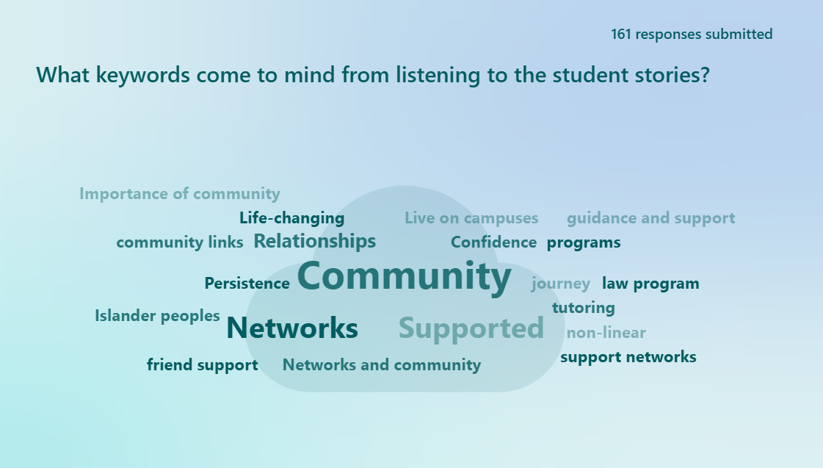

Attendees were then moved into small groups (in-person and via breakout rooms on Zoom) and were asked to reflect on the following questions:
- What is currently happening at your institution/provider to support Aboriginal and Torres Strait Islander students in pathway programs? Our focus is on courses with curriculum that provide foundational skills for students who do not meet the requirements of university or a particular degree. What could be improved?
- What data is being collected at your institution/provider about Indigenous students in pathway programs and the links to university completion? Where is the data being stored?
Each group then returned to the main group and shared their perspectives briefly in a larger discussion. Participants were also asked to share their responses and thoughts into a Padlet (online virtual bulletin board), which was organised according to the discussion questions.
Attendees were then moved into another small group activity and asked to provide feedback on the proposed strategies developed as part of the project and asked to answer the following questions:
- Do you have suggestions for how the draft strategies could be revised/improved and/or additional strategies that could be included?
- How will we know if these strategies are working? Consider the qualitative or quantitative data that you might want to collect/analyse. What are the barriers/obstacles to building a base of evidence for your work?
- What is one thing you can do when you return to your institution/provider to improve the experiences of Indigenous students?
- What additional resources would be useful to boost institutional/provider capacity to support successful enabling or pathway programs that meet the needs of Indigenous students?
Each group returned to the main group and shared their perspectives briefly. The feedback was collated and then used to further refine the suggested strategies.
The following section describes the data collected as part of the research.

Qualitative data collection: Interviews
The qualitative part of this project involved in-depth interviews with Indigenous graduates, university students, and pathway program students from three universities, and staff who teach and support Indigenous students in pathway programs. Table 2 presents the categories of participants types and number of interviews per category. The purpose of these interviews was to explore success factors of pathway programs, areas to improve pathway programs to support Indigenous student success, and potential links to university completion. Interviews were undertaken online (via Zoom), by telephone, or in person. Informed consent was obtained from participants, and interviews were audio recorded with their permission. The semi-structured interviews were 30–60 minutes in length. Table 3 presents the overall participant type and number of people involved from each university.

Table 2: Participant type and number of interviews
Participant type | Interview
Staff | 25
Graduates | 6
University students | 17
Current pathway program students | 2

Table 3: Participant type and number of interviews per university
Participant | A | B | C
Staff | 13 | 8 | 4
Graduates | 1 | 3 | 2
University students | 8 | 6 | 3
Current pathway program students | 2 | 0 | 0

Qualitative data analysis
All recorded interview data was transcribed by a professional transcription service and de-identified with names, locations, and institutions replaced with pseudonyms. The transcripts were then imported into NVivo 12. Line-by-line coding was conducted with each transcript to enable initial themes to be identified from the data. The themes were then repeatedly examined and analysed for consistent themes and sub-themes. This process was complemented by reflective journals that involved interrogating and examining the themes. The themes identified in the data were shared with the project team and the reference group at the second reference group meeting, the focus of which was to receive feedback on the data and themes presented.

Quantitative data analysis and collation
Admission and student outcome data for Indigenous students from the Department of Education’s Higher Education Statistics collection, based on publicly available reports on applications, offers, success, retention, and completion, was requested. Data from three selected universities (labelled hereafter in tables and figures as “selected”) was included in the project and compared to national data collated from the same dataset. All data was collated and analysed in Excel.

Limitations
There are inevitably some methodological limitations to this research. The qualitative aspects of the research involved Indigenous graduates, university students, current pathway program students, and staff being asked for their views based on their experiences—and these responses are by nature subjective. Many of the key staff across the university sites used their personal and professional networks to identify eligible participants for the study. As a result, many of the Indigenous graduates, university students, and current students who participated in the research had a strong relationship with their university Indigenous centre/unit. Therefore, we were less likely to capture the experiences of Indigenous students who did not interact or interacted very little with the Indigenous centre/unit at their university. It was difficult to recruit Indigenous graduates because after leaving university they could only be contacted via their university email, which many did not use. Each of the three university sites were originally considered case studies for comparative purposes; however, due to the small sample, we have analysed the themes in the data across the three university sites rather than comparing them. In addition, while the team recognises that financial support/scholarships, and intersectional factors such as gender, parenting, remoteness, or disability could contribute to key success and/or inhibiting factors, these were outside the scope of the project. In relation to the quantitative data, several limitations prevented more rigorous exploration of the effectiveness of Indigenous student pathways into and through undergraduate degrees. It appears that the “basis of admission” categorisation has not provided sufficient granularity to account for the complexity of pathways into university. While recent steps have been taken to add granularity to this data (“HE [higher education] enabling” has been recorded as a distinct “basis of admission” since 2020), it appears that basis of admission may still be too blunt an instrument to account for the often-complex nature of student pathways through and engagement with university study.
However, the wider body of knowledge regarding Indigenous student completion and student success—consisting of other research, both national and international—also informs the findings included within this report. Care has been taken to ensure that findings derived from quantitative and qualitative interview data are also supported by other research and/or other relevant data. Therefore, it is reasonable to assume that these findings are generally transferable to the wider context of success factors of pathway programs leading to transition into and through university to completion for Indigenous students.

Findings
This section presents the findings in three main sections: graduate and student interviews, staff interviews, and quantitative findings.

About the programs
As noted, a diverse range of pathway programs are offered, with different content, lengths, and delivery. Three pathway programs were included in this project (see Table 4). Program A is offered by a private provider situated on the campus of University A. It has been operating in its current form since late 2021 and is a 30-week free program, open to all domestic students, and develops core academic skills. It is designed for students who are 18 years or older or have completed year 12 but not achieved their desired ATAR. Program B is an Indigenous-specific three-week intensive residential program. There are no costs associated with the program for students, and the program introduces students to university life within a culturally inclusive environment. The program aims to prepare students for a degree and assist Indigenous students to understand what to expect as a university student. At the completion of pathway program B, students are either offered a place in a degree at University B or encouraged to enrol in a further year-long pathway program at University B. Program C is an Indigenous-specific pathway into a degree, with a total length of 3.5 years. The first year is a foundational year to assist students to meet the prerequisite for the degree and the program includes the option of an exit diploma after the first year.
The project team also interviewed several students who had participated in TAFE programs before transitioning to university, as noted with the interview quotations below.
Table 4: The programs
Program | Length | Students | Description
Program A | 30 weeks | Open to all domestic students | Develops core academic skills
Program B | 3 weeks | Indigenous-specific | Introduces students to university life within a culturally inclusive environment
Program C | 3.5 years | Indigenous-specific | First year is a foundational year to meet the prerequisites, with the option of exiting with a diploma after the first year

Examples of student pathways
Graduates and students who were interviewed for the project had diverse and often non-linear pathways into and through university. For example, as illustrated in Figure 2, University A Student 4 left school in year 11 and then attended TAFE. They later undertook Pathway Program A but did not achieve the required results to gain entry into university. They then attended TAFE again and transitioned to University X and later transferred over to University A.
Figure 2: University A Student 4’s pathway into university
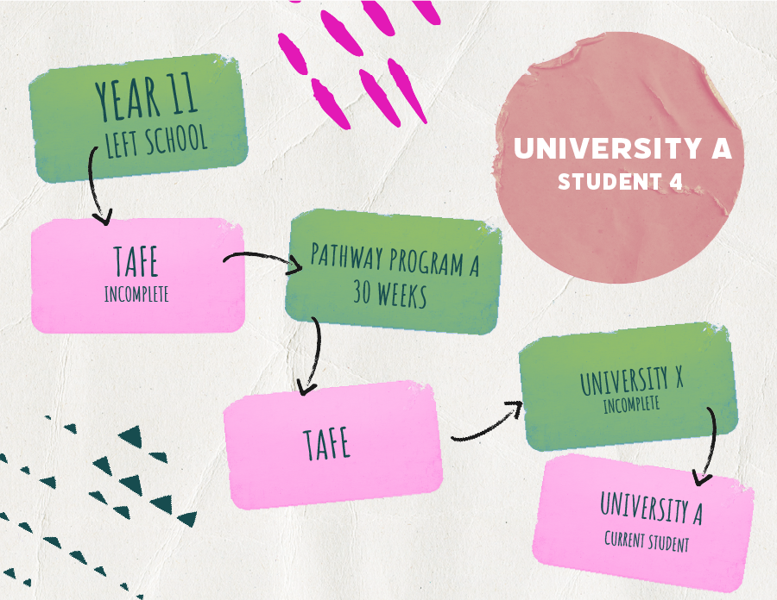

As illustrated in Figure 3, University B Graduate 1 participated in two outreach programs while at school and then attended Pathway Program B. They then undertook a one-year diploma at University B and transitioned into a double degree, which they completed in six years.
Figure 3: University B Graduate 1’s pathway into university
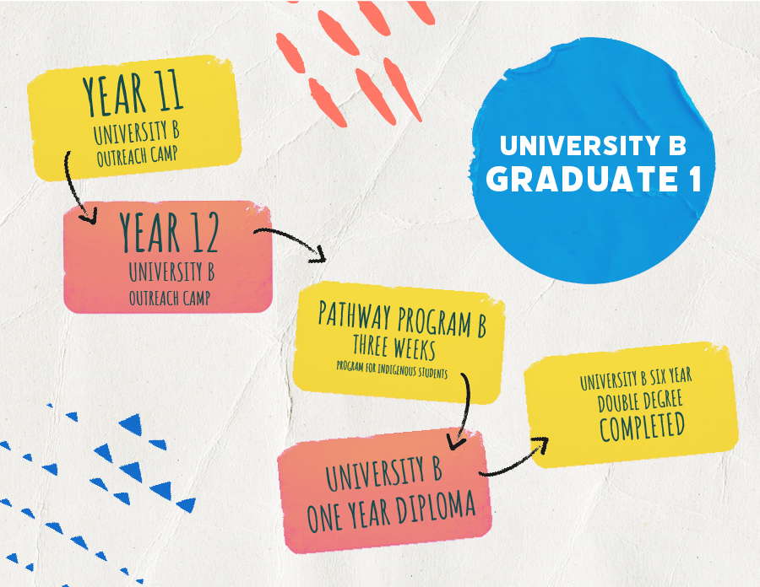

These student pathways, and many others of the graduates and students interviewed, demonstrate that student pathways are often long, winding, and complex.

Qualitative interview findings

Graduate and student interviews
Six Indigenous graduates, 17 current university students, and two current pathway program students from across three universities were interviewed as part of this study. Four of the graduates/student participants had not completed high school, nine had entered into the pathway program after completing high school, seven had an extended break between high school and the pathway program, and five had partially completed a degree before attending the pathway program. Five students who had gone to TAFE before university were also interviewed.

Themes in the graduate and student interview data

Graduate and student perspectives on success factors of pathway programs
Graduates and students discussed a number of success factors of pathway programs and potential links to support university completion, and these are detailed below within the following themes:
- connecting with peers
- connecting with staff
- connecting with the Indigenous centre/unit
- ITAS.
The importance of connecting with peers was highlighted by many graduates and students as an important factor for their success within the pathway program and an important factor in their success at university. University programs B and C are offered specifically for Indigenous students and often have quite small cohorts. This was spoken positively about by interviewees particularly when universities continue to be, at times, culturally unsafe spaces for Indigenous students:
You still encounter a little bit of just racism and [a lack of] cultural safety. Having that little community of mob, just who are going through the same experiences and are strong within themselves is just really supportive and uplifting to see, even for yourself. (University C Graduate 2, attended Program C)
It just makes such a difference, like cultural safe friendship when you’re learning and trying to get your head around topics. (University B Student 3, attended Program B)
Because we had a cohort of only, let’s say eight people going through at once, we were a really, really tight-knit group. So, I think that we really bounced off of each other and leaned on each other for when we were learning concepts that [we] hadn’t heard of before. (University B Graduate 3, attended Program B)
Many of the connections Indigenous students made with their peers during the pathway program continued into their degree, which they viewed as an important factor in their success at university:
Definitely the cohort, they’re making it a safe space for us all. There was lots of time for building those connections that were maintained, and I know a lot of them are still friends and still catch up. (University A Student 1, attended TAFE)
So we actually organised to meet on the first day of uni in person, so then we all met and we all had the same classes so it was really good to carry that connection, and they’re all still in my classes today and like we’re all still best friends so it’s really nice to have that. (University B Student 1, attended Program B)
I still have friends from my [pathway program] course that are doing law and social work and education and I got a really deep connection with them. (University B Student 2, attended Program B)
This aligns with Raciti et al. (2018) who found that Indigenous university students often felt a strong sense of belonging “to the group of Indigenous student peers” rather than the “university entity as a whole” (p. 32). Many students and graduates spoke about the connections they made with staff within pathway programs:
The teachers are really mindful. A lot of them they’ve either worked with people who hadn’t finished high school or they come from backgrounds themselves where they had alternative entries into university. (University A Student 3, current Program A student)
They treated you like an equal. They didn’t belittle, they didn’t do anything like that because if you didn’t understand there was … and then that … there was that many resources for you. If you didn’t understand for them to come see them privately. (University A Student 5, attended Program A)
The fact that we had the best of the best, and these were people who were genuinely interested in us succeeding, just made it so much easier than it could have been. And I think also the willingness, their willingness to provide extra time, first time probably being treated as an adult. (University B Graduate 3, attended Program B)
Graduates and students also discussed how these connections with staff often continued into their university studies:
I still have my connection, my teacher from [Program B], who I still talk to about anything throughout my masters, if I’m having any struggles … having that go-to person throughout the journey is really nice. (University C Graduate 2, attended Program C)
I know that if I ever have a problem with my bachelor, I can always come back to those teachers that I did [Program A] with because, yeah, that’s the personality that they have. They’re all really, really nice. (University A Student 5, attended Program A)
A bunch of the teachers I had in [Program C], I still see them around. I still say hi to them, and they still come to me with any opportunities they think I might like. (University C Student 2, attended Program C)
The Indigenous centre/unit on campus was another key success factor discussed by graduates and students. A number of interviewees discussed how important having this space was to connect with Indigenous peers while undertaking the pathway program and through their degree:
It was a place where everyone would congregate. I guess it was very much like a good place, whether you just want to yarn or study or anything that, anything was available with other people. (University C Graduate 1, attended Program C)
I met this young fella who was doing the program as well. We used to meet at the unit and do extra study … I think a lot of that’s the support that I got from the unit, and also the other students, because we worked together and really supported each other through finishing our courses. (University A Student 8, attended Program A)
I’m basically there every day. I think it’s one of the only places on campus where I will hang. I think it’s nice to have our own space on campus where you can just talk to other Indigenous students; I think it’s just a very relaxing kind of safe space… I’m always there. (University B Student 4, attended Program B)
The facilities of the Indigenous centre/unit (including study spaces, printing, and food provided) were also discussed by a number of graduates and students as important for their success within the pathway program and as they continued their pathway into a degree:
The [Indigenous centre/unit] had computers, printing, you know, toaster, kettle, and just staffing there that at any given time you walk in, they stop what they’re doing and they come out to sort of talk to you. So that went a long way. I dare say it probably stopped me from pulling out a few times, definitely. (University B Graduate 2, attended Program B)
There’s computers and stuff available, there’s quiet spaces, a little canteen and there’s all this stuff that’s there available to you. (University A Student 6, attended Program A)
They did a lot of lunches at the Indigenous centre … so they had us getting really familiar with that centre and really pushed us to come and visit there and study there and they were like, this is your space. (University B Student 2, attended Program B)
In addition, the important role of ITAS administered by the Indigenous centres/units was also discussed by students and graduates as being particularly important, both with pathway programs and for the successful completion of their degrees. Numerous students and graduates noted how useful it was if the tutor was also an Indigenous student who had undertaken a similar pathway:
Having a tutor that was also a student … you get to look at them and see that’s where you want to be at some point, or that’s not where you want to be, and get a bit of a feel about what that, what the next steps would be like. (University C Graduate 2, attended Program C)
I think most notably through the tutoring, because they had Indigenous tutors. That connection point was the strongest there when they did tips and tricks in terms of how to get through … I had an Indigenous student that was always doing really well. (University B Student 7, attended Program B)
There was a … student that had already matriculated into their undergraduate degree, they helped me out with understanding how to structure assignments, paragraphs … getting my head around that sort of business. (University A Student 6, attended Program A)
This illustrates the importance of ITAS to support Indigenous students to succeed at university (also see Enciso, 2025; Lydster & Murray, 2019a; Wilks et al., 2017), alongside the importance of Indigenous centres/units more generally in providing a safe space that builds a sense of community and belonging for Indigenous students to pathway into and through university to completion.

Graduate and student perspectives on what could be improved to strengthen pathway programs
Four themes discussed by graduates and students as areas to improve pathway programs to support students to transition into and through university are examined below. They are:
- the need for more mentoring opportunities for pathway program students with graduates/students
- the need for more Indigenous perspectives in the curriculum within pathway programs
- the need for more Indigenous staff in pathway programs
- the need for further outreach into schools.
The need for more mentoring opportunities for Indigenous students in pathway programs was highlighted by numerous graduates as something that should be improved in these programs. Graduates and students spoke about the potential of connecting beginning pathway program students with Indigenous university students who have come through that pathway to support Indigenous student success and completion:
If you could re-engage students that have gone through the [pathway program], Indigenous students, who have now matriculated and they’re doing their undergrad degree, get them getting that knowledge back in there. (University A Student 6, attended Program A)
That would … give the other students an accessible outlet if they needed extra support. (University C Student 2, attended Program C)
A buddy, I think … something, you know, that’s very unofficial and organic and just literally finding the right people to be a buddy, that’s the most important part. And then just giving them someone to connect with and say, “You know, this is your buddy, they’ve been here for a couple [of] years”. (University B Graduate 2, attended Program B)
The importance of mentoring and nurturing Indigenous students is also highlighted by Best and Stuart (2014) as a significant element to ensure the success and graduation of Indigenous students.
While many pathway programs are making a concerted attempt to embed Indigenous perspectives within the curriculum of their programs, some students and graduates did acknowledge that more could be done to embed Indigenous perspectives:
The positioning of this curriculum coming from that sort of Western framework in the first place, it’s harder to try and implement Indigenous knowledges into that when it’s already coming from that framework. So that’s a more institutional problem, though, and I don’t know how to answer that question in terms of systemic change in our universities, but that’s also something that’s really important to address. (University C Graduate 1, attended Program C)
I think programs or subjects [with more Indigenous perspectives] included in such a program would be really beneficial because obviously [Indigenous students] can relate to it and it’s also something that they would most likely be passionate about. (University A Student 3, attended TAFE)
I came from a family who [sic] isn’t very connected to their culture due to just displacement from that. And I think something that I would’ve liked to have seen [the university] … facilitate that connection of culture with the local land councils and mob because I feel like I’ve had to facilitate that myself, [but] I think it would’ve been a good thing for the [pathway program] to have done more. (University C Student 3, attended Program C)
This highlights the importance of including Indigenous perspectives in the curriculum of diverse degrees. As Fredericks et al. (2015) point out, learning content in university contexts often “reflects very little, if any, Indigenous perspectives” (p. 1). Paige et al. (2016) argue that “culturally responsive pedagogy” (p. 26) is needed to support Indigenous students’ learning outcomes and provide examples of engaging with Indigenous knowledges and cultural contexts in teaching and learning.
Linked with the embedding of Indigenous perspectives within pathway programs, some graduates and students spoke about the need for more Indigenous staff working within the programs, both as teachers and as support staff:
None of the teaching staff that we had were First Nations people, and being the Western institution that it is, everything was taught in that sort of Western style. That’s just how it was. (University C Graduate 1, attended Program C)
[If it could be] taught by Aboriginal academics … then people would really value their time and are going to really look up to these people who are teaching in the classroom. And that’s also going to hold people accountable throughout the duration of an enabling program. (University B Graduate 3, attended Program B)
You need an Indigenous support person over there … you’re over there by yourself, you need someone to be there, an Indigenous person over there working. (University A Student 2, attended Program A)
The need to build the numbers of Indigenous staff across universities, including within pathway programs, is a key goal of the Universities Australia Indigenous Strategy 2017–2020 (UA, 2017). Certainly, the recruitment of and nurturing of Indigenous staff is also highlighted in the literature as vital to improve Indigenous student higher education access and success (for example, Andersen et al., 2008; Page & Asmar, 2008; Povey et al., 2023).
The role of outreach into schools was also discussed by some graduates and students as important to ensuring Indigenous students are aware of pathway programs as an option:
I think there needs to be better community engagement, especially [at] our year 10 level and above to promote these pathways into university. (University B Student 4, attended Program B)
So my school … [there] was little to no discussion on [pathway] courses as it was because it was considered, you go straight to a higher tertiary institution … let students know that even if you don’t get in on your first go, if you’re passionate, persistent enough, determined, there are other options that will allow you to get into uni … Like I said, my school didn’t inform me of these programs. (University A Student 3, attended TAFE)
I feel like in even advertising it more in communities so that it’s a known thing to them because in their heads it’s more … because a lot of them don’t finish school and I’m saying that because I’m from an Aboriginal community, a lot of them don’t finish school and they don’t think that they have [options]. (University A Student 5, attended Program A)
Overall, students and graduates spoke about the important role of peer and staff connections within pathway programs, which often continue through their university degrees. They also spoke about the important role of Indigenous centres/units in providing a sense of community and belonging and the importance of the physical space of Indigenous centres/units, providing food for students, and building relationships between staff and students. The role of ITAS in supporting Indigenous students in pathway programs and to complete their degrees was also highlighted by the interviewees. Students and graduates indicated the need to build the numbers of Indigenous staff within pathway programs, increase mentoring opportunities, increase and strengthen Indigenous perspectives in pathway program course content, and improve outreach into schools so that students are aware of pathway programs as an option.

Staff interviews
Twenty-five staff from across three universities were interviewed as part of this study. Twenty of the staff identified as non-Indigenous and five of the staff were Indigenous. Seventeen were teachers within programs A, B and C, four were support staff working with Indigenous students in pathway programs, and four were pathway program coordinators.

Themes in the staff interview data

Staff perspectives on success factors of pathway programs
Staff discussed a number of success factors of pathway programs that support Indigenous success and transition into and through university and these themes are detailed below. The themes are:
- connections with peers
- Indigenous perspectives in the curriculum
- connections to the Indigenous centre/unit
- learning opportunities for staff to be culturally competent.
Like many of the students and graduates interviewed, staff noted the importance of Indigenous students connecting with their Indigenous peers within pathway programs, particularly in programs B and C, which are Indigenous-specific programs with small cohorts of Indigenous students:
Indigenous students seem to do better when they have friends in class and you want to have little table groups and present opportunities for them to kind of demonstrate their knowledge to each other ... When we’re able to create those kinds of environments where people have a chance to make friends, make connections, those ones tend to ace it. (Staff 2, Program B)
The small groups are really good for retention, I think. The students work together a lot and they get to know each other really well and they have a really good cohort experience. (Staff 2, Program C)
I think the relationships we build in [Program B] and that they build with their peers, with [the Indigenous unit/centre], and with the staff is absolutely vital. It means they’ve got lots of touch points … [in Program B] those friendships, the students made their friends there. (Staff 6, Program B)
However, staff in Program C did note that because the cohort in Program C is such a small group (5–10 students), this cohort model is not always successful if students do not make connections with their peers and students can also feel under surveillance:
I’ve had students that never really gelled, would sit at different tables, not really talk to each other, and I feel like they haven’t gone so well … There’s also the concern that because they’re so small, they’re overly checked in on, and that can also sometimes be a concern that they’re over-surveyed. (Staff 3, Program C)
It doesn’t always work. You have a small cohort and these people could be very, very different from each other. We’ve had a year or so where students come into the room and they don’t dislike each other, but their natural tendency is to all sit at separate tables. So you’ve got five students in the room sitting at five separate tables. (Staff 1, Program C)
Similar to the students and graduates, staff talked about how key including Indigenous perspectives in the curriculum is to ensuring that Indigenous students have an optimal experience in the pathway program and create a sense of connection with the curriculum and with their own identities:
Indigenising curriculum is I think a really key part for all of our students … we’re focusing now on making changes to the next step with our curriculum, and looking at trying to embed minimum Indigenous perspectives into the program objectives, so I think having something like that really, then, so it’s more explicit in our program objectives … We can make it work everywhere. (Staff 1, Program A)
There’s a real, conscious effort to try and be aware of how we can adapt and change and even include in our curriculum more about Aboriginal and Torres Strait Islander culture. (Staff 12, Program A)
Indigenising the curriculum is absolutely key. And making sure that it’s Aboriginal and Torres Strait Islander experts that are coming in to teach around that and for us. (Staff 6, Program B)
Non-Indigenous teaching staff in the three pathway programs discussed the ways in which they are embedding Indigenous perspectives in the curriculum, including through co-teaching with Indigenous people, and the benefits of this for Indigenous students to support their learning and affirm their sense of identity and place within the university:
The co-teaching with Indigenous people … so there is Indigenising of curricula happening and it’s happening in a lot of different ways. So those kinds of approaches are done in the bigger [pathway program] subjects … A couple of weeks ago I had an Elder come into one of my classes and we were learning about combustion reactions … we talked about the chemical reactions that are going on but also how [Aboriginal] people use fire for landscape management and those kinds of things. (Staff 2, Program C)
Making sure that we’re engaging/employing Aboriginal and Torres Strait Islander experts in different fields, to design and teach, to weave through curriculum, not add on at the end. (Staff 6, Program B)
To provide these Aboriginal and Torres Strait Islander students with that kind of very positive cultural support, very early on, I think gives them a little bit more of a kind of buffer against that imposter syndrome or that feeling like they don’t belong. (Staff 8, Program B)
Linked with the importance of Indigenising the curriculum, staff also highlighted the importance of non-Indigenous teaching and support staff within pathway programs building their cultural capability to work with Indigenous students. All three programs actively attempt to educate and provide professional development to ensure staff are culturally capable in working with Indigenous students and to Indigenise the curriculum:
We’ve always got seminars, symposiums, we’ve brought in many Aboriginal and Torres Straits Islander people across a range of nations, ages, expertise, experience, and so forth … lots of opportunities from external courses, but also with a lot of our conferences and so forth, we’ll bring in different Indigenous specialists in relation to their disciplines. (Staff 6, Program B)
So [Program C] has run cultural competency workshops and so I’ve done three of those. (Staff 2, Program C)
There was a PD [professional development] workshop that was focused on understanding cultural communication, understanding culture as a journey of learning. Recently I went to the NAIDOC [National Aboriginal and Islanders Day Observance Committee] week lecture about reflections on the referendum … Earlier in the week there was an Indigenising curriculum meeting. (Staff 4, Program B)
Similar to students and graduates, staff also emphasised the importance of Indigenous students in pathway programs connecting with the Indigenous centre/unit at the university:
I think having [the Indigenous centre/unit] there, that’s probably the most important of all, to be quite honest. Just the space where people can go and feel comfortable, and they can talk about things ... I think that’s perhaps one of the most important things. (Staff 3, Program B)
We’ve got our [Indigenous] centre here where I think our students hang out there a bit and I’ve noticed … one of the key things that I see as being helpful for the students and helping them to progress further is having a sense of, kind of, cohort or a sense of community amongst themselves … they’re so important, and that’s the feedback I get from the students. (Staff 4, Program C)
A big part of it is just making students feel welcome and feel like they’ve got a place to be and … it might feel a little bit isolating. So, you know, bringing [pathway program] students into the [Indigenous centre/unit] is a big thing. (Staff 10, Program A)

Staff perspectives on what could be improved to strengthen pathway programs
Three themes discussed by staff as areas to improve pathway programs for Indigenous students are examined below:
- more Indigenous perspectives in the curriculum
- more data on student pathways and tracking students
- more training for staff to ensure cultural capability.
Like many of the Indigenous students and graduates interviewed, staff discussed the need for more Indigenous perspectives in the curriculum of pathway programs:
I think it would be beneficial if we could add more Indigenous knowledges into the curriculum and [that’s] something that we’re actively looking to doing. (Staff 4, Program B)
Sometimes it’s difficult when our … staff don’t have an understanding that the very epistemology is different. They make assumptions about how things will just transition over. (Staff 12, Program A)
It’s very early days, but an active attempt, I should say, or goal, to embed more Indigenous knowledges just within every kind of subject matter where possible. That’s really the beginning stages. (Staff 3, Program C)
Staff also highlighted the need for better data gathering in relation to Indigenous students’ experiences and pathways and the need for better tracking of students so that timely support can be provided and programs can be continually improved:
It’s hard to get hold of outcomes data for these programs … It is really hard to get info about the data of places and institutions aren’t very good at keeping data. (Staff 1, Program C)
I would want to say I think it’s effective and I know I’ve seen some students go through and they’re doing great things and they’re going and getting awards and doing great things. But it’s not something that I’ve looked at the hard data. So it’s hard to tell. (Staff 4, Program B)
What I didn’t know is that there’s actually a heap of students who’ve done the pathway program and I found a whole heap of them last year when I was working with [person’s name] at [Program A] about, you know, trying to uncover this data … no-one knew where to look for it. It was actually always there. (Staff 10, Program A)
Having a better student management system that, actually, that is fit for purpose. I don’t think it’s fit for purpose … having a better up-to-date system for our learning, support, and learning advisors so that they can provide timely support. (Staff 1, Program A)
The need for further tracking of students aligns with Nakata et al. (2019) who note the importance of “monitoring and following up on student educational needs and progress” (p. 5). However, at the same time, a staff member from Program B noted the importance of “protecting student data and not over-communicating so these students aren’t overwhelmed with things like that” (Staff 5, Program B). This highlights the importance of working closely with Indigenous expertise in monitoring and evaluating data to strengthen evaluation processes.
Staff also noted that, while there were learning opportunities in each of the programs for staff to improve their cultural capability, more training could be done to strengthen this:
I feel like we will probably need further training to assist those students … I think it’s something that we would need to be trained on as staff … as a teacher. (Staff 8, Program A)
I feel like the next process will be also to expand the teaching for staff. Because there [are] more and more course design meetings where a member of that team will come in if there is Indigenous content and teach the facilitators or whoever will be, it would be fortuitous if facilitators know how to conduct that class in a culturally safe [way]. (Staff 8, Program B)
I think it’s been more self-education ... It’s more us having to drive it from inside than having had it offered by the institution. (Staff 1, Program C)
Overall, staff spoke about the importance of Indigenous students connecting with their peers and the important role of Indigenous centres/units in providing safe spaces that provide students with a sense of community and belonging. The role of Indigenous perspectives in the curriculum and creating learning opportunities for staff to be culturally competent was also highlighted by staff. Like the graduates, staff indicated the need to increase the focus on Indigenous perspectives in university course content and improve data gathering and student tracking to ensure programs can be continually strengthened and improved, as well as the need to improve cultural competency training of staff and students to strengthen Indigenous student completion rates nationally.

Quantitative findings
The following sections use data from the Department of Education’s Higher Education Statistics collection. The intention of the analysis was to provide a broader context for the selected programs and to investigate the programs’ effectiveness in providing opportunities to navigate into and through university. Upon commencement of the analysis, it became clear that several limitations of the available data would prevent valid in-depth statistical analysis within the scope of the current project. While an analysis of the effectiveness of the selected programs was not possible, the following sections provide broader context for the programs and point to directions for future evaluative research.

Progression through application, offer, enrolment, and retention
Figures 4, 5, and 6 represent an overview of the number of applications, offers, enrolments, and retained Indigenous students at the three selected universities for cohorts between 2010 and 2018. The collation of student numbers at these four points of the student lifecycle provides initial insights into trends in Indigenous student participation and success at the selected institutions, to be unpacked further in the following sections.

Figure 4: Collation of numbers of Indigenous applications, offers, enrolled students, and retained students, University A, 2010–2018

Figure 5: Collation of numbers of Indigenous applications, offers, enrolled students, and retained students, University B, 2010–2018

Figure 6: Collation of numbers of Indigenous applications, offers, enrolled students, and retained students, University C, 2010–2018

Applications, offers, and offer rates
Figures 7–9 show trends in applications and offers at the three selected institutions between 2010–2021. Data from 2019–2021 include Queensland Tertiary Admissions Centre data. Figure 7 shows the number of Indigenous students applying to an institution as their first preference. Figure 8 shows the number of students offered a place, regardless of student preference. Figure 9 shows the offer rates, calculated as the number of offers as a percentage of the number of applications.
Figure 7: Indigenous applications to selected universities, 2010–2021

a: Includes Queensland Tertiary Admissions Centre data.
Figure 8: Offers to Indigenous students from selected universities, 2010–2021

a: Includes Queensland Tertiary Admissions Centre data.
Figure 9: Ratio of offers to applications, expressed as a percentage, at selected universities and a national average, 2010–2021

a: Includes Queensland Tertiary Admissions Centre data.
As shown in Figures 7 and 8, the number of applications and offers have increased over time, demonstrating an increase in participation at all three institutions. Figure 9 shows that while the offer rates of Universities B and C have remained between approximately 60% and 70%, the acceptance rate for University A has gradually increased over time to approach the national average of 80% in 2021. The data suggests that while approximately one in five Indigenous applicants do not receive undergraduate offers across the sector, this number is higher in the selected universities. While the precision of this finding is limited by the inability to account for later preferences in applications, it still highlights the need for pathway programs that provide further opportunities for undergraduate access and success.

Basis of admission into undergraduate degrees
The following section provides an initial exploration into the use of basis of admission data to inform discussions of pathways into university for Indigenous students, and points to the need for further analysis upon the release of the next round of data from the Department of Education.
Table 5 identifies the descriptors of the basis of admission identified for Indigenous students at the selected universities, as well as the labels given for each category in Figures 10, 11, 12, and 13.
Table 5: Department of Education descriptors
Department of Education descriptor | Label (Figures 10–13)
An enabling or bridging course delivered by a higher education (HE) provider (complete or incomplete) | HE enabling
Higher education course (Australian or overseas equivalent; complete or incomplete) | HE course
Other basis | Other
Secondary education (Australian or overseas equivalent) | High school
VET award course or VET-delivered enabling or bridging course other than a secondary education course (Australian or overseas equivalent; complete or incomplete) | VET or other course
Work and life experience/mature age/professional qual | Work and life experience

Basis of admission trends
Figures 10, 11, and 12 show the Equivalent Full-Time Student Load (EFTSL) count of Indigenous students entering undergraduate studies separated by basis of admission categories, between 2010 and 2022.
Figure 10: EFTSL by basis of admission, University A

Figure 11: EFTSL by basis of admission, University B

Figure 12: EFTSL by basis of admission, University C

As shown in Figures 10, 11, and 12, pathways for Indigenous students appear to vary between institutions. Whereas the majority of students entering University A are school leavers, alternative pathways are more commonly used by Universities B and C.
Unfortunately, the number of students accounted for by the new category instituted in 2020—"An enabling or bridging course delivered by a higher education provider (complete or incomplete)”—means that further analysis on enabling programs is not yet appropriate. However, it is hypothesised that the inclusion of this new category is likely to affect the number of admissions based on the “Other” category, allowing for more granular analyses in the future. Unfortunately, categorisation of enabling (and other) programs whether “complete or incomplete” will limit the validity of analyses seeking to evaluate the effectiveness of completing such programs.

Success rates
Figure 13 shows the success rates of Indigenous students according to their basis of admission. Success rates may provide preliminary data to help evaluate the effectiveness of pathways to prepare students for studies.

Figure 13: Success rates by basis of admission

As identified above, only a small number of students have been categorised as being admitted on the basis of a HE enabling program, limiting the validity of statistical analyses comparing enabling pathways to others on the basis of this data. Upon the release of more recent data, the sector is likely to benefit from further exploration of success rates (as well as retention and completion rates) between bases of admission. Furthermore, analysis within the HE enabling category of admission would provide empirical foundations for evaluation of the effectiveness of pathways to prepare students for their transition into undergraduate degrees.

Discussion
The universities focused included in this project have higher Indigenous student completion rates than the national average and utilise a range of strategies to support Indigenous students in pathway programs to transition into university and complete their degrees. The students who attended the pathway programs at the three selected universities also have specific characteristics. The previous section discussed the findings that emerged from the research based on data derived from qualitative and quantitative sources. To identify success factors of pathway programs for Indigenous students and potential links to transition into and through university from a range of perspectives, interviews were undertaken with Indigenous graduates and students and with staff who teach and/or support Indigenous students in pathway programs. In addition to the interviews, a pilot analysis was undertaken to understand data requirements to analyse admission pathways, enrolment rates, and student outcomes for Indigenous students across the selected universities over time and in comparison to those across the sector. As a result, the research project obtained rich findings. This section brings together these findings with the relevant literature to explore the overarching themes in the data.

Student characteristics: Persistence and determination
As Pechenkina et al. (2011) highlight, “student characteristics have a major effect on completion rates, which is likely to be equally or perhaps more important than the level of support offered” (p. 65). Certainly, it is important to note that Indigenous students are a “distinct but quite diverse cohort, with a range of individual interests, behaviours, approaches, capacities, skills, and needs” (Day et al., 2015, pp. 505–6) and, therefore, combining these quantitative findings with qualitative findings from interviews with graduates, students, and staff builds a richer understanding of how Indigenous students at universities with high completion rates pathway in, progress through, and complete their university study. Many of the students and graduates discussed how their persistence and determination were key factors in their successful pathway into and through university. For example, a graduate stated, “I had this certain drive and certain interest to succeed” (University C Graduate 1, attended Program C), while another student said, “I guess my own persistence was a major factor because I knew what I wanted to do and I was really persistent in wanting to get to that point” (University A Student 3, attended Program A). Another graduate noted:
I wanted to prove to myself and not just myself, but to also everyone else around me that I do belong here as much as any high-ATAR achieving student. And I think over time, not just me, but other mob have also been able to show that as well, that whatever ATAR and whatever high school or previous education stuff, it’s not really indicative of the work that you’re capable of doing within institutions like this. (University C Graduate 2, attended Program C)
This aligns with the work of Martin et al. (2017) and Day et al. (2015) who highlight the role of the persistence and determination of Indigenous students at universities. Elsewhere, Walker (2000) also highlights the “personal and interpersonal aspects of student persistence and achievement” (p. 148).

Benefits of pathway programs and potential links to university completion
The qualitative data from graduates and students demonstrates the many benefits of pathway programs in providing access to university. For example, a graduate noted, “The pathway [program] made the university accessible for me … If there was no bridging course available, I wouldn’t have gone to university, and I wouldn’t be where I am now. So I’m immensely grateful for that” (University C Graduate 1, attended Program C). As Nakata and Nakata (2023) point out, pathway programs are central to preparing and transitioning Indigenous students into university. A number of graduates and students also discussed the benefits of pathway programs in introducing them to the expectations of university and also teaching them important skills to succeed at and complete university. For example, graduates stated that it was a “taste of what uni is like” (University B Graduate 1, attended Program B); “It was essentially a trial run for uni” (University B Graduate 2, attended Program B); and “By the time we got to the degree … we were miles in front of the other students in terms of knowing what was expected of us” (University B Graduate 1, attended Program B). As Crawford (2014) points out:
Students who transition from an enabling program … arrive in their first semester of their degree course equipped with generic academic skills necessary to make a smooth start. In addition, they already have support networks (academic and social) with their peers, familiarity with staff in student services, and are adept at navigating the built and online university environments. (p. 26)
This is particularly important for Indigenous students as universities continue to not always be safe spaces, and supporting that transition into and through university is key. As one graduate stated about transitioning into university:
I immediately felt comfortable at uni … even though I don’t even know someone who’s been to a university, I was able to just feel confident straight off the bat rather than, I guess, walking into a foreign environment with 50,000 people running around … I just feel like I was a step ahead of someone who might not have gone through that program. (University B Graduate 3, attended Program B)
This is supported by Fredericks et al. (2017) who also note the important role of pathway programs to “support Indigenous students to navigate the contemporary tertiary education landscape” (p. 199).
Certainly, it is difficult to show the potential correlations between pathway programs to completion, as many different aspects affect student completion. In addition, universities often lack clear data that tracks students in their pathway into and through university. Further, the complexity of government data means that it is often unclear whether specific pathway programs are considered within the fields of “HE enabling”, “pathway”, or “other” categories at specific universities. As Cadby (2025) suggests, there is a need to “create a system that reflects the unique needs of each institution, while harmonising data collection practices” to “ensure all students have the support they deserve” (n.p.). Integration of application/admission and enrolment data would be an important consideration of such a system, to facilitate exploration of the student lifecycle in its entirety.

Long and non-linear pathways
Qualitative findings from the interviews found that many Indigenous students had long and non-linear pathway into and through university. For example, one student noted:
It was a fairly large break for me between leaving school, graduating in 1991, and didn’t enter university until 2020. Between then, leaving school and entering university, I entered the workforce … I did a lot of travelling and working in the Pacific region … and it just really engaged my interest in international relations. So, I decided that I wanted to actually go to university. (University A Student 6, attended Program A)
Another student stated their pathway “was a long one and there was a lot of obstacles and hurdles along the way” (University A Student 3, attended TAFE). Several students interviewed entered in and out of a number of pathway programs before transitioning to university. For example, one student noted:
I dropped out of high school in year 11 and then I went to TAFE for a bit … then I guess in 2020, I enrolled in the pathway program [A] and then I failed that in terms of my overall GPA. Then I went to go to TAFE. (University A Student 4, attended Program A)
Another student had started university but then had a long break and stated the pathway program was “more just … a sidestep. My [first attempt at university] studies didn’t really count being so long ago” (University B Student 2, attended Program B). This long and winding pathway is not uncommon for students more broadly, as transitions into and through higher education, regardless of entry pathway, are not always linear (Bennett & Lumb, 2019), and are often complex and disrupted. As Harrison and Waller (2017) highlight, a student’s journey through the education system is influenced by power structures, economic competitiveness, and personal liberties. This is supported by Shalley et al. (2019) who note, “students can discontinue and re-enter degree courses over time, exit with a different degree type, change their study discipline, change universities within their degree, and change their study intensity between full and part-time, and study modality between internal and external” (p. 1).

The importance of an Indigenised curriculum
The importance of incorporating Indigenous perspectives into curricula has been repeatedly emphasised in higher education reports and policy documents. For example, the Universities Australia Indigenous Strategy 2017–2020 (UA, 2017) acknowledged the inherent value of Aboriginal peoples’ unique knowledge systems. The qualitative findings in this study affirm the benefits of Indigenising the curriculum for Indigenous students within pathway programs. For example, one student noted that including Indigenous perspectives in the curriculum of the pathway program “was just a really good way to help us connect with the knowledges that we were learning through our own cultural perspective” (University C Student 3, attended Program C). Staff also noted the importance of Indigenous perspectives within the curriculum for Indigenous students. For example, a staff member stated, “Indigenising the curriculum is absolutely key. And making sure that it’s Aboriginal and Torres Strait Islander experts that are coming in to teach around that and for us” (Staff 6, Program B). Another staff member noted that Indigenous perspectives within the curriculum can provide students with “a little bit more of a kind of buffer against … that feeling like they don’t belong” (Staff 8, Program B). This is supported by Fredericks et al. (2017) who highlight that teaching staff who worked on an Indigenous-specific pathway program emphasised that including an Indigenised curriculum was beneficial for Indigenous students and affirmed their sense of identity. Further, Martin et al. (2017) argue that effective teaching and pedagogy can be used to support the learning of Indigenous students and make a difference in their retention and success.
The need for further Indigenisation of pathway program curricula was also discussed by students and staff, with an acknowledgement that more work is to be done to ensure Indigenous perspectives are strongly embedded across all areas of a pathway program’s curriculum. As one staff member noted:
Curriculum is definitely an area that we can still work on … I still think the same issues arise, issues such as how do I fit this stuff in? And understanding that it’s not a matter of having to fit it in. It’s already there. You just have to be able to … make those connections there. (Staff 12, Program A)
This highlights the need for further guidelines and best-practice frameworks in relation to Indigenising the curriculum of pathway programs. Elsewhere, Fredericks et al. (2017) call for the development of best-practice guidelines for teaching staff to improve course content in pathway programs for Indigenous students. Certainly, the process of Indigenising curriculum is complex, and numerous scholars have noted the institutional support required and the challenges of poorly taught curriculum that can reinforce stereotypes (for example, Howlett et al., 2013; Nakata, 2007). In the context of pathway programs, Bennett et al. (2022) highlight:
Bridging courses (also known as access or enabling programs) … present complex pedagogical and curriculum challenges in that they cater to a wide range of students, including near-miss direct-entry students, mature-age students, those with disrupted educational backgrounds, and those with a range of equity backgrounds. Key commonalities in these courses are their focus on academic skills development, university acculturation, and foundational disciplinary knowledge. (p. 2)
Therefore, this suggests that context-specific best-practice guidelines could be developed to ensure Indigenous perspectives are strongly embedded in the curriculum depending on the structure, length, and delivery of these programs.

The important role of Indigenous centres/units, peer-to-peer connections, and ITAS
The findings from this study indicate Indigenous centres/units continue to play an important role in supporting Indigenous students in pathway programs and through to completion of their degrees. Comments from graduates and students highlighted the ways in which the Indigenous centre/unit at the university they attended supported them. As one student stated:
A lot of the students that come to university are not from [here], so they’re from other states. So you’re leaving behind your family, you’re leaving behind your friends, and it’s so important to be able to create that new network and that new community of people. (University C Graduate 1, attended Program C)
Staff also noted the impact that engaging with the Indigenous centre/unit on campus has in supporting Indigenous pathway program students to succeed, transitioning into university, and completing their degrees. For example, one staff member noted the importance of “just having that constant face that students can connect to” (Staff 11, Program A).
The sense of belonging, community, and care that Indigenous centres/units provide was particularly highlighted by graduates and students. One graduate stated, “I think just that reassurance and just that genuine care, just made it feel so homely and added to my positive experience” (University B Graduate 3, attended Program B). Another student said, “knowing that people actually care about you, you in general and your success is actually really important” (University A Student 3, current Program A student). Similarly, a staff member noted the Indigenous centre/unit “provides safe places, culturally safe places, for the students to come and feel as though they are very welcome on campus” (Staff 8, Program B).This is supported by Fredericks et al. (2023b) who also found that Indigenous centres/units provide a space where Indigenous students can connect with each other, with staff, and with their own cultural identities, which supports their success and university completion. As Day et al. (2015) highlight, the pastoral and personal care that is offered by Indigenous centre/units “supports Indigenous identities, values, and goals based on the commitment of Indigenous staff to political and cultural tenets of the Indigenous community more generally” (p. 505). The important role of Indigenous centres/units in building a sense of community and belonging is noted in the literature (for example, Andersen et al., 2008; Kinnane et al., 2014; Oliver et al., 2015). Kinnane et al. (2014) also emphasise the role of Indigenous centres/units in providing “a sense of community” (p. 123). Elsewhere, Oliver et al. (2015) argue that “clearly Aboriginal centres play an important role in student completion and are of considerable benefit to students” (p. 29).
Another finding from the qualitative data is the importance of peer-to-peer connections made within pathway programs and particularly through the Indigenous unit/centre. For example, one staff member noted:
[Students] having a sense of, kind of, cohort or a sense of community amongst themselves … they’ve sort of all become close friends and … I see that being really helpful because they encourage each other and sort of keep each other accountable. (Staff 4, Program C)
Students also noted the importance of connections they made with peers within pathway programs, which continue through their degree. For example, one graduate stated, “We’re able to just connect and relate to each … you learn collectively with mob as well” (University C Graduate 2, attended Program C).
The qualitative data from graduates and staff demonstrates the important role of ITAS in supporting Indigenous students to complete their degrees. Many of the graduates and students discussed the impact ITAS had on their pathway program experience and university success. For example, a student noted:
I’ve been using that [ITAS] all the way throughout my degree. That’s really, really helpful. So we sort of got an insight to that as well on [the pathway program] because we had a tutor who would then be registered and then we would be able to meet with them again. (University B Student 1, attended Program B)
Another graduate stated that “having a tutor that was also a student, with mob in my pathway degree, who had also done this subject before me was also really helpful because they really understood where we were at” (University C Graduate 2, attended Program C).
This is supported by Lydster and Murray (2019a) who draw on interviews with staff and students at Bond University to highlight that ITAS is “consistently referred to in a positive light” and has led to “increased confidence amongst students, reduced stress, and improved grades” (p. 140). Similarly, reporting on the perspectives of ITAS tutors and Indigenous students receiving ITAS tutoring in two regional universities, Wilks et al. (2017) note that ITAS tutoring has “enabled many students to manage their transition through university and complete their studies” (p. 14). Further, Nakata et al. (2019) demonstrate that, while Indigenous students may initially utilise the tutoring for what could be considered remedial purposes, they then often start to use the tuition in a far more strategic manner, showing their active roles in seeking knowledge and uncovering the “hidden knowledge” regarding how to develop academically (p. 7; also see Enciso, 2025, for discussion of a tutor’s perspective on ITAS; see Whatman et al., 2008, for analysis of the quality and efficacy of ITAS).

Importance of mentoring between beginning pathway program students and current university students/graduates
The qualitative data from graduates, students, and staff demonstrates the important role of mentoring in supporting Indigenous students within pathway programs and to support their transition into and through university to completion. For example, one graduate spoke about “meeting other successful Aboriginal people from other disciplines all throughout. It was probably the first time … that it was cool to be a blackfella. And it was really celebrated, and it was a real benchmark of black excellence” (University B Graduate 3, attended Program B). A number of students noted that developing further mentoring programs between current Indigenous university students and beginning pathway program students would be beneficial. A graduate stated that “engaging the undergrad [sic] students that have gone through the [pathway program] who are in their second or their final year … that would be brilliant” (University A Student 6, attended Program A). This aligns with Best and Stuart (2014) who found that individual mentoring and nurturing of Indigenous students was an important success factor to successfully graduate Indigenous nursing students at the University of Southern Queensland. While there is much literature on mentoring more broadly, as Povey et al. (2023) highlight, mentoring is not a one-size-fits-all model and is a “complex and raced space” where “individual needs of Indigenous mentees vary” and a “sense of connectedness between the mentor and mentee” is central (pp. 1175–1176).

Conclusion
The three pathway programs focused on within this project are diverse in their delivery, length, and curriculum. Two are Indigenous-specific programs (Programs B and C) while one is open to all domestic students (Program A). However, all three programs attempt to prepare and equip Indigenous students with the skills to transition into and through university. The three universities that this project focused on have strong completion rates compared to the national average. Prior to this research project, the evidence for success factors of pathway programs to support Indigenous students to transition into and through universities was very limited. It is difficult to identify the links between pathway programs and university completion as there are many factors that influence university completion. In addition, it is important to avoid a one-size-fits-all conclusion and consider tailored programs for diverse environments. However, the project was a timely and valuable way of building a stronger evidence base about effective strategies to support Indigenous students within pathway programs and potential links to university completion through a high-impact research project with key stakeholder networks. The findings are valuable to the sector as they have identified a number of success factors that support Indigenous students in pathway programs and serve to inform and strengthen pathway programs to support Indigenous students to transition into and through higher education.
Students and graduates highlighted the many benefits of pathway programs for Indigenous students. Several graduates and students noted that, without the pathway program, their transition to university would not have been possible. For example, a graduate stated that “the pathway [program] made the university accessible for me” (University C Graduate 2, attended Program C). Many of the students and graduates interviewed had very long, non-linear pathways but a number of graduates noted they would not change this because of the skills, experience, and knowledge they gained. For example, one student stated:
If I had the chance to go back and either do the [pathway] program again and then go into [university] or go straight into [university], I would still probably choose the pathway program because it just gave me a few more skills and more knowledge to get me ready for [university] considering how prestigious [the university] is. (University A Student 2, attended Program A)
Similarly, another graduate noted:
Now that I am where I am now, I wouldn’t have changed a thing. For me and my own journey, I had to take the amount of time that I had to take … And I can’t compare myself to others, who maybe figured it out more quickly, or didn’t take as many twists and turns. (University C Graduate 1, attended Program C)
The benefits of pathway programs were strongly expressed by graduates and students in terms of preparing them for university, demystifying university expectations, and building a sense of belonging within university. For example, one student stated, “I think it prepared me really, really well for the main degree. Like, I still use all the techniques I learnt on the [pathway program] now when I’m writing my assessments … I think it was an easier transition” (University B Student 1, attended Program B). Another student highlighted that the pathway program assisted with the transition into university:
It’s a very daunting place, the uni. It’s very big, there’s so many people here. I think I was just lucky enough to … slowly walk into the uncertainty of it all. I knew where I was going, I knew my way around campus. I knew who I could go to. I knew what the content was going to be like. (University B Student 6, attended Program B)
The importance of Indigenous centres/units as safe spaces where Indigenous students can experience a sense of community and belonging was highlighted in interviews with graduates, students, and staff. Further, the role of ITAS as an important tutoring mechanism in supporting Indigenous students to complete their degrees was discussed by a number of graduates and students. Strong peer-to-peer connections and staff–student connections also were highlighted as particularly important to ensure students’ success within pathway programs and to support their transition into and through university. Linked with this, the role of mentoring was discussed by graduates and students as a potential mechanism to strengthen programs by connecting beginning Indigenous pathway program students with Indigenous university students who have come through university in the same or similar pathway. As one graduate noted, this could “make sure everyone’s doing okay and coping, I guess, with the content and just the intensity of the program” (University C Student 2, attended Program C). This demonstrates the need for holistic support for Indigenous students that includes connecting with the Indigenous centre/unit, accessing ITAS, and receiving mentoring. This also highlights the importance of a “relationship-rich” educational experience (Felten et al., 2023) for Indigenous students in pathway programs and through university. In the context of Indigenous students’ experiences and success, relationality learnt through “reciprocity, obligation, shared experiences, coexistence, cooperation, and social memory” is particularly important (Moreton-Robinson, 2020, p. 16).
The benefits of Indigenising the curriculum in pathway programs was also emphasised by graduates, students, and staff. Graduates and students noted how affirming it can be for their identities and their connection to the university to have Indigenous perspectives included in the curriculum of pathway programs. While all three programs are embedding Indigenous perspectives in their curriculum, there was some acknowledgement by staff that that this could continue to be strengthened. For example, a staff member stated in relation to Indigenising the curriculum, “We’re not anywhere near, I think, where we could be, but it’s a start” (Staff 12, Program A), while another staff member noted, “I do think that is a weak point and something that would improve the program” (Staff 4, Program B). This suggests that there is a need for developing best-practice guidelines for pathway programs on how to Indigenise their curriculum. This aligns with Fredericks et al. (2017) who point out that “there is a need for best-practice guidelines to be provided to teaching staff which are embedded with strategies and processes for the development of a ‘radical pedagogy’ for Indigenous Australia circumstances as part of a best-practice framework for Indigenous enabling programs” (pp. 129–130). Elsewhere, Fredericks et al. (2015) emphasise that “best practice involves a complex interplay with considerations of pedagogy, curriculum, and mode of delivery, superimposed by the institutional ethos and drivers for implementation, and framed by local, regional, and national Indigenous perspectives” (p. 69). Certainly, Indigenisation of curriculum benefits all pathway program students because it enhances understandings of Indigenous ways of knowing across the disciplines. It should be done in conjunction with Indigenous academics and community members to enrich the learning experiences of all students and, most importantly, to allow Indigenous students to see themselves within the curriculum.
Overall, the findings from interviews with graduates, students, and staff are particularly valuable, as they provide rich narratives about their experiences in relation to support for Indigenous students to succeed in pathway programs and then transition and progress through their degrees to completion. This data highlights both the strengths of the university pathway programs in the study and the areas for improvement within the programs, and also within pathway programs more broadly. These findings could be adapted for broader use in smaller or regional institutions in addition to the Go8 universities included in this project. Certainly, there is a national imperative to Indigenise the curriculum. In addition, Indigenous centres/units are important places at all universities and can provide a hub of belonging and connection for Indigenous students.
The pilot quantitative analysis complements the interview data by providing a framework to consider quantitative data about Indigenous student pathways that facilitate access and success as they work towards completion. By understanding Indigenous students’ pathways into undergraduate programs, institutions can better inform practice and policy to meet students where they are on their learning journeys.

Strategies to strengthen pathway programs for Indigenous students
Suggested strategies to strengthen pathway programs for Indigenous students have been developed from the findings and in consultation with the Indigenous reference group and other staff who participated in the national symposium.
Strategies for pathway program teachers:
- Build opportunities for peer-to-peer connections between Indigenous students.
- Develop course content that has strong Indigenised curriculum components that is relevant and engaging so that Indigenous students can see themselves in the curriculum.
- Build strong student–staff connections within pathway programs.
Strategies for pathway program leaders:
- Work closely with the Indigenous centre/unit to ensure strong relationships between pathway programs and the Indigenous centre/unit.
- Ensure tutoring/ITAS is known as an option to all Indigenous students.
- Utilise Indigenous university students as mentors for Indigenous pathway program students.
- Ensure there are opportunities and time given for cultural competency training for non-Indigenous teaching and support staff so that staff increase their understandings about Aboriginal and Torres Strait Islander cultures, histories, and peoples.
- Recruit Indigenous pathway program teachers as role models and ambassadors.
- Work with university information technology services and the Indigenous centre/unit to investigate the possibility of stronger data gathering in relation to Indigenous students to track student pathways and ensure timely support.
- Connect with outreach programs for Indigenous communities so that pathway programs can be introduced as options to Indigenous school students and non-school leavers.
Institutional enablers (such as strong Indigenous leadership, funding, and infrastructure) are factors that could support the implementation of these strategies and ensure they are actionable.

Future research opportunities
Ideas for future research include investigating the development of best-practice guidelines for Indigenising the curriculum in pathway programs and further exploring the interrelationships between students, their pathways into university, study characteristics, and their relative contributions to completion rates. Future research could include further tracking of student data including more specific measures of academic success, such as changes in completion rates, GPA, or time to complete degrees, which may contribute to more detailed metrics of impact. The long-term career outcomes for Indigenous students’ post-university completion could also be explored further as well as developing a monitoring and evaluation framework alongside the recommendations to support best practice in pathway programs for Indigenous students. Further consideration could also be given to the role of persistence and determination of Indigenous students at universities with high completion rates to extend the work of Martin et al. (2017) in this area. Further advocacy for improved national data that tracks student pathways and outcomes is also needed.

Recommendations
The findings of this project inform eight high-level recommendations under two broad categories:
- key stakeholder recommendations
- Australian Government recommendations.

Key stakeholder recommendations
- Pathway program leaders need to ensure cultural competency training opportunities for teachers and support staff in pathway programs.
- Pathway program teaching staff should work collaboratively with Indigenous academics and community members to ensure Indigenous perspectives are strongly embedded in course curricula.
- Pathway program leaders and Indigenous centre/unit staff should work together to ensure strong supports are in place for Indigenous students.
- Pathway program teachers/support staff and Indigenous centre/unit staff should continue to develop and strengthen strategies that build a sense of belonging and connection for Indigenous pathway program students to the university (for example, student-led events, creative workshops, or co-design sessions with students).
- Pathway program leaders should ensure there are initiatives in place to provide mentoring opportunities for Indigenous students in pathway programs (for example, with graduates or university students who previously participated in a pathway program).
- Pathway program leaders should work with university information technology services and the Indigenous unit/centre to develop better data gathering so that student pathways can be tracked and timely support provided to Indigenous students. This could then assist with setting up mentoring opportunities between past and present Indigenous pathway program students.

Australian Government recommendations
- The Australian Government Department of Education could pilot amendments to data collection practices to facilitate more granular analysis of the student lifecycle from application to completion potentially using Unique Student Identifiers.
- The Australian Government Department of Education could pilot including a separate analysis of the national Indigenous student population in the annual cohort analysis of higher education students.

References
Andersen, C., Bunda, T., & Walter, M. (2008). Indigenous higher education: The role of universities in releasing the potential. The Australian Journal of Indigenous Education, 37, 1–8.
Andrewartha, L., & Harvey, A. (2014). Willing and enabled: The academic outcomes of a tertiary enabling program in regional Australia. Australian Journal of Adult Learning, 54(1), 50–68.
Asmar, C., Page, S., & Radloff, A. (2011). Dispelling myths: Indigenous students’ engagement with university. AUSSE Research Briefings, 10(April). https://research.acer.edu.au/ausse/2/
Australian Government. (2023). Australian Universities Accord interim report. Department of Education. https://www.education.gov.au/australian-universities-accord/resources/accord-interim-report
Australian Government. (2024). Australian Universities Accord final report. Department of Education. https://www.education.gov.au/australian-universities-accord/resources/final-report
Barney, K. (2016). Listening to and learning from the experiences of Aboriginal and Torres Strait Islander students to facilitate success. Student Success, 7(1), 1–11.
Barney, K., & Williams. H. (2025). Re-defining “success” in relation to outreach programs for Aboriginal and Torres Strait Islander students: Centering the voices of students, staff and caregivers. Australian Educational Researcher (online ahead of print). https://doi.org/10.1007/s13384-025-00812-w
Behrendt, L., Larkin, S., Griew, R., & Kelly, P. (2012). Review of higher education access and outcomes for Aboriginal and Torres Strait Islander people: Final report. Department of Industry, Innovation, Science, Research, and Tertiary Education, Australian Government.
Bennett, A., Hodges, B., Kavanagh, K., Fagan, S., Hartley, J., & Schofield, N. (2013). “Hard” and “soft” aspects of learning as investment: Opening up the neo-liberal view of a programme with “high” levels of attrition. Widening Participation and Lifelong Learning, 14(3), 141–156.
Bennett, A., & Lumb, M. (2019). Policy misrecognitions and paradoxes: Developing more contextually attuned access and equity policies in Australian higher education. Policy Futures in Education, 17(8), 966–982.
Bennett, R., Strehlow, K., & Hill, B. (2022). Myth-busting in an Aboriginal pre-university enabling program: Embedding transformative learning pedagogy. The Australian Journal of Indigenous Education, 51(1), 1–19.
Best, O., & Stuart, L. (2014). An Aboriginal nurse-led working model for success in graduating Indigenous Australian nurses. Contemporary Nurse, 48(1), 59–66.
Cadby, G. (2025, Feb 3). Paving new paths: Harmonising equity data across institutions. Needed Now in Learning and Teaching. https://needednowlt.substack.com/p/paving-new-paths-harmonising-equity
Carroll, S. R., Garba, I., Figueroa-Rodríguez, O. L., Holbrook, J., Lovett, R., Materechera, S., Parsons, M., Raseroka, K., Rodriguez-Lonebear, D., Rowe, R., Sara, R., Walker, J. D., Anderson, J., & Hudson, M. (2020). The CARE principles for Indigenous data governance. Data Science Journal, 19(1), 43. https://doi.org/10.5334/dsj-2020-043
Chesters, J., & Watson, L. (2016). Staying power: The effect of pathway into university on student achievement and attrition. Australian Journal of Adult Learning, 56(2), 225–248.
Cocks, T., & Stokes, J. (2013). Policy into practice: A case study of widening participation in Australian higher education. Widening Participation and Lifelong Learning, 15(1), 22–38.
Crawford, N. (2014). Practical and profound: Multi-layered benefits of a university enabling program and implications for higher education. Access: Critical Explorations of Equity in Higher Education, 1(2), 15–30.
Cunninghame, I., & Pitman, T. (2019). Framing the benefits of higher education participation from the perspective of non-completers. Higher Education Research & Development, 39(5), 926–939.
Day, A., Nakata, V., Nakata, M., & Martin, G. (2015). Indigenous students’ persistence in higher education in Australia: Contextualising models of change from psychology to understand and aid students’ practices at a cultural interface. Higher Education Research & Development, 34(3), 501–512.
Department of Education. (2025). Higher education statistics collection. Australian Government.
DiGregorio, K. D., Farrington, S., & Page, S. (2000). Listening to our students: Understanding the factors that affect Aboriginal and Torres Strait Islander students’ academic success. Higher Education Research & Development, 19(3), 297–309
Enciso, S. W. (2025). The Indigenous Tutorial Assistance Scheme from a tutor’s point of view: Groundwork for a critical pedagogy. Australian Educational Researcher (online ahead of print). https://doi.org/10.1007/s13384-024-00776-3
Felten, P., Lambert, L. M., Artze-Vega, I., & Miranda Tapia, O. R. (2023). Connections are everything: A college student’s guide to relationship-rich education. Johns Hopkins University Press.
Fredericks, B., Barney, K., Bunda, T., Hausia, K., Martin, A., Elston, J., & Bernardino, B. (2023a). Calling out racism in university classrooms: The ongoing need for Indigenisation of the curriculum to support Indigenous student completion rates. Student Success,14(2), 19–29.
Fredericks, B., Barney, K., Bunda, T., Hausia, K., Martin, A., Elston, J., & Bernardino, B. (2023b). The importance of Indigenous centres/units for Aboriginal and Torres Strait Islander students: Ensuring connection and belonging to support university completion. Higher Education Research & Development, 43(4), 859–872.
Fredericks, B., Barney, K., Bunda, T., Hausia, K., Martin, A., Elston, J., Bernardino, B., & Griffiths, D. (2022). Building the evidence to improve completion rates for Indigenous students. NCSEHE project final report. National Centre for Student Equity in Higher Education (NCSEHE), Curtin University. https://www.acses.edu.au/research-policies/building-the-evidence-to-improve-completion-rates-for-indigenous-students-2/
Fredericks, B., Kinnear, S., Daniels, C., CroftWarcon, P., & Mann, J. (2015). Path+ways: Towards best practice in Indigenous access education. National Centre for Student Equity in Higher Education (NCSEHE), Curtin University. https://www.acses.edu.au/research-policies/pathways-towards-best-practice-in-indigenous-access-education-2/
Fredericks, B., Kinnear, S., Daniels, C., Croft-Warcon, P., & Mann, J. (2017). Perspectives on enabling education for Indigenous students at three comprehensive universities in regional Australia. In J. Frawley, S. Larkin and J. A. Smith (Eds.), Indigenous pathways, transitions and participation in higher education: From policy to practice (pp. 119–132). Springer Open.
Guenther, J., Fuqua, M., Ledger, S., Davie, S., Cuervo, H., Lasselle, L., & Downes, N. (2023). The perennials and trends of rural education: Discourses that shape research and practice. Australian and International Journal of Rural Education, 33(3), 1–29.
Hall, L. (2015). What are the key ingredients for an effective and successful tertiary enabling program for Aboriginal and Torres Strait Islander students?: An evaluation of the evolution of one program. Australian Journal of Adult Learning, 55(2), 244–266.
Harrison, N., & Waller, R. (2017). Success and impact in widening participation policy: What works and how do we know? Higher Education Policy, 30(2),141–160. https://doi.org/10.1057/s41307-016-0020-x
Hearn, S., Benton, M., Funnell, S., & Marmolejo-Ramos, F. (2019). Investigation of the factors contributing to Indigenous students’ retention and attrition rates at the University of Adelaide. The Australian Journal of Indigenous Education, 50(1), 1–9.
Hodges, B., Bedford, T., Hartley, J., Klinger, C., Murray, N., O’Rouke, J., & Schofield, N. (2013). Enabling retention: Processes and strategies for improving student retention in university-based enabling programs. Office for Learning and Teaching, Australian Government.
Hollinsworth, D., Raciti, M., & Carter, J. (2021). Indigenous students’ identities in Australian higher education: Found, denied, and reinforced. Race Ethnicity and Education, 24(1), 112–131.
Howlett, C., Ferreira, J., Seini, M., & Matthews, C. (2013). Indigenising the Griffith School of Environment curriculum: Where to from here? The Australian Journal of Indigenous Education, 42(1), 68–74.
Hughes, J., Turnbull, C., Li, S., King, J., Smith, L. (2025). How do Indigenous students and their families define success in education? Reporting on the results of Indigenous-led qualitative interviews and participatory diagramming. Australian Journal of Social Issues, (early view), 1–24. https://doi.org/10.1002/ajs4.387
Kemp, D., & Norton, A. (2014). Review of the demand driven funding system: Report. Department of Education, Australian Government.
Kinnane, S., Wilks, J., Wilson, K., Hughes, T., & Thomas, S. (2014). “Can’t be what you can’t see”: The transition of Aboriginal and Torres Strait Islander students into higher education. Office for Learning and Teaching, Australian Government.
Li, I. W., Carroll, D. R., & Jackson, D. (2022). Equity implications of non-ATAR pathways: Participation, academic outcomes, and student experience. National Centre for Student Equity in Higher Education (NCSEHE), Curtin University. https://www.acses.edu.au/research-policies/equity-implications-of-non-atar-pathways-participation-academic-outcomes-and-student-experience-2/
Lo, N. H. N., Spandagou, I., & Evans, D. (2024). University pathway teachers’ salient beliefs of inclusive education: An elicitation study of the theory of planned behaviour. Higher Education Research & Development, 43(6), 1325–1340.
Lydster, C., & Murray, J. (2019a). “Not just a tutor”: Successful supplementary tuition for Australian Indigenous students in higher education. Journal of Academic Language and Learning, 13(1), 140–160.
Lydster, C., & Murray, J. (2019b). Understanding the challenges, yet focusing on the successes: An investigation into Indigenous university students’ academic success. The Australian Journal of Indigenous Education, 48(2), 107–118.
Martin, G., Nakata, V., Nakata, M., & Day, A. (2017). Promoting the persistence of Indigenous students through teaching at the cultural interface. Studies in Higher Education, 42(7), 1158–1173.
Moreton-Robinson, A. (2020). Talkin’ up to the white woman: Indigenous women and feminism (2nd ed.). University of Queensland Press.
Nakata, M. (2007). Disciplining the savages: Savaging the disciplines. Aboriginal Studies Press.
Nakata, M., & Nakata, V. (2023). Supporting Indigenous students to succeed at university: A resource for the higher education sector. Routledge.
Nakata, M., Nakata, V., Day, A., Martin, G., & Peachey, M. (2019). Indigenous undergraduates’ use of supplementary tutors: Developing academic capabilities for success in higher education studies. The Australian Journal of Indigenous Education, 48(2), 119–128.
Oliver, R., Grote, E., Rochecouste, J., & Dann, T. (2015). Indigenous student perspectives on support and impediments at university. The Australian Journal of Indigenous Education, 45, 23–35.
Oliver, R., Rochecouste, J., & Grote, E. (2013). The transition of Aboriginal and Torres Strait Islander students into higher education. Office for Learning and Teaching, Australian Government.
Osborne, S., & Guenther, J. (2013). Red dirt thinking on aspiration and success. The Australian Journal of Indigenous Education, 42(2), 88–99.
Page, S., & Asmar, C. (2008). Beneath the teaching iceberg: Exposing the hidden support dimensions of Indigenous academic work. The Australian Journal of Indigenous Education, 37(S1), 109–117.
Page, S., Trudgett, M., & Sullivan, C. (2017). Past, present, and future: Acknowledging Indigenous achievement and aspiration in higher education. Higher Education Research & Development, 4(July), 29–51.
Paige, K., Hattam, R., Rigney, L., Osborne, S., & Morrison, A. (2016). Strengthening Indigenous participation and practice in STEM: University initiatives for equity and excellence. University of South Australia.
Pechenkina, E., Kowal, E., & Paradies, Y. (2011). Indigenous Australian students’ participation rates in higher education: Exploring the role of universities. The Australian Journal of Indigenous Education, 40(1), 59–68.
Pham, T. D. X., Blue, L. E., Baeza, A., Anderson, P. J., Xing, C., & Saward, M. (2024). Higher education success factor model: A means to explore factors influencing Indigenous Australian completion rates. Student Success, 16(1), 1–15.
Pitman, T., Harvey, A., McKay, J., Devlin, M., Trinidad, S., & Brett, M. (2017). The impact of enabling programs on Indigenous participation, success, and retention in Australian higher education. In J. Frawley, S. Larkin & J. A. Smith (Eds.), Indigenous pathways, transitions and participation in higher education: From policy to practice (pp. 325–250). Springer Open.
Pitman, T., Trinidad, S., Devlin, M., Harvey, A., Brett, M., & McKay, J. (2016). Pathways to higher education: The efficacy of enabling and sub-bachelor pathways for disadvantaged students. National Centre for Student Equity in Higher Education (NCSEHE), Curtin University.
Povey, R., Trudgett, M., Page., S., Locke, M., & Harry, M. (2023). Raising an Indigenous academic community: A strength-based approach to Indigenous early career mentoring in higher education. Australian Educational Researcher, 50, 1165–1180.
Raciti, M., Carter, J., Gilbey, K., & Hollinsworth, D. (2018). The “university place”: How and why place influences the engagement and retention of Aboriginal and Torres Strait Islander university students: Final report 2017. Department of Education and Training, Australian Government.
Shalley, F., Smith, J., Wood, D., Fredericks, B., Robertson, K., & Larkin, S. (2019). Understanding completion rates of Indigenous higher education students from two regional universities: A cohort analysis. National Centre for Student Equity in Higher Education (NCSEHE), Curtin University. https://www.acses.edu.au/research-policies/understanding-completion-rates-of-indigenous-higher-education-students-from-two-regional-universities-2/
Shay, M., Fredericks., B., & Raciti, M. (2023, July 3). Uncapping uni places for Indigenous students is a step in the right direction, but we must do much more. The Conversation. https://theconversation.com/uncapping-uni-places-for-indigenous-students-is-a-step-in-the-right-direction-but-we-must-do-much-more-208918
Smith, J., Pollard, K., Robertson, K., & Shalley, F. (2018). Strengthening evaluation in Indigenous higher education contexts in Australia. Equity Fellowship Report. National Centre for Student Equity in Higher Education (NCSEHE), Curtin University.
Street, C., Guenther, J., Smith, J. A., Robertson, K., Ludwig, W., Motlap, S, Woodroffe, T., Ober, R., Gillan, K., Larkin, S., Shannon, V., Maypilama, E., & Wallace, R. (2024). “Success” in Indigenous higher education policy in the Northern Territory, Australia: Reclaiming purpose for power. Race Ethnicity and Education, 27(7), 953–969.
Thomas, K., Ellis, B., Kirkham, R., & Parry, L. (2014). Remote Indigenous students: Raising their aspirations and awareness of tertiary pathways. Australian and International Journal of Rural Education, 24(2), 23–35.
Uink, B., Hill, B., Day, A., & Martin, G. (2019). ‘Wings to fly’: a case study of supporting Indigenous student success through a whole-of-university approach. The Australian Journal of Indigenous Education, 50(1), 10–19. https://doi.org/10.1017/jie.2019.6
Uink, B., Bennett, R., Hill, B., Van den Berg, C., & Rolfe, J. (2022). Interrogating relationships between student support initiatives and Indigenous student progression. National Centre for Student Equity in Higher Education (NCSEHE), Curtin University. https://www.acses.edu.au/publication/interrogating-relationships-between-student-support-initiatives-and-indigenous-student-progression
Universities Australia. (2017). Indigenous strategy 2017–2020. https://universitiesaustralia.edu.au/wp-content/uploads/2019/06/Indigenous-Strategy-2019.pdf
Universities Australia. (2022). Indigenous strategy 2022–2025. https://universitiesaustralia.edu.au/policy-submissions/diversity-equity/universities-australias-indigenous-strategy-2022-2025/
Universities Australia. (2023). Indigenous strategy annual report. https://universitiesaustralia.edu.au/publication/universities-australia-indigenous-strategy-annual-report/
Walter, M., Kukutai, T., Carroll, S.R., & Rodriguez-Lonebear, D. (Eds.). (2020). Indigenous data sovereignty and policy (1st ed.). Routledge. https://doi.org/10.4324/9780429273957
Walker, R. (2000). Indigenous performance in Western Australian universities. Department of Education, Training, and Youth Affairs, Australian Government.
Whatman, S., McLaughlin, J., Willsteed, S., Tyhuis, A., & Beetson, S. (2008). Quality and efficacy of the Indigenous Tutorial Assistance Scheme (ITAS) for university students. The Australian Journal of Indigenous Education, 37(S1), 118–130.
Wilks, J., Radnidge, E., & Wilson, K. (2017). Indigenous Tutorial Assistance Scheme: Tertiary tuition and beyond: Transitioning with strengths and promoting opportunities. Australian Universities’ Review, 59(1), 14–23.

Appendices

Appendix 1: Photos from national symposium

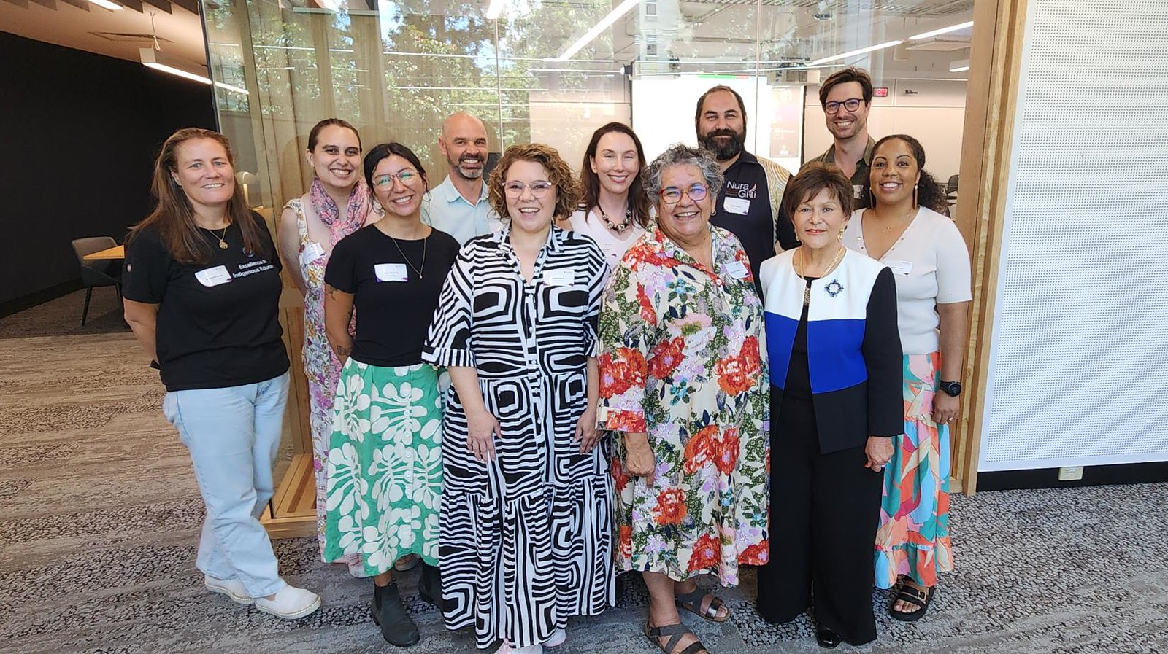
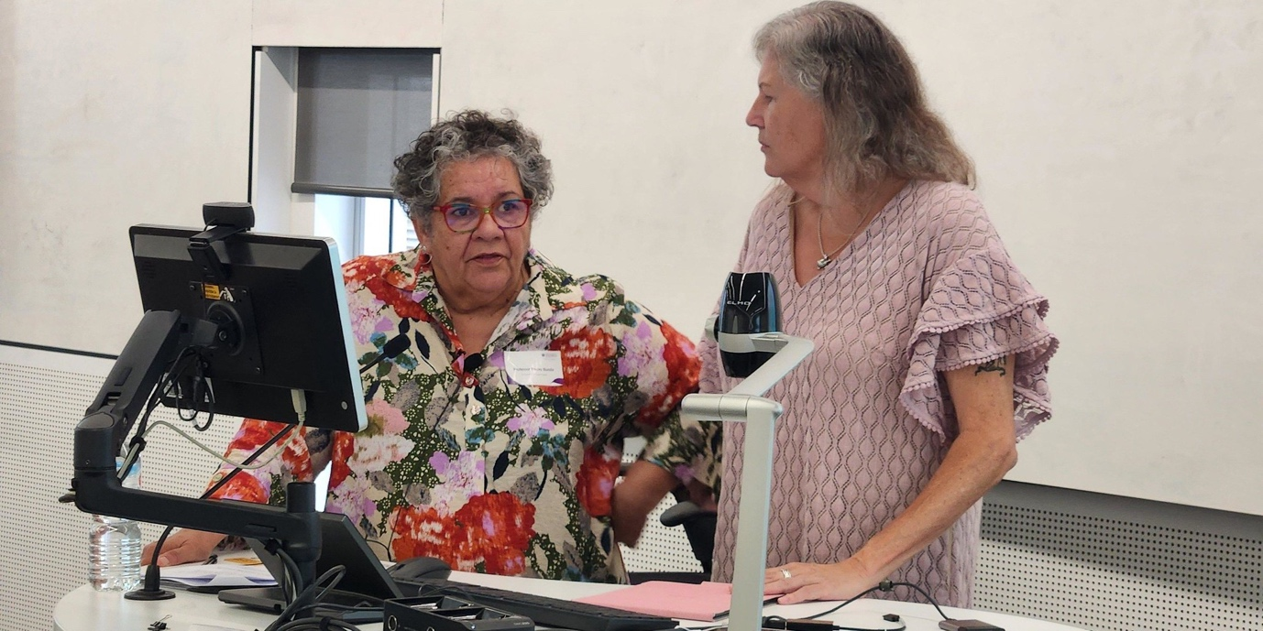
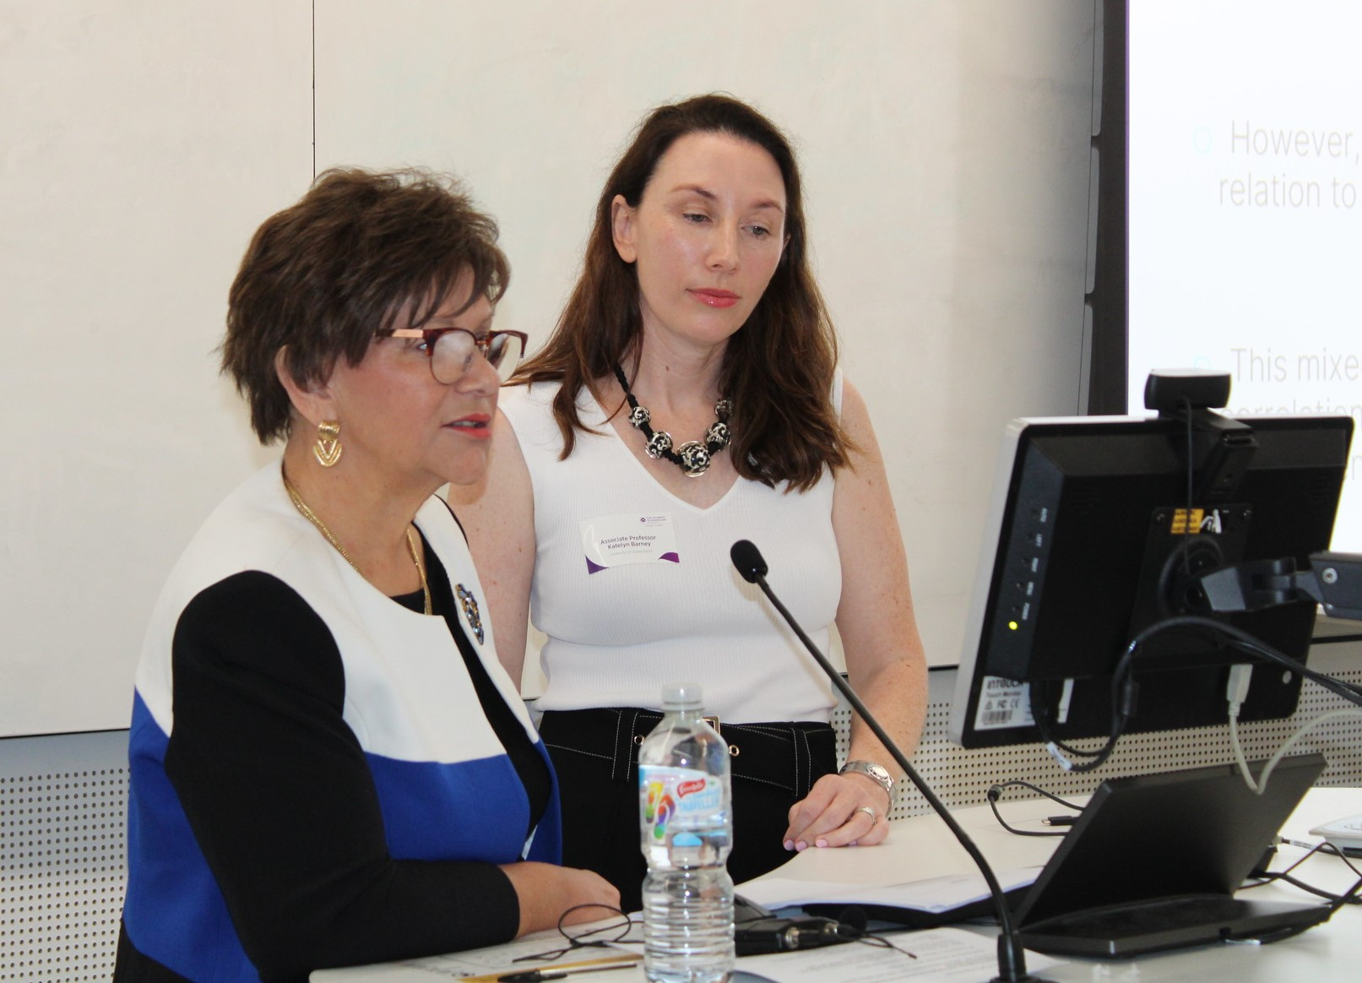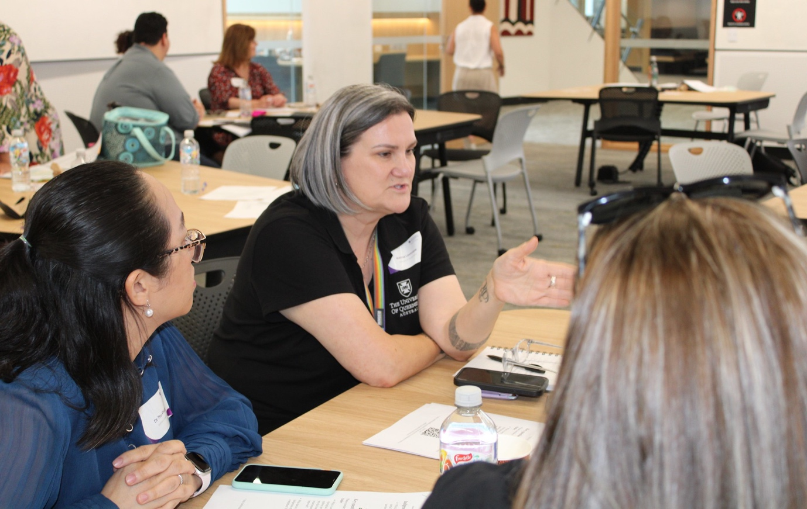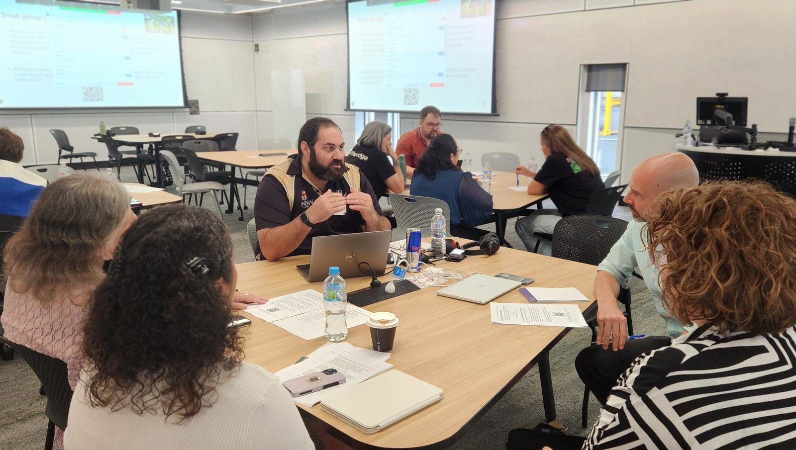

While acknowledging the diversity among and between Aboriginal and Torres Strait Islander people, in this report the term “Indigenous” is used to refer to both Aboriginal and Torres Strait Islander people.
See Working with Aboriginal and Torres Strait Islander pathway program students: Strategies for staff (Fredericks et al., 2025), available on the ACSES website at https://www.acses.edu.au/publication/pathway-programs-and-indigenous-student-completion/
ITAS has provided Australian Government funding for one-to-one and group tutorial study support for Aboriginal and Torres Strait Islander students attending Australian universities since 1989 (Wilks et al., 2017). Some interviewees referred to the program as “ITAR” (Indigenous Tutorial Assistance and Retention Program).
Success rate for year(x) is the proportion of actual student load (EFTSL) for units of study that are passed divided by all units of study attempted (passed + failed + withdrawn). Any units of study undertaken as “Work Experience in Industry” are excluded from the calculation (Department of Education, 2025). The project team acknowledges that “success” is multi-dimensional and much broader than academic progress. In addition, measures of success could include employment, wellbeing, and connection to cultural identity and to peers (see Barney & Williams, 2025).

