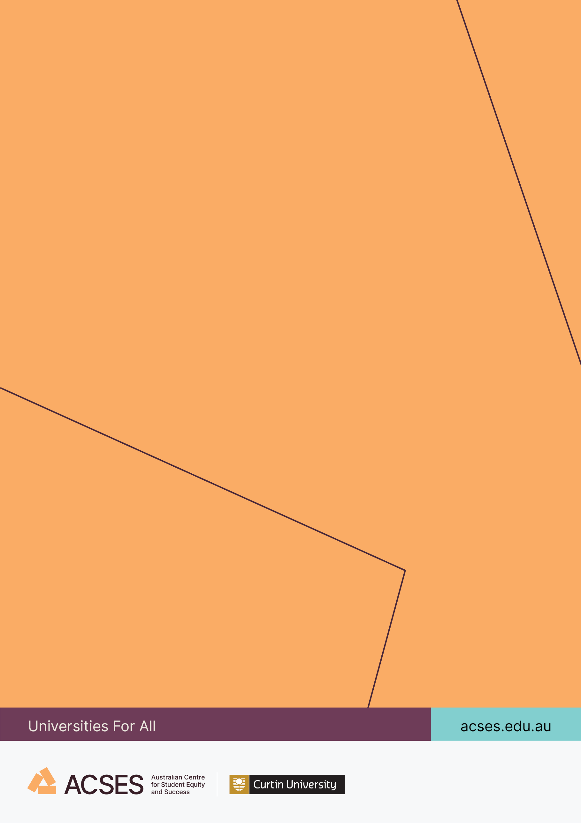
SMALL GRANTS RESEARCH PROGRAM REPORT

Investigating the relationships between First-in-Family status, equity groups, and university access

Tomasz Zając, Garth Stahl,
Wojtek Tomaszewski, and Ning Xiang
2025

Investigating the relationships between First-in-Family status, equity groups, and university access

2 October 2025

Tomasz Zając, The University of Queensland
Garth Stahl, The University of Queensland
Wojtek Tomaszewski, The University of Queensland
Ning Xiang, The University of Queensland

Suggested citation: Zając, T., Stahl, G., Tomaszewski, W., & Xiang, N. (2025). Investigating the relationships between First-in-Family status, equity groups, and university access (Small Grants Research Program final report). Australian Centre for Student Equity and Success, Curtin University.

Australian Centre for Student Equity and Success
Tel: +61 8 9266 1573
Email: acses@curtin.edu.au
Web: www.acses.edu.au
Building 100
Curtin University
Kent St, Bentley WA 6102GPO Box U1987, Perth WA 6845

DISCLAIMER
Information in this publication is correct at the time of release but may be subject to change. This material does not purport to constitute legal or professional advice.
Curtin accepts no responsibility for and makes no representations, whether express or implied, as to the accuracy or reliability in any respect of any material in this publication. Except to the extent mandated otherwise by legislation, Curtin University does not accept responsibility for the consequences of any reliance which may be placed on this material by any person. Curtin will not be liable to you or to any other person for any loss or damage (including direct, consequential or economic loss or damage) however caused and whether by negligence or otherwise which may result directly or indirectly from the use of this publication.

COPYRIGHT
© Curtin University 2025
Except as permitted by the Copyright Act 1968, and unless otherwise stated, this material may not be reproduced, stored or transmitted without the permission of the copyright owner. All enquiries must be directed to Curtin University.
CRICOS Provider Code 00301J
ISBN 978-0-6454877-3-2

Acknowledgement of Country
The Australian Centre for Student Equity and Success acknowledges Indigenous peoples across Australia as the Traditional Owners of the lands on which the nation’s campuses are situated. With a history spanning more than 60,000 years as the original educators, Indigenous peoples hold a unique place in our nation. We recognise the importance of their knowledge and culture, and reflect the principles of participation, equity, and cultural respect in our work. We pay our respects to Elders past, present, and future, and consider it an honour to learn from our Indigenous colleagues, partners, and friends.

At a glance
What we did
The study involved analysis of data on two cohorts of young people from the Person Level Integrated Data Asset (PLIDA), a dataset linking administrative records from multiple public agencies, to compare the university enrolment patterns of First-in-Family (FiF) students, defined as students without university-educated parents, with that of non-FiF students. Data on individuals aged 16 or 17 years at the time of the 2016 Census, who lived with at least one parent, were used to capture their social background, including parental education. Using immigration records, the sample was narrowed to Australian citizens and permanent residents. Higher education records were then used to track their university enrolment status until 2019. The final analytic dataset comprised 443,609 individuals.
What we found
- FiF students constitute over two-thirds of the student population but have not been recognised as an official equity group in Australian higher education equity policy.
- FiF students have substantially lower rates of enrolment in university education than non-FiF students, by around 23 percentage points. The enrolment gap was larger than that observed for most of the official equity groups, with only students with disabilities observed to have a larger enrolment gap.
- Beyond access issues, FiF students also face additional disadvantage in enrolment at selective universities (defined as those with higher entry requirements). Over half of non-FiF students attended selective universities, as compared to only 39% of FiF students.
- There were also differences in the field of enrolment by FiF status, with FiF students more likely to enrol in education or health (excluding medicine) fields, and less likely to enrol in natural and physical sciences, engineering and related technologies, and medical studies.
What we recommend
- The Australian Government and stakeholders should consider First-in-Family (FiF) status (or parental education) as another important factor affecting university enrolments, access to first-tier institutions, and certain fields of study.
- The Australian Government and stakeholders should work together to build a data asset covering the full educational paths that would allow investigation of when and how the educational pathways of FiF individuals and their peers diverge.
- The Australian Government should consider funding further research exploring why attitudes and aspirations of FiF young people differ from those of non-FiF youth and how they shape educational outcomes. This is needed to better understand the mechanisms leading to the divergence of educational pathways.
- The Australian Government and stakeholders should invest in approaches to assist FiF individuals in gaining access to higher education, selective institutions, and fields in which they are underrepresented. They should also expand outreach and career counselling programs to equip FiF individuals with the knowledge necessary to navigate the higher education system as well as help them understand various career paths.
Acknowledgements
This report was commissioned by the Australian Centre for Student Equity and Success (ACSES) through its 2024 Small Research Grants Program. We are grateful to ACSES for its financial support. The research builds on a previous study funded by the Australian Research Council Centre of Excellence for Children and Families over the Life Course (project number CE200100025). Ethics approval for the research was granted by The University of Queensland’s Office of Research Ethics (project number 2023/HE002438).
The results of these studies are based, in part, on data supplied to the Australian Bureau of Statistics (ABS) under the Taxation Administration Act 1953, A New Tax System (Australian Business Number) Act 1999, Australian Border Force Act 2015, Social Security (Administration) Act 1999, A New Tax System (Family Assistance) (Administration) Act 1999, Paid Parental Leave Act 2010, and/or the Student Assistance Act 1973. Such data may only be used for the purpose of administering the Census and Statistics Act 1905 or performance of functions of the ABS as set out in section 6 of the Australian Bureau of Statistics Act 1975. No individual information collected under the Census and Statistics Act 1905 is provided back to custodians for administrative or regulatory purposes. Any discussion of data limitations or weaknesses is in the context of using the data for statistical purposes and is not related to the ability of the data to support the core operational requirements of the Australian Taxation Office, Australian Business Register, Department of Social Services, and/or Department of Home Affairs.
Legislative requirements to ensure privacy and secrecy of these data have been followed. For access to data from the Person Level Integrated Data Asset (PLIDA) and/or the Business Longitudinal Analysis Data Environment (BLADE) under Section 16A of the ABS Act 1975 or enabled by section 15 of the Census and Statistics (Information Release and Access) Determination 2018, source data are de-identified and so data about specific individuals has not been viewed in conducting this analysis. In accordance with the Census and Statistics Act 1905, results have been treated where necessary to ensure that they are not likely to enable identification of a particular person or organisation.

Table of contents
1. Executive summary 2
2. Recommendations 4
3. Introduction 5
4. Background 7
4.1 Social background and educational outcomes 7
4.1.1 Theories of social class 7
4.1.2 Relevance of parental education 8
4.1.3 The role of cultural capital and habitus 8
4.2 First-in-Family students in Australia 10
4.2.1 Common barriers experienced by First-in-Family students 11
4.2.2 Motivations of First-in-Family students 12
5. Methods 15
5.1 Data and sample selection 15
5.2 Measures 15
5.2.1 Outcome variables 15
5.2.2 First-in-Family status 16
5.2.3 Equity group membership 16
5.2.4 Control variables 17
5.3 Analytic approach 17
6. Findings 19
6.1 Access to higher education by First-in-Family status and current equity groups 20
6.1.1 Descriptive patterns 20
6.2 Regression modelling 23
6.2.1 Enrolment in higher education 23
6.2.2 Enrolment in selective institutions 26
6.2.3 Field of study choice 30
7. Discussion 37
8. Conclusion 40
9. References 42
10. Appendices 51

List of tables
Table 1: Selected model coefficients (odds ratios) from logistic regression models of enrolment in a bachelor’s level course 23
Table 2: Selected model coefficients (odds ratios) from logistic regression models of enrolment in a selective institution 28
Table 3: Selected model coefficients (relative risk ratios) from multinomial logistic regression models of field of study 32

List of figures
Figure 1: Proportion of individuals belonging to First-in-Family group, by equity-group membership 19
Figure 2: Proportion of individuals enrolling in higher education, by equity-group membership and First-in-Family status 20
Figure 3: Proportion of students enrolling in a selective institution by equity-group membership and First-in-Family status 21
Figure 4: Distribution of fields of study among those enrolled in a bachelor’s level course by equity-group membership and First-in-Family status 22
Figure 5: Adjusted proportion of individuals enrolling in higher education by equity-group membership and First-in-Family status 24
Figure 6: Adjusted proportion of individuals enrolling in higher education by interacted equity-group membership and First-in-Family status 25
Figure 7: Average marginal effects of First-in-Family status on enrolments in higher education by equity group membership 26
Figure 8: Adjusted proportion of students enrolled in a selective institution by equity group membership and First-in-Family status 28
Figure 9: Adjusted proportion of students enrolled in a selective institution by interacted equity group membership and First-in-Family status 29
Figure 10: Average marginal effects of First-in-Family status on enrolments in a selective institution by equity group membership 30
Figure 11: Adjusted proportions of students enrolled in fields of study by First-in-Family status and equity group membership 33
Figure 12: Average marginal effects of First-in-Family status on field of study by equity group membership 35

Abbreviations
ABS Australian Bureau of Statistics
ACSES Australian Centre for Student Equity and Success
AME Average marginal effect
ASGS Australian Statistical Geography Standard
ATAR Australian Tertiary Admission Rank
BLADE Business Longitudinal Analysis Data Environment
DEEWR Department of Education, Employment and Workplace Relations
DIICSRTE Department of Industry, Innovation, Climate change, Science, Research and Tertiary Education
EG Equity group
ESB English Speaking Background
FGS First-Generation Students
FiF First-in-Family
HEI Higher education institution
HEIMS Higher Education Information Management System
NESB Non-English Speaking Background
NSW New South Wales
OR Odds ratio
PLIDA Person Level Integrated Data Asset
pp Percentage points
RR Regional and remote
SEIFA Socio-Economic Indexes for Areas
SES Socio-economic status
STEM Science, technology, engineering, and mathematics
WINTA Women in Non-Traditional Areas

Executive summary
Since the 1960s, successive Australian governments have focused on equity in the higher education sector where, for the most part, it is recognised that university education has a pivotal role to play in enhancing the socio-economic status (SES) and quality of life for disadvantaged individuals. Much of the debate on equity within Australian higher education has focused on six recognised equity groups: people from low SES backgrounds, people from Non-English Speaking Backgrounds (NESB), Aboriginal and Torres Strait Islander peoples, people from regional and remote (RR) areas, people with disability, and Women in Non-Traditional Areas (WINTA) of study. Critics of the Australian higher education equity framework have underscored the existence of other potential groups that experience disadvantage and are underrepresented in higher education and yet currently lack official recognition. First-in-Family (FiF) students, that is, people without university-educated parents, are one of the disadvantaged groups that are not included in the current equity framework.
There is rich theoretical and empirical literature linking social background to educational outcomes. One important marker of social background – parental education – has been identified as a key factor affecting educational trajectories. Studies focused on FiF students have provided ample evidence of their disadvantage in higher education. The lack of cultural capital, mentoring, and guidance are important factors hindering FiF students’ success. Both in Australia and internationally, there is evidence that FiF students choose educational pathways differently from their peers. However, in Australia, the evidence on FiF students comes mostly from small-scale qualitative studies.
This study aimed to close the gap in existing literature by drawing on unique whole-of-population data to provide robust evidence on access to university for young people whose parents did not complete higher education. It involved analysis of data on two cohorts of young people from the Person Level Integrated Data Asset (PLIDA). Specifically, data on social background from the 2016 Census were linked with Higher Education Information Management System (HEIMS) records to compare the university enrolment patterns of FiF students with that of non-FiF students. Data on individuals aged 16 or 17 years at the time of the 2016 Census, who lived with at least one parent, were used to capture their social background, including parental education. Using immigration records, the sample was narrowed to Australian citizens and permanent residents. Higher education records were then used to track their university enrolment status until 2019. The final analytic dataset comprised 443,609 individuals.
The analysis documented significant overlaps between FiF status and four equity groups: people from low SES backgrounds, people from RR areas, Aboriginal and Torres Strait Islander peoples, and people with disability. The overlaps were particularly large for Indigenous people and people from low SES backgrounds, nearly 90% of whom belonged to the FiF category. However, over two-thirds of the sample were classified as FiF, compared to 18.0% who qualified as low SES and 3.9% as Indigenous, which meant that the vast majority of FiF individuals are not low SES or Indigenous.
Furthermore, the analysis provided evidence of the effects of FiF status on educational pathways. It revealed a wide gap associated with FiF status in chances of enrolling in an undergraduate program. The adjusted enrolment rate among the FiF category was 35.7% compared to 58.6% among those with university-educated parents. Comparing the effect of FiF status to those of equity-group membership showed that only people with disability were more disadvantaged in terms of enrolment rate compared to their peers. The gap in adjusted proportions was 30.7 percentage points (pp) for that group.
Marked differences were also observed in the case of enrolments in selective institutions (that is, those that attract students with higher Australian Tertiary Admission Rank (ATAR) scores). This analysis provided evidence that FiF individuals, who were already less likely to enter higher education, were also less likely to secure a spot at a first-tier university. While over half of non-FiF students were studying at a selective institution, the share among FiF students was only 39.3%.
The final stage of the analysis focused on representation of FiF individuals within fields of study. The results from multinomial logistic regression models suggested that a large proportion of fields were equally likely to be studied by FiF students and their peers with university-educated parents. However, FiF students were significantly more likely than their peers to enrol in education programs and health programs other than medical studies and less likely than their peers to study natural and physical sciences, engineering and related technologies, and medical studies.
Combined, the study outcomes emphasise that FiF status—and parental education more broadly—are very important factors affecting educational trajectories. There are some overlaps between students who belong to the officially identified equity groups and those identified as FiF. However, the latter is a much larger group, and as the results indicate, the disadvantage stemming from FiF status is distinct from that resulting from being a member of any of the designated equity groups.

Recommendations
Based on the findings, the following four recommendations are made:
Recommendation 1. The Australian Government and stakeholders at other levels should consider First-in-Family (FiF) status (or parental education) as another important factor affecting university enrolments, access to first-tier institutions, and certain fields of study.
Young people whose parents did not attend university were themselves significantly less likely to attend university and enrol in a selective institution. Furthermore, our results provide evidence that FiF status can affect the choice of field of study. It is also important to note that young people without university-educated parents were not a small minority. On the contrary, they constituted a majority of the cohort under study (two-thirds of the sample).
Recommendation 2. The different levels of the Australian Government and other stakeholders should work together to build a data asset covering the full educational paths that would allow investigation of when and how the educational pathways of FiF individuals and their peers diverge.
Recommendation 3. The Australian Government should consider funding further research exploring why attitudes and aspirations of FiF young people differ from those of non-FiF youth and how they shape educational outcomes. This is needed to better understand the mechanisms leading to the divergence of educational pathways.
These new data sources and research studies would significantly expand current understandings of how FiF status affects educational trajectories of young people and help to design policy interventions to address equity challenges across the educational lifecycle.
Recommendation 4. The Australian Government and other stakeholders should invest in approaches to assist FiF individuals in gaining access to higher education, selective institutions, and fields in which they are underrepresented and expand outreach and career counselling programs that would equip FiF individuals with the knowledge necessary to navigate the higher education system as well as help them understand various career paths.
Such programs could mitigate the effects of FiF status by reducing the disparities in the cultural capital and knowledge necessary to navigate the higher education system, which previous literature identified as important factors contributing to educational inequality.

Introduction
Since the 1960s, successive Australian governments have focused on equity in the higher education sector where, for the most part, it is recognised that university education has a pivotal role to play in enhancing the socio-economic status (SES) and quality of life for disadvantaged individuals. David (2021) noted that “how to make educational opportunities more equal or equitable for various groups” has been a policy theme “throughout the second half of the twentieth century” (xviii). The commitment to widening participation emerged from the acknowledgment that the underrepresentation of certain groups indicated a failure to fully utilise human potential. Increasing access for non-traditional populations remains a key priority.
In 1988, the Federal Government demonstrated its commitment to enhancing equity in higher education through the Dawkins White Paper on Higher Education Policy (Dawkins, 1988), which highlighted barriers hindering access to and success in higher education for several disadvantaged groups. This document served as a cornerstone for subsequent discussions, notably the paper "A fair chance for all: national and institutional planning for equity in higher education" (DEET, 1990), which, along with "Equity and general performance indicators in higher education" by Martin (1994), laid the groundwork for the current equity framework. The aim of A Fair Chance for All was to radically change the student population and set the stage for success. It was “focused explicitly on access and representation, advocating the need for composition of the student population to reflect the broader population” (Harvey, Andrewartha, & Burnheim, 2016, p. 6). This framework identified six equity groups based on characteristics associated with barriers to higher education participation and success, including: 1) people from low SES backgrounds, 2) Aboriginal and Torres Strait Islander peoples, 3) people from regional and remote (RR) areas, 4) people from Non-English Speaking Backgrounds (NESB), 5) people with disability, and 6) Women in Non-Traditional Areas (WINTA) of study.
Interrelated with the agenda to improve equity in higher education was the massification of the Australian higher education sector in 1989 (Dobson, 2001). This was followed by the development of a “demand-driven funding system” implemented between 2010 and 2017 with the aim of increasing domestic student numbers and providing greater access to higher education for underrepresented groups (Australian Government, 2009).
The outcomes of the demand-driven university system were “a mixed report card”, as reported by the Productivity Commission in its research paper (Productivity Commission, 2019). While the number of students from low SES backgrounds increased following the expansion of university places, this expansion did not lead to increased participation rates among Aboriginal and Torres Strait Islander peoples or young people from RR communities. This conclusion was also supported by a range of empirical evidence from equity scholars (Chesters & Watson, 2013; Czarnecki, 2018).
Another result of the expansion in higher education is an increase in the number of First-in-Family (FiF) students. In this report, we foreground that the FiF status—in other words having parents who did not obtain a university/college degree—should be considered as another important disadvantaging factor in the Australian equity framework. People with FiF status have certain structural barriers that impact their chances of success in their education. International and domestic research suggests university students from this group are more likely to struggle in and drop out of higher education than their peers (see King et al., 2015; Luzeckyj et al., 2011; O'Shea, 2007; O'Shea et al., 2014; O’Shea, 2020; Patfield, Gore, & Fray, 2022; Spiegler & Bednarek, 2013). Furthermore, both theoretical and empirical sociological literature suggests that parental education is a key factor contributing to differences in young people’s educational outcomes (for example, Blossfeld, 2019; Erikson, 2019; Jackson, 2013).
This study used unique whole-of-population data on two cohorts of young people from Person Level Integrated Data Asset (PLIDA) to address the gap in existing literature and provide robust evidence on the relationship between FiF status, equity group membership, and higher education. Specifically, information on social background from the 2016 Census was linked to Higher Education Information Management System (HEIMS) records to investigate differences in university enrolment patterns between FiF and non-FiF individuals. This provided evidence to better understand the disadvantage of FiF youth in terms of access to higher education, independent of the disadvantage observed in the case of the recognised equity groups. It also makes a substantial contribution to the Australian literature on the matter, which has mostly relied on relatively small-scale qualitative studies, to document the disadvantage of FiF students.
The report is organised into four main sections as follows: Section 4 reviews key aspects of the literature on FiF students as well as the broader sociological literature linking class and social background and educational outcomes; Section 5 discusses the methodology, including data, measures and analytical approach; Section 6 presents the findings drawing on the two whole-of-population data sources; Sections 7 and 8 contain the discussion and conclusion, respectively.

Background

Social background and educational outcomes

Theories of social class
The study of class differences and social mobility remain areas of interest for researchers interested in widening participation, and theories of social class are particularly relevant to understanding the experience of First-in-Family students as parental education is a key indicator of socio-economic status. Theories of social class and social mobility have evolved considerably since the structural approaches represented in the early seminal texts of Marx, Weber, and Durkheim. Influenced by these scholars, the last half of the twentieth century was witness to a move towards quantitative and positivist methodologies to explore class. These approaches, which primarily concerned the development of class schemas, mainly defined class in terms of employment and financial resources (Goldthorpe, 1996). Within these studies, which were typically large-scale, education was often in the background, and economics were often emphasised and there was a greater interest in developing rational-choice models (Goldthorpe, 1996) and studying intra-class differences (Bernstein, 1962).
Contemporary research on social class and mobility takes a much broader theoretical stance to incorporate the study of a wider range of practices. In taking such a stance, it begins to complicate how we understand social reproduction. Many of these approaches, which gained popularity over the late twentieth and early twenty-first centuries, were strongly influenced by Bourdieusian concepts, specifically the acquiring (and maintaining) of capitals, symbolic violence, and the internalisation of class (Reay, 2005; Loveday, 2016). Bourdieu conceived of education as an institutional structure for social separation, an “ideological and cultural site of socialization that…was often more likely to reproduce, rather than challenge, social inequality in the state” (Dillabough, 2004, p 490). Rendered simply, Bourdieu argues that within educational contexts, the cultural capital of the middle and upper classes is rewarded, while the capitals of the lower classes are systematically devalued. Within the social sciences, the ongoing “structure-agency” debate heavily influenced Bourdieu’s development of both his theory of practices and theoretical tools in his study of class-based power.
For many sociologists, Bourdieu’s theoretical contribution led to a deeper theorising of class, which emphasised the importance of emotions, stigma, history, and lived experience. Class is now theorised as formed in and through identities, agentic practices as well as historical discourses rather than a simple reflection of present financial capital and occupations. In understanding the role social class plays in identity formation, a range of theorists have documented how family socialisation practices reproduce social class differences across generations (Lareau, 2003; Vincent et al., 2013). For example, in contrast to working-class parents, middle-class parents have been documented as describing their children as “bright”, fostering certain dispositions toward academic attainment (Reay et al. 2011) while putting “a tremendous amount of effort into cultivating particular identities [and] stacking the deck in their child’s favor” (Weis & Cipallone, 2013, p. 710).

Relevance of parental education
There is a long history of research interest in the impact of young people’s social origin or SES of their family on their education outcomes in the sociology of education (see Boudon, 1974; Bourdieu, 1973; Erikson, 2019; Jackson, 2013). Socio-economic characteristics of families and the social and cultural resources available to them have been shown to profoundly influence individual dispositions (for example, views, attitudes, and aspirations), capabilities (for example, cognitive and non-cognitive skills etc.), and behaviours (for example, post-school pathway and course selections) (Boudon, 1974; Bourne et al., 2018; Czarnecki, 2018; Erikson, 2019; Jackson, 2013; Palmisano et al., 2022).
Despite the ongoing debate in the field, there is an emerging consensus on the multidimensional nature of social origin, which suggests that parental education, income, as well as social status and class should be regarded as only one part of the equation. There are different indicators of socio-economic status that may affect individuals’ educational and socio-economic outcomes via different mechanisms (Blossfeld, 2019, 2020; Bukodi et al., 2018; Erikson, 2016).
In considering social class and social mobility in reference to social change, Bukodi and Goldthorpe (2013) employed data from three cohorts born in the UK in 1946, 1958, and 1970 to explore the effects of parents’ class, education, and status on their offspring’s qualification attainment. They found that all three indicators have separate effects that are independent of each other. In a similar vein, Erikson (2016) in Sweden found that parental education, class, status, and income have independent effects on their children’s educational attainment. This is because parental education, occupation, or social status have captured different family resources/capital, which impact an individual’s education and labour market outcomes.
Furthermore, among the indicators of SES, parental education can be considered the most important indicator, not only because it largely lays the foundation for the parents’ occupational prestige and is correlated with social class but also as it has been shown to have a greater association with offspring’s educational attainment than other indicators (for example, Blossfeld, 2019; Erikson, 2019; Erola et al., 2016). Students with highly educated parents can gain exposure to more stimulating cultural, intellectual, and learning-focused environments at home, which can influence school performance as well as aspirations and decision-making (Bukodi & Goldthorpe, 2013; Gunn, 2005). In particular, parental education has been shown to be a major factor that exerts considerable influence on offspring’s educational outcomes, including whether they enter higher education, the trajectories with higher education, studied subjects, etc. (Blossfeld, 2020; Buis, 2013; Chesters & Watson, 2013; Erola et al., 2016; Zając & Tomaszewski, 2023), which supports the claims around the relevance of FiF status for university attendance.

The role of cultural capital and habitus
There is a rich sociological literature theorising the links between various forms of parental SES and educational outcomes. The rational action theory (Breen & Goldthorpe, 1997; Breen et al., 2014; Goldthorpe, 2014) and effectively maintained inequality (Lucas, 2001) are two examples. Both theories are based on rational choice arguments and assume that socio-economic self-interests generate the motivation for parents to mobilise the resources they can command. The rational action theory with its models of status maintenance posits that families aim, at a minimum, to maintain their status for their children when setting and pursuing educational occupational goals for their children. Therefore, according to the theory, families are assumed to be motivated to aim for different occupational statuses, and high SES families, in particular, are motivated to deploy their resource advantage to ensure high SES outcomes for their children (Breen & Goldthorpe, 1997). In turn, effectively maintained inequality posits that the advantaged will always act to ensure advantages for themselves and their children (Lucas, 2001) and will mobilise their socio-economic status to achieve this advantage. Specifically, the theory predicts that, as university education becomes more common, high SES parents will seek to differentiate their offspring from other university graduates through pursuing high-status options, including more enrolment in more prestigious fields of study (for example, medicine, law, engineering) and more selective institutions (for example, Australian Group of Eight institutions).
However, these theories do not consider parental education separately from other aspects of SES. In turn, the work of Bourdieu offers particularly useful insights on the mechanisms through which parental education, and consequently FiF status, impacts educational pathways. Bourdieu's concept of cultural capital has been extensively explored as a pivotal idea in understanding the reproduction of social inequalities through education (Barsegyan & Maas, 2024; Davies & Rizk, 2018; Dumais, 2002; Gunn, 2005; Jæger & Holm, 2007; Noble & Davies, 2009; O’Shea, 2016; Tramonte & Willms, 2010). Bourdieu (1984) defined cultural capital as the non-financial social assets that promote social mobility. These assets include education, intellect, style of speech, dress, and even physical appearance. Bourdieu identified three forms of cultural capital: embodied, objectified, and institutionalised. Embodied cultural capital refers to the knowledge, skills, and dispositions that individuals acquire over time, often unconsciously, through their upbringing and socialisation. Objectified cultural capital encompasses physical objects and media, such as books, artworks, and instruments, which can transmit cultural knowledge and skills. Institutionalised cultural capital is formal recognition, most notably through educational qualifications and credentials, which validate and legitimise an individual's cultural competence. All of these contribute to how class status is maintained.
Bourdieu (1984) posited that cultural capital is rarified and unequally distributed among social classes and that this disparity plays a significant role in maintaining social stratification. The dominant classes invest heavily in passing on substantial amounts of cultural capital to their offspring, thereby giving them a distinct advantage in educational settings and, ultimately, in their professional lives. In contrast, those from less privileged backgrounds often lack the same level of cultural capital, making it more challenging for them to succeed within the educational system and achieve upward social mobility. This concept is crucial for understanding how education can both perpetuate and challenge social inequalities.
Another key concept in this area is Bourdieu’s notion of habitus, which refers to the dispositions, beliefs, and behaviours an individual acquires through subjective perceptions of structural constraints in their environment (Appadurai, 2004; Bourdieu, 1973; Walpole, 2003). Walpole (2003) further defines habitus as a person's network of perceptions regarding opportunities, which develops as individuals internalise aspects of the social structure and their class position, forming beliefs about what is possible in their lives (Dumais, 2002). These beliefs include aspirations and expectations aligned with their habitus (Dumais, 2002). Research shows that students’ educational decisions are made within the context of their habitus (Walpole, 2003). For example, in the area of FiF research, Reay et al. (2005) note that choices among working-class participants are influenced by their perceptions of "fit" with the institution. Similarly, Evans (2009) highlights the phenomenon of "self-limitation" (p. 348) in the context of working-class girls’ decisions regarding higher education. For FiF students, this tendency toward self-restriction often leads them to "study less prestigious subjects at less prestigious universities" (Spiegler & Bednarek, 2013, p. 324). In contrast, in their study of school students in New South Wales (NSW), Patfield et al. (2021) used the lens of familial habitus to describe the ways in which family context can nurture aspirations for higher education among prospective FiF students. They discussed projected familial habitus in which higher education is associated with the opportunity to build a diﬀerent, better life, meritocratic habitus, in which higher education is presented as a reward for hard work at school, and supportive habitus, which is about supporting children in their aspirations and decision-making as well as overcoming barriers.

First-in-Family students in Australia
The massification of the higher education sector resulted in a growing number of “non-traditional” students entering universities (Bowl, 2001). The term “non-traditional students” serves as an umbrella category that includes a wide range of individuals coming from underrepresented groups who do not fit the traditional student profile. Students from non-traditional backgrounds often “face unique, class-specific challenges, evident in higher levels of uncertainty” regarding their higher education choices, which can have implications for retention (Lehmann, 2009, p. 139). Their underrepresentation in higher education and increased likelihood of facing challenges in university life compared to their “traditional” peers attracted research and policy interest (Gale & Tranter, 2011; Reay et al., 2009). Among these “non-traditional” students, FiF students have been a major focus of research in higher education equity (for reviews, see King et al., 2015; Spiegler & Bednarek, 2013).
While international research is robust, empirical evidence from Australia is still somewhat limited and based largely on small-scale studies. A longitudinal study of educational aspirations of prospective FiF students NSW by Patfield, Gore, and Weaver (2022) is a notable exception. In the Australian literature, the term First-in-Family is often aligned with students from low-income households, who may face financial challenges that impact their educational experiences; students from minority ethnic or racial backgrounds, who may encounter systemic biases and cultural differences within the academic environment; and mature students, defined as those aged 21 or over at the time of university entry, who often juggle additional responsibilities such as work or family commitments (O'Shea, 2007; O'Shea et al., 2014; O’Shea, 2020; Wong, 2018). However, given the relatively lower educational attainment of older generations, a majority of young people in Australia nowadays do not have university-educated parents, meaning that a large proportion of FiF students come from middle or even high-income households.
What should be fundamental to how we understand the diversity in FiF experience is the social justice implications in what they are accessing. As Bennett and Southgate (2014) note, widening participation in Australia remains a fragmented picture, where there are different conversations at play under the term widening participation. They highlight “differential levels of access and participation by the type of institution (first tier/elite versus other) and degree (prestigious degrees such as medicine versus lower status/social mobility degrees such as nursing or teaching)” (p. 23; see also Stahl & McDonald, 2023). This aligns with Chesters’s (2015) findings suggesting that Australian young people are more likely to graduate from an elite university if at least one parent has a university degree; similarly, high-status degrees such as medicine and law are associated with parental university qualifications. These findings highlight how, despite the efforts to widen participation, Australian universities remain socially stratified (Bunn et al., 2022).
In Stahl and McDonald’s (2022; 2023) First-in-Family Project, a qualitative study, they saw how FiF students maintained a strong identification with the “caring professions” (see also O’Shea & Stone, 2014; Thomas & Hovdhaugen, 2023). The attraction to caring work by FiF participants of both genders could be due to the familiarity with these professions and the idea that these are “employable” professions, whereas they saw very few participants aspiring to careers more aligned with competitive fields such as business or law.
Existing studies suggest that FiF students, while diverse, share common motivations and behaviours and face significant barriers similar to other non-traditional students from socially and economically disadvantaged backgrounds (McDonald, 2024; Stahl et al., 2021). In surveying both quantitative and qualitative analyses of FiF students’ experiences at university, researchers continue to find that the underlying mechanisms or the barriers that FiF students encounter are their lack of cultural capital in negotiating the rules and norms of university as well as a lack of social capital through limited social assets (Collier & Morgan, 2008; King et al., 2015; Luzeckyj et al., 2011; Luzeckyj et al., 2017; Noble & Davies, 2009; Patfield et al., 2022; Simmons, 2011), or a “mismatch” between their habitus and the new field of university (King et al., 2015; Stephens et al., 2012).

Common barriers experienced by First-in-Family students
There are many common barriers referenced in international research on FiF students. Many of these barriers align with the key barriers of non-traditional students attending university, many of which come from backgrounds where there may be little to no experience with universities.
FiF students differ significantly from non-FiF students in terms of educational aspirations. Drawing on a large-scale survey of government school students in NSW, Patfield, Gore, and Weaver (2022) identified a substantial gap in the proportion of students aspiring to attend university between prospective FiF and non-FiF students. The difference was apparent across all stages of schooling covered by the research, that is, Grades 3 to 12.
Family resources are another key factor. For many FiF students, families “are often unable to provide the same level of financial, informational, mentoring, and/or identity support as middle-class families provide to their sons and daughters” (Rubin, Evans, & McGuffog, 2019, p. 2). Where their peers with university-educated parents often benefit from their parents’ insights and experiences with tertiary education, FiF students remain uncertain of how to navigate the space, which has significant implications for their sense of belonging (Ostrove & Long, 2007; Read, Archer, & Leathwood, 2003; Southgate et al., 2014). Parental educational and cultural capital has been shown to play a role in the choice of educational paths, for example, choosing a selective university and the decision to pursue graduate studies (Barsegyan & Maas, 2024).
Financial resources and attitudes to financial risk are another factor. Enrolling in university often involves a significant financial investment, typically justified by the prospect of future economic benefits. For FiF students from low-income backgrounds, this financial undertaking is compounded by additional challenges related to their personal circumstances and limited access to resources. Research indicates that economically disadvantaged students frequently exhibit a generational reluctance to assume the student debt required to finance higher education (Rauscher & Elliott III, 2014). This hesitancy not only constrains their ability to pursue university studies but may shape their educational pathways and the quality of their learning experiences (Montacute, 2018).
Differences in access to schools are another factor. As Chesters and Watson (2014) note, the predominant means of accessing higher education for young people is through the completion of secondary school through to Year 12 where their results “are converted to an Australian Tertiary Admission Rank (ATAR) which enables students to be ranked against their peers Australia-wide” (p. 1635). Historically, and in the present day, low SES students are disproportionately likely to receive low ATARs, which is directly linked to the schools they attend (Chester, 2019; Tranter, 2011) and their socio-economic status (Cardak & Ryan, 2009). Adding a layer of complexity to how we understand access and choice of fields of study, students from less privileged backgrounds tend to be concentrated in government schools, which tend to have fewer resources as well as narrower curriculum offerings (Teese, 2006). Furthermore, schools’ resources affect the quality of career counselling offered to students (Chester, 2019; McDonald et al., 2024).
Additionally, substantial research suggests that the higher education sector has not yet adapted to accommodate the needs of FiF students. As a result, FiF students often struggle with a sense of belonging and inhabiting the student role (Collier & Morgan, 2008) with many framing their understanding of their experience as “entering an unknown arena that triggered a range of emotional responses” (King et al. 2015). O’Shea, May, Stone, and Delahunty (2024) write that for “learners from diverse backgrounds who are entering university, the risk of incompatible identity positions can be increased” (p. 13), which has implications for how they navigate their academic journeys. The phenomenon of identity dislocation, where FiF students feel out of place or disconnected within the university environment, is a significant barrier. This sense of alienation can be so intense that it leads to higher dropout rates, sometimes occurring as early as the first two months of enrolment (see Lehmann, 2009). The persistent feeling of not belonging highlights the social and cultural adjustments FiF students must make, which can be overwhelming and contribute to their decision to leave university prematurely.

Motivations of First-in-Family students
While FIF students face a series of distinct challenges in their higher education journeys, previous literature suggests some common attitudes among them. FiF students are often characterised by their strong motivation and resilience (Gore, Holmes, Smith, Lyell, et al., 2015; Stahl & McDonald, 2023). In terms of motivation and resilience, a common thread among FiF students is their pursuit of an improved quality of life, viewing higher education as integral to achieving their aspirations (King et al., 2015).
For example, a substantial body of literature around FIF students (for example, King et al., 2015; Luzeckyj et al., 2011; Spiegler & Bednarek, 2013) investigated how they managed to overcome barriers to getting into universities (O’Shea, 2020), how they made decisions on the choices of university and program (Luzeckyj et al., 2011), their experiences at university (King et al., 2015), their post-graduation outcomes and employment mobility (O’Shea, 2019; O’Shea et al., 2021). King et al. (2015) note that this drive for a better future is a powerful motivator that helps FiF students overcome additional academic and social hurdles, underscoring their determination to succeed.
Many studies have shown FiF students to be primarily motivated by pragmatic, job-related reasons for attending university. Their main goals include improving their job prospects and acquiring specific job training, reflecting a practical approach to higher education that prioritises immediate employment outcomes (Gore, Holmes, Smith, Lyell et al., 2015; Gore, Holmes, Smith, Southgate et al., 2015; Krause et al., 2005). For example, it could be argued that their sense of pragmatism informs their chosen discipline of study. Research shows they are more frequently enrolled in courses such as education and nursing, which they have some familiarity with and see as having a high likelihood of employability (Stahl & McDonald, 2023). This differs substantially from non-FiF students who often pursue degrees in fields like engineering, law, medicine, and health sciences, which are typically associated with higher cut-off scores and are considered more prestigious with greater earning potential after graduation (Simmons, 2011). Moreover, these choices remain highly gendered (McDonald & Stahl, 2024; Stahl & McDonald, 2023).
Research in Australia from King et al. (2015) and others found that FiF students are more likely to enrol in university for directly job-related motives, which are “improving my job prospects” and “getting training for a specific job” (Krause et al., 2005, p. 12; Stahl & McDonald, 2022). This pattern was further validated by following studies (Luzeckyj et al., 2011; Luzeckyj et al., 2017).
Furthermore, much of the scholarship on FiF students highlights how they are very committed to becoming socially mobile. While they recognise their path may be unconventional and risky, this can often inspire them to be persistent (Delahunty & O’Shea, 2024). Additionally, research continues to document how FiF students exhibit a strict work ethic and essential time-management skills, which are crucial for balancing university commitments with family obligations. Research by Aries and Seider (2005) and Byrd and MacDonald (2005) emphasises how these students effectively manage their time and develop disciplined study habits, demonstrating their commitment and adaptability. Research by McCafferty, Tomlinson, and Kirby (2024) documented that FiF students recognised the value of leveraging their capitals through activities like work experience and extracurriculars. However, their readiness to acquire capitals varied and appeared to depend heavily on formative experiences. Importantly, they found that students were unable to fully develop their employability capital during their studies, something others might take for granted. King et al. (2015) assert that many FiF students display a high level of autonomy, arriving at university with significant motivational strengths drawn from challenging life experiences, which help them thrive academically.
In summary, there is rich theoretical and empirical literature linking social background to educational outcomes. Parental education has been identified as a key factor affecting educational trajectories. Studies focused on FiF students have provided ample evidence of their disadvantage in higher education. FiF students are characterised by their different educational aspirations (Patfield, Gore, & Weaver, 2022), practical motivations for higher education, identity management, and the significant barriers they face in adapting to university life (Gore, Holmes, Smith, Lyell, et al., 2015; Gore, Holmes, Smith, Southgate, et al., 2015). The lower level of cultural capital as well as reduced availability of mentoring and guidance compared to non-FiF students are important factors hindering FiF students’ success. Both in Australia and internationally, there is evidence that FiF students choose educational pathways differently from their more advantaged peers. However, in Australia, the evidence on FiF students comes mostly from small-scale, mostly qualitative studies. This study aims to close that research gap by drawing on whole-of-population data to provide robust evidence on the disadvantage in university access of individuals whose parents did not complete higher education. The next section presents the methodology.

Methods

Data and sample selection
This study leveraged a PLIDA data extract comprising, among others, the 2016 Census data linked to immigration records provided by the Australian Government Department of Home Affairs and HEIMS records provided by the Australian Government Department of Education. Census data included information about family structures, which allowed us to link children to their parents. We used Census data on individuals aged 16 or 17 years at the time of the Census, that is, born in 1999 or 2000, who lived with at least one parent, to capture their social background, including parental education. By bringing in immigration records, the sample was narrowed to individuals eligible for government-supported places at Australian universities, that is, Australian citizens and permanent residents. Higher education records were used to track their university enrolment status until 2019. The final analytic dataset comprised 443,609 individuals.

Measures

Outcome variables
Enrolment in higher education and field of study were the primary outcome variables in this study. Enrolment in higher education was defined as commencing any bachelor’s level course by the age of 19. That means that enrolments are tracked until 2018 for the cohort born in 1999 and until 2019 for the cohort born in 2000. By the age of 19, 44% of the sample were enrolled in higher education.
Fields of study were grouped using the highest level in the Australian Standard Classification of Education, that is, broad fields of study (2-digit code). There were ten broad fields in higher education: natural and physical sciences, information technology, engineering and related technologies, architecture and building, agriculture, environmental and related studies, health, education, management and commerce, society and culture, and creative arts. However, the standard classification was modified to distinguish two narrow fields—law and medical studies—which stand out from their broad fields, society and culture and health, respectively. These are prestigious fields with strong ties to high-earning career paths. Table B-1: Descriptive statistics of all variables included in the analyses 10.Appendix B presents the distribution of fields of study.
Selective institutions might be particularly inaccessible to individuals from underrepresented backgrounds. To allow investigation of the effects of the FiF status on access to the most selective universities, the analysis included a variable capturing enrolment in the selective institutions. The most selective institutions were chosen using the average tertiary entrance score of commencing students. The top one-third of institutions were classified as selective. Among those who enrolled in higher education, 46% enrolled in a selective institution.

First-in-Family status
The primary variable of interest was FiF status. This indicator was based on information about parental education from the Census. It identified individuals whose parents did not have a higher education degree. Within the sample, 67% of individuals belonged to the FiF category, which is a much larger group than any of the equity groups described in the next section.

Equity group membership
Census data were also used to approximate five of the officially designated equity groups in the Australian higher education system. The constructed variables followed the official definitions used by the Australian Government as closely as possible (Tomaszewski et al., 2020; Zając et al., 2021):
- Non-English Speaking Background (NESB) individuals were foreign-born individuals who reported speaking a language other than English at home.
- Low socio-economic status (SES) individuals were those who lived in the 20% of areas with the lowest values in the Socio-Economic Indexes for Areas (SEIFA) Index of Education and Occupation.
- Individuals from regional and remote (RR) areas were those who lived in areas other than major cities, based on the Australian Statistical Geography Standard (ASGS) Remoteness Structure.
- Indigenous individuals were those who identified themselves as being Aboriginal and/or Torres Strait Islander in the Census.
- Individuals with disability were identified using the Census measure capturing the need for assistance with core activities, that is, requiring assistance in their day-to-day lives due to a long-term health condition (lasting six months or more) or a disability (lasting six months or more).
The Women in Non-Traditional Areas (WINTA) group is not covered in this report. Membership in this group requires enrolling in specific fields of education. As such, WINTA could not be included in the analyses as it focuses on the access stage. However, the sex variable from the Census was included among the independent variables.
Nearly one in five individuals (18.0% of the sample) qualified as low SES, 29.0% as RR, 3.4% as NESB, 3.0% as having disability, and 3.9% as Indigenous.

Control variables
The models included a set of variables that may confound the relationships between socially disadvantaged backgrounds and entry into higher education. The control variables captured other aspects of young people’s circumstances that may hinder or facilitate their access to higher education: living in a single-parent household (yes/no), family income (four income bands and partial/no information category), and having a parent working in managerial or professional positions (yes/no). Table B-1 in 10.Appendix B presents descriptive statistics of all variables included in the analyses.

Analytic approach
The main analysis was divided into three main stages. The first aimed at investigating the overlaps between FiF status and current equity groups. The second involved analysing the impact on educational outcomes of FiF status and equity group membership without controlling for each other and other background characteristics. The third stage focused on modelling the relationship between educational outcomes, FiF status, and equity group membership. This stage of the analysis was divided into three substages, each consisting of three steps:
- First, a series of logistic regression models were used to investigate the associations between FiF status and the probability of enrolling in higher education:
  - The first model investigated the relationship between FiF status and enrolment in higher education without controlling for equity group membership. This yielded a “baseline” model against which to compare more complex models.
  - The second model investigated the same relationship but while controlling for equity group membership to investigate whether the effects of FiF status were independent of those of equity group membership.
  - The third model included interaction terms between FiF status and equity group membership to investigate moderation of the effects of FIF status by equity group membership. In other words, this model investigated if the effects of FiF status differed for individuals who did and did not belong to equity groups.
- Second, a series of logistic regression models were used to investigate the associations between FiF status and the probability of enrolling in a selective institution. The sample was restricted only to individuals who enrolled in higher education. The analysis followed the same pattern as the first substage: the “baseline” model investigated the effects of FiF status without controlling for equity group membership, the second model controlling for equity group membership, and the third model with interaction terms to investigate the moderating effects of equity group membership.
- Third, a series of multinomial logistic regression models investigating the relationship between FiF status and the field of study. Again, the sample was restricted only to individuals who enrolled in higher education. The analysis was conducted in a similar manner as before, that is, with three models (baseline, controlling for equity group membership, with interactions between FiF and equity group membership).
A more detailed exposition of the analytical approach, including the model specifications, is presented in Appendix A.

Findings
Overlaps between First-in-Family status and current equity groups
Figure 1 shows the proportion of individuals from different equity and non-equity groups identified as FiF. The share of men and women identified as FiF was almost the same—66.7% and 66.3%, respectively. Among the NESB group, the share of FiF individuals was smaller than among their English Speaking Background (ESB) peers, at 58.5% and 66.8%, respectively. This should not come as a surprise, given Australia’s selective immigration process. At the same time, the FiF category was overrepresented among all other equity groups. The biggest difference between equity and non-equity individuals could be observed in the case of the low SES category. Among individuals from low SES areas, the share of those classified as FiF was 87.7% compared to 61.8% among those from other areas, resulting in a 26-percentage-point (pp) difference. The gap was 4 pp smaller for the Indigenous category, with 88.0% share of FiF among the Indigenous and 65.6% among non-Indigenous individuals. The differences were much smaller but still noticeable for the RR category (14 pp higher share of FiF among RR compared to people from major cities) and individuals with disability (9 pp higher share of FiF than among people without disability).
Figure 1: Proportion of individuals belonging to First-in-Family group, by equity-group membership
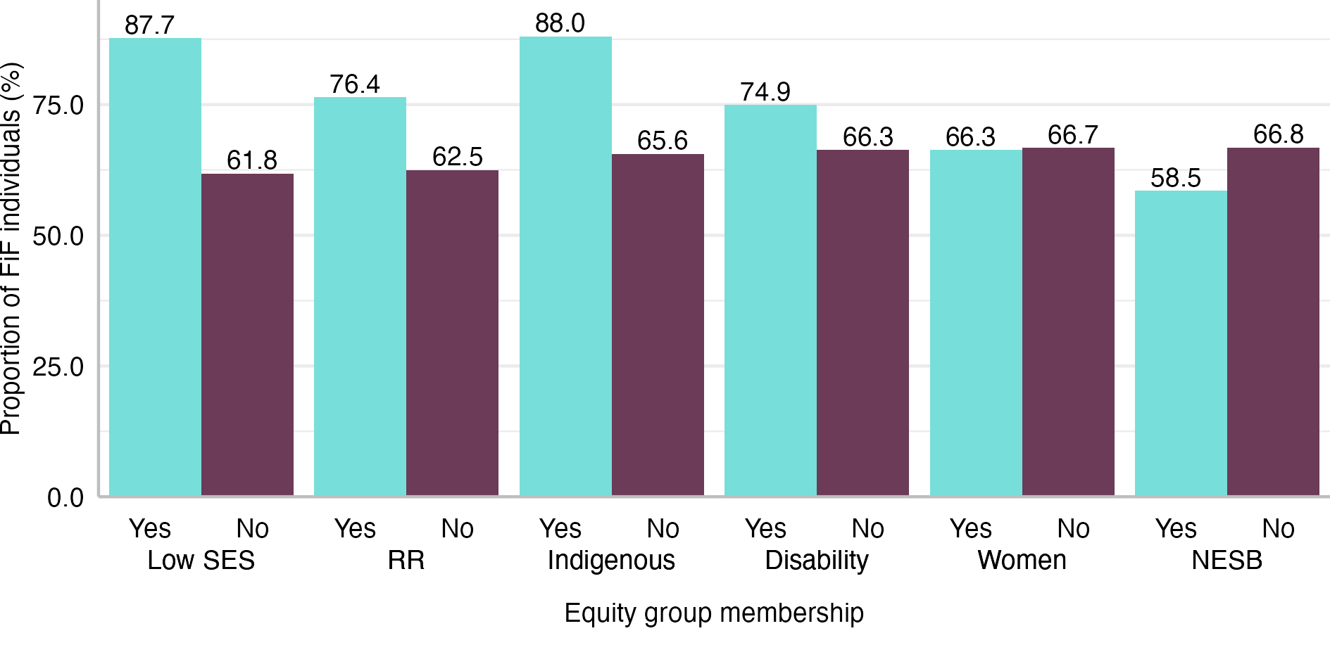
Notes: Data from PLIDA. SES: socio-economic status. NESB: Non-English Speaking Background. RR: regional or remote.
While the vast majority of Indigenous and low SES individuals belonged to the FiF category, it is worth noting that the FiF category was much larger. It means that a large proportion of FiF individuals did not come from a low SES background and were not Indigenous.

Access to higher education by First-in-Family status and current equity groups

Descriptive patterns
Figure 2 presents the proportion of individuals who enrolled in a bachelor’s level course. Members of most of the studied groups accessed higher education at a much lower rate than their peers. Less than one-third of FiF individuals enrolled in a university course, which was less than half the rate for those with a university-educated parent. Large differences could also be observed for low SES (21.2 pp less than non-low SES), RR (21.4 pp less than major cities), and Indigenous individuals (30.1 pp less than non-Indigenous) as well as people with disability (34.3 pp less than people without disability). In contrast, women and NESB individuals were more likely to commence university studies than men and ESB individuals, respectively.
Figure 2: Proportion of individuals enrolling in higher education, by equity-group membership and First-in-Family status
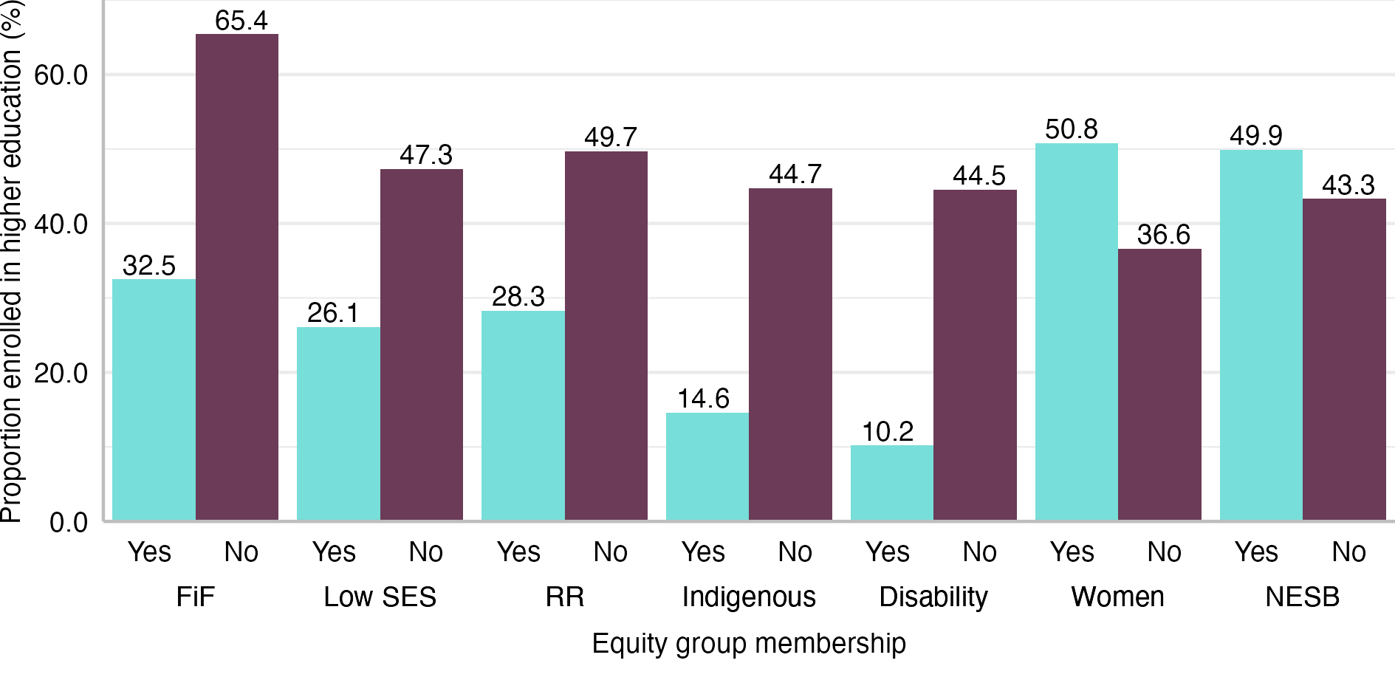
Notes: Data from PLIDA. FiF: First-in-Family status. SES: socio-economic status. NESB: Non-English Speaking Background. RR: regional or remote.
The disadvantage was even greater once the selectivity of the universities was factored in. Young people from disadvantaged groups, who were already less likely to enrol in a bachelor’s program, were also less likely to enter a selective institution. Figure 3 shows the proportion of those who commenced studies at a selective institution among those who entered higher education calculated for each studied group and their counterparts. Only 37% of FiF students studied at a selective institution, while the share among those with university-educated parents was 17.8 pp higher. Marked differences could be observed for most equity groups. In the case of RR students, the difference was even larger than among FiF students—25.4 pp. Interestingly, women, who were more likely than men to enter higher education, were less likely to enrol in a selective institution, albeit the difference was not as large as in the case of other groups. In contrast to other groups, NESB individuals exhibited a 10.9 pp higher rate of enrolment in a selective institution than their ESB peers.
Figure 3: Proportion of students enrolling in a selective institution by equity-group membership and First-in-Family status
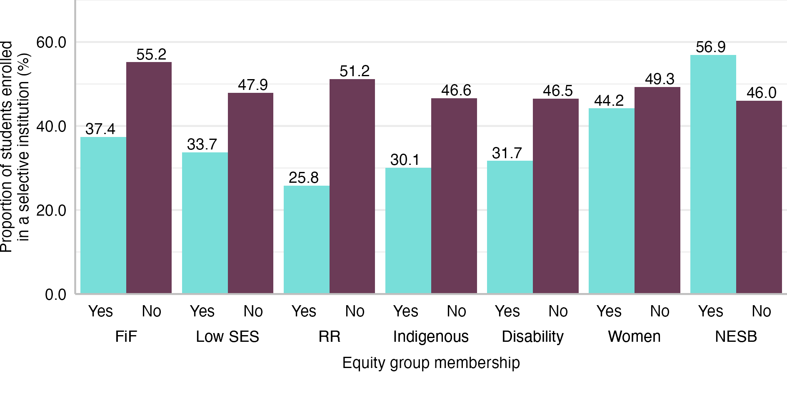
Notes: Data from PLIDA. FiF: First-in-Family status. SES: socio-economic status. NESB: Non-English Speaking Background. RR: regional or remote.
Figure 4 presents the distribution of fields of study among those who enrolled in a bachelor’s level course. It consists of seven panels, one per group. As in Figure 2 and Figure 3, the left column (light colour) represents individuals belonging to a given group, for example, FiF individuals, and the right column (dark colour) represents their counterparts.
FiF status and equity group membership were also associated with the field of study in which students enrolled, resulting in an underrepresentation of disadvantaged groups in some fields. However, there was no common pattern for all groups. However, the degree of under- or overrepresentation varied widely, and there were some exceptions. For example, the above FiF students were much less likely to enrol in medical studies than other students (0.3% compared to 1.3%, resulting in a relative risk of 0.23) and 70% more likely to choose education (8.2% compared to 4.8%, and relative risk = 1.7). In turn, in the case of Indigenous students, the underrepresentation was particularly large in the case of management and commerce (8.9% compared to 15.9%, relative risk = 0.56). At the same time, Indigenous students were more likely to study law than non-Indigenous students (2.8% compared to 2.0%, relative risk = 1.4).
Figure 4 shows, the NESB individuals were a distinct category, overrepresented in areas such as medical studies, science, technology, engineering, and mathematics (STEM) fields, and management and commerce, in which other groups tended to be underrepresented. Other groups were generally overrepresented in education and other health and underrepresented in architecture and building, management and commerce, engineering and related technologies, and natural and physical sciences.
Figure 4: Distribution of fields of study among those enrolled in a bachelor’s level course by equity-group membership and First-in-Family status
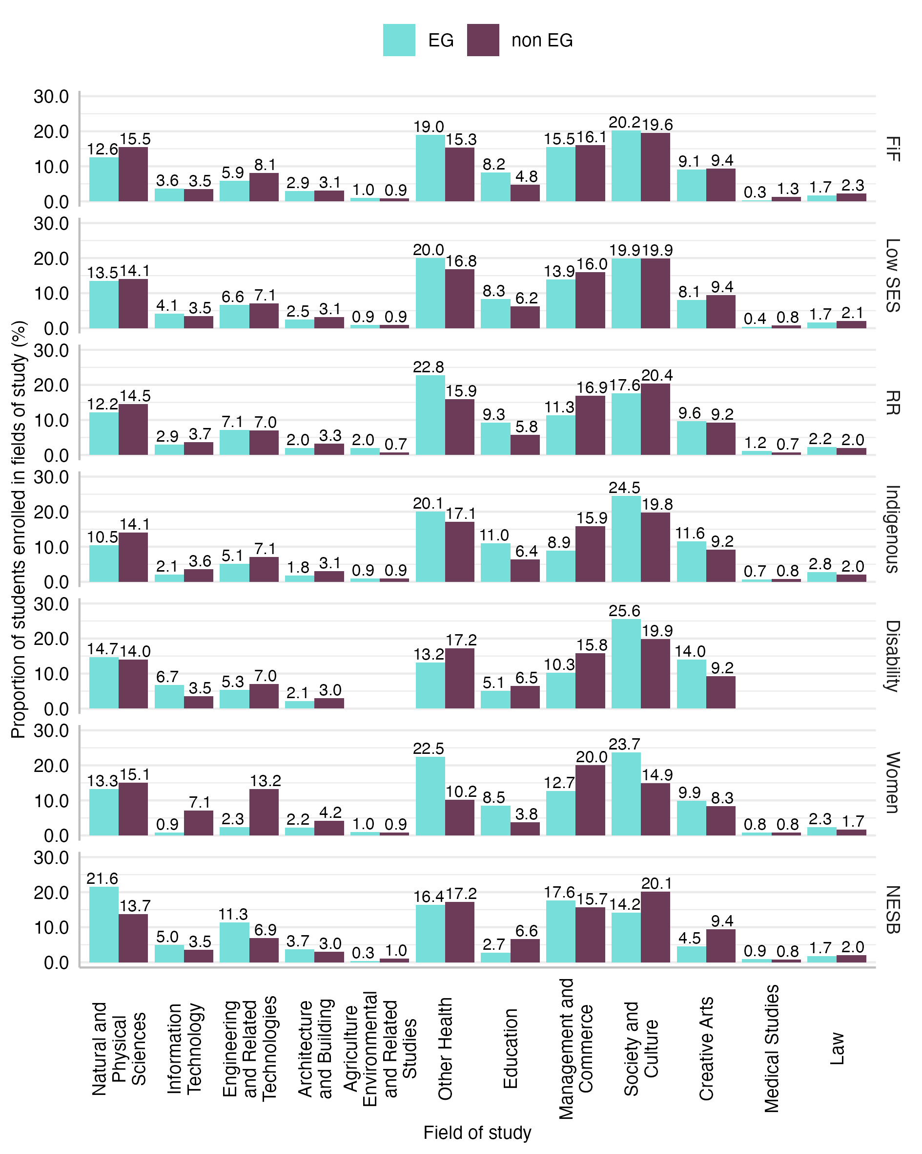
Notes: Data from PLIDA. EG: equity group. FiF: First-in-Family status. SES: socio-economic status. NESB: Non-English Speaking Background. RR: regional or remote. Data on the share of students with disability in some fields (for example, law) needed to be suppressed to meet ABS data clearance requirements.

Regression modelling
To verify the descriptive results, multivariable logistic and multinomial logistic regression models were used to examine the relationships between educational outcomes, FiF status, and equity-group membership while accounting for potential confounds, that is, parental occupation, family income, and number of parents in the household.

Enrolment in higher education
The first set of models (see Models I, II, and III in Table 1) aimed to verify the descriptive patterns shown in Figure 2. The models considered the effects of FiF status on university enrolments in three steps. The first model investigated the effects after introducing the control variables but without considering equity group membership. The second model investigated the effects then after introducing equity group membership. In other words, the model tested whether FiF status and equity group membership affected enrolment in higher education independently of each other. Finally, the last model explored the moderating effects of equity group membership on the relationship between FiF status and university enrolments, that is, whether FiF status affects the enrolment rates differently for members and non-members of equity groups.
Table 1: Selected model coefficients (odds ratios) from logistic regression models of enrolment in a bachelor’s level course
Model number | I | II | III
Model title | FiF | FiF+EG | FiFxEG
FiF | 0.33*** | 0.35*** | 0.33***
Low SES |  | 0.67*** | 0.69***
RR |  | 0.47*** | 0.47***
Indigenous |  | 0.37*** | 0.37***
NESB |  | 1.09*** | 1.13***
Women |  | 1.95*** | 1.78***
Disability |  | 0.15*** | 0.13***
FiF # Low SES |  |  | 0.96
FiF # RR |  |  | 0.99
FiF # Indigenous |  |  | 0.99
FiF # NESB |  |  | 0.95
FiF # Women |  |  | 1.15***
FiF # Disability |  |  | 1.39***
Controls | Yes | Yes | Yes
Observations | 443609 | 443609 | 443609
Pseudo R² | 0.085 | 0.138 | 0.138

Notes: Data from PLIDA. EG: equity group. FiF: First-in-Family status. SES: socio-economic status. NESB: Non-English Speaking Background. RR: regional or remote. Full sets of model results are available in Table B-2 in Appendix B. Statistical significance: * p < 0.05, ** p < 0.01, *** p < 0.001.

The results from Model I suggest that FiF status had a significant effect on the chances of university enrolment even after controlling for family income, parental occupation, and household composition. The odds ratio (OR) of 0.33 was statistically significant at the 0.001 level. The coefficient did not change substantially after introducing variables capturing equity group membership in Model II. Furthermore, the results from Model II provide evidence of the associations between membership in the current equity groups and lower rates of enrolment in higher education net of the effects of FiF status.
Marginal predictions were used to better compare the magnitude of the effects of equity group membership and FiF status on university enrolments. Figure 5 visualises the differences in adjusted enrolment rates (predicted probabilities/proportions of enrolled individuals) between the equity groups as well as FiF status. As expected, the magnitude of differences between students from disadvantaged backgrounds and their more advantaged counterparts shrunk compared to the unadjusted results. However, the gaps in enrolment rates remained large, suggesting that the effects of various social background characteristics are independent of each other. FiF status was associated with one of the largest gaps. The adjusted enrolment rate among the FiF category was 35.7%, which was over 23.0 pp less than among those with university-educated parents. Only for people with disability was the gap in adjusted proportions larger—30.7 pp. The gaps for Indigenous young people, those from RR and low SES areas, were smaller—18.8 pp, 15.4 pp, and 8.1 pp, respectively.
Furthermore, the model results show that after introducing various controls, the advantage in enrolment rates of NESB individuals was reduced to 1.8 pp. However, women with an adjusted enrolment rate of 50.5% retained their advantage over men whose adjusted enrolment rate stood at 36.8%.
Figure 5: Adjusted proportion of individuals enrolling in higher education by equity-group membership and First-in-Family status
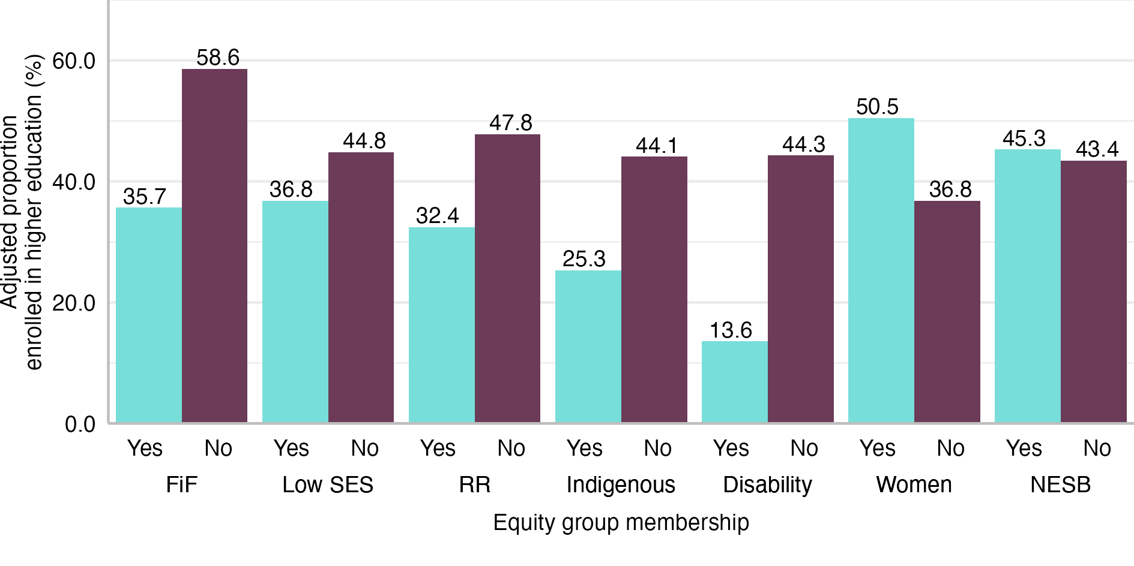
Notes: Data from PLIDA. FiF: First-in-Family status. SES: socio-economic status. NESB: Non-English Speaking Background. RR: regional or remote. Predicted probabilities based on the model results presented in column II of Table B-2 in Appendix B
The third model, presented in the last column in Table 1, included interaction terms between FiF status and equity group membership, which allowed us to investigate whether the effects of the FiF status on the enrolment rate varied between individuals belonging to equity groups and their counterparts. Figure 6 presents the predictions based on the model results calculated for categories resulting from intersecting FiF status and equity group membership. It shows that FiF status was always associated with lower chances of enrolling in higher education. As a result, individuals who belonged to a disadvantaged group and did not have university-educated parents were least likely to commence university studies. For example, the adjusted or predicted enrolment rate for FiF individuals from low SES areas was 28.8% compared to 52% for those from low SES areas who were not FiF, 37.0% for those who were FiF but lived in higher SES areas, and 60.1% for those who were not FiF and did not live in a low SES area.
Figure 6: Adjusted proportion of individuals enrolling in higher education by interacted equity-group membership and First-in-Family status
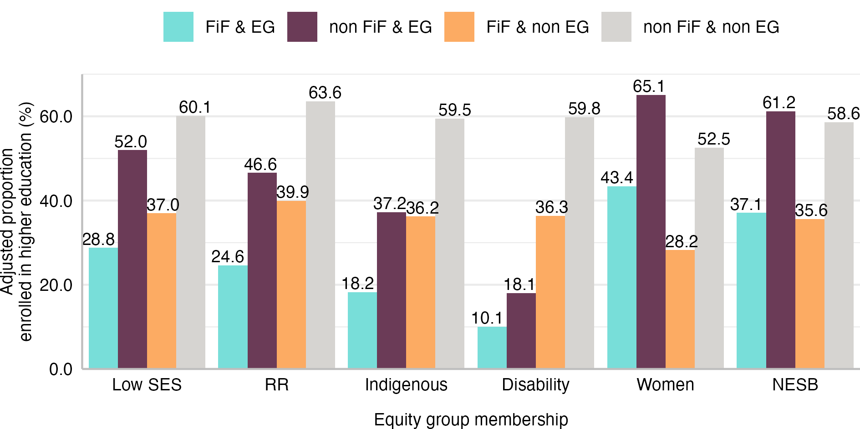
Notes: Data from PLIDA. EG: equity group. FiF: First-in-Family status. SES: socio-economic status. NESB: Non-English Speaking Background. RR: regional or remote. Predicted probabilities based on the model results presented in column III in Table B-2 in Appendix B.
To facilitate the analysis of the moderating effects, average marginal effects (AMEs) were estimated using the results from the third model. Figure 7 represents the AMEs, which are the differences in enrolment rates associated with FiF status calculated for those who belong to an equity group and their non-equity group counterparts. For example, the first bar shows that FiF individuals from low SES areas had a 23.2 pp lower enrolment rate than non-FiF individuals from low SES areas. The second bar shows that the average change in the chance of enrolling in higher education associated with being FiF was also -23.2 pp. This suggests that there was no moderation of the effect of FiF status by low SES background. NESB individuals are the other group for which moderation effects are small and statistically non-significant.
There was some evidence of moderation in the case of RR, Indigenous background, and gender. However, the differences in AME, while statistically significant, were not very large in magnitude, up to -4.3 pp, compared to the actual AMEs. Disability was the only exception. Among people with disability, FiF status had a much smaller effect on predicted enrolment rates than among people without disability.
Figure 7: Average marginal effects of First-in-Family status on enrolments in higher education by equity group membership
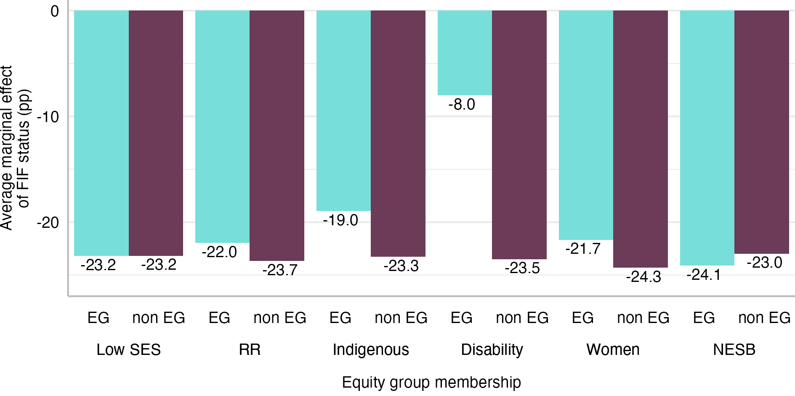
Notes: Data from PLIDA. EG: equity group. FiF: First-in-Family status. SES: socio-economic status. NESB: Non-English Speaking Background. RR: regional or remote. Predicted probabilities based on the model results presented in column III in Table B-2 in Appendix B.

Enrolment in selective institutions
The next set of models, results from which are presented in Table 2, investigated how social background characteristics were related to enrolments in the most selective institutions. The steps in the analysis were like the analysis of university enrolments; however, the sample was restricted to those who enrolled in higher education. This allowed us to study the relationships separately from the effects that social background had on university enrolments in general. Results from Model IV suggest that FiF status was again significantly and strongly associated with the outcome variable with OR at 0.51 (p<0.001). As in the case of university enrolments, the effect of FiF status did not diminish by much after equity group membership was introduced to the model (Model V). Again, despite the overlaps between FiF and membership in some equity groups, all variables are significantly associated with the outcome variable.

Table 2: Selected model coefficients (odds ratios) from logistic regression models of enrolment in a selective institution
Model number | IV | V | VI
Model title | FiF | FiF+EG | FiFxEG
FiF | 0.51*** | 0.56*** | 0.56***
Low SES |  | 0.77*** | 0.66***
RR |  | 0.36*** | 0.33***
Indigenous |  | 0.75*** | 0.66***
NESB |  | 1.43*** | 1.32***
Women |  | 0.88*** | 0.92***
Disability |  | 0.54*** | 0.50***
FiF # Low SES |  |  | 1.24***
FiF # RR |  |  | 1.18***
FiF # Indigenous |  |  | 1.21*
FiF # NESB |  |  | 1.19***
FiF # Women |  |  | 0.90***
FiF # Disability |  |  | 1.17
Controls | Yes | Yes | Yes
Observations | 192995 | 192995 | 192995
Pseudo R2 | 0.027 | 0.056 | 0.057
Notes: Data from PLIDA. EG: equity group. FiF: First-in-Family status. SES: socio-economic status. NESB: Non-English Speaking Background. RR: regional or remote. Full sets of model results are available in Table B-3 in Appendix B. Statistical significance: * p < 0.05, ** p < 0.01, *** p < 0.001.
Again, the results from the models were used to calculate predicted or adjusted proportions of students enrolled in a selective institution. Figure 8 presents such adjusted results based on Model V, which includes variables capturing equity group membership. It shows that FiF students, with a proportion of 39.3%, were markedly less likely to study at a selective institution than their counterparts with university-educated parents, of whom over half studied at a selective institution. The difference between the estimated proportions was 13.8 pp.
NESB students were the only group included in this study that had a higher proportion of students enrolled in selective institutions than their non-equity group counterparts—54.3% compared to 46.1%. Belonging to all other groups was associated with a lower chance of enrolling in a selective institution. The gap varied from a relatively small difference between women and men (3.0 pp) to a 23.0 pp difference between RR students and their peers from major cities.
Figure 8: Adjusted proportion of students enrolled in a selective institution by equity group membership and First-in-Family status
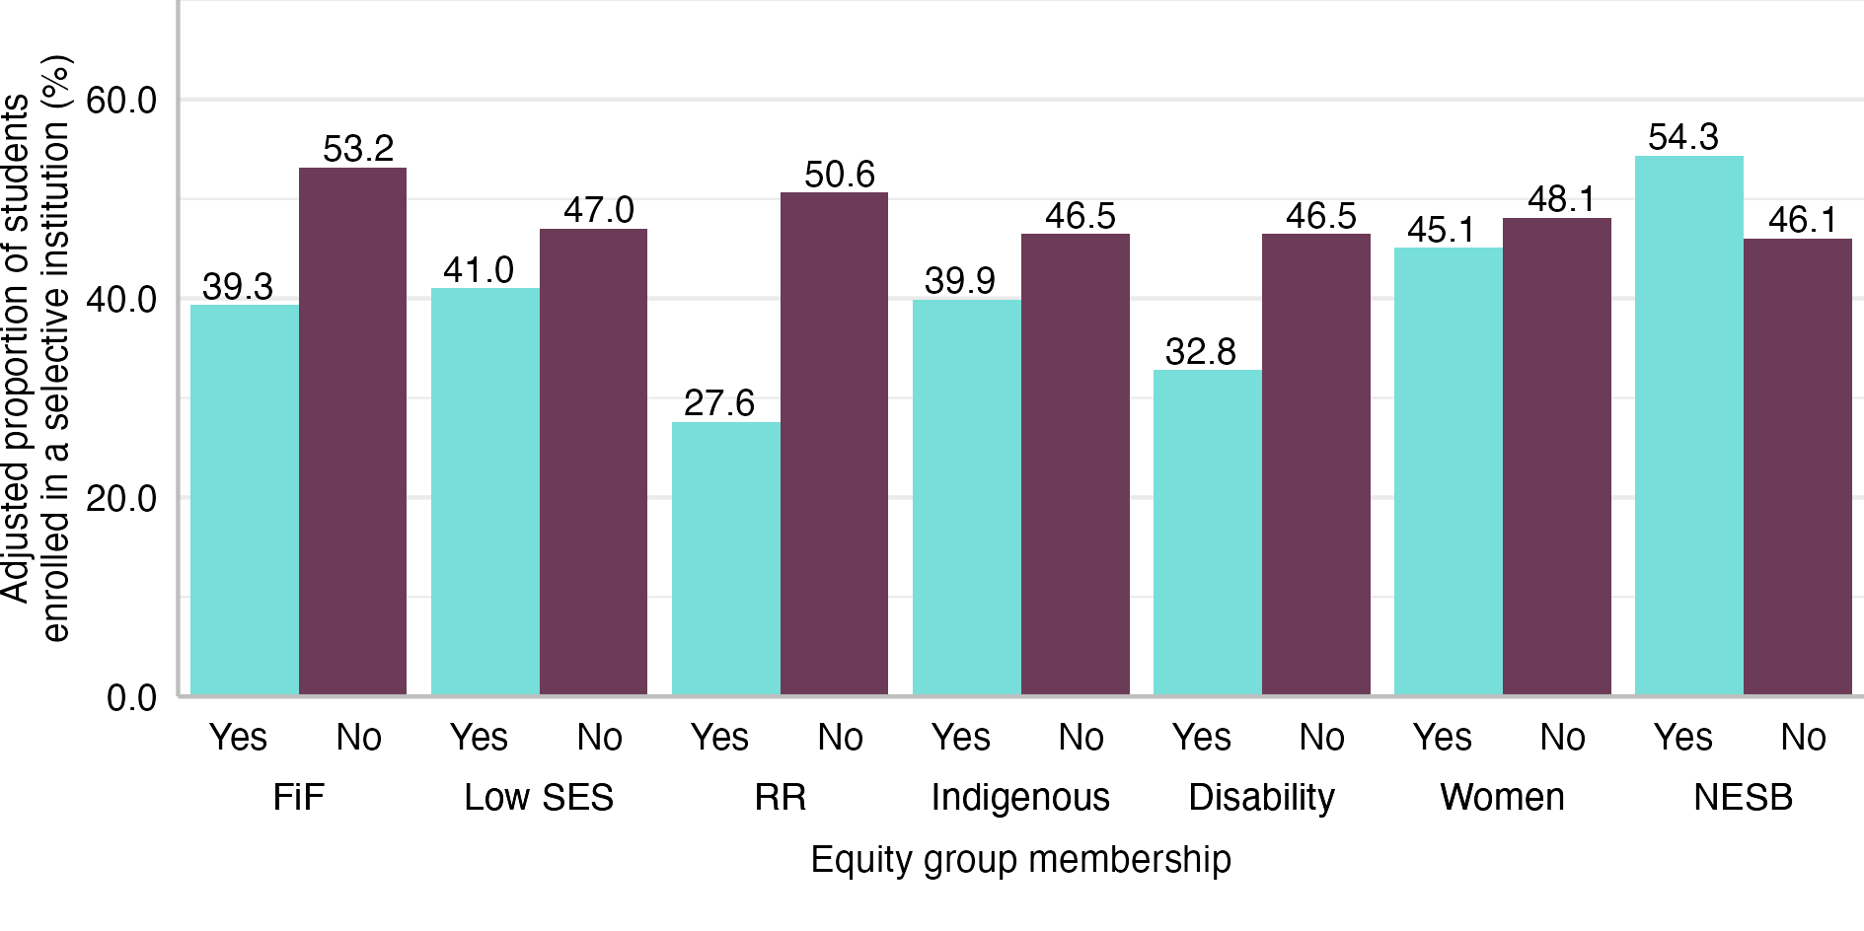
Notes: Data from PLIDA. FiF: First-in-Family status. SES: socio-economic status. NESB: Non-English Speaking Background. RR: regional or remote. Predicted probabilities based on the model results presented in Column II of Table B-3 in Appendix B.
Figure 9 presents the predicted proportions of students enrolled in a selective institution based on the results from Model VI, which includes interaction terms between FiF status and equity group membership. Similarly to enrolment in any higher education institution, the association between FiF status and lower chances of enrolment in a selective institution could be observed across all groups. This led to the lowest adjusted proportions of students enrolled in selective institutions among those who belonged to a disadvantaged group and did not have university-educated parents. For example, only 22.9% of students who were FiF and lived in RR areas started studies at selective institutions, compared to 31.6% among people from RR areas who were not FiF. Similarly, among students coming from major cities and who were FiF, 43.0% studied at a selective institution, while the share among those who were not FiF was 57.9%.
Figure 9: Adjusted proportion of students enrolled in a selective institution by interacted equity group membership and First-in-Family status
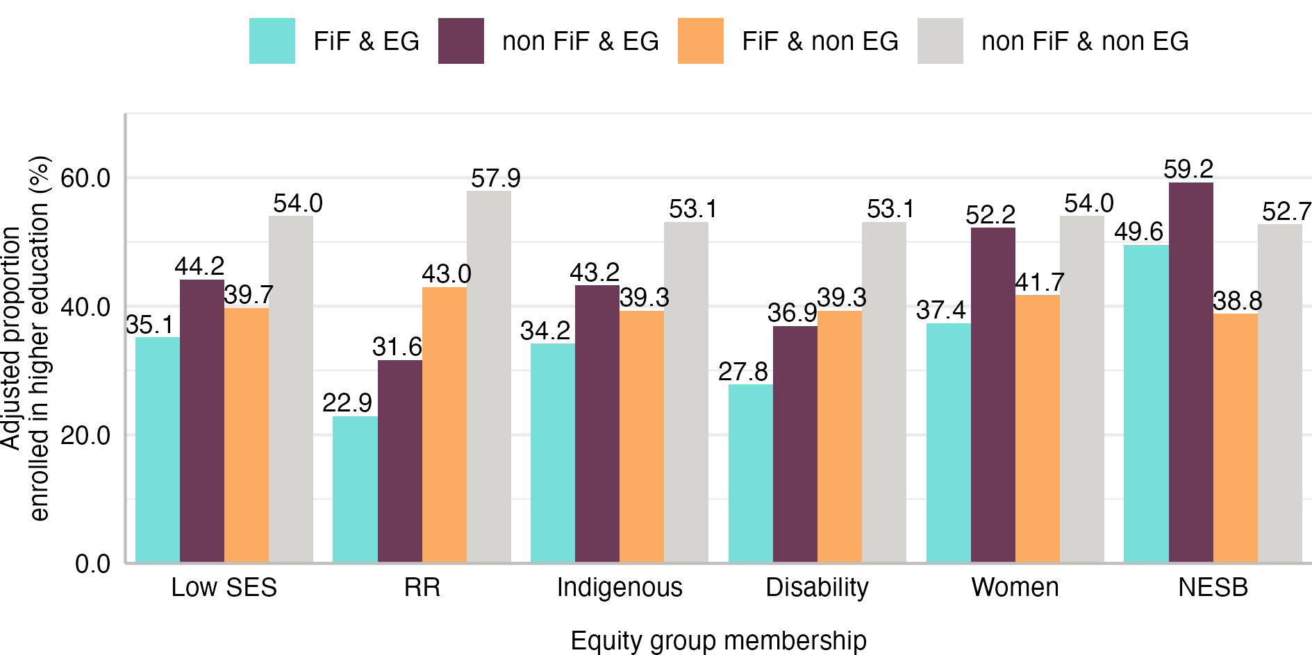
Notes: Data from PLIDA. EG: equity group. FiF: First-in-Family status. SES: socio-economic status. NESB: Non-English Speaking Background. RR: regional or remote. Predicted probabilities based on the model results presented in Column III of Table B-3 in Appendix B.
Figure 10 presents the AMEs calculated using the results from Model VI that illustrate the differences in the magnitude of the effect of FiF status on enrolments in selective institutions across various groups. The results were similar for students from low SES and RR areas, those of Indigenous background, and those with disability. For those groups, the effects of FiF status were quite similar, with AMEs ranging from -8.7 pp to -9.1 pp. Furthermore, those effects were smaller than for their peers from more privileged backgrounds.
The results were different for women and NESB students. Women were the only group that was less likely to enrol in selective institutions and had a higher AME for FiF status than their counterparts. However, the moderating effect was not particularly strong, with the AME among women at -14.8 pp and -12.3 pp for men. In the case of NESB, the effects of FiF status were more pronounced among non-NESB students, that is, the group that was less likely to enter a selective institution.
Figure 10: Average marginal effects of First-in-Family status on enrolments in a selective institution by equity group membership
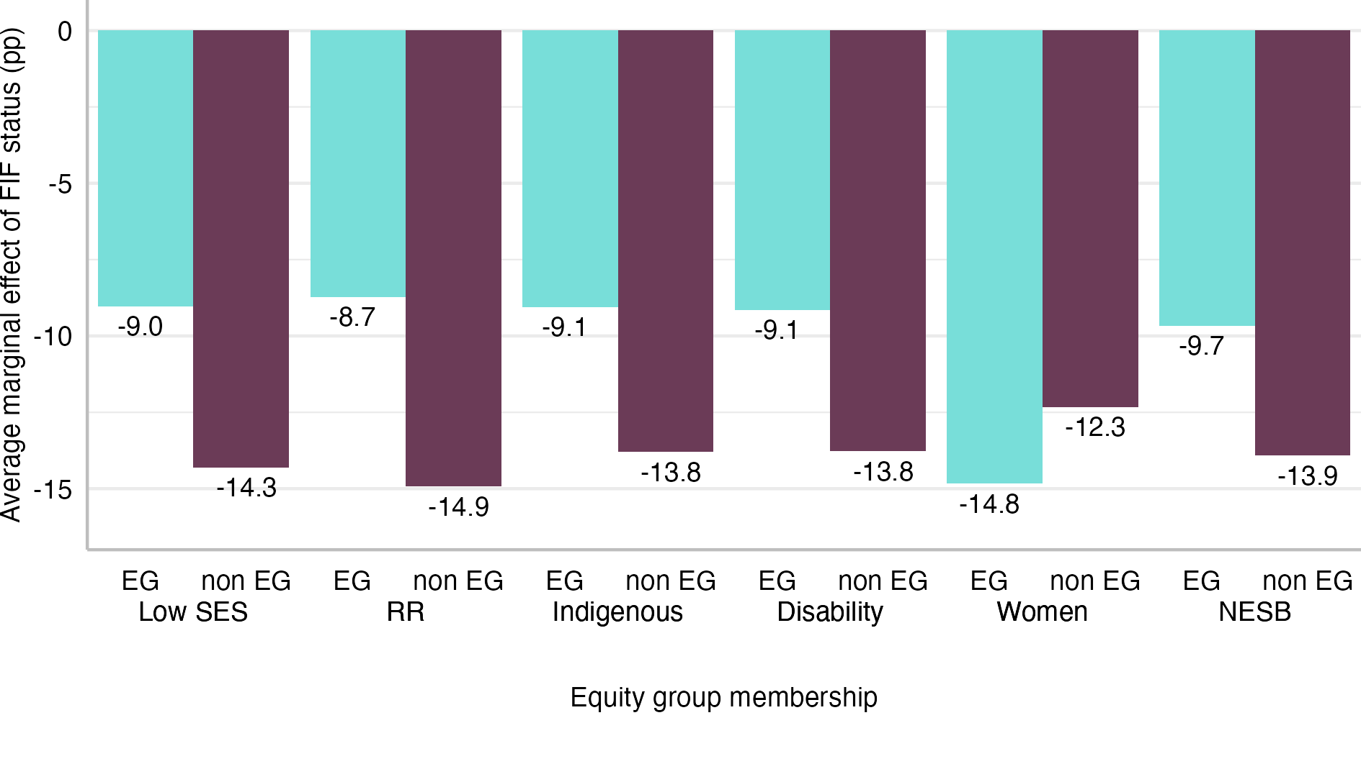
Notes: Data from PLIDA. EG: equity group. FiF: First-in-Family status. SES: socio-economic status. NESB: Non-English Speaking Background. RR: regional or remote. Predicted probabilities based on the model results presented in Column III of Table B-3 in Appendix B.

Field of study choice
In the next step of the analysis, the effects of FiF status on field of study choices were explored using multinomial logistic regression models. Table 3 compares the coefficients (relative risk ratios) for FiF status from Model VII, which included FiF status and control variables, and Model VIII, which also included variables capturing equity group membership. Full sets of results, including the coefficients for the equity group membership variables, are available in Table B-4 and Table B-5 in Appendix B. Comparing the results from both models suggests that introducing variables capturing equity group membership reduced some of the effects of FIF status (relative risk ratios were closer to 1) and resulted in some turning statistically nonsignificant (for example, architecture & building and management & commerce). However, the overall patterns were similar. Results from Model VII show that FiF status was associated with the likelihood of studying some fields of study. For example, the RR for education in Model VII stood at 1.70 (p < 0.001) and for medical studies at 0.28 (p < 0.001). The relative risk ratios for those fields from Model VIII were similar, 1.59 (p < 0.001) and 0.28 (p < 0.001).

Table 3: Selected model coefficients (relative risk ratios) from multinomial logistic regression models of field of study
 | Model
Outcome (ref. Society & Culture) | VII | VIII
Natural & Physical Sciences | 0.75*** | 0.79***
Information Technology | 0.84*** | 0.93*
Engineering & Related Technology | 0.69*** | 0.76***
Architecture & Building | 0.93* | 1.01
Agriculture Environmental & Rel. Studies | 1.24*** | 1.13*
Other Health | 1.20*** | 1.15***
Education | 1.70*** | 1.59***
Management & Commerce | 0.94*** | 1.00
Creative Arts | 0.98 | 0.97
Medical Studies | 0.28*** | 0.28***
Law | 0.80*** | 0.80***
Equity group membership | No | Yes
Other controls | Yes | Yes
Notes: Data from PLIDA. Full sets of model results are available in Table B-4 and Table B-5 in Appendix B Statistical significance: * p < 0.05, ** p < 0.01, *** p < 0.001.
To better illustrate the relationship between field of study and social background, adjusted or predicted probabilities were estimated using the results from Model VIII. Figure 11 presents the predicted probabilities of entering fields of study by FiF students, members of the equity groups, and their counterparts. Overall, the model-based predictions did not differ significantly from the unadjusted results presented in Section 6.1.1.
The first panel from the top shows the results for FiF students and their counterparts with university-educated parents. For many of the fields, the difference in enrolments between FiF and non-FiF students was very small. However, FiF students were more likely than their peers to choose other health and education, with the adjusted proportion at 18.4% compared to 16.0% and 7.9% compared to 5.0%. At the same time, FiF students were underrepresented in fields such as natural and physical sciences, engineering and related technologies, and medical studies. In the last case, the difference between predicted probabilities is small, only 0.9 pp, but the share of FiF students was nearly four times smaller than among non-FiF students. The results showed that while FiF students might be underrepresented among students of some fields opening lucrative career paths, they were not concentrated in fields leading to below-average earnings.
Coming from a low SES area seemed to have a smaller effect than FiF status on the field of study in which students enrolled. Students from low SES areas were also more likely than their peers to study education and other health subjects, but the differences were much smaller, 0.6 pp and 1.2 pp. The differences between equity group members and other students were much more pronounced in the case of other equity groups, but the patterns varied a lot.
Students from RR areas were similar to FiF students in their overrepresentation in education and programs belonging to the other health category, as well as underrepresentation in natural and physical sciences. For example, the adjusted proportion of those studying other health subjects was 21.7% among the RR students compared to 16.1% among their counterparts from major cities. However, there were some noticeable differences compared to the FiF students. RR students were underrepresented in management and commerce (11.9% compared to 16.7% among students from major cities) and society and culture (17.1% compared to 20.6% among students from major cities). Furthermore, they were more likely to choose studies in agriculture, environmental and related studies, and medical studies. While the differences expressed in pp were not large, as both fields were not chosen by many students, the ratios of proportions were large. RR students were nearly three times more likely to study agriculture and nearly two times more likely to study medicine than students from major cities.
Indigenous students were most underrepresented in management and commerce. The adjusted proportion of Indigenous students enrolled in a study program in this field was only 10.5%, while the rate among non-Indigenous students stood at 15.9%. Indigenous students were also somewhat less likely to study STEM disciplines than their non-Indigenous counterparts. At the same time, they were overrepresented in the academic disciplines of humanities, arts, and social sciences, including education (8.6% compared to 6.4% among non-Indigenous students) and law (2.9% compared to 2.0% among non-Indigenous students).
Students with disability were also more likely than their less disadvantaged counterparts to choose society and culture or creative arts programs. After adjusting the proportions, over a quarter of students with disability chose the former field compared to less than one in five among students without disability. In the case of creative arts, the adjusted proportions among students with and without disability stood at 13.9% and 9.2%, respectively. Students with disability were also overrepresented in programs in information technology, with the predicted proportion at 6.0% compared to 3.5% among students without disability. At the same time, students with disability were less likely than students without disability to choose most other fields. The gap was particularly noticeable in the case of management and commerce, for which the adjusted proportions stood at 10.3% for students with disability and 15.9% for students without disability.
Differences between men and women were much larger than for other groups. Men were more likely to study STEM subjects, particularly engineering and related technologies and information technologies, as well as management and commerce. For example, the adjusted proportion of female students enrolled in information technology programs was only 0.9%, while for men the rate was 7.1%. Similarly, the adjusted proportion of engineering students among women was 2.4% compared to 13.1% among men. At the same time, women were markedly more likely to choose other health, education, and society and culture. The adjusted proportion of other health students among women was 22.3%, which was more than twice the value for men (10.4%). The adjusted proportion of women in education (8.3%) was also over double the rate among men (4.0%). In the case of society and culture, the adjusted proportions for women and men were 23.8% and 14.9%, respectively.
The NESB students stood out as they tended to be overrepresented in fields in which previous groups were less likely to choose than their more privileged peers and underrepresented in fields in which members of other analysed groups were less likely to enrol. The former was best illustrated by natural and physical sciences with adjusted enrolment rates for NESB students at 20.6% and 11.1% compared to 13.8% and 6.9%, respectively, among ESB students. The latter could be seen in adjusted proportions of students in society and culture (14.3% among NESB compared to 20.1% among ESB) and creative arts (4.7% among NESB compared to 9.4% among ESB).
Figure 11: Adjusted proportions of students enrolled in fields of study by First-in-Family status and equity group membership
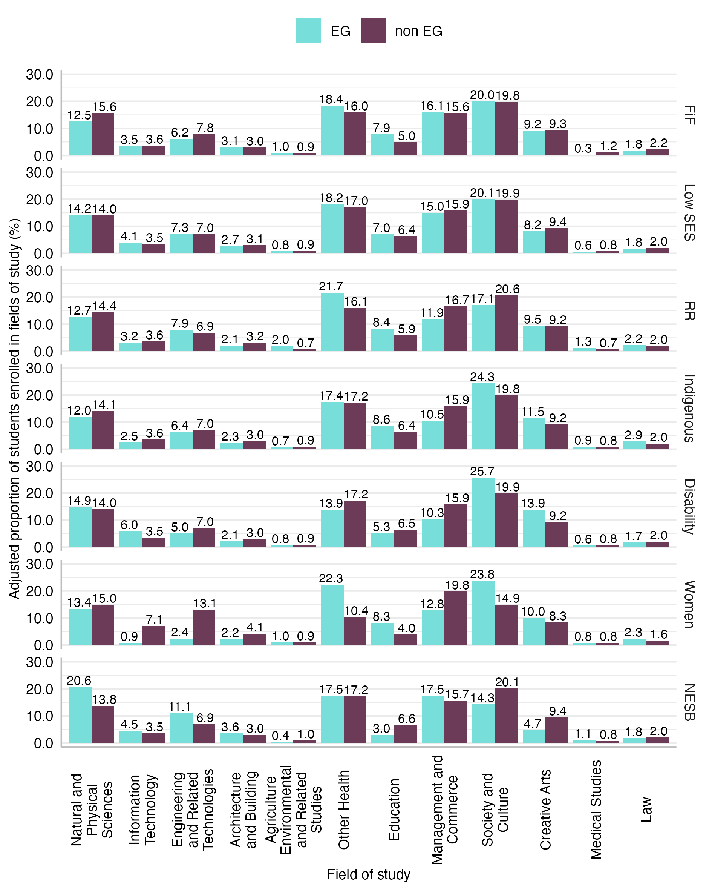
Notes: Data from PLIDA. EG: equity group. FiF: First-in-Family status. SES: socio-economic status. NESB: Non-English Speaking Background. RR: regional or remote. Predicted probabilities based on the model results presented in Table B-5 in Appendix B.
In the next step, the moderating effects of equity group membership were investigated. The results from Model IX (available in Table B-6 in Appendix B) were used to calculate predicted probabilities and average marginal effects for combinations of FiF status and equity group membership—for example, FiF students who also came from low SES areas and FiF students who did not come from low SES areas. Figure B-1 in Appendix B presents the predicted probabilities. The AMEs are shown below in Figure 12. The bars represent how much FiF status increased or decreased the average predicted probability of enrolling in a given field for members and non-members of the equity group listed on the right-hand side of the plot. For example, the first two values from the top left show the drop in predicted proportion associated with FiF status among low SES students (-2.7 pp) and non-low SES students (-3.1 pp), suggesting that the effect of FiF status is slightly larger among students who did not come from low SES backgrounds.
The moderating effects of Indigenous status, disability, NESB, and low SES background were not particularly strong. There were some exceptions—for example, education in the case of NESB and low SES students or society and culture in the case of students with disability. However, most of the time, the effects of FiF status did not differ significantly between equity group members and their non-equity group counterparts. The differences are small and mostly statistically non-significant.
The results looked different for RR and female students. In the case of RR students, the differences in AMEs were statistically significant for architecture and building, agriculture, environmental and related studies, natural and physical sciences, management and commerce, creative arts, and medical studies. FiF status had a negative effect on enrolments in architecture and building among RR students, who were already underrepresented, and positive among others. In the case of agriculture, environmental and related studies, the effect of FiF status was positive among RR, who were already overrepresented, and close to zero for others. In the case of other fields, FiF status had a stronger negative effect on groups that were overrepresented, for example, non-RR students’ enrolments in natural and physical sciences, or a stronger positive effect among underrepresented groups.
In the case of female students, the differences in AMEs were statistically significant for six fields of study. The effects of FiF status on enrolments were more negative among women than men in the case of natural and physical sciences, information technology, and architecture and building, fields in which women were underrepresented. At the same, FiF status had a stronger positive effect among female than male students on proportions studying education and other health subjects, fields in which female students were overrepresented. In contrast, for enrolments in creative arts, FiF status had a negative effect among women, who were already underrepresented, and positive among men.
Figure 12: Average marginal effects of First-in-Family status on field of study by equity group membership
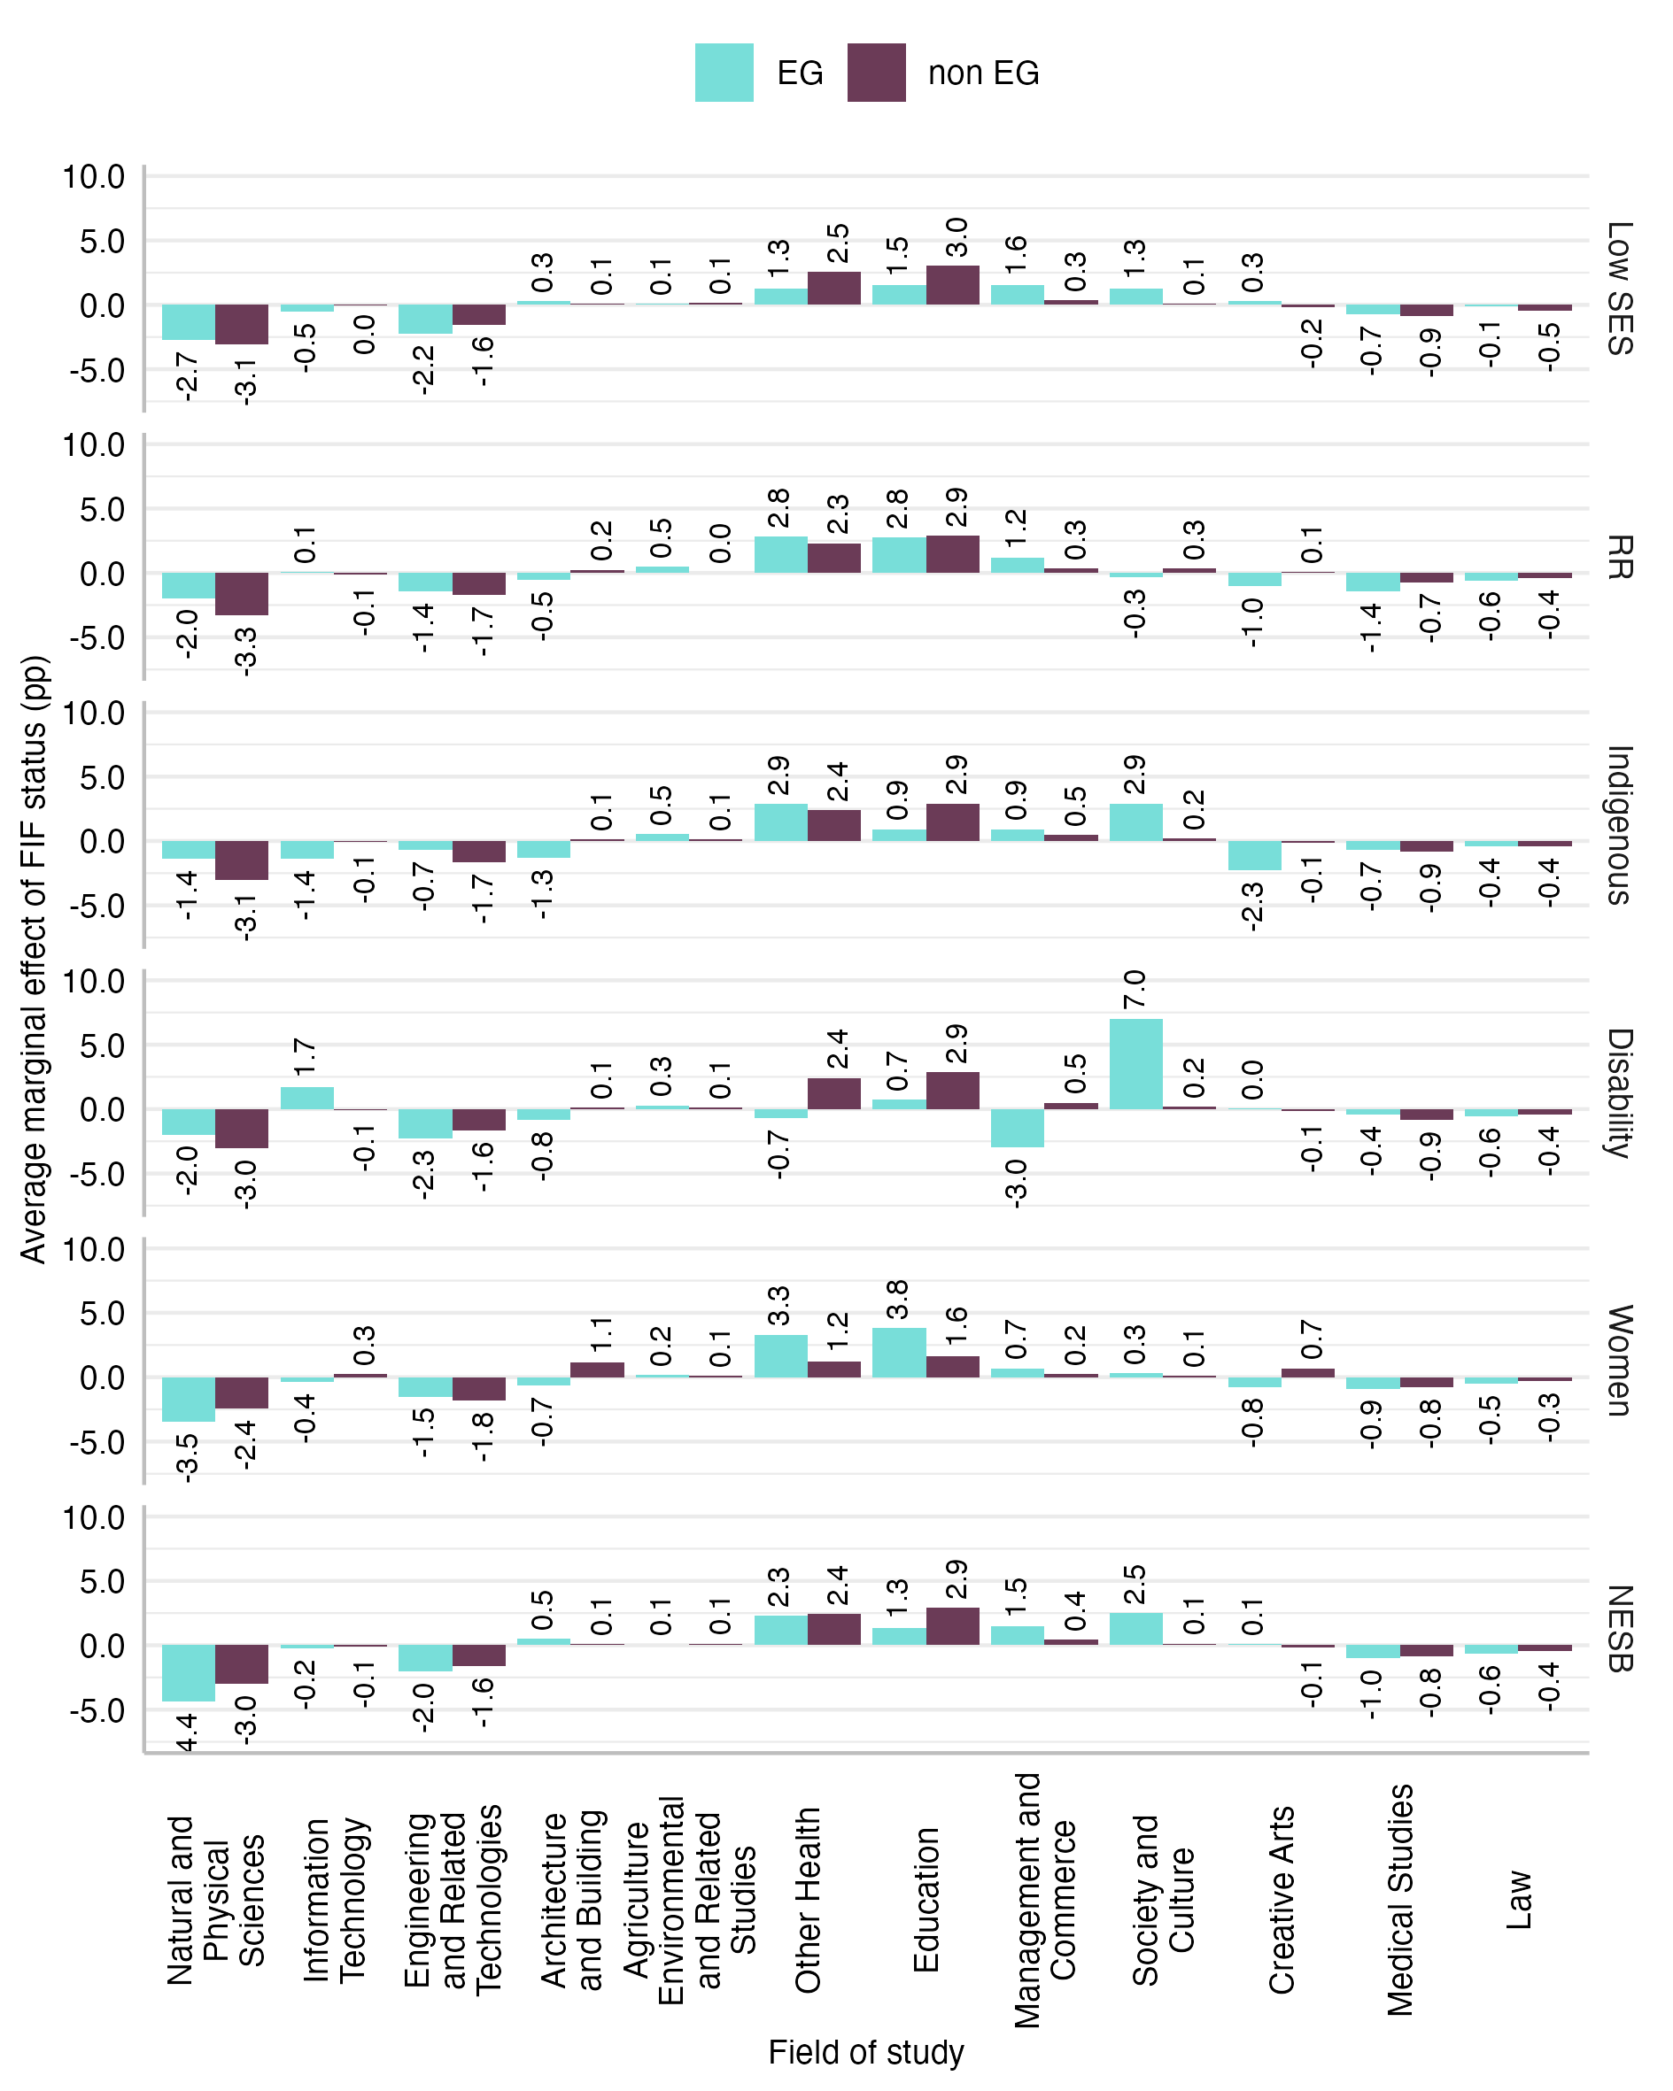
Notes: Data from PLIDA. EG: equity group. FiF: First-in-Family status. SES: socio-economic status. NESB: Non-English Speaking Background. RR: regional or remote. Predicted probabilities based on the model results presented in Table B-6 in Appendix B.

Additional analyses explored the effects of FiF status and equity group membership on fields of study chosen at selective institutions. The distribution of fields among students of selective institutions was somewhat different from that among the student population in general. While there were some differences in the patterns of over and underrepresentation of students from various disadvantaged backgrounds compared to the results presented above, the overall conclusions were similar. The tables and figures with the results are available in Appendix C.

Discussion
This study presents robust empirical evidence on the educational disadvantage of young people whose parents did not attend university and confirms the relevance of FiF status to Australia’s higher education equity framework. The analysis utilised novel and powerful linked administrative data to shed light on how FiF status impacts university enrolments.
The first part of the analysis focused on the link between equity groups and FiF status. It documented significant overlaps between FiF status and four equity groups: people from low SES backgrounds, people from RR areas, Indigenous people, and people with disability. The overlaps were particularly large for Indigenous and low SES, nearly 90% of whom belonged to the FiF category. However, over two-thirds of the sample were classified as FiF, compared to 18.0% who qualified as low SES and 3.9% as Indigenous, which meant that the vast majority of FiF individuals were not low SES or Indigenous.
The remainder of the analysis explored the relationships between FiF status, equity group membership, and access to higher education. Specifically, it investigated how FiF status affected enrolments in higher education in general, enrolments in selective institutions, and enrolments in specific fields of study. For each outcome, three regression models were fitted to evaluate the statistical effects of FiF status with and without controlling for equity group membership, as well as to assess if the effects of FiF status were moderated by equity group membership.
The first stage of the analysis revealed a wide gap associated with FiF status in chances of enrolling in a bachelor’s degree. The adjusted enrolment rate among the FiF category was 35.7% compared to 58.6% among those with university-educated parents. These results were based on a model that controlled for equity-group membership, meaning that these effects were net of the effects of equity groups. Furthermore, the same model allowed the effect of FiF status to be compared to those of equity group membership. Only people with disability were more disadvantaged compared to their peers. The gap in adjusted proportions stood at 30.7 pp for that group. The results are consistent with theoretical perspectives and empirical studies linking social background and educational outcomes (for example, Boudon, 1974; Bourdieu, 1973; Bourne et al., 2018; Czarnecki, 2018; Erikson, 2019; Jackson, 2013) and especially those pointing to the significant role of parental education (for example, Blossfeld, 2020; Buis, 2013; Chesters & Watson, 2013; Erola et al., 2016).
The next stage of the analysis looked only at those who enrolled in higher education and explored the effects of FiF status on entering a selective institution. This analysis provided evidence that FiF individuals, who were already less likely to enter higher education, were also less likely to secure a spot at a first-tier university. While over half of non-FiF students studied at a selective institution, the share among FiF students was only 39.3%. The results echo observations of equity scholars highlighting differences in access and participation by the type of institution (Bennett & Southgate, 2014; Stahl & McDonald, 2022). This is important because it means elite spaces remain exclusive, where the critical mass of the student body comes from professional-class backgrounds “with intimate knowledge of the educational system, where the academic language of the home has prepared them for their future educational pathways” (Thomsen, Munk, Eiberg-Madsen, & Hansen, 2011, pp. 469–470; see Smith et al. 2023)
The final stage of the analysis focused on the fields of study. The results from multinomial logistic regression models suggest that a large proportion of fields were equally likely to be studied by FiF students and their counterparts with university-educated parents. However, FiF students were significantly more likely than their peers to enrol in programs in education and other health (that is, health programs other than medical studies) and less likely than their peers to study natural and physical sciences, engineering and related technologies, and medical studies. That means that FiF students, while underrepresented in the fields that are often associated with high earning potential, were not overrepresented in the fields with the lowest earning potential. These results echo the findings of earlier studies reporting the underrepresentation of FiF students in more fields (Bennett & Southgate, 2014; Stahl & McDonald, 2022). Previous studies have reported FiF students’ practical approach to higher education prioritising employment outcomes (Gore, Holmes, Smith, Lyell, et al., 2015; Gore, Holmes, Smith, Southgate, et al., 2015; Krause et al., 2005) as well as their strong identification with the “caring professions” (O’Shea & Stone, 2014; Stahl and McDonald’s, 2022; 2023; Thomas & Hovdhaugen, 2023), which could explain the higher proportion of FiF students choosing education and programs in health other than medicine.
While the analysis focused primarily on FiF status, investigating how FiF status effects changed depending on whether equity group membership was taken into account was a key element of this study. Importantly, the effect of FiF status on university enrolment was largely independent of equity group membership. Adjusting the models for equity group membership did not meaningfully reduce the effects of FiF status. For example, the OR for FiF status in the model predicting university enrolment changed from 0.33 to 0.35 after introducing variables capturing equity group membership to the model.
Furthermore, the results showed that despite the significant overlaps between FiF status and some equity groups, the latter were important predictors of university enrolment. They had an effect on enrolments that was independent of FiF status. This is particularly relevant in the case of the area-based low SES indicator, which has attracted considerable attention. Soon after the six equity groups were defined, Western and collaborators (McMillan & Western, 2000; Western et al., 1998) argued that individual-level information on parental education and occupation serves as better indicators of low SES than area-based measures. In the following years, the area-based measure of low SES has received substantial criticism. For instance, an area-level measure that captures the average characteristics of households does not necessarily reflect individual circumstances, leading to measurement error (Bok, 2010; James et al., 2008). Furthermore, residential address information supplied at the time of higher education study may not accurately reflect where a student grew up (Dockery et al., 2016) and the 25% (quartile) cut-off is not granular enough to identify different levels of disadvantage (Harvey et al., 2016). By contrast, the results here strengthen the existing body of evidence suggesting that both the area-based indicator and parental education had a significant and independent impact on young people’s likelihood to access higher education (Tomaszewski et al., 2018; Zajac & Tomaszewski, 2023).
Lastly, the analysis included models with interaction terms to examine whether the effects of FIF status differed between equity group members and others. The results differed depending on the outcome variable. There was no evidence of strong moderating effects of equity group membership on the relationship between FiF status and university enrolments, with the exception of students with disability. In the case of enrolments in selective institutions, FiF status had a smaller effect among students from low SES, students from RR areas, Indigenous students, and students with disability than among their more privileged peers. The effects of FIF on the probability of studying most fields of study did not differ significantly between equity group and non-equity group students, with the exception of women. FiF status seems to exacerbate female disadvantage in some STEM fields and the overrepresentation of women in education and other health programs.
Notwithstanding the importance and robustness of the current findings, some study limitations must be acknowledged. First, although PLIDA includes information on family relationships that allowed children to be linked to their parents, Census data could not be used to reliably link individuals from the studied cohorts with their older siblings. Older siblings were likely to have left the household and be recorded as members of different households. While siblings are unlikely to provide financial support, they might be role models and provide assistance with navigating the higher education system.
In addition, the study was targeted in scope. It focused on just one stage of the student life course. To further understand the impact of FiF status, future research could examine its impact on later stages of the student life course, especially on the university-to-work transitions and longer-term labour market outcomes. PLIDA, with its large scale and expanding observation window, is well-suited for such research.
Finally, the study does not explore the mechanisms through which FiF status affects whether young people enter higher education, what type of institution they enrol in, and which field they study. The existing literature suggests a number of ways in which FiF status might affect educational pathways, including poorer school performance, limited financial resources, lack of support navigating the university system, or, more broadly, lack of cultural and social capital (Barsegyan & Maas, 2024; Ostrove & Long, 2007; Read, Archer, & Leathwood, 2003; Southgate et al., 2014). Unfortunately, with data at hand, factors that matter most could not be tested. Administrative data do not contain information on key variables necessary to evaluate each of those factors. However, further improvements to social science data infrastructure could open new research opportunities. Linking PLIDA to state-level educational data would enable, among others, large-scale research on how educational trajectories of FiF and non-FiF youth diverge over time and the possibility of investigating relative contributions of primary and secondary effects of parental education (Boudon, 1974).

Conclusion
The current study carries important lessons for policy and practice. This section briefly discusses the implications of the findings for the development of potential policy responses to increase equity in Australian higher education.
As noted in the previous section, not long after the six equity groups were defined, scholars argued for replacing the area-based measure of low SES with individual-level information, including parental education (McMillan & Western, 2000; Western et al., 1998). Partially to settle such debate, the Australian Government conducted two rounds of consultations in the higher education sector regarding how to capture the low SES background properly in the past decades. Specifically, in 2009, the Department of Education, Employment and Workplace Relations (DEEWR) initiated the first round of consultation in their discussion paper Measuring the Socio‐economic Status of Higher Education Students (DEEWR, 2009). Four years later, the Department of Industry, Innovation, Climate change, Science, Research and Tertiary Education (DIICSRTE) collated and summarised sector responses to DEEWR (2009) and made a decision to continue with the area-based measure to capture low SES in their discussion paper Moving to an Enhanced Indicator of HE Students’ Socio-economic Status (DIICSRTE, 2013). The area-based low SES proved to be an important predictor of education access in our analysis, so we would advise against abandoning it. However, FiF status had a greater impact on university enrolments, which leads us to issue the following recommendation:
Recommendation 1. The Australian Government and stakeholders at other levels should consider First-in-Family (FiF) status (or parental education) as another important factor affecting university enrolments, access to first-tier institutions, and certain fields of study.
As we noted describing the study’s limitations, we could identify mechanisms that contribute most to the observed differences in educational pathways between FiF individuals and their peers. This was partly because of the nature of administrative data, which by definition do not capture attitudes and opinions, and partly because the different Australian data assets are still not being fully integrated. We therefore further recommend that:
Recommendation 2. The different levels of the Australian Government and other stakeholders should work together to build a data asset covering the full educational paths that would allow investigation of when and how the educational pathways of FiF individuals and their peers diverge.
And:
Recommendation 3. The Australian Government should consider funding further research exploring why attitudes and aspirations of FiF young people differ from those of non-FiF youth and how they shape educational outcomes. This is needed to better understand the mechanisms leading to the divergence of educational pathways.
While prior studies described attitudes and aspirations of FiF students and documented differences in aspirations between FiF and non-FiF students (Patfield, Gore, & Weaver, 2022), they did not explain how those differences had arisen, nor to what extent they impacted enrolment patterns. While further studies are needed to fully understand the causes of the educational disadvantage of FiF students in Australia, the research will take time. Therefore, we should leverage existing literature to design policy interventions that might mitigate some of the effects of FiF status. The lack of cultural capital and the knowledge necessary to navigate the higher education system is a common thread in the literature. This leads us to our final recommendation:
Recommendation 4. The Australian Government and other stakeholders should invest in approaches to assist FiF individuals in gaining access to higher education, selective institutions, and fields in which they are underrepresented and expand outreach and career counselling programs that would equip FiF individuals with the knowledge necessary to navigate the higher education system as well as help them understand various career paths.
The programs should aim to engage young people early enough to give them time to choose a more university-oriented path in secondary education. While such programs will not solve the problem entirely, they are relatively easy to implement. They should not only benefit young people before the access stage but might also help those who enter higher education to stay on track.

References
Appadurai, A. (2004). The capacity to aspire: Culture and the terms of recognition. In V. Rao & M. Walton (Eds.), Culture and public action (pp. 59–84). Stanford University Press.
Aries, E., & Seider, M. (2005). The interactive relationship between class identity and the college experience: The case of lower income students. Qualitative Sociology, 28, 419–443. https://doi.org/10.1007/s11133-005-8366-1
Australian Government. (2009). Transforming Australia’s higher education system. DEEWR.
Australian Institute of Health and Welfare (AIHW). (2014). Towards a performance measurement framework for equity in higher education. Australian Institute of Health and Welfare.
Barsegyan, V., & Maas, I. (2024). First-generation students’ educational outcomes: the role of parental educational, cultural, and economic capital–a 9-years panel study. Research in Social Stratification and Mobility, 100939. https://doi.org/10.1016/j.rssm.2024.100939
Bennett, A., & Southgate, E. (2014). Excavating widening participation policy in Australian higher education: Subject positions, representational effects, emotion. Creative Approaches to Research, 7(1), 21–45.
Bernstein, B. (1962) Social class, linguistic codes and grammatical elements. Language and Speech, Vol 5, Issue 4.
Blossfeld, P. N. (2019). A multidimensional measure of social origin: theoretical perspectives, operationalization and empirical application in the field of educational inequality research. Quality & Quantity, 53(3), 1347-1367. https://doi.org/10.1007/s11135-018-0818-2
Blossfeld, P. N. (2020). The role of the changing social background composition for changes in inequality of educational opportunity: An analysis of the process of educational expansion in Germany 1950–2010. Advances in Life Course Research, 100338. https://doi.org/10.1016/j.alcr.2020.100338
Bok, J. (2010). The capacity to aspire to higher education: ‘It's like making them do a play without a script. Critical studies in education, 51(2), 163-178. https://doi.org/10.1080/17508481003731042
Boudon, R. (1974). Education, Opportunity and Social Inequality. Wiley.
Bourdieu, P. (1973). Cultural reproduction and social reproduction. In R. Brown (Ed.), Knowledge, Education and Cultural Change: Papers in the Sociology of Education (pp. 71-112). Tavistock.
Bourdieu, P. (1984). Distinction. A Social Critique of the Judgement of Taste. Harvard University Press.
Bourne, M., Bukodi, E., Betthäuser, B., & Goldthorpe, J. H. (2018). ‘Persistence of the social’: The role of cognitive ability in mediating the effects of social origins on educational attainment in Britain. Research in Social Stratification and Mobility, 58, 11-21.
Bowl, M. (2001). Experiencing the barriers: Non-traditional students entering higher education. Research Papers in Education, 16(2), 141-160. https://doi.org/10.1080/02671520110037410
Breen, R., & Goldthorpe, J. H. (1997). Explaining educational differentials towards a formal rational action theory. Rationality and Society, 9(3), 275-305. https://doi.org/10.1177/104346397009003002
Breen, R., van de Werfhorst, H. G., & Jæger, M. M. (2014). Deciding under doubt: A theory of risk aversion, time discounting preferences, and educational decision-making. European Sociological Review, 30(2), 258–270.
Buis, M. L. (2013). The composition of family background: The influence of the economic and cultural resources of both parents on the offspring's educational attainment in the Netherlands between 1939 and 1991. European sociological review, 29(3), 593-602.
Bukodi, E., Eibl, F., Buchholz, S., Marzadro, S., Minello, A., Wahler, S., Blossfeld, H.-P., Erikson, R., & Schizzerotto, A. (2018). Linking the macro to the micro: a multidimensional approach to educational inequalities in four European countries. European Societies, 20(1), 26-64. https://doi.org/10.1080/14616696.2017.1329934
Bukodi, E., & Goldthorpe, J. H. (2013). Decomposing ‘social origins’: The effects of parents’ class, status, and education on the educational attainment of their children. European sociological review, 29(5), 1024-1039.
Bunn, M., Burke, P. J., & Threadgold, S. (2022). Classed trajectories in higher education and the graduate labour market: Affective affinities in a ‘meritocracy’. British Journal of Sociology of Education, 43(8), 1273–1287.
Byrd, K. L., & MacDonald, G. (2005). Defining college readiness from the inside out: First-generation college student perspectives. Community College Review, 33(1), 22-37. https://doi.org/10.1177/009155210503300102
Cardak, B. A. and C. Ryan, 2009. Participation in Higher Education in Australia: Equity and Access*. Economic Record 85: 433-448.
Chesters, J., & Watson, L. (2013). Understanding the persistence of inequality in higher education: Evidence from Australia. Journal of Education Policy, 28(2), 198-215.
Chesters, J. & Watson, L. (2014). Returns to education for those returning to education: evidence from Australia. Studies in Higher Education. 39(9): 1634-1648.
Chesters, J. (2015). Maintaining inequality despite expansion: Evidence of the link between parents’ education and qualitative differences in educational attainment. Higher Education Quarterly, 69 (2), 138–157.
Chesters, J. (2019). Alleviating or exacerbating disadvantage: Does school attended mediate the association between family background and educational attainment?. Journal of Education Policy, 34(3), 331-350.
Collier, P. J., & Morgan, D. L. (2008). “Is that paper really due today?”: Differences in first-generation and traditional college students’ understandings of faculty expectations. Higher education, 55, 425-446. https://doi.org/10.1007/s10734-007-9065-5
Czarnecki, K. (2018). Less inequality through universal access? Socioeconomic background of tertiary entrants in Australia after the expansion of university participation. Higher education, 76(3), 501-518. https://doi.org/10.1007/s10734-017-0222-1
Dawkins, J. S. (1988). Higher education: a policy statement. Canberra: Australian Government Publishing Service.
Davies, S., & Rizk, J. (2018). The three generations of cultural capital research: A narrative review. Review of educational research, 88(3), 331-365.
David, M. (2021). Feminist imaginings challenging the world of academic capitalism for gender equality in global higher education. In C. Fontanini, K. M. Joshi, & S. Paivandi (Eds.), International perspectives on gender and higher education (pp. xv–xxx). Bingley: Emerald Publishing.
Department of Education Employment and Workplace Relations. (2009). Measuring the Socio‐economic Status of Higher Education Students: Discussion Paper. DEEWR.
Department of Employment, Education and Training (DEET). (1990). A fair chance for all: National and institutional planning for equity in higher education. Canberra: Australian Government Publishing Service.
Dillabough, J. A., (2004). "Class, Culture and the "Predicaments of Masculine Domination': Encountering Pierre Bourdieu." British Journal of Sociology of Education 25(4): 489-506.
DIICSRTE. (2013). Moving to an enhanced indicator of higher education students' socio-economic status. Department of Industry, Innovation, Climate change, Science, Research and Tertiary Education.
Dobson, I. R. (2001). How has massification changed the shape of Australian universities? Tertiary Education and Management, 7(4), 295-310.
Dockery, A. M., Seymour, R., & Koshy, P. (2016). Promoting low socio-economic participation in higher education: a comparison of area-based and individual measures. Studies in Higher Education, 41(9), 1692-1714. https://doi.org/10.1080/03075079.2015.1020777
Delahunty, J., & O’Shea, S. (2024). A critical exploration of first in family student persistence and the enactment of sisu. Higher Education, 1-18.
Dumais, S. A. (2002). Cultural capital, gender, and school success: The role of habitus. Sociology of Education, 75(1), 44-68. https://doi.org/10.2307/3090253
Erikson, R. (2016). Is it enough to be bright? Parental background, cognitive ability and educational attainment. European Societies, 18(2), 117-135. https://doi.org/10.1080/14616696.2016.1141306
Erikson, R. (2019). How does education depend on social origin? In R. Becker (Ed.), Research Handbook on the Sociology of Education (pp. 35-56). Edward Elgar Publishing.
Erola, J., Jalonen, S., & Lehti, H. (2016). Parental education, class and income over early life course and children's achievement. Research in Social Stratification and Mobility, 44, 33-43. https://doi.org/10.1016/j.rssm.2016.01.003
Evans, S. (2009). In a different place: Working-class girls and higher education. Sociology, 43(2), 340-355. https://doi.org/10.1177/0038038508101169
Gale, T., & Tranter, D. (2011). Social justice in Australian higher education policy: An historical and conceptual account of student participation. Critical studies in education, 52(1), 29-46.
Goldthorpe, J. H. (1996). Class analysis and the reorientation of class theory: The case of persisting differentials in educational attainment. British Journal of Sociology, 47(3), 481-505. https://doi.org/10.2307/591365
Goldthorpe, J. H. (2014). The role of education in intergenerational social mobility: Problems from empirical research in sociology and some theoretical pointers from economics. Rationality and Society, 26(3), 265–289.
Gore, J., Holmes, K., Smith, M., Lyell, A., Ellis, H., & Fray, L. (2015). Choosing University: The Impact of Schools and Schooling: Final Report to the National Centre for Student Equity in Higher Education. National Centre for Student Equity in Higher Education, Curtin University.
Gore, J., Holmes, K., Smith, M., Southgate, E., & Albright, J. (2015). Socioeconomic status and the career aspirations of Australian school students: Testing enduring assumptions. The Australian Educational Researcher, 42(2), 155-177.
Gunn, S. (2005). Translating Bourdieu: Cultural capital and the English middle class in historical perspective. British Journal of Sociology, 56(1), 49-64. https://doi.org/10.1111/j.1468-4446.2005.00046.x
Harvey, A., Andrewartha, L., & Burnheim, C. (2016). Out of Reach? University for People from Low Socio-Economic Status Backgrounds. In A. Harvey, C. Burnheim, & M. Brett (Eds.), Student Equity in Australian Higher Education: Twenty-five years of A Fair Chance for All (pp. 69-85). Springer Singapore. https://doi.org/10.1007/978-981-10-0315-8
Jackson, M. (Ed.). (2013). Determined to Succeed? Performance versus Choice in Educational Attainment. Stanford University Press.
Jæger, M. M., & Holm, A. (2007). Does parents’ economic, cultural, and social capital explain the social class effect on educational attainment in the Scandinavian mobility regime? Social science research, 36(2), 719-744. https://doi.org/10.1016/j.ssresearch.2006.11.003
James, R., Bexley, E., Anderson, A., Devlin, M., Garnett, R., Marginson, S., & Maxwell, L. (2008). Participation and equity: A review of the participation in higher education of people from low socioeconomic backgrounds and indigenous people. Centre for the Study of Higher Education, University of Melbourne.
King, S., Luzeckyj, A., McCann, B., & Graham, C. (2015). Exploring the experience of being first in family at university. National Centre for Student Equity: Curtin University.
Krause, K.-L., Hartley, R., James, R., & McInnis, C. (2005). The first year experience in Australian universities: Findings from a decade of national studies. Australian Department of Education, Science and Training.
Lareau, A., 2003. Unequal Childhoods. Berkley, Los Angeles, London, University of California Press.
Lehmann, W. (2009). " I just didn't feel like I fit in": The role of habitus in university dropout decisions. Canadian Journal of Higher Education, 37(2).
Loveday, V. (2016). Embodying deficiency through ‘affective practice’: Shame, relationality, and the lived experience of social class and gender in higher education. Sociology, 50(6), 1140-1155.
Lucas, S. R. (2001). Effectively maintained inequality: Education transitions, track mobility, and social background effects. American Journal of Sociology, 106(6), 1642–1690.
Luzeckyj, A., King, S., Scutter, S., & Brinkworth, R. (2011). The significance of being first: A consideration of cultural capital in relation to “first in family” student’s choices of university and program. A Practice Report. The International Journal of the First Year in Higher Education, 2(2), 91-96. https://doi.org/10.5204/intjfyhe.v2i2.89
Luzeckyj, A., McCann, B., Graham, C., King, S., & McCann, J. (2017). Being first in family: Motivations and metaphors. Higher Education Research & Development, 36(6), 1237-1250. https://doi.org/10.1080/07294360.2017.1300138
Martin, L. M. (1994). Equity and general performance indicators in higher education (Vols. 1 & 2). Canberra: Australian Government Publishing Service.
McCafferty, H., Tomlinson, M., & Kirby, S. (2024). ‘You have to work ten times harder’: first-in-family students, employability and capital development. Journal of Education and Work, 37(1-4), 32-47.
McDonald, S. (2024). ‘I don’t feel like I belong’: first-in-family girls’ constructions of belonging and space during the transition from secondary school into university. Gender and Education, 36(2), 183-197. https://doi.org/10.1080/09540253.2024.2308037
McDonald, S., & Stahl, G. (2024). ‘Girls do this, guys do that’: how first-in-family students negotiate working-class gendered subjectivities during a time of social change. The Australian Educational Researcher, 1-21. https://doi.org/10.1007/s13384-024-00717-0
McDonald, S., Stahl, G., Nguyen, T., & Fairbairn, K. (2024). Resourcing Their Own Aspirations: First-In-Family Young People and DIY Career Counselling. British Journal of Educational Studies, 72(2), 235-252.
McMillan, J., & Western, J. (2000). Measurement of the socio-economic status of Australian higher education students. Higher education, 39(2), 223-247.
Montacute, R. (2018). Access to Advantage: The influence of schools and place on admissions to top universities. https://www.suttontrust.com/wp-content/uploads/2019/12/AccesstoAdvantage-2018.pdf
Noble, J., & Davies, P. (2009). Cultural capital as an explanation of variation in participation in higher education. British journal of Sociology of Education, 30(5), 591-605. https://doi.org/10.1080/01425690903101098
O'Shea, S. (2007). Well, I Got here… but What Happens Next?–Exploring the Early Narratives of First Year Female Students Who Are the First in the Family to Attend University. JANZSSA-Journal of the Australian and New Zealand Student Services Association, 15(1), 36-51.
O'Shea, S., May, J., Stone, C., & Delahunty, J. (2024). First-in-family students, university experience and family life: Motivations, transitions and participation (2nd ed.). Palgrave Macmillan. https://doi.org/10.1007/978-3-031-34451-0
O'Shea, S., Stone, C., & May, J. (2014). Breaking the barriers: supporting and engaging mature age first-in-family university learners and their families 17th International FYHE Conference, Brisbane.
O’Shea, S., & Stone, C. (2014). The hero’s journey: Stories of women returning to education. The International Journal of the First Year in Higher Education, 5(1), 79–91. https://doi.org/10.5204/intjfyhe.v5i1.186
O’Shea, S. (2016). Avoiding the manufacture of ‘sameness’: First-in-family students, cultural capital and the higher education environment. Higher education, 72, 59-78. https://doi.org/10.1007/s10734-015-9938-y
O’Shea, S. (2019). Literature review: 'Mind the gap!' Exploring the post-graduation outcomes and employment mobility of individuals who are first in their family to complete a university degree. the National Centre for Student Equity in Higher Education (NCSEHE).
O’Shea, S. (2020). Crossing Boundaries: Rethinking the ways that first-in-family students navigate ‘barriers’ to higher education. British journal of Sociology of Education, 41(1), 95-110. https://doi.org/10.1080/01425692.2019.1668746
O’Shea, S., Groves, O., & Delahunty, J. (2021). ‘… having people that will help you, that know the ropes and have walked that road before you’: How does first in family status impact graduates in the employment field? Journal of Teaching and Learning for Graduate Employability, 12(2), 36-50.
Ostrove, J. M., & Long, S. M. (2007). Social class and belonging: Implications for college adjustment. The Review of Higher Education, 30(4), 363–389.
Palmisano, F., Biagi, F., & Peragine, V. (2022). Inequality of Opportunity in Tertiary Education: Evidence from Europe. Research in higher education, 63(3), 514-565.
Patfield, S., Gore, J., & Fray, L. (2021). Reframing first-generation entry: How the familial habitus shapes aspirations for higher education among prospective first-generation students. Higher Education Research & Development, 40(3), 599-612. https://doi.org/10.1080/07294360.2020.1773766
Patfield, S., Gore, J., & Fray, L. (2022). Degrees of “being first”: toward a nuanced understanding of first-generation entrants to higher education. Educational Review, 74(6), 1137-1156. https://doi.org/10.1080/00131911.2020.1740172
Patfield, S., Gore, J. & Weaver, N. (2022). On ‘being first’: the case for first-generation status in Australian higher education equity policy. Australian Educational Researcher, 49, 23–41. https://doi.org/10.1007/s13384-020-00428-2
Pitman, T., & Koshy, P. (2014). A framework for measuring equity performance in higher education: Draft framework document V1.6. Perth: National Centre for Student Equity in Higher Education
Productivity Commission. (2019). The demand driven university system: A mixed report card, Commission Research Paper. Productivity Commission.
Rauscher, E., & Elliott, W., III. (2014). The effects of wealth inequality on Higher Education outcomes: A critical review. Sociology Mind, 4, 282–297.
Read, B., Archer, L., & Leathwood, C. (2003). Challenging cultures? Student conceptions of ‘belonging’ and ‘isolation’ at a post-1992 university. Studies in Higher Education, 28(3), 261–277.
Reay, D., (2005). "Beyond Consciousness?: The Psychic Landscape of Social Class." Sociology 39(5): 911-928.
Reay, D., Crozier, G., & Clayton, J. (2009). ‘Strangers in paradise’? Working-class students in elite universities. Sociology, 43(6), 1103-1121. https://doi.org/10.1177/0038038509345700
Reay, D., David, M. E., & Ball, S. J. (2005). Degrees of choice: Class, race, gender and higher education. Trentham books.
Reay, D., Crozier, G., James, D. 2011. White Middle-Class Identities and Urban Schooling. Palgrave MacMillan.
Rubin, M., Evans, O., & McGuffog, R. (2019). Social class differences in social integration at university: Implications for academic outcomes and mental health. In J. Jetten, & K. Peters (Eds.), The social psychology of inequality (pp. 87–102). Cham: Springer.
Simmons, O. S. (2011). Lost in transition: The implications of social capital for higher education access. Notre Dame Law Review, 87(1), 205-252.
Southgate, E., Douglas, H., Scevak, J., Macqueen, S., Rubin, M., & Lindell, C. (2014). The academic outcomes of first-in-family in an Australian university: An exploratory study. International Studies in Widening Participation, 1(2), 31–35.
Spiegler, T., & Bednarek, A. (2013). First-generation students: What we ask, what we know and what it means: An international review of the state of research. International studies in sociology of education, 23(4), 318-337. https://doi.org/10.1080/09620214.2013.815441
Smith, J. A., Stahl, G., Harvey, A., Hill, B., Gupta, H., Moore, S., & Wang, J. (2023). Understanding the identity work and aspirations of Indigenous males navigating elite Australian higher education. Educational Review, 1-21.
Stahl, G., & McDonald, S. (2022). Gendering the First-in-Family Experience: Transitions, Liminality, Performativity. Routledge.
Stahl, G., & McDonald, S. (2023). Investigating the role of gender, social class and curriculum in the first-in-family higher education experience. Educational Review, 1-18. https://doi.org/10.1080/00131911.2023.2176468
Stahl, G., McDonald, S., & Young, J. (2021). Possible selves in a transforming economy: upwardly mobile working-class masculinities, service work and negotiated aspirations in Australia. Work, employment and society, 35(1), 97-115. https://doi.org/10.1177/0950017020922336
Stephens, N. M., Fryberg, S. A., Markus, H. R., Johnson, C. S., & Covarrubias, R. (2012). Unseen disadvantage: how American universities' focus on independence undermines the academic performance of first-generation college students. Journal of personality and social psychology, 102(6), 1178. https://doi.org/10.1037/a0027143
Teese, R. (2006). Condemned to innovate. In J. Schultz (Ed.), Griffith review edition 11 – Getting smart: The battle for ideas in education. Queensland: Griffith University.
Thomas, L., & Hovdhaugen, E. (2023). The role of professional passion and identity in improving diversity and success in professional education including teaching. In E. Keane, M. Heinz, & R. Mc Daid (Eds.), Diversifying the teaching profession (pp. 98–109). Routledge.
Thomsen, J. P., Munk, M. D., Eiberg-Madsen, M., & Hansen, G. I. (2011). The educational strategies of Danish university students from professional and working-class backgrounds. Comparative Education Review, 57(3), 457–480.
Tomaszewski, W., Kubler, M., Perales, F., Clague, D., Xiang, N., & Johnstone, M. (2020). Investigating the Effects of Cumulative Factors of Disadvantage. Institute for Social Science Research, Report Prepared for the Australian Government Department of Education, Skills and Employment.
Tomaszewski, W., Kubler, M., Perales, F., Western, M., Rampino, T., & Xiang, N. (2018). Review of identified equity groups. The University of Queensland submitted to the Australian Department of Education and Training.
Tomlinson, M. (2017). “Forms of Graduate Capital and Their Relationship to Graduate Employability.” Education & Training 59 (4): 338–352.
Tramonte, L., & Willms, J. D. (2010). Cultural capital and its effects on education outcomes. Economics of Education Review, 29(2), 200-213.
Tranter, D. (2011). Unequal schooling: how the school curriculum keeps students from low socio‐economic backgrounds out of university. International Journal of Inclusive Education, 16(9), 901-916. https://doi.org/10.1080/13603116.2010.548102
Walpole, M. (2003). Socioeconomic status and college: How SES affects college experiences and outcomes. The review of higher education, 27(1), 45-73.
Weis, L., & Cipollone, K. (2013). ‘Class work’: Producing privilege and social mobility in elite US secondary schools. British Journal of Sociology of Education, 34(5–6), 701–722.
Western, J. S., McMillan, J., & Durrington, D. (1998). Differential access to higher education: The measurement of socioeconomic status, rurality and isolation. Australian Government Publishing Service.
Wong, B. (2018). By chance or by plan?: The academic success of nontraditional students in higher education. AERA Open, 4(2), 2332858418782195. https://doi.org/10.1177/2332858418782195
Vincent, C., Ball, S., Rollock, N. and Gillborn, D. (2013) Three generations of racism: Black middle-class children and schooling. British Journal of Sociology of Education, 34(5–6), 929–946.
Zajac, T., & Tomaszewski, W. (2023). Relative influence of different markers of socioeconomic status on university participation. In AIHW (Ed.), Australia's welfare: 2023 data insights (pp. 193-214). Australian Institute of Health and Welfare (AIHW) Australian Government.
Zając, T., Perales, F., Xiang, N., Tomaszewski, W., & Zubrick, S. R. (2022). Investigating the relevance of mental health for the current equity groups framework: an analysis of multi-agency linked-administrative data. Perth, WA, Australia: National Centre for Student Equity in Higher Education.

Appendices

– Modelling approach
The models used to investigate the relationships between First-in-Family (FiF) and enrolment in higher education and enrolment in a selective institution had a similar form (the second variable was modelled only for those who enrolled in university studies). First, we fitted the baseline model of the following form:
$$\ln\left(\frac{p\left(E=1\right)}{1-p\left(E=1\right)}\right)= α+β_{1}FiF+ β_{2}C$$
Where E was a binary variable capturing, depending on the model, either university enrolment or enrolment in a selective institution; FiF represented First-in-Family status; C₁ was a set of control variables; α was the model’s intercept; β₁ and β₂ were vectors of coefficients to be estimated.
In the next steps, we investigated whether the effects of FIF status were independent of equity group membership by introducing measures of the latter as model controls. In the model specification below, EG stands for a set of dummy variables capturing membership in the equity groups. We assessed the results by comparing the coefficients on FiF status across the models.
$$\ln\left(\frac{p\left(E=1\right)}{1-p\left(E=1\right)}\right)= α+β_{1}FiF+ β_{2}EG+ β_{3}C$$
In the final step, we tested whether equity group membership had a moderating effect on the relationship between FIF status and university enrolment/enrolment in a selective institution. We did so by introducing interaction terms as follows:
$$\ln\left(\frac{p\left(E=1\right)}{1-p\left(E=1\right)}\right)= α+β_{1}FiF+ β_{2}EG+β_{3}(FiF×EG)+β_{4}C$$
For ease of interpretation, model results are expressed as odds ratios (ORs)—that is, exponentiated coefficients. ORs greater than 1 indicate that a one-unit increase in a given explanatory variable is associated with an increase in the odds of respondents taking the value 1 in the outcome variable, all else being equal. Correspondingly, ORs smaller than 1 indicate that a one-unit increase in a given explanatory variable is associated with a decrease in the odds of respondents taking the value 1 in the outcome variable, all else being equal. Furthermore, we used model results to calculate marginal predictions—adjusted or predicted probabilities of enrolling in higher education/enrolling in a selective institution—as well as average marginal effects (AME). Both marginal predictions and effects were calculated while holding covariates at the observed values.
To analyse the relationship between FiF status and field of study, we fitted three multinomial logistic regression models. These models were in fact a series of logistic regression models exploring how the independent variables are related to the ratio of the probability of studying a specific field and the probability of the baseline category—studying society and culture. The analysis was conducted in a manner similar to the analysis of enrolments; that is, the right-hand side of the equations changed in the same way as the logistic models discussed above. The models had the following forms:
$$\ln\left(\frac{p\left(F=j\right)}{p\left(F=S\&C\right)}\right)= α_{j}+β_{1j}FiF+ β_{2j}C$$
$$\ln\left(\frac{p\left(F=j\right)}{p\left(F=S\&C\right)}\right)= α_{j}+β_{1j}FiF+ β_{2j}EG+ β_{3j}C$$
$$\ln\left(\frac{p\left(F=j\right)}{p\left(F=S\&C\right)}\right)= α_{j}+β_{1j}FiF+ β_{2j}EG+β_{3j}(FiF×EG)+β_{4j}C$$
Where F was a categorical variable capturing the field of study; j represents a specific value of F; FiF represented First-in-Family status; EG stands for a set of dummy variables capturing membership in the equity groups; C was a set of control variables; α_{j} was the model’s intercept and β_{1j} to β_{4j} were vectors of coefficients to be estimated for the specific j-th value of F.
Model results were expressed as relative risk ratios, which are similar in interpretation to ORs. A relative risk ratio greater than 1 indicates that a one-unit increase in a given explanatory variable is associated with increased odds of respondents taking the value j in the outcome variable compared to the reference category, all else being equal. Correspondingly, a relative risk ratio smaller than 1 indicates that a one-unit increase in a given explanatory variable is associated with a decrease in the odds of respondents taking the value j in the outcome variable compared to the reference category, all else being equal. Furthermore, we calculated adjusted probabilities of enrolling in specific fields of study and AME.

– Additional tables
Table B-1: Descriptive statistics of all variables included in the analyses
 | Summary
N | 443,609
Enrolled in a bachelor’s level programme
0 | 56.5%
1 | 43.5%
Enrolled in a bachelor’s level programme at selective HEI
0 | 53.6%
1 | 46.4%
Field of study
Natural and Physical Sciences | 14.1%
Information Technology | 3.6%
Engineering and Related Technologies | 7.0%
Architecture and Building | 3.0%
Agriculture Environmental and Related Studies | 0.9%
Other Health | 17.2%
Education | 6.5%
Management and Commerce | 15.8%
Society and Culture | 19.9%
Creative Arts | 9.2%
Medical Studies | 0.8%
Law | 2.0%
Field of study at selective HEI
Natural and Physical Sciences | 20.2%
Information Technology | 3.4%
Engineering and Related Technologies | 8.9%
Architecture and Building | 3.4%
Agriculture Environmental and Related Studies | 0.7%
Other Health | 10.8%
Education | 3.1%
Management and Commerce | 17.9%
Society and Culture | 21.9%
Creative Arts | 7.1%
Medical Studies | 1.0%
Law | 1.6%
First-in-Family
Not First-in-Family | 33.5%
First-in-Family | 66.5%
Low SES
0 | 82.0%
1 | 18.0%
RR
0 | 71.0%
1 | 29.0%
Indigenous
0 | 96.1%
1 | 3.9%
NESB
0 | 96.6%
1 | 3.4%
Female
0 | 51.3%
1 | 48.7%
Disability
0 | 97.0%
1 | 3.0%
Father: manager/professional
0 | 72.4%
1 | 27.6%
Mother: manager/professional
0 | 74.7%
1 | 25.3%
Single-parent family
Couple | 75.8%
Single parent | 24.2%
Family income
$1,249 or less | 23.0%
$1,250-$1,999 | 18.8%
$2,000-$2,999 | 21.0%
$3,000 or more | 23.4%
Partial or no information | 13.8%
Notes: Data from PLIDA. SES: socio-economic status. NESB: Non-English Speaking Background. RR: regional or remote.

Table B-2: Model coefficients (odds ratios) from logistic regression models of enrolment in a bachelor’s level course.
Model number | I | II | III
Model title | FiF | FiF+EG | FiFxEG
FiF | 0.33*** | 0.35*** | 0.33***
Father: not manager/professional | 0.72*** | 0.73*** | 0.73***
Mother: not manager/professional | 0.89*** | 0.86*** | 0.86***
Single parent | 0.68*** | 0.68*** | 0.68***
Family income (ref. $3,000 or more)
$1,249 or less | 0.85*** | 0.98 | 0.98
$1,250-$1,999 | 0.85*** | 0.93*** | 0.93***
$2,000-$2,999 | 0.85*** | 0.90*** | 0.90***
Partial/no information | 0.80*** | 0.89*** | 0.89***
Low SES |  | 0.67*** | 0.69***
RR |  | 0.47*** | 0.47***
Indigenous |  | 0.37*** | 0.37***
NESB |  | 1.09*** | 1.13***
Women |  | 1.95*** | 1.78***
Disability |  | 0.15*** | 0.13***
FiF # Low SES |  |  | 0.96
FiF # RR |  |  | 0.99
FiF # Indigenous |  |  | 0.99
FiF # NESB |  |  | 0.95
FiF # Women |  |  | 1.15***
FiF # Disability |  |  | 1.39***
Observations | 443609 | 443609 | 443609
Pseudo R² | 0.085 | 0.138 | 0.138
Notes: Data from PLIDA. FiF: First-in-Family status. SES: socio-economic status. NESB: Non-English Speaking Background. RR: regional or remote. Statistical significance: * p < 0.05, ** p < 0.01, *** p < 0.001.

Table B-3: Model coefficients (odds ratios) from logistic regression models of enrolment in a selective institution
Model number | I | II | III
Model title | FiF | FiF+EG | FiFxEG
FiF | 0.51*** | 0.56*** | 0.56***
Father: not manager/professional | 0.84*** | 0.83*** | 0.84***
Mother: not manager/professional | 1.06*** | 0.99 | 0.99
Single parent | 0.99 | 0.99 | 0.99
Family income (ref. $3,000 or more)
$1,249 or less | 1.05** | 1.08*** | 1.09***
$1,250-$1,999 | 0.86*** | 0.90*** | 0.91***
$2,000-$2,999 | 0.79*** | 0.82*** | 0.83***
Partial/no information | 0.92*** | 1.01 | 1.01
Low SES |  | 0.77*** | 0.66***
RR |  | 0.36*** | 0.33***
Indigenous |  | 0.75*** | 0.66***
NESB |  | 1.43*** | 1.32***
Women |  | 0.88*** | 0.92***
Disability |  | 0.54*** | 0.50***
FiF # Low SES |  |  | 1.24***
FiF # RR |  |  | 1.18***
FiF # Indigenous |  |  | 1.21*
FiF # NESB |  |  | 1.19***
FiF # Women |  |  | 0.90***
FiF # Disability |  |  | 1.17
Observations | 192995 | 192995 | 192995
Pseudo R² | 0.027 | 0.056 | 0.057
Notes: Data from PLIDA. FiF: First-in-Family status. SES: socio-economic status. NESB: Non-English Speaking Background. RR: regional or remote. Statistical significance: * p < 0.05, ** p < 0.01, *** p < 0.001.

Table B-4: Model coefficients (RR) from Model VII, multinomial logistic regression models of field of study
Outcome (ref. Society & Culture) | Natural & Physical Sciences | Information Technology | Engineering & Related Technology | Architecture & Building | Agriculture Environmental & Rel. Studies | Other Health | Education | Management & Commerce | Creative Arts | Medical Studies | Law
FiF | 0.75*** | 0.84*** | 0.69*** | 0.93* | 1.24*** | 1.20*** | 1.70*** | 0.94*** | 0.98 | 0.28*** | 0.80***
Father: not manager/professional | 0.97 | 1.06 | 0.98 | 0.93* | 0.71*** | 1.13*** | 1.14*** | 0.94** | 0.91*** | 0.62*** | 0.86***
Mother: not manager/professional | 1.11*** | 1.30*** | 1.13*** | 1.11** | 0.73*** | 1.03 | 0.96 | 1.20*** | 0.98 | 0.82*** | 0.97
Single parent | 0.75*** | 0.71*** | 0.66*** | 0.64*** | 0.93 | 0.73*** | 0.73*** | 0.82*** | 0.99 | 0.66*** | 1.04
Family income (ref. $3,000 or more)
$1,249 or less | 1.29*** | 1.51*** | 1.17*** | 1.14* | 1.04 | 0.93* | 0.90** | 0.93** | 1.00 | 1.38** | 0.94
$1,250-$1,999 | 1.15*** | 1.38*** | 1.11** | 1.04 | 1.37*** | 1.06* | 1.13*** | 0.92** | 1.09** | 0.92 | 1.03
$2,000-$2,999 | 1.06* | 1.24*** | 1.08* | 0.93 | 1.48*** | 1.09*** | 1.22*** | 0.89*** | 1.11*** | 0.92 | 0.99
Partial/no information | 1.11*** | 0.97 | 1.02 | 1.07 | 1.50*** | 1.02 | 0.94 | 0.89*** | 1.02 | 1.16 | 1.06
Observations | 192995
Pseudo R² | 0.005
Notes: Data from PLIDA. FiF: First-in-Family status. SES: socio-economic status. NESB: Non-English Speaking Background. RR: regional or remote. Statistical significance: * p < 0.05, ** p < 0.01, *** p < 0.001.

Table B-5: Model coefficients (RR) from Model VIII, multinomial logistic regression models of field of study
Outcome (ref. Society & Culture) | Natural & Physical Sciences | Information Technology | Engineering & Related Technology | Architecture & Building | Agriculture Environmental & Rel. Studies | Other Health | Education | Management & Commerce | Creative Arts | Medical Studies | Law
FiF | 0.79*** | 0.93* | 0.76*** | 1.01 | 1.13* | 1.15*** | 1.59*** | 1.00 | 0.97 | 0.28*** | 0.80***
Low SES | 1.00 | 1.15*** | 1.03 | 0.88** | 0.87 | 1.06* | 1.10** | 0.93** | 0.87*** | 0.76* | 0.88*
RR | 1.06* | 1.01 | 1.35*** | 0.75*** | 3.40*** | 1.64*** | 1.73*** | 0.84*** | 1.24*** | 2.29*** | 1.34***
Indigenous | 0.68*** | 0.53*** | 0.70*** | 0.59*** | 0.59* | 0.83** | 1.10 | 0.53*** | 1.01 | 0.95 | 1.16
NESB | 2.17*** | 2.00*** | 2.50*** | 1.79*** | 0.57** | 1.41*** | 0.62*** | 1.63*** | 0.71*** | 1.93*** | 1.23*
Women | 0.55*** | 0.08*** | 0.11*** | 0.33*** | 0.67*** | 1.35*** | 1.33*** | 0.40*** | 0.75*** | 0.65*** | 0.87***
Disability | 0.81* | 1.28* | 0.54*** | 0.53** | 0.62 | 0.63*** | 0.63*** | 0.50*** | 1.16 | 0.55 | 0.67
Father: not manager/professional | 0.96 | 1.09* | 1.00 | 0.94 | 0.75*** | 1.12*** | 1.14*** | 0.95* | 0.92*** | 0.62*** | 0.87***
Mother: not manager/professional | 1.10*** | 1.29*** | 1.14*** | 1.09** | 0.81*** | 1.05** | 0.99 | 1.19*** | 1.00 | 0.87* | 0.98
Single parent | 0.78*** | 0.75*** | 0.69*** | 0.66*** | 0.95 | 0.73*** | 0.72*** | 0.84*** | 0.98 | 0.68*** | 1.05
Family income (ref. $3,000 or more)
$1,249 or less | 1.22*** | 1.42*** | 1.10* | 1.12* | 1.01 | 0.90*** | 0.89** | 0.92** | 1.02 | 1.30** | 0.93
$1,250-$1,999 | 1.11*** | 1.37*** | 1.09* | 1.06 | 1.27** | 1.02 | 1.10** | 0.93** | 1.10** | 0.86 | 1.02
$2,000-$2,999 | 1.04 | 1.22*** | 1.05 | 0.94 | 1.38*** | 1.06* | 1.19*** | 0.89*** | 1.11*** | 0.87 | 0.98
Partial/no information | 1.09** | 0.95 | 0.98 | 1.08 | 1.30** | 0.96 | 0.89** | 0.90*** | 1.01 | 1.06 | 1.03
Observations | 192995
Pseudo R² | 0.038
Notes: Data from PLIDA. FiF: First-in-Family status. SES: socio-economic status. NESB: Non-English Speaking Background. RR: regional or remote. Statistical significance: * p < 0.05, ** p < 0.01, *** p < 0.001.
Table B-6: Model coefficients (RR) from Model IX, multinomial logistic regression models of field of study
Outcome (ref. Society & Culture) | Natural & Physical Sciences | Information Technology | Engineering & Related Technology | Architecture & Building | Agriculture Environmental & Rel. Studies | Other Health | Education | Management & Commerce | Creative Arts | Medical Studies | Law
FiF | 0.83*** | 1.05 | 0.86*** | 1.36*** | 1.01 | 1.14*** | 1.67*** | 0.99 | 1.11** | 0.30*** | 0.84**
Low SES | 1.03 | 1.31*** | 1.14* | 0.88 | 0.93 | 1.18*** | 1.44*** | 0.91 | 0.88* | 0.84 | 0.83
RR | 1.00 | 0.96 | 1.28*** | 0.88* | 3.01*** | 1.61*** | 1.88*** | 0.79*** | 1.30*** | 2.29*** | 1.36***
Indigenous | 0.69** | 0.80 | 0.71 | 0.93 | 0.31* | 0.89 | 1.58** | 0.55*** | 1.25 | 0.90 | 1.21
NESB | 2.33*** | 2.15*** | 2.59*** | 1.81*** | 0.60 | 1.53*** | 0.67*** | 1.72*** | 0.75*** | 1.98*** | 1.41**
Women | 0.58*** | 0.10*** | 0.14*** | 0.43*** | 0.65*** | 1.33*** | 1.29*** | 0.39*** | 0.81*** | 0.68*** | 0.90*
Disability | 0.91 | 1.24 | 0.69* | 0.75 | 0.63 | 0.81 | 0.89 | 0.68** | 1.34* | 0.57 | 0.82
FiF # Low SES | 0.97 | 0.84 | 0.87 | 1.01 | 0.91 | 0.87* | 0.71*** | 1.02 | 0.99 | 0.84 | 1.10
FiF # RR | 1.12* | 1.09 | 1.10 | 0.74*** | 1.25* | 1.02 | 0.87** | 1.12** | 0.93 | 0.96 | 0.97
FiF # Indigenous | 0.98 | 0.54* | 1.00 | 0.50* | 2.15 | 0.92 | 0.62** | 0.94 | 0.74 | 1.28 | 0.96
FiF # NESB | 0.86 | 0.85 | 0.92 | 0.97 | 0.88 | 0.84* | 0.86 | 0.90 | 0.89 | 1.05 | 0.72
FiF # Women | 0.90** | 0.64*** | 0.59*** | 0.56*** | 1.07 | 1.03 | 1.04 | 1.04 | 0.85*** | 0.93 | 0.95
FiF # Disability | 0.83 | 1.06 | 0.61 | 0.49 | 0.97 | 0.63* | 0.56* | 0.55** | 0.78 | 1.18 | 0.68
Father: not manager/professional | 0.96 | 1.08* | 0.99 | 0.94 | 0.75*** | 1.12*** | 1.13*** | 0.95* | 0.92*** | 0.62*** | 0.86***
Mother: not manager/professional | 1.09*** | 1.29*** | 1.13*** | 1.10** | 0.80*** | 1.05** | 1.00 | 1.19*** | 1.00 | 0.87* | 0.98
Single parent | 0.78*** | 0.75*** | 0.70*** | 0.67*** | 0.95 | 0.74*** | 0.72*** | 0.84*** | 0.98 | 0.68*** | 1.05
Family income (ref. $3,000 or more)
$1,249 or less | 1.22*** | 1.42*** | 1.10* | 1.12* | 1.01 | 0.89*** | 0.89** | 0.92** | 1.02 | 1.30** | 0.93
$1,250-$1,999 | 1.11*** | 1.36*** | 1.08* | 1.05 | 1.28** | 1.01 | 1.09* | 0.93** | 1.10** | 0.86 | 1.01
$2,000-$2,999 | 1.04 | 1.22*** | 1.05 | 0.93 | 1.38*** | 1.05* | 1.18*** | 0.89*** | 1.10*** | 0.87 | 0.98
Partial/no information | 1.09** | 0.95 | 0.98 | 1.08 | 1.30*** | 0.96 | 0.89** | 0.90*** | 1.00 | 1.06 | 1.03
Observations | 192995
Pseudo R² | 0.039
Notes: Data from PLIDA. FiF: First-in-Family status. SES: socio-economic status. NESB: Non-English Speaking Background. RR: regional or remote. Statistical significance: * p < 0.05, ** p < 0.01, *** p < 0.001.
Figure B-1: Adjusted proportions of students enrolled in fields of study by First-in-Family status and equity group membership
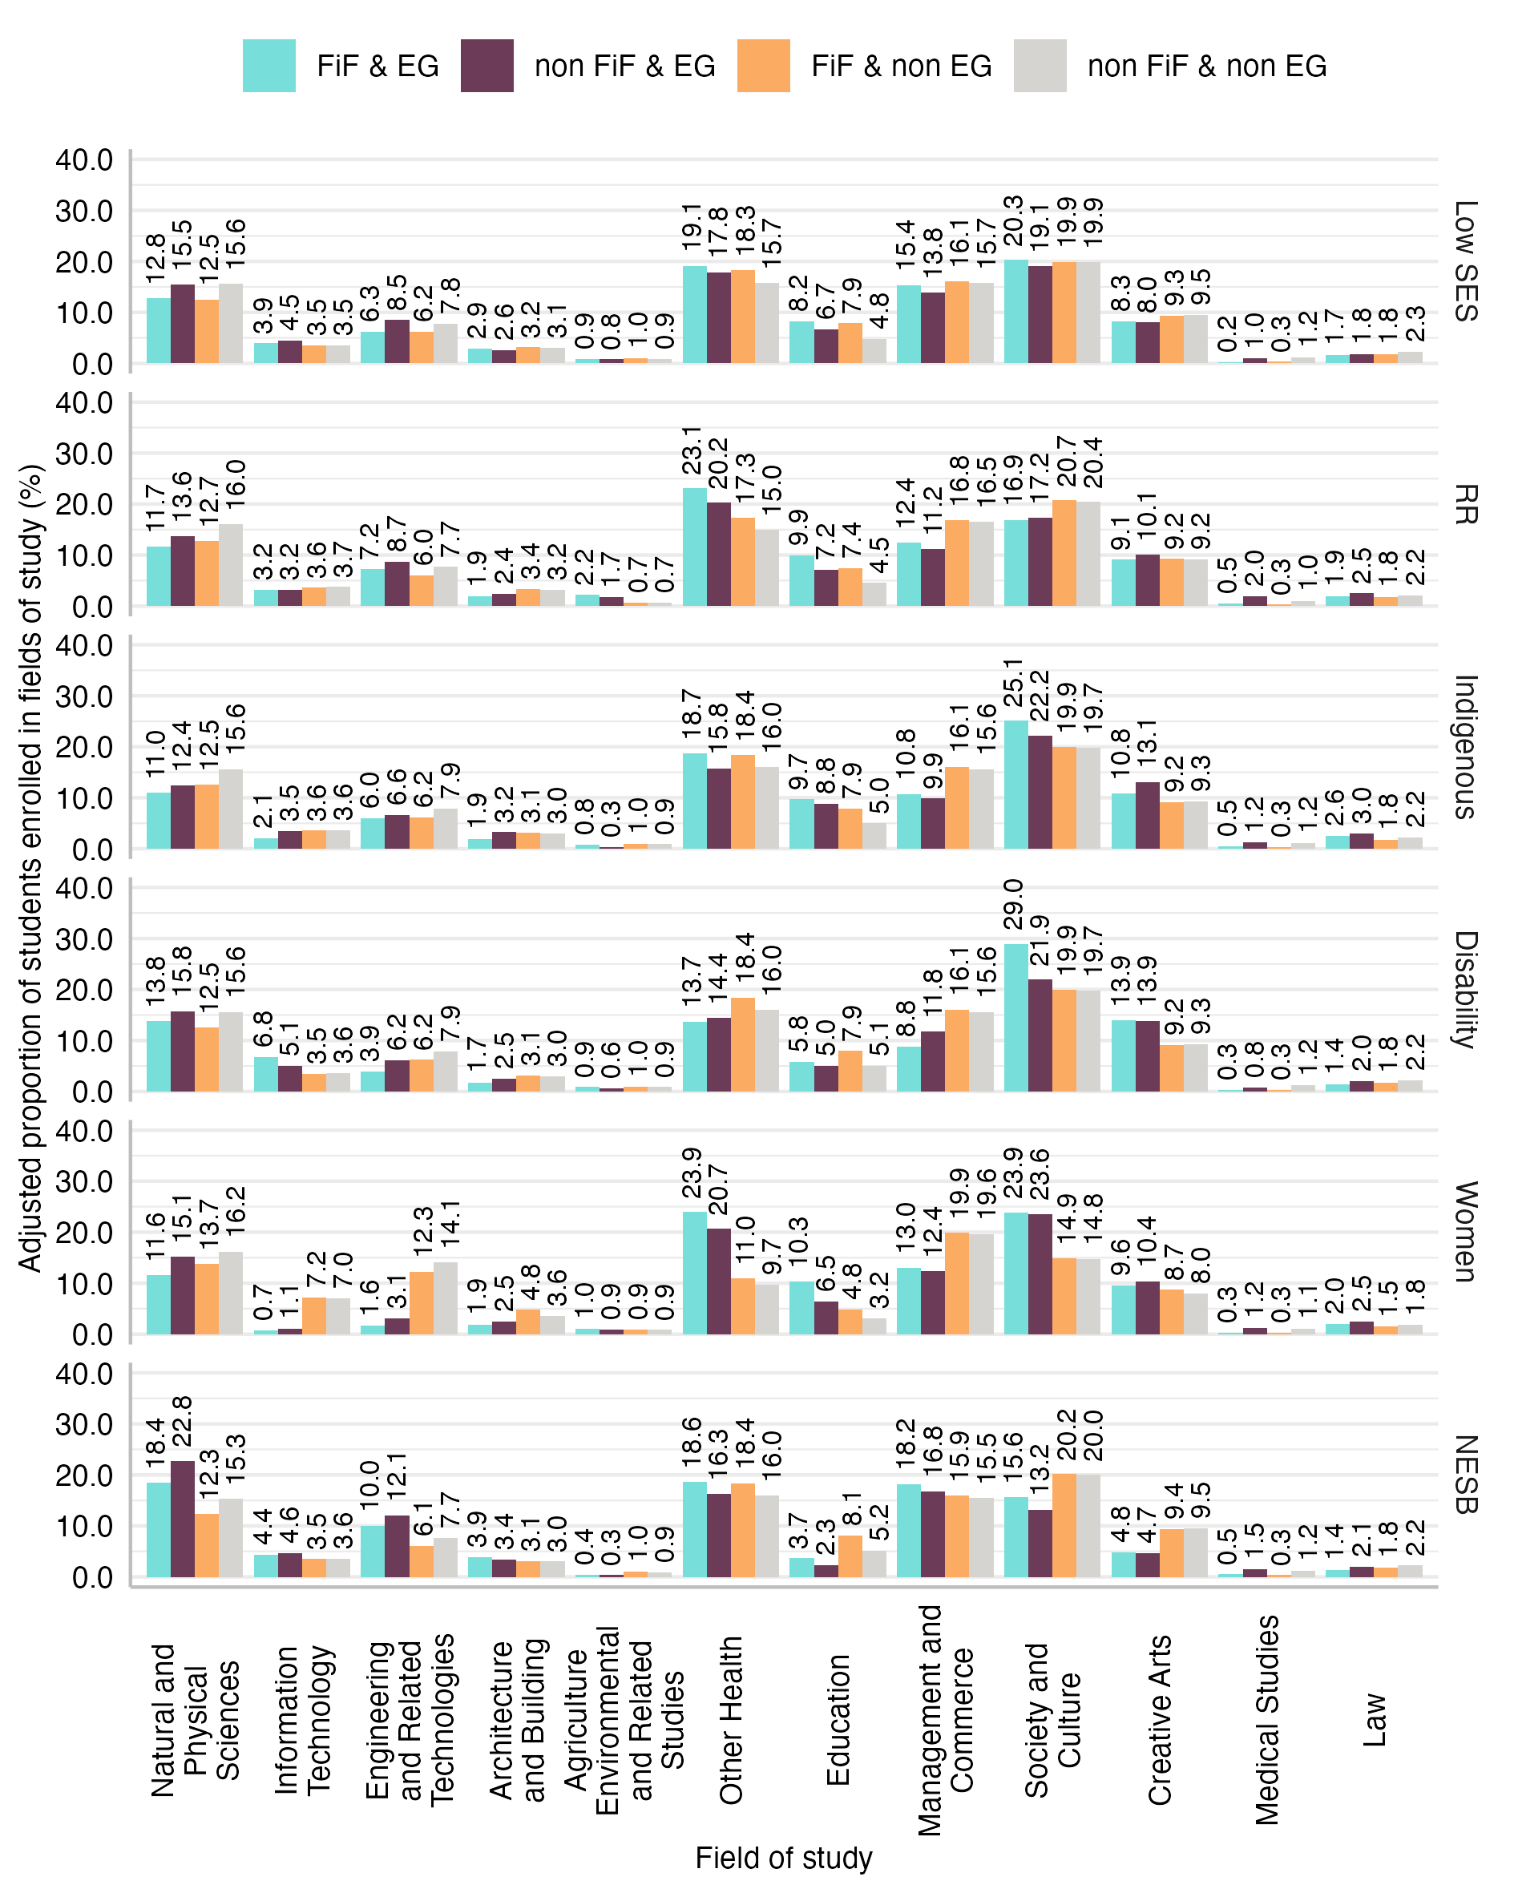
Notes: Data from PLIDA. EG: equity group. FiF: First-in-Family status. SES: socio-economic status. NESB: Non-English Speaking Background. RR: regional or remote. Predicted probabilities based on the model results presented in Table B-6 in Appendix B.

– Field of study at selective institutions
Figure C-1: Adjusted proportions of students enrolled in fields of study at selective institutions by First-in-Family status and equity group membership
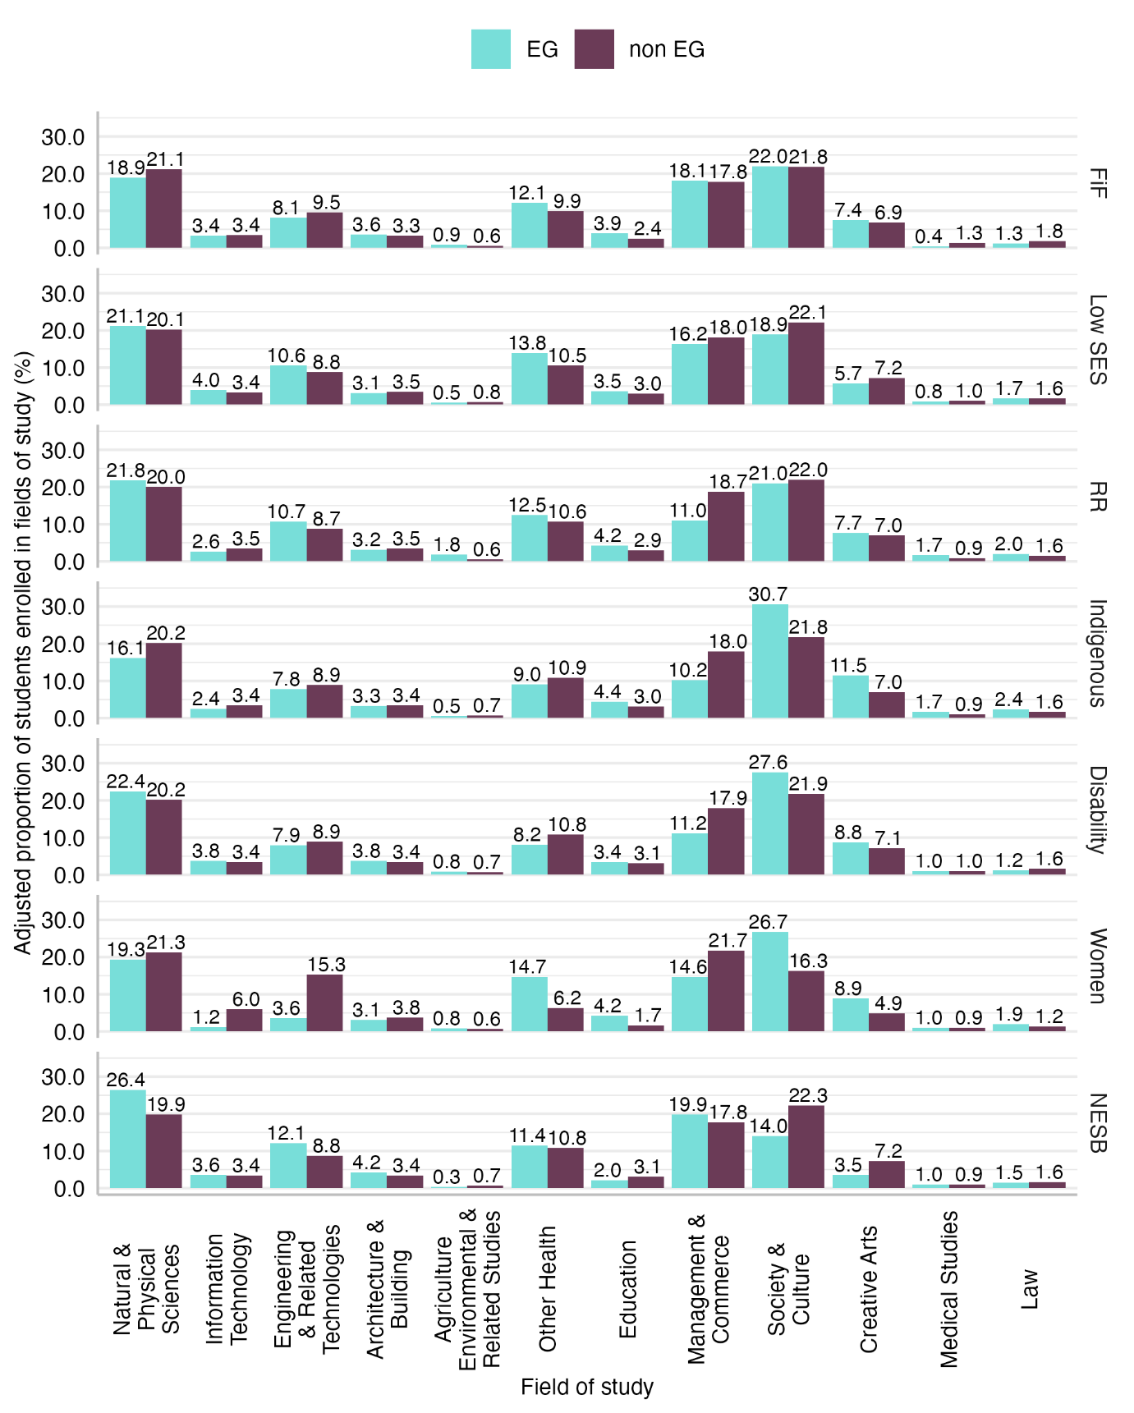
Notes: Data from PLIDA. EG: equity group. FiF: First-in-Family status. SES: socio-economic status. NESB: Non-English Speaking Background. RR: regional or remote. Predicted probabilities based on the model results presented in Table C-2.
Figure C-2: Adjusted proportions of students enrolled in fields of study at selective institutions by First-in-Family status and equity group membership
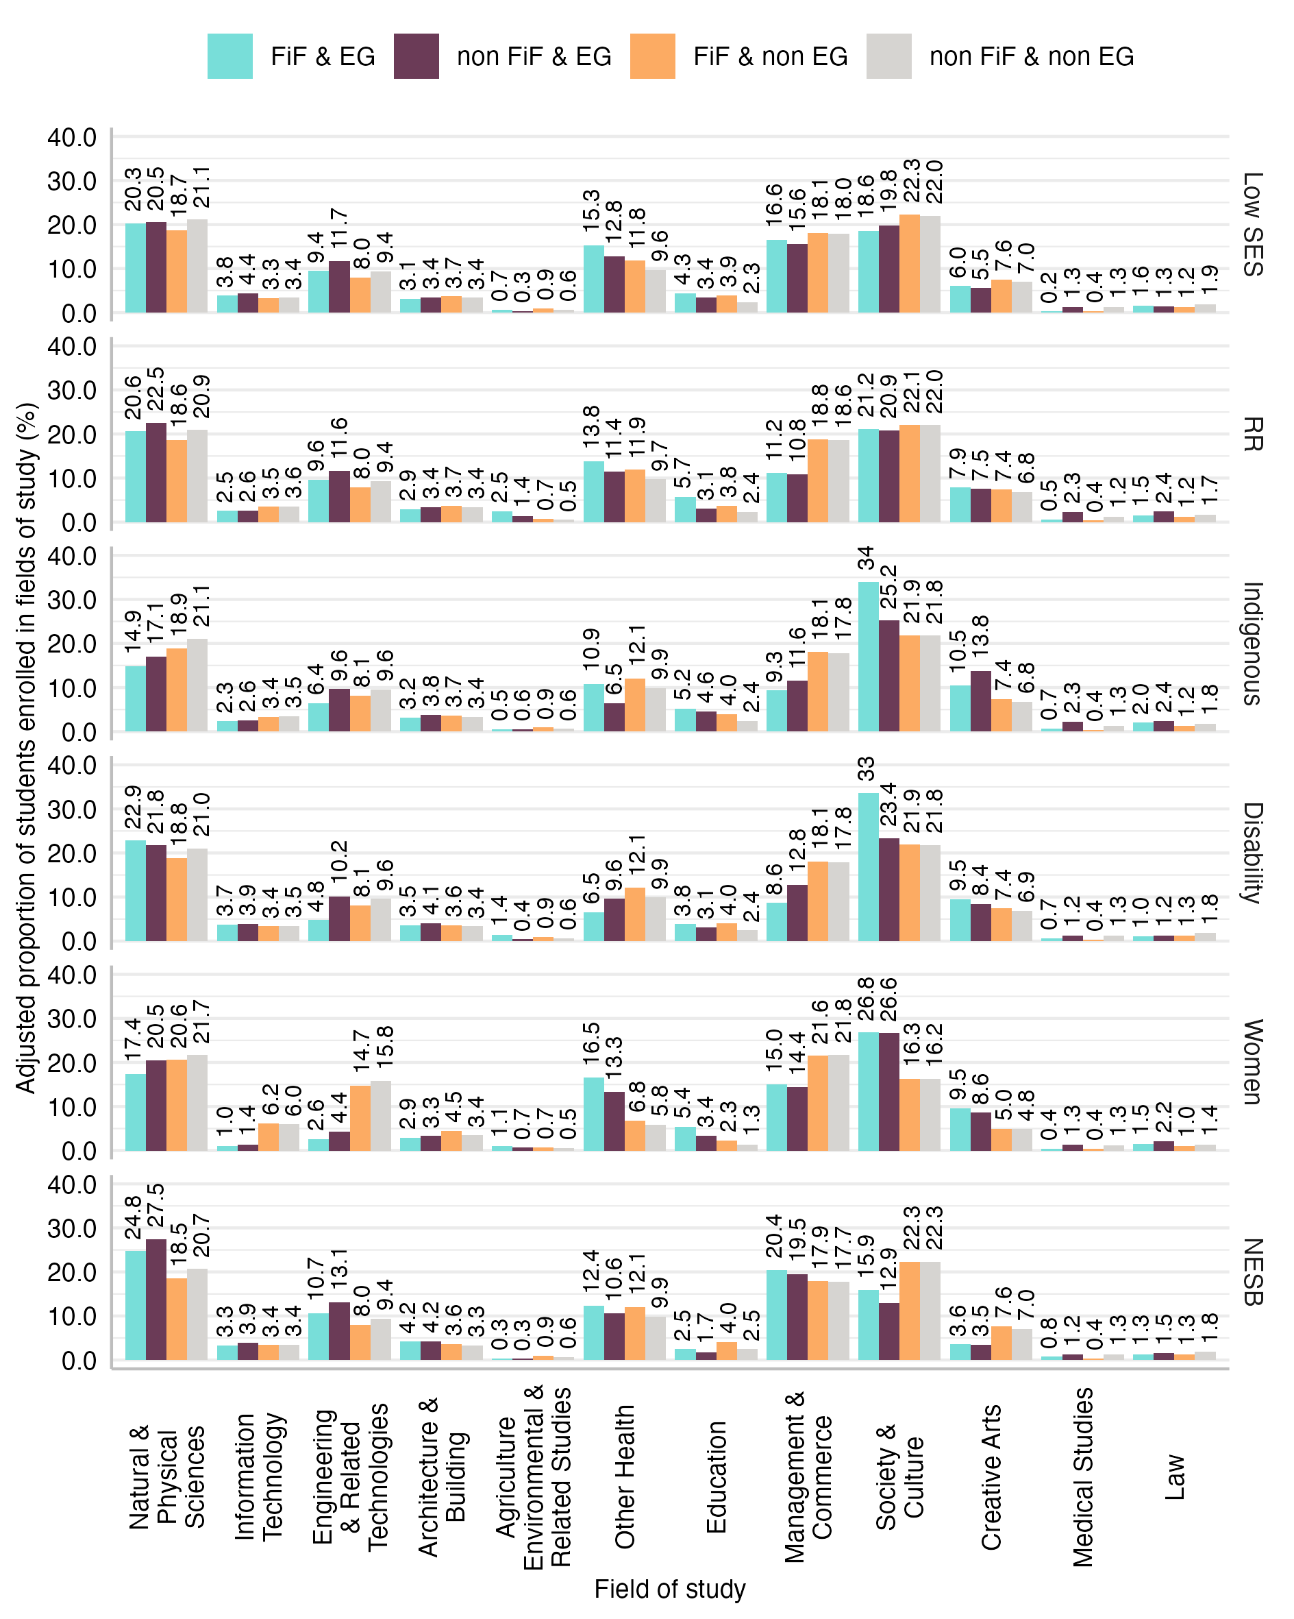
Notes: Data from PLIDA. EG: equity group. FiF: First-in-Family status. SES: socio-economic status. NESB: Non-English Speaking Background. RR: regional or remote. Predicted probabilities based on the model results presented in Table C-3.

Figure C-3: Average marginal effects of First-in-Family status on field of study at a selective institution by equity-group membership
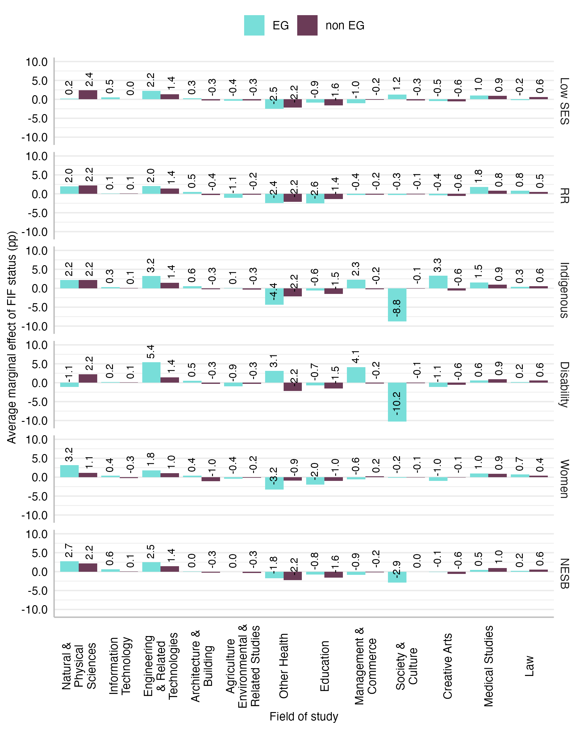
Notes: Data from PLIDA. EG: equity group. FiF: First-in-Family status. SES: socio-economic status. NESB: Non-English Speaking Background. RR: regional or remote. Predicted probabilities based on the model results presented in Table C-3.

Table C-1: Model coefficients (RR) from Model X, multinomial logistic regression models of field of study at selective institutions
Outcome (ref. Society & Culture) | Natural & Physical Sciences | Information Technology | Engineering & Related Technology | Architecture & Building | Agriculture Environmental & Rel. Studies | Other Health | Education | Management & Commerce | Creative Arts | Medical Studies | Law
FiF | 0.86*** | 0.90* | 0.80*** | 1.02 | 1.60*** | 1.25*** | 1.71*** | 0.94* | 1.09* | 0.28*** | 0.70***
Father: not manager/professional | 1.04 | 1.15** | 1.07* | 0.97 | 0.76** | 1.22*** | 1.24*** | 0.99 | 0.92* | 0.69*** | 0.87*
Mother: not manager/professional | 1.13*** | 1.44*** | 1.21*** | 1.09 | 0.87 | 1.15*** | 1.00 | 1.28*** | 1.00 | 0.88 | 1.03
Single parent | 0.70*** | 0.66*** | 0.63*** | 0.65*** | 0.94 | 0.60*** | 0.71*** | 0.75*** | 0.94 | 0.52*** | 1.09
Family income (ref. $3,000 or more)
$1,249 or less | 1.44*** | 1.57*** | 1.34*** | 1.33*** | 0.89 | 1.36*** | 1.18* | 1.08* | 1.00 | 2.10*** | 1.21
$1,250-$1,999 | 1.25*** | 1.44*** | 1.24*** | 1.21** | 1.21 | 1.32*** | 1.37*** | 0.98 | 1.09 | 1.23 | 1.20
$2,000-$2,999 | 1.11*** | 1.30*** | 1.12** | 1.08 | 1.35** | 1.23*** | 1.34*** | 0.87*** | 1.11* | 1.15 | 1.05
Partial/no information | 1.08* | 0.96 | 1.02 | 1.17* | 1.27 | 1.00 | 0.93 | 0.89** | 0.99 | 1.22 | 1.20*
Observations | 89522
Pseudo R² | 0.005
Notes: Data from PLIDA. FiF: First-in-Family status. SES: socio-economic status. NESB: Non-English Speaking Background. RR: regional or remote. Statistical significance: * p < 0.05, ** p < 0.01, *** p < 0.001.

Table C-2: Model coefficients (RR) from Model XI, multinomial logistic regression models of field of study at selective institutions
Outcome (ref. Society & Culture) | Natural & Physical Sciences | Information Technology | Engineering & Related Technology | Architecture & Building | Agriculture Environmental & Rel. Studies | Other Health | Education | Management & Commerce | Creative Arts | Medical Studies | Law
FiF | 0.88*** | 0.94 | 0.82*** | 1.06 | 1.50*** | 1.22*** | 1.63*** | 0.99 | 1.08* | 0.28*** | 0.69***
Low SES | 1.23*** | 1.41*** | 1.42*** | 1.04 | 0.80 | 1.54*** | 1.38*** | 1.06 | 0.93 | 0.99 | 1.24*
RR | 1.13*** | 0.75*** | 1.26*** | 0.94 | 3.11*** | 1.24*** | 1.53*** | 0.61*** | 1.15** | 1.96*** | 1.37***
Indigenous | 0.55*** | 0.47** | 0.58*** | 0.66 | 0.48 | 0.59*** | 1.05 | 0.39*** | 1.17 | 1.27 | 1.05
NESB | 2.16*** | 1.84*** | 2.35*** | 1.99*** | 0.67 | 1.66*** | 1.03 | 1.84*** | 0.76** | 1.77*** | 1.44**
Women | 0.55*** | 0.12*** | 0.14*** | 0.50*** | 0.83* | 1.43*** | 1.49*** | 0.41*** | 1.12*** | 0.64*** | 0.93
Disability | 0.87 | 0.86 | 0.68* | 0.86 | 0.85 | 0.60** | 0.87 | 0.49*** | 0.99 | 0.84 | 0.58
Father: not manager/professional | 1.03 | 1.17** | 1.08* | 0.97 | 0.79* | 1.18*** | 1.22*** | 1.00 | 0.92* | 0.70*** | 0.87*
Mother: not manager/professional | 1.12*** | 1.43*** | 1.22*** | 1.08 | 0.93 | 1.13*** | 1.00 | 1.25*** | 1.01 | 0.91 | 1.03
Single parent | 0.72*** | 0.69*** | 0.65*** | 0.66*** | 0.94 | 0.61*** | 0.71*** | 0.77*** | 0.93 | 0.53*** | 1.10
Family income (ref. $3,000 or more)
$1,249 or less | 1.34*** | 1.48*** | 1.24*** | 1.27** | 0.89 | 1.25*** | 1.14 | 1.04 | 1.01 | 1.99*** | 1.16
$1,250-$1,999 | 1.21*** | 1.44*** | 1.20*** | 1.18* | 1.18 | 1.25*** | 1.33*** | 0.98 | 1.10 | 1.18 | 1.16
$2,000-$2,999 | 1.08* | 1.30*** | 1.09* | 1.07 | 1.30* | 1.20*** | 1.31*** | 0.87*** | 1.11** | 1.11 | 1.02
Partial/no information | 1.05 | 0.95 | 0.98 | 1.16* | 1.14 | 0.97 | 0.90 | 0.90** | 0.99 | 1.15 | 1.17
Observations | 89522
Pseudo R² | 0.035
Notes: Data from PLIDA. FiF: First-in-Family status. SES: socio-economic status. NESB: Non-English Speaking Background. RR: regional or remote. Statistical significance: * p < 0.05, ** p < 0.01, *** p < 0.001.
Table C-3: Model coefficients (RR) from Model XII, multinomial logistic regression models of field of study at selective institutions
Outcome (ref. Society & Culture) | Natural & Physical Sciences | Information Technology | Engineering & Related Technology | Architecture & Building | Agriculture Environmental & Rel. Studies | Other Health | Education | Management & Commerce | Creative Arts | Medical Studies | Law
FiF | 0.94 | 1.07 | 0.95 | 1.36*** | 1.28 | 1.16** | 1.78*** | 0.99 | 1.03 | 0.29*** | 0.68***
Low SES | 1.09 | 1.45** | 1.40*** | 1.13 | 0.53 | 1.48*** | 1.63*** | 0.97 | 0.88 | 1.08 | 0.80
RR | 1.13** | 0.76** | 1.28*** | 1.06 | 2.76*** | 1.24*** | 1.41*** | 0.61*** | 1.17* | 2.05*** | 1.43***
Indigenous | 0.69* | 0.62 | 0.83 | 0.95 | 0.81 | 0.57* | 1.65 | 0.54** | 1.75** | 1.52 | 1.14
NESB | 2.34*** | 2.11*** | 2.57*** | 2.22*** | 0.83 | 1.85*** | 1.19 | 1.97*** | 0.85 | 1.62* | 1.44*
Women | 0.57*** | 0.14*** | 0.17*** | 0.58*** | 0.77* | 1.37*** | 1.55*** | 0.40*** | 1.08* | 0.65*** | 0.95
Disability | 0.96 | 1.04 | 0.98 | 1.12 | 0.63 | 0.91 | 1.21 | 0.66 | 1.14 | 0.88 | 0.62
FiF # Low SES | 1.21* | 0.97 | 1.02 | 0.90 | 1.70 | 1.06 | 0.81 | 1.14 | 1.08 | 0.73 | 1.91**
FiF # RR | 1.01 | 0.97 | 0.95 | 0.76* | 1.26 | 0.98 | 1.13 | 1.01 | 0.96 | 0.78 | 0.91
FiF # Indigenous | 0.71 | 0.64 | 0.56 | 0.57 | 0.44 | 1.03 | 0.52 | 0.58 | 0.52* | 0.83 | 0.91
FiF # NESB | 0.82 | 0.70 | 0.79 | 0.75 | 0.59 | 0.78* | 0.72 | 0.84 | 0.77 | 1.89 | 1.05
FiF # Women | 0.89** | 0.70*** | 0.63*** | 0.68*** | 1.17 | 1.08 | 0.92 | 1.05 | 1.09 | 0.97 | 0.95
FiF # Disability | 0.81 | 0.65 | 0.37* | 0.55 | 1.53 | 0.39* | 0.52 | 0.46* | 0.73 | 1.31 | 0.86
Father: not manager/professional | 1.03 | 1.16** | 1.08* | 0.97 | 0.80* | 1.18*** | 1.22*** | 1.00 | 0.92* | 0.70*** | 0.87*
Mother: not manager/professional | 1.12*** | 1.42*** | 1.22*** | 1.08 | 0.92 | 1.13*** | 1.00 | 1.25*** | 1.01 | 0.91 | 1.03
Single parent | 0.72*** | 0.69*** | 0.66*** | 0.67*** | 0.94 | 0.61*** | 0.71*** | 0.77*** | 0.93 | 0.53*** | 1.10
Family income (ref. $3,000 or more)
$1,249 or less | 1.34*** | 1.48*** | 1.23*** | 1.26** | 0.90 | 1.25*** | 1.14 | 1.04 | 1.01 | 1.99*** | 1.16
$1,250-$1,999 | 1.21*** | 1.43*** | 1.20*** | 1.18* | 1.19 | 1.25*** | 1.32*** | 0.98 | 1.09 | 1.18 | 1.17
$2,000-$2,999 | 1.08* | 1.29*** | 1.08* | 1.06 | 1.31* | 1.20*** | 1.30*** | 0.87*** | 1.11* | 1.11 | 1.03
Partial/no information | 1.05 | 0.95 | 0.98 | 1.15* | 1.14 | 0.97 | 0.90 | 0.90** | 0.99 | 1.15 | 1.17
Observations | 89522
Pseudo R² | 0.035
Notes: Data from PLIDA. FiF: First-in-Family status. SES: socio-economic status. NESB: Non-English Speaking Background. RR: regional or remote. Statistical significance: * p < 0.05, ** p < 0.01, *** p < 0.001.

The definition of “selective institutions” in this study can be found in Section 5.2.1 of the section on methods.
While these efforts are to be applauded, it is also important to recognise that Australia’s investment in widening participation is influenced by global human capital theory where increasing the participation “is an essential component of the strategy to increase the nation’s competitiveness, growth and productivity in the global knowledge economy” (Luzeckyj et al., 2011, p. 95).
The equity framework has undergone scrutiny in various significant reviews in recent years (for example, James et al., 2004; AIHW, 2014; Pitman & Koshy, 2014; Tomaszewski et al., 2018), reflecting ongoing efforts to assess and improve equity in higher education.
A cautionary note on terminology is due here. In the international literature, the terms FiF and First-Generation Students (FGS) are often used interchangeably, though there are subtle differences between the two groups. FiF typically refers to individuals who are the first in their immediate family to pursue or complete higher education, emphasising the family context, including the role of siblings. FGS, on the other hand, generally highlights the lack of parental experience in higher education and is commonly used in studies and policies, particularly in the United States of America. Despite these nuances, both terms share a focus on students who may face unique challenges, such as limited access to guidance about navigating university systems or feelings of isolation. The Census data used in this study allows the identification of FGS only, as data on siblings cannot be reliably linked. However, we decided to use the term FiF as it is more commonly used in the Australian context (King et al., 2015).
Who are also called prospective FiF/FGS students in the literature, that is, those who would be first in their families to enrol in higher education (Patfield et al., 2021; Patfield, Gore, & Weaver, 2022).
These data come from PLIDA address histories compiled from multiple sources, including individuals’ interactions with the Australian public service, Medicare and the income-support system, as well as from Census records.
For more information about the Census “Core activity need for assistance” variable see: https://www.abs.gov.au/census/guide-census-data/census-dictionary/2021/variables-topic/disability-and-carers/core-activity-need-assistance-assnp.
For more information about the Census sex variable see: https://www.abs.gov.au/census/guide-census-data/census-dictionary/2021/variables-topic/population/sex-sexp
See Appendix A for information about the interpretation of odds ratios.
See Appendix A for information about the interpretation of relative risk ratios.

