Retention rates in Australian higher education

ACSES Data Insights Series, Report 2

Acknowledgements
This report was prepared by the Data Program of the Australian Centre for Student Equity and Success (ACSES) at Curtin University.
The authors would like to acknowledge the staff at ACSES for their comments and assistance in the production of this publication and extend thanks to the Australian Government Department of Education for the provision of student equity data.
The report may be cited as: ACSES Data Program. (2025). Retention rates in Australian higher education. Australian Centre for Student Equity and Success (ACSES), Perth: Curtin University.
This report focuses on retention rates among domestic undergraduate students over the past seven years, with a focus on the 2022/2023 period. For further information on retention, participation, success, six- and nine-year cohort completion — please see the ACSES Student Equity Data Interactive Tool: https://www.acses.edu.au/data/interactive-tool/
Copyright ownership of this material resides with Curtin University.
ISBN - 978-0-6454877-2-5

The Australian Centre for Student Equity and Success Data Insights Series
The Australian Centre for Student Equity and Success (ACSES) is an evidence-based research and public policy centre based at Curtin University and funded by the Australian Government Department of Education. ACSES is committed to providing the higher education sector with tangible proof of what works to improve the quality and impact of student equity practices in higher education.
The ACSES Data Insights Series reports on equity student participation and outcomes in Australian higher education. It focuses on trends among identified equity groups in domestic undergraduate enrolments in Australia, including, but not limited to:
- Low socio-economic status (SES) students
- Students with Disability
- First Nations (Aboriginal and Torres Strait Islander) Australian students
- Regional students
- Remote students
For further information on ACSES, please visit www.acses.edu.au.

Data Explanatory Notes
All student data reported in this document are sourced from a customised request to the Australian Government Department of Education (the Department).
For this report:
- The retention rate used is the Sector Retention Rate (New Adjusted Retention Rate), which counts students who switch institutions in the previous year as being retained within the higher education system.
- Retention rate is a lagging indicator. This means that data labelled “2022” refers to students from 2022 who returned to higher education in 2023.
- Analysis was restricted to Table A institutions (Higher Education Support Act 2003).
- The identification of students from low SES, regional, and remote areas is based on their first address.
- “Non-equity students” refers to students who do not belong to any of the key equity groups presented in this report, namely, students with disability, First Nations Australian students, and students from low SES, regional and remote areas.
Readers should know that the Department of Education released the following note about the 2020 equity data collection:
A Note about 2020 Higher Education Equity and Equity Performance Data
During the transition to the Tertiary Collection of Student Information (TCSI) System, enrolment numbers for students with disability were substantially under-reported in the case of several universities. This issue affects data in Section 11, Section 16 and some Visual Analytics products. Caution should be taken when using the 2020 enrolment data points for students with disability. All other time points are unaffected. (Australian Government Department of Education, 2025).
This caveat applies to data sourced via the Department’s official site and customised requests. For this reason, caution should be exercised in reporting and analysing data on disability from 2020.

Retention rates in Australian higher education
Student retention rates are a key indicator of both student success and institutional performance within Australian higher education. They also serve as a critical measure of equity student engagement in higher education, reflecting the effectiveness of institutions in supporting underserved student cohorts. Low retention rates (and corresponding high attrition rates) are a concern for students because of unsatisfactory learning outcomes and accumulated tuition debt, and for higher education providers and government in terms of reduced productivity and financial inefficiencies (TEQSA, 2020).
Ensuring the retention and success of students from equity backgrounds (for example, low SES and students with disability) is critical to sustaining success and participation in higher education. Historically, these groups have exhibited lower retention rates compared to their peers, a disparity often attributed to factors like increased employment commitments during study, heightened financial stress, and a greater prevalence of part-time enrolment (TEQSA, 2020; NCSEHE, 2016; Universities Australia, 2017; Li et al 2019).
The Australian Department of Education administers the Higher Education Participation and Partnerships Program (HEPPP), which allocates funding to Table A universities. This initiative aims to increase the retention of students from regional and remote Australia, low SES backgrounds and First Nations Australian communities. HEPPP funding enables institutions to develop and implement student support programs, designed to increase retention rates, and in turn, improve degree completion outcomes.

Importance of comparative data
Comparisons between higher education institutions are an important tool for understanding and benchmarking institutional equity performance and identifying areas for improvement. For instance, an institution with a student retention rate of 80% might want to see how this compares to other institutions to gauge its relative performance. While such comparisons are valuable, they require careful consideration due to a range of factors that can complicate meaningful analysis, including geographical, institutional, and operational differences. For further information, please see Student Equity Data Guide: Challenges in Comparing Student Outcomes Across Higher Education Institutions.

Retention rates over the past seven years

Overall retention has decreased between 2016 and 2022
Over the past seven years, the retention rate of domestic undergraduate students has decreased by 2.3%. The retention rate across all Table A institutions was 84.2% in 2016, increasing to 85.5% in 2019, and decreasing to 83.2% in 2022.
Figure 1: Retention rate of domestic undergraduate students between 2016 and 2022 enrolled at Table A institutions.
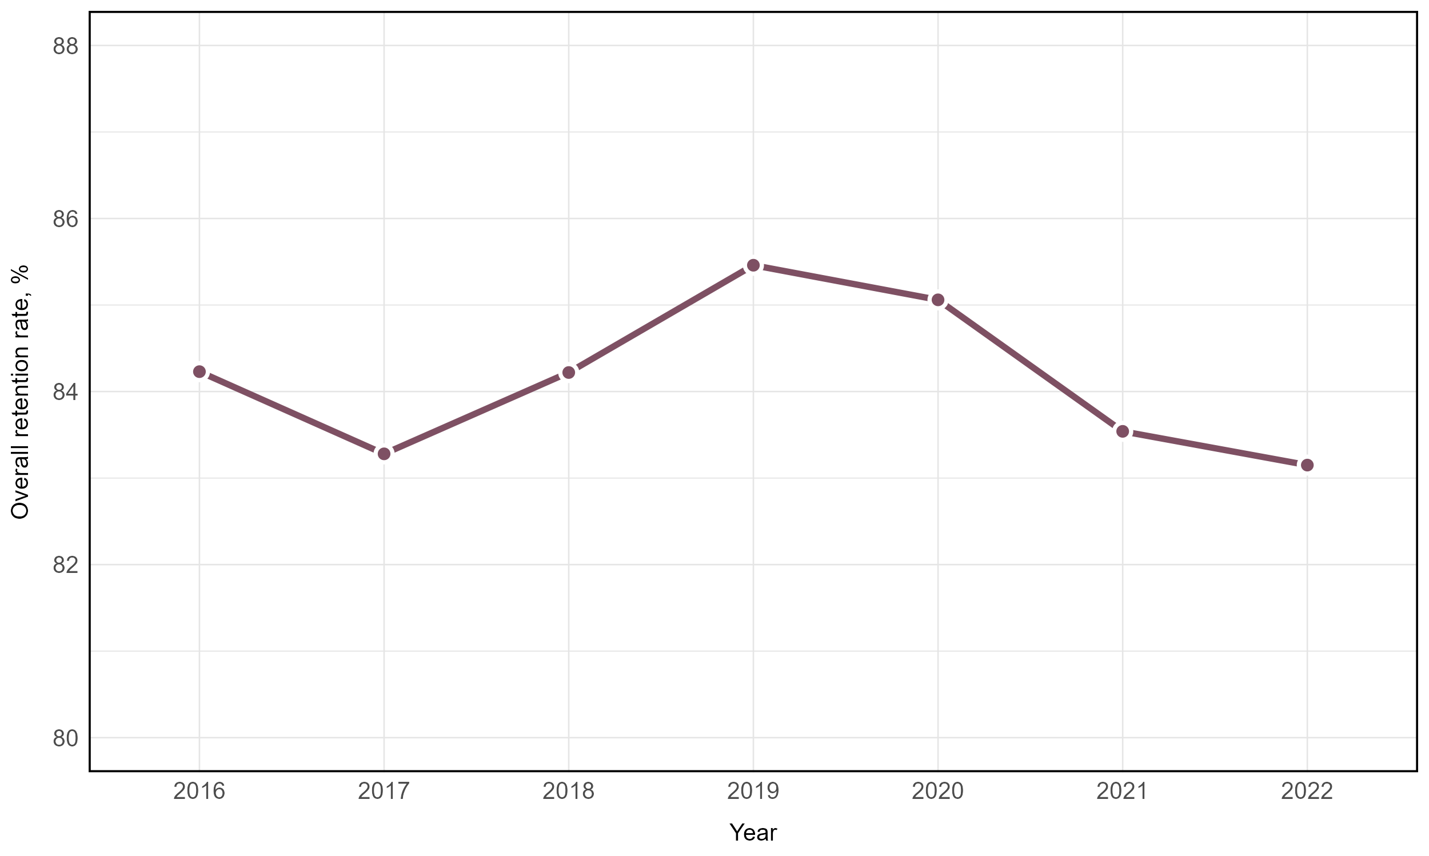

There are significant differences in retention rates between equity student groups
Between 2016 and 2022, non-equity students consistently had higher retention rates than each of the equity groups. All student groups, including non-equity students, had lower retention rates in 2022, compared to 2016. The largest decline in retention rates was for First Nations Australian students, who had a decrease in retention of 3.2 percentage points (73.9% in 2016 and 70.7% in 2022). First Nations Australian students had the lowest retention rate across all years, followed by students from remote areas.
Figure 2: Retention rate of domestic undergraduate students between 2016 and 2022 enrolled at Table A institutions, split by equity group.
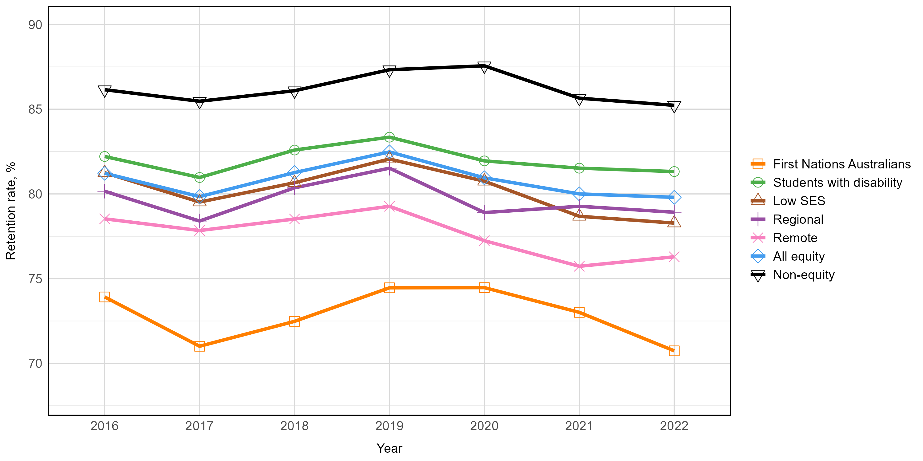

Students from remote and low SES areas had consistently low
retention rates
Figure 3: Retention rate of domestic undergraduate students between 2016 and 2022 enrolled at Table A institutions, split by multiple equity group membership.
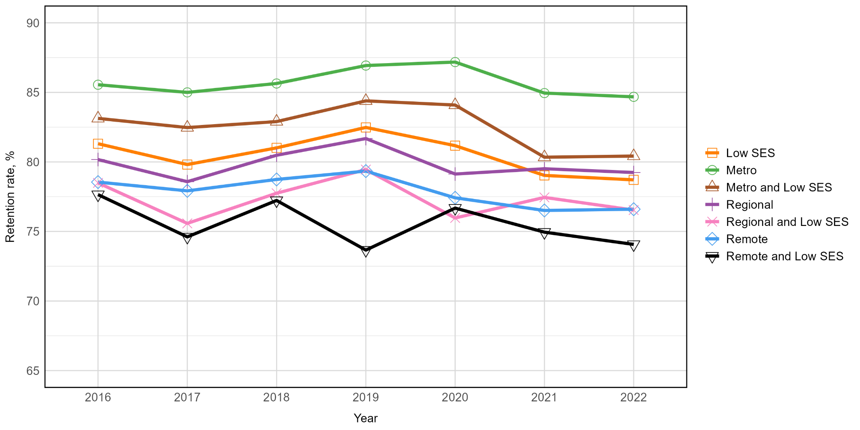

First Nations Australian students from regional and remote areas had much lower retention rates than other regional and remote groupings
Figure 4: Retention rate of domestic undergraduate students between 2016 and 2022 enrolled at Table A institutions, split by multiple equity group membership.
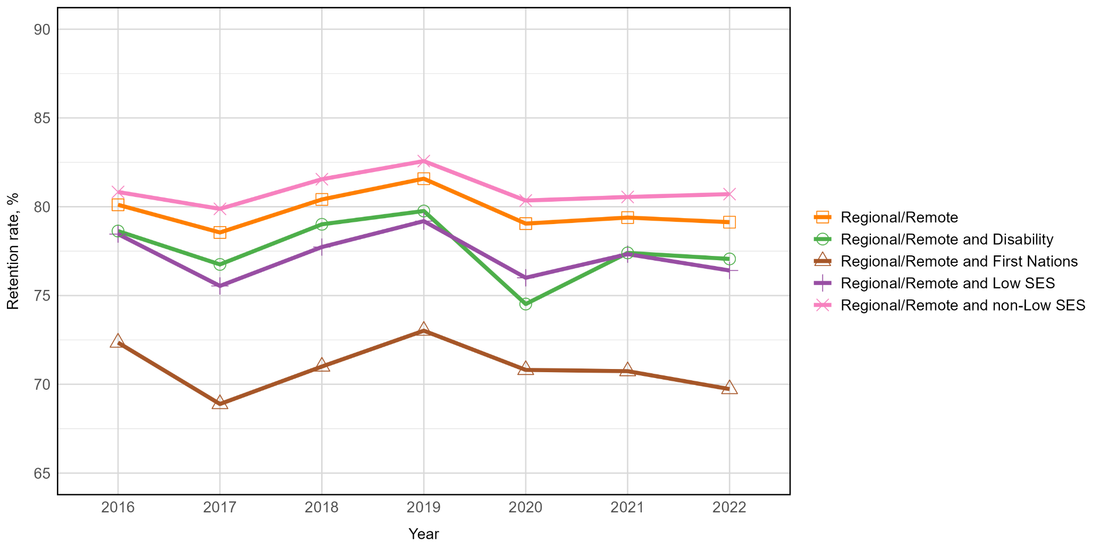

First Nations Australian students from metropolitan areas had
higher retention rates than First Nations Australians from regional
and remote areas
Figure 5: Retention rate of domestic undergraduate students between 2016 and 2022 enrolled at Table A institutions, split by multiple equity group membership.
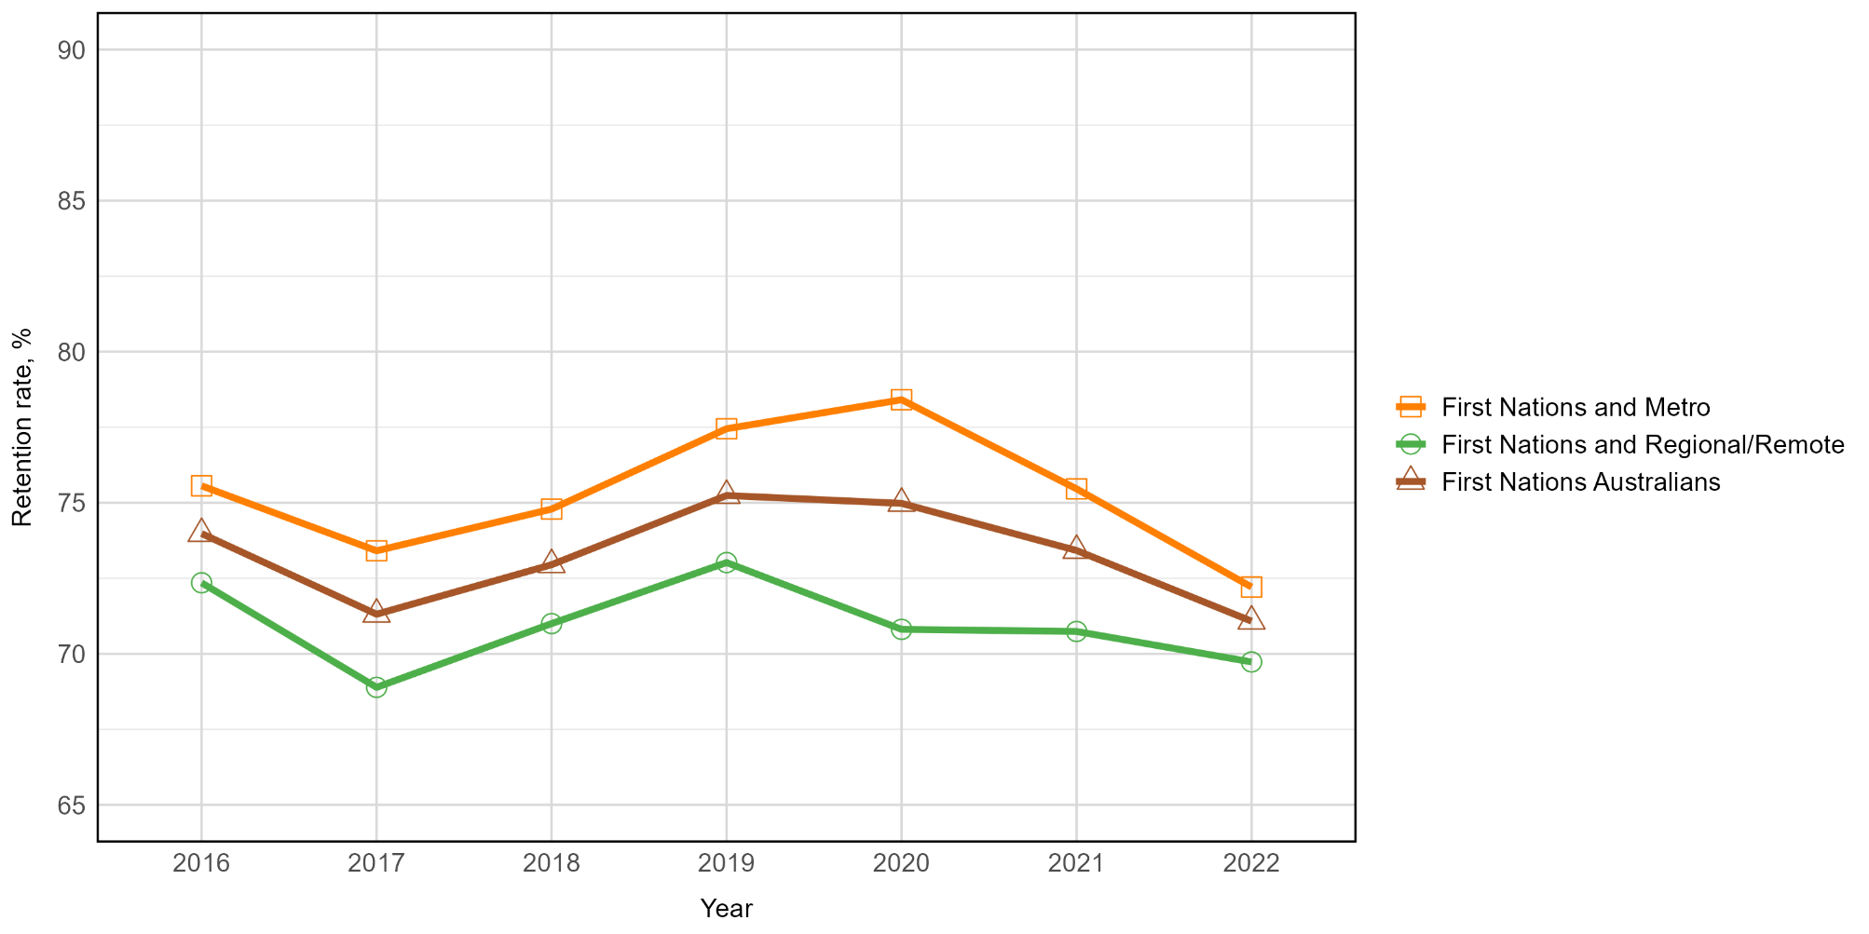

Students with disability from regional and remote areas had similar retention rates to students with disability from low SES areas
Figure 6: Retention rate of domestic undergraduate students between 2016 and 2022 enrolled at Table A institutions, split by multiple equity group membership.
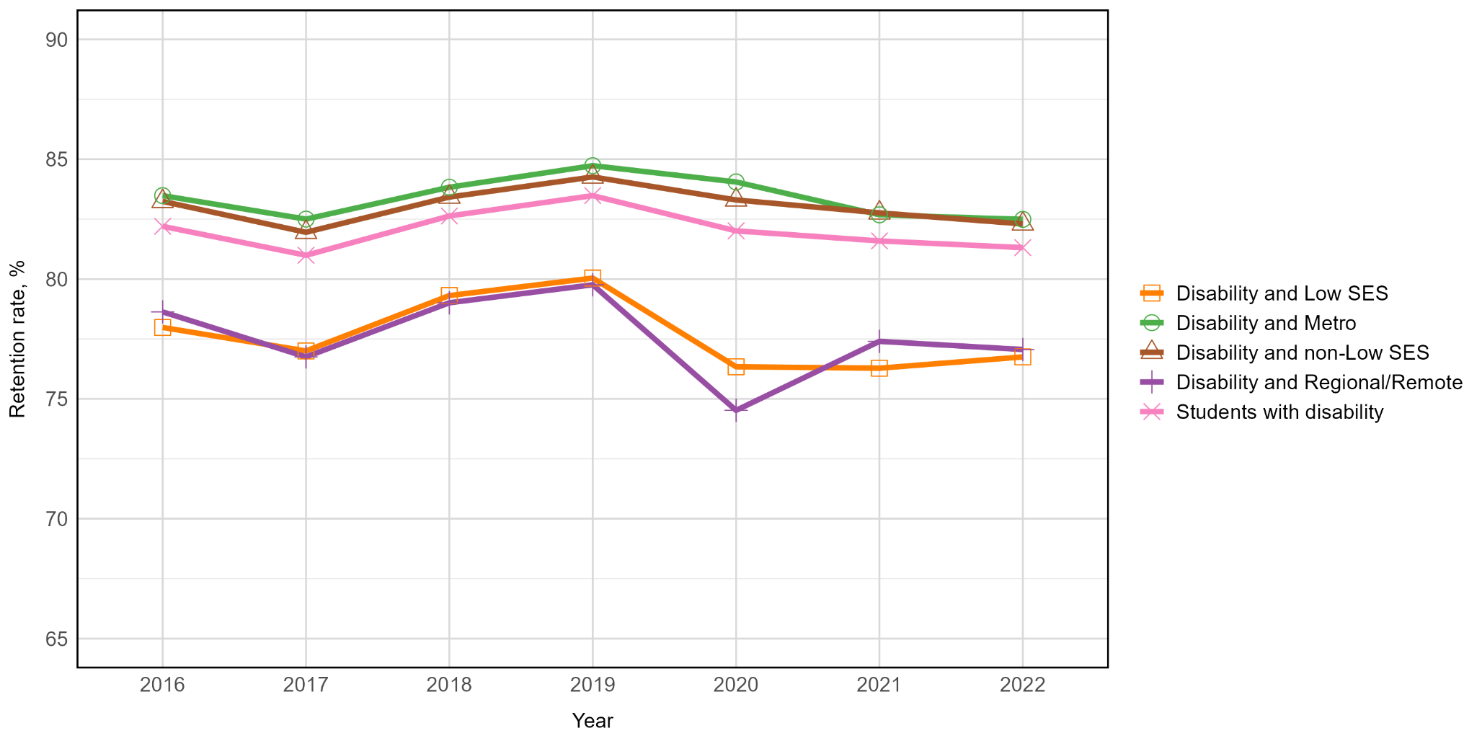

There is substantial variation in changes in retention rates over the past seven years across institutions
When looking at changes in institutional retention rates from 2016 to 2022, substantial institutional variation was observed within each student equity group (Figure 7). This is particularly evident for students from remote areas, where only three institutions have seen an increase in retention of more than 10 percentage points in the past seven years, while eight institutions had a decrease in retention of more than 10 percentage points, with one institution showing a decrease of 44 percentage points. In Figure 7 a positive value indicates an increase from 2016 to 2022, so a data point of 5 indicates the institution had an increased (improved) retention rate of five percentage points from 2016 to 2022.
Figure 7: Change in retention rate of domestic undergraduate students between 2016 and 2022 enrolled at Table A institutions, split by equity group. Each dot represents a Table A institution. A negative value indicates a decrease in retention from 2016 to 2022, and a positive value indicates an increase in retention from 2016 to 2022.
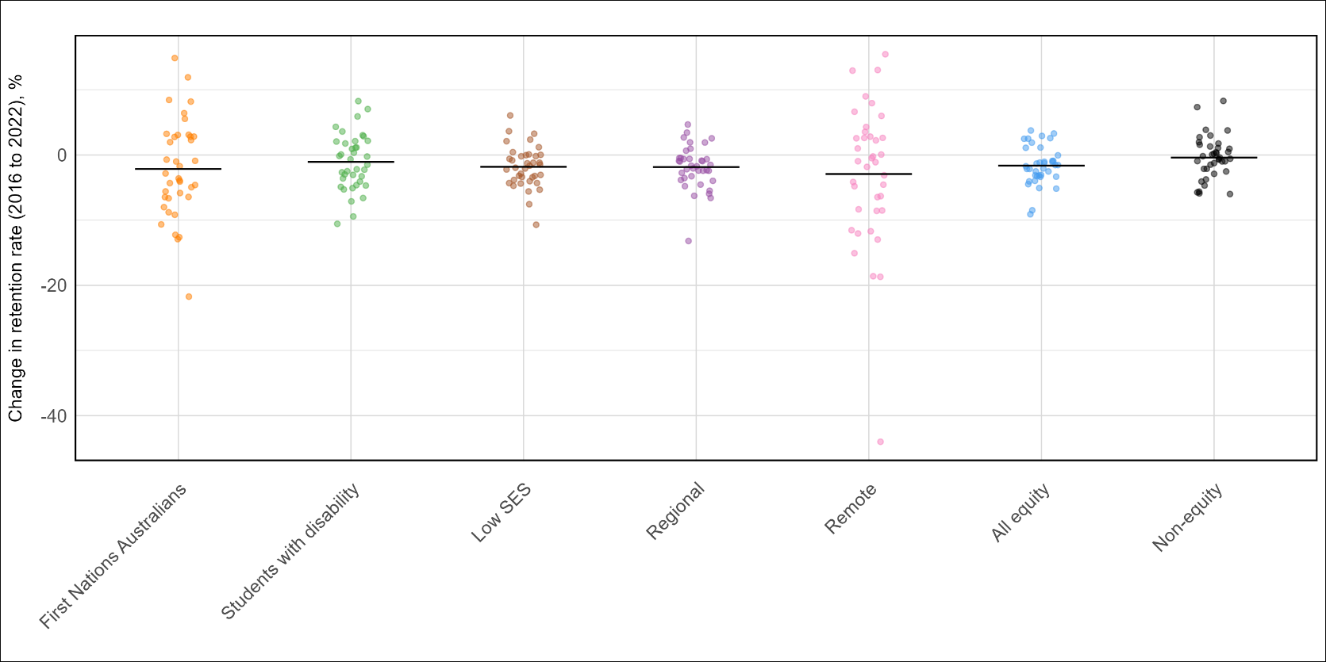

Retention rates in 2022 (students returning in 2023)

Retention rates vary across institutional groupings and states
and territories
Table 1: 2022 retention rates (%) for equity groups, by Institutional Groupings and State and Territory for Table A institutions.
 | Students with disability | Low SES | Regional | Remote | First Nations Australians | Non-equity students | Equity students
National — Table A institutions | 81.3 | 78.7 | 79.2 | 76.6 | 71.1 | 85.7 | 80.1
Institutional Groupings
Group of Eight (Go8) | 89.0 | 90.7 | 90.5 | 90.2 | 83.6 | 93.6 | 90.3
Australian Technology Network (ATN) | 81.4 | 79.9 | 80.5 | 74.8 | 69.9 | 85.3 | 80.8
Innovative Research Universities (IRU) | 78.0 | 77.2 | 81.0 | 79.7 | 67.0 | 80.7 | 78.6
Regional University Network (RUN) | 73.5 | 74.2 | 75.7 | 76.3 | 70.2 | 77.5 | 75.3
Non-aligned | 80.3 | 77.6 | 77.0 | 69.4 | 71.3 | 83.9 | 78.7
States and Territories
New South Wales | 82.2 | 80.3 | 79.7 | 80.0 | 72.2 | 87.8 | 81.1
Victoria | 83.7 | 82.2 | 81.7 | 79.6 | 75.8 | 87.1 | 83.0
Queensland | 80.0 | 77.8 | 80.4 | 78.8 | 73.6 | 84.1 | 79.8
Western Australia | 79.0 | 76.1 | 75.4 | 77.0 | 63.7 | 83.2 | 77.6
South Australia | 79.4 | 75.3 | 76.7 | 77.9 | 63.4 | 78.4 | 76.6
Tasmania | 70.0 | 65.0 | 70.6 | 64.0 | 63.4 | 65.8 | 70.2
Northern Territory | 71.9 | 71.4 | 72.9 | 60.5 | 62.2 | 73.0 | 71.2
Australian Capital Territory | 89.4 | 84.1 | 85.7 | 85.8 | 75.0 | 89.4 | 86.4
Multi-State | 83.7 | 82.3 | 86.0 | 73.4 | 68.9 | 84.7 | 83.5

Across all Table A institutions, retention was highest for non-equity students. Among institutional groupings, Go8 universities had the highest average retention rate across all student groups. There are noticeable differences between the states and territories in terms of retention rates – for instance, non-equity students generally had higher retention than equity students, except for in Tasmania. The Australian Capital Territory had the highest retention rates across all equity groups, except for First Nations Australians where Victoria had the highest retention.

Sector-wide 2022 retention rates mask substantial variation
across institutions
Figure 8 shows that there was substantial variation in the retention rate of student groups across all institutions in 2022. The largest variation across institutions was for students from remote areas, with estimates ranging from 39.6% to 100%. All other student equity groups showed a large variation across institutions, with the highest and lowest institutional retention rate in each student group ranging from differences of 23 percentage points to 34 percentage points.
Figure 8: Retention rate of domestic undergraduate students in 2022, split by equity group. Each dot represents a Table A institution, and the black horizontal line represents the overall retention rate across all institutions for each equity group.
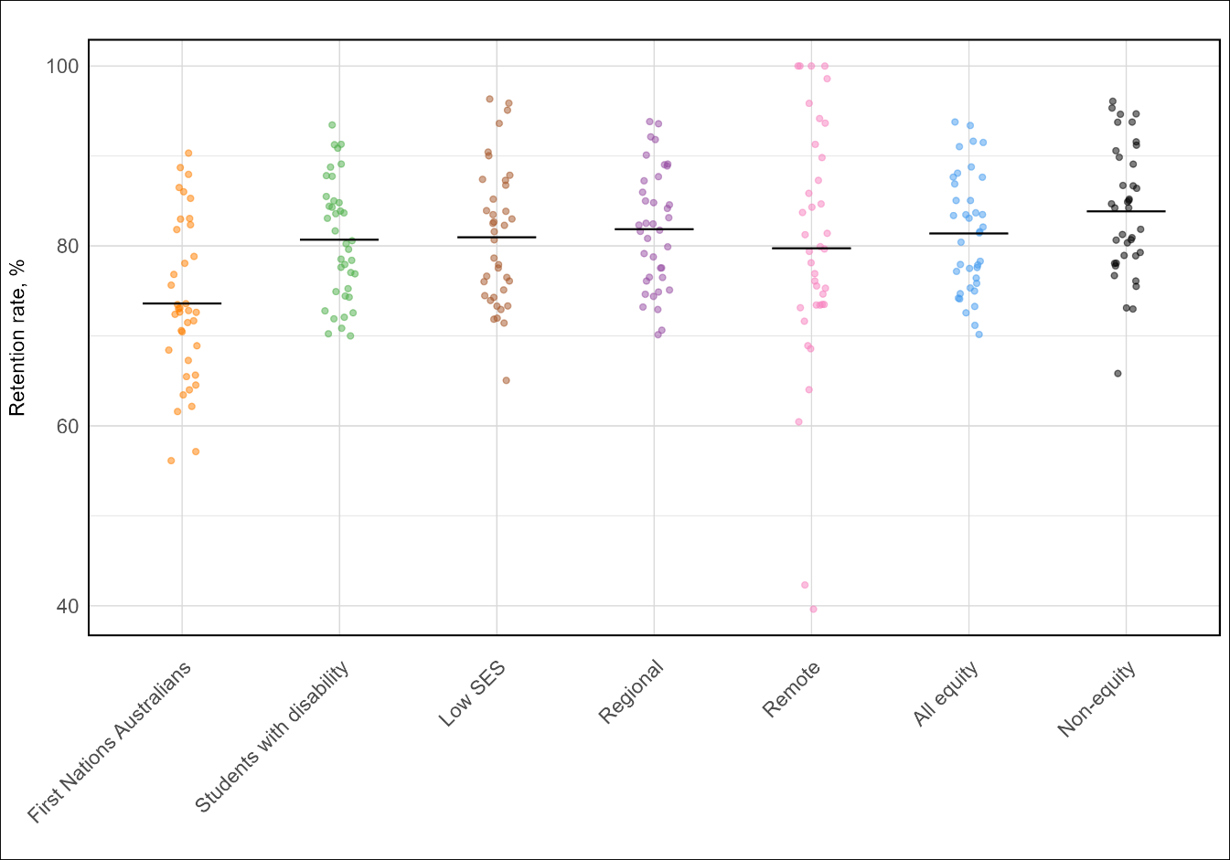

Within-institution retention rates
To identify differences in retention between equity student groups and non-equity student groups within each institution, their retention rates can be compared (Figures 9 to 13). In Figure 9, the vertical (y-) axis represents the retention rate for students with disability, while the horizontal (x-) axis represents the retention rate for students without disability at the same institution. If retention rates are identical for both groups within an institution, its data point will lie on the 45-degree line. If retention rates at an institution are higher for students with disability compared to students without disability, the dot will be above the 45-degree line, and if retention rates are lower for students with disability compared to students without disability, the dot will be below the 45-degree line.

Retention rates for students with disability were similar to retention rates for students without disability
Figure 9: Relationship between the retention rate of students who did not report a disability and students with disability. Each dot represents a Table A institution. The dotted line represents x=y, where institutions falling on this line have the same retention rate in both student groups. Institutions falling above the dotted line have higher retention rates for students with disability compared to students not reporting a disability.
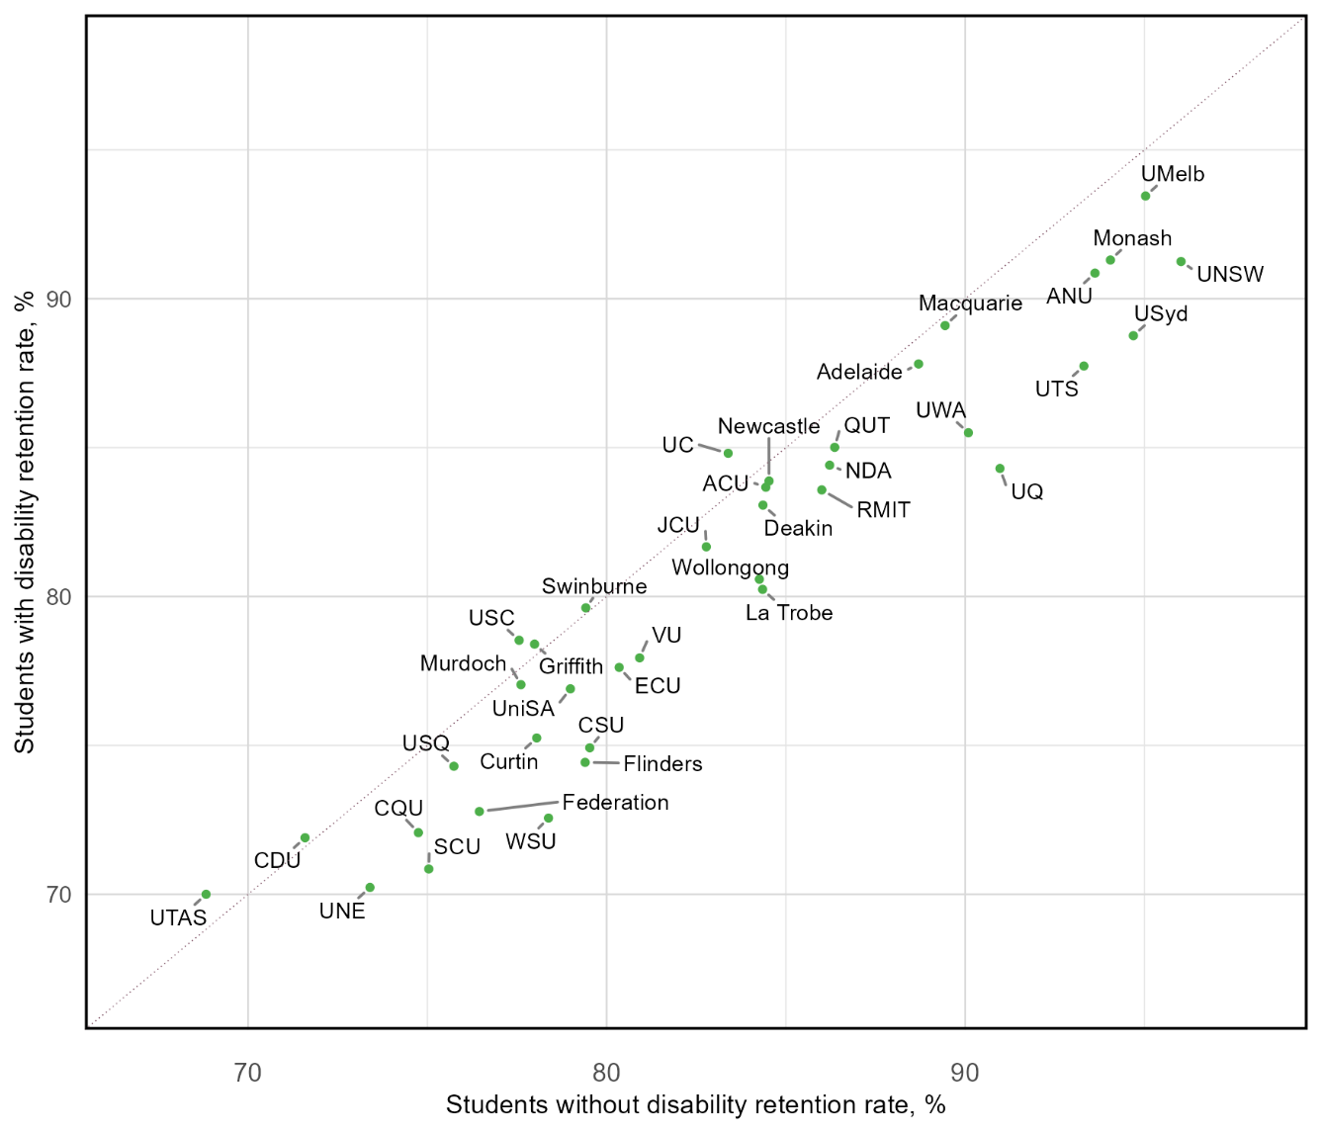

Retention rates for First Nation Australian students were
substantially lower than non-First Nation Australian students,
except for two institutions
Figure 10: Relationship between the retention rate of students who do not identify as First Nations Australians and First Nations Australian students. Each dot represents a Table A institution. The dotted line represents x=y, where institutions falling on this line have the same retention rate in both student groups. Institutions falling above the dotted line have higher retention rates for First Nations Australian students compared to students who are not First Nations Australians.
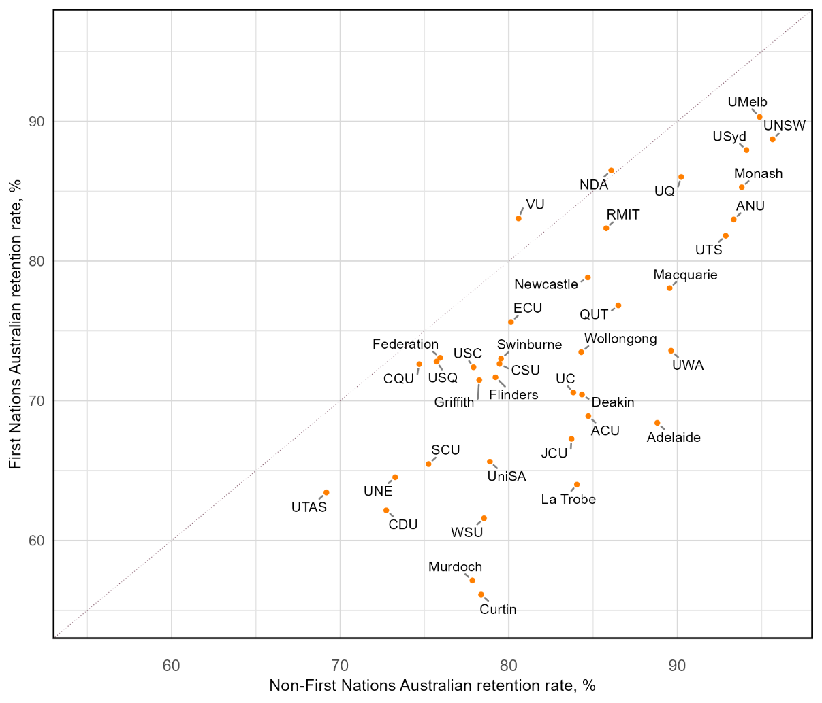

Retention rates for students from low SES areas were lower than students from high SES areas, except for seven institutions
Figure 11: Relationship between the retention rate of students from high SES areas and low SES areas. Each dot represents a Table A institution. The dotted line represents x=y, where institutions falling on this line have the same retention rate in both student groups. Institutions falling above the dotted line have higher retention rates for students from low SES areas compared to students from high SES areas.
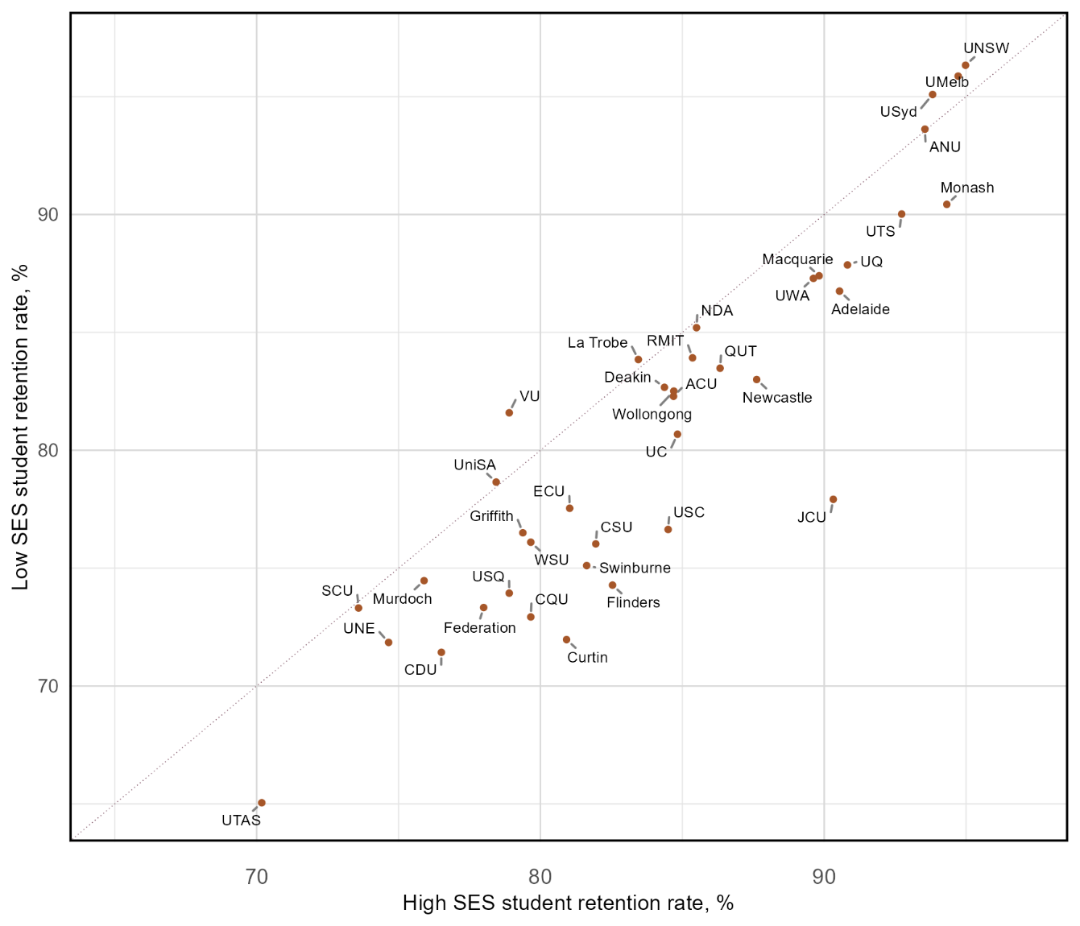

Retention rates for students from regional areas were relatively similar to students from metropolitan areas
Figure 12: Relationship between the retention rate of students from metropolitan areas and regional areas. Each dot represents a Table A institution. The dotted line represents x=y, where institutions falling on this line have the same retention rate in both student groups. Institutions falling above the dotted line have higher retention rates for students from regional areas compared to students from metropolitan areas.
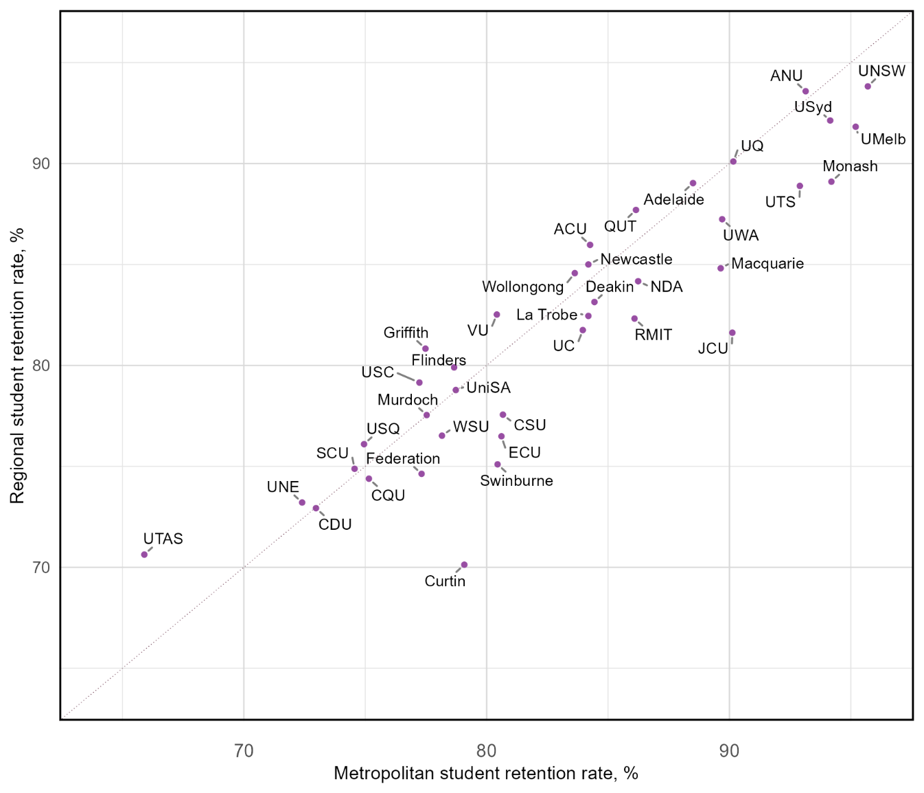

Retention rates for students from remote areas were lower compared to students from metropolitan areas
Figure 13: Relationship between the retention rate of students from metropolitan areas and remote areas. Each dot represents a Table A institution. The dotted line represents x=y, where institutions falling on this line have the same retention rate in both student groups. Institutions falling above the dotted line have higher retention rates for students from remote areas compared to students from metropolitan areas.
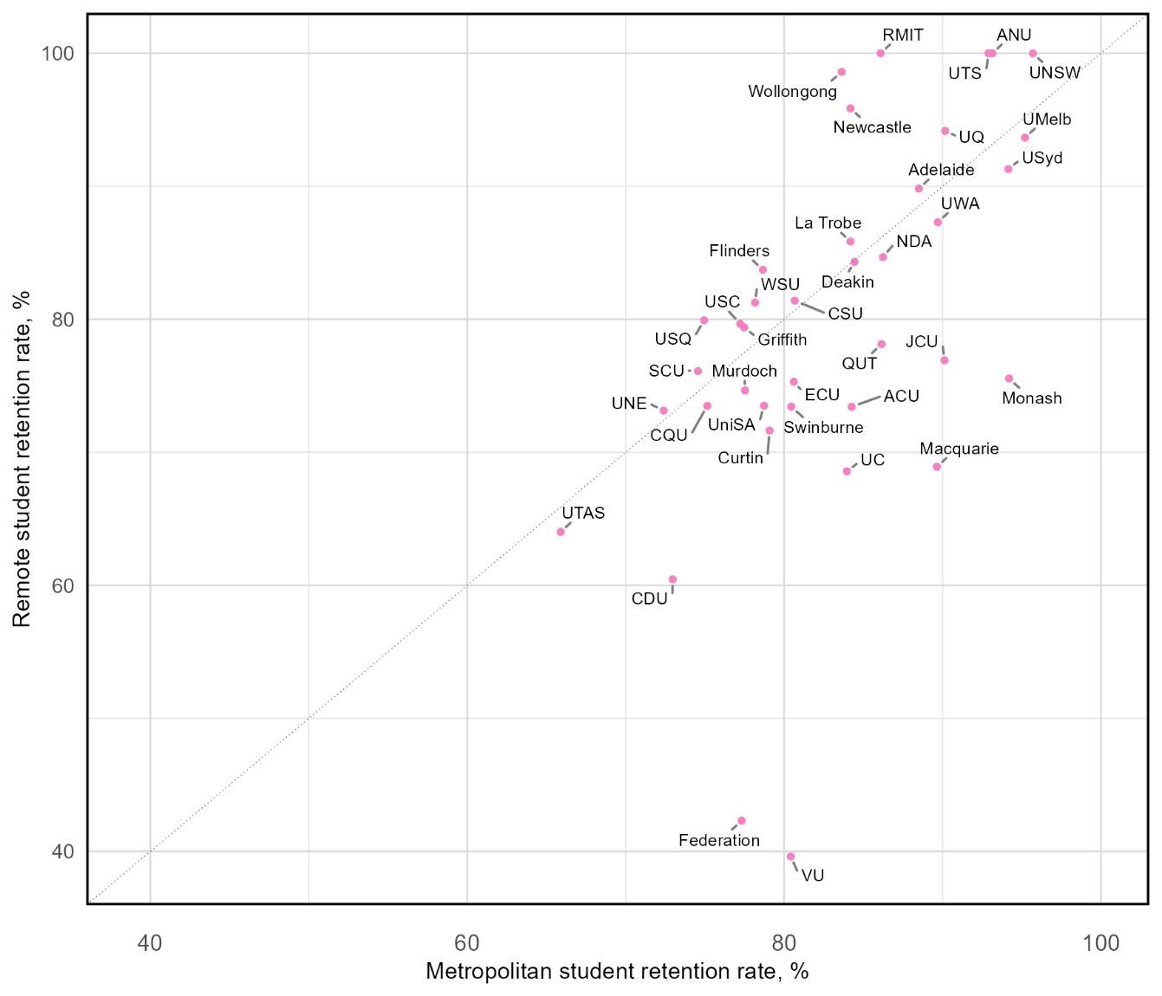

Relationship between retention rate and
participation share
It is important to note that there are large variations in the number of students within each of these equity groups at different institutions. When examining the correlation between 2022 retention rates and 2023 participation shares (Figures 14 to 18), we observe a negative correlation for low SES, regional, remote, and First Nations Australian students. That is, institutions with a lower share of students from these equity groups tend to have higher retention rates for these groups. In contrast, we find no correlation between retention rates and participation shares for students with disability.
These findings highlight the importance of considering both retention rates and participation shares together, rather than in isolation. When comparing retention rates between institutions, it is important to compare institutions with similar participation shares rather than focusing solely on retention rates. Comparing an institution with a high proportion of equity students to a highly selective institution with very few equity students may not provide meaningful insights. Instead, benchmarking retention rates against institutions with similar student demographics can help identify which institutions are particularly effective at supporting equity students and where targeted interventions may be needed.

There was no relationship between the participation share of students with disability and the retention rate
Figure 14: Relationship between institutional participation share and retention rate for students with disability. Each dot represents the Table A institution, as labelled.
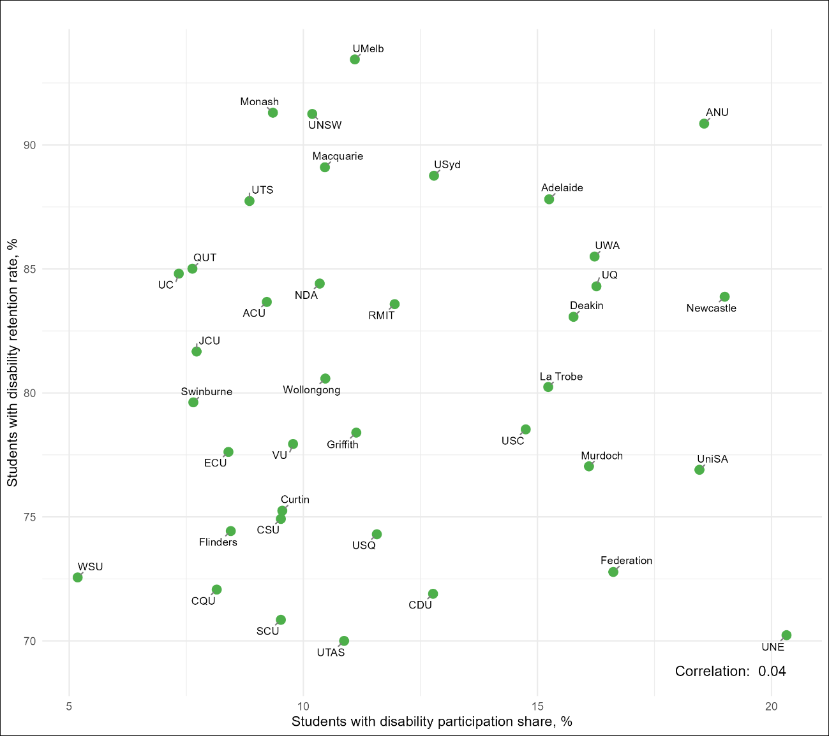

There was a negative correlation between retention rates and participation share for First Nations Australian students
Figure 15: Relationship between institutional participation share and retention rate for First Nations Australian students. Each dot represents the Table A institution, as labelled.
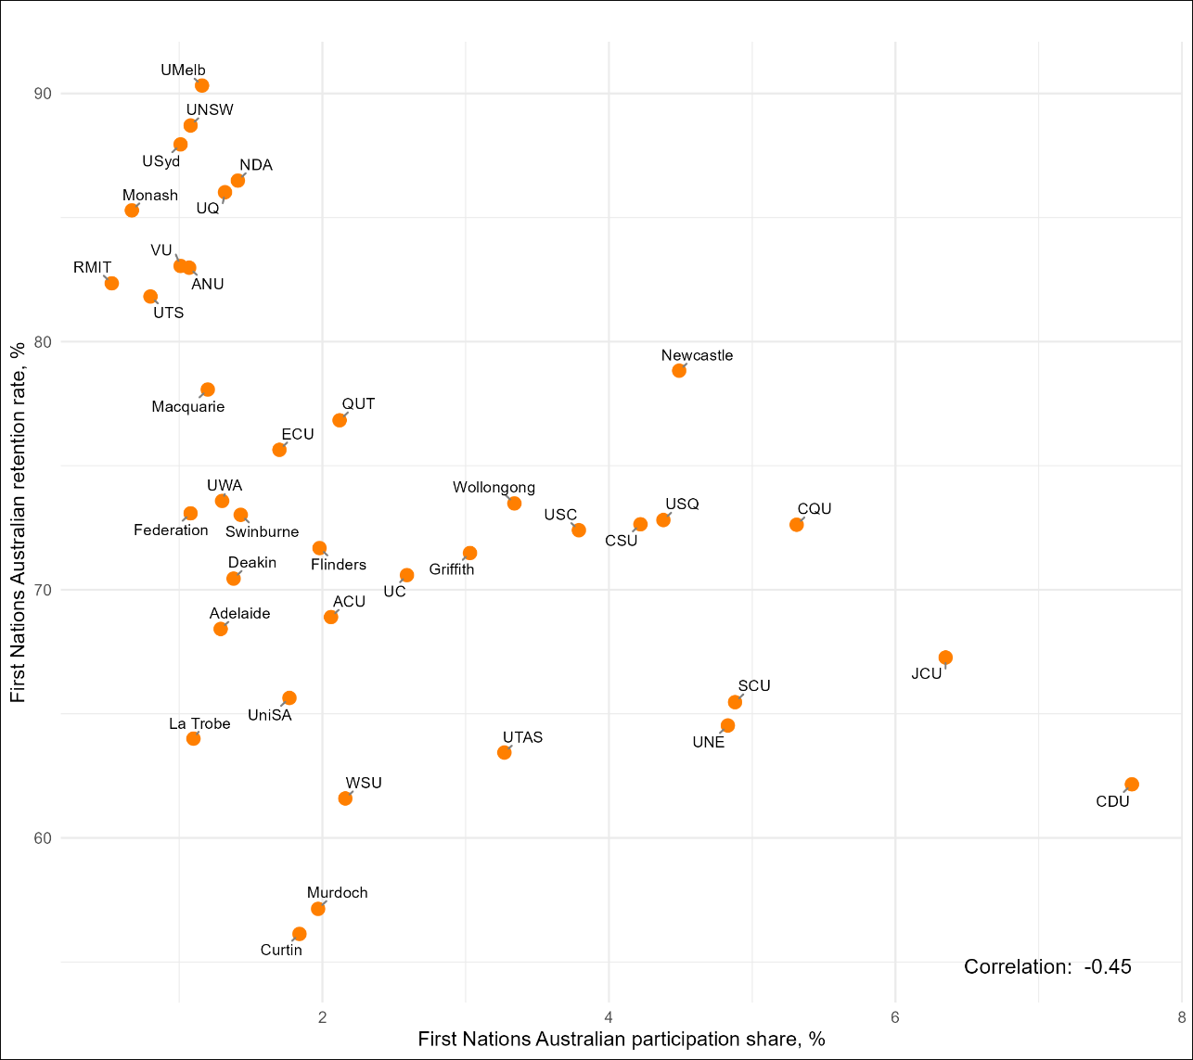

There was a strong negative correlation between retention rates and participation share for students from low SES areas
Figure 16: Relationship between institutional participation rate and retention rate for students from low SES areas. Each dot represents the Table A institution,
as labelled.
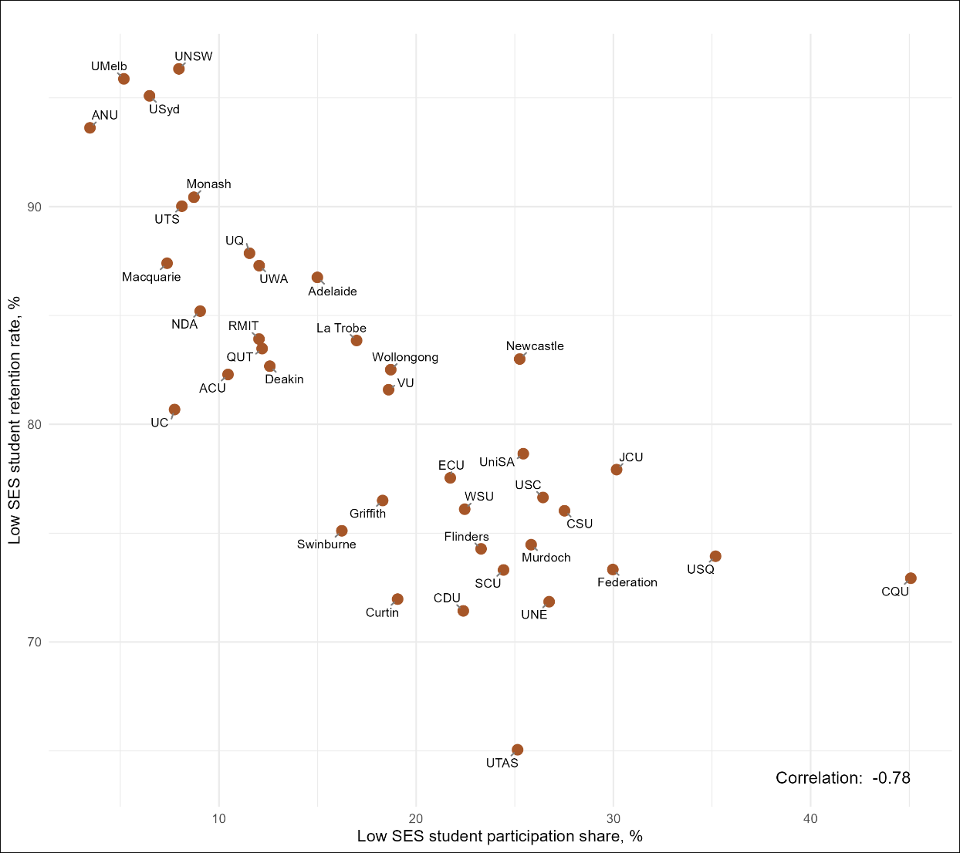

There was a negative correlation between retention rates and participation share for students from regional areas
Figure 17: Relationship between institutional participation rate and retention rate for students from regional areas. Each dot represents the Table A institution,
as labelled.
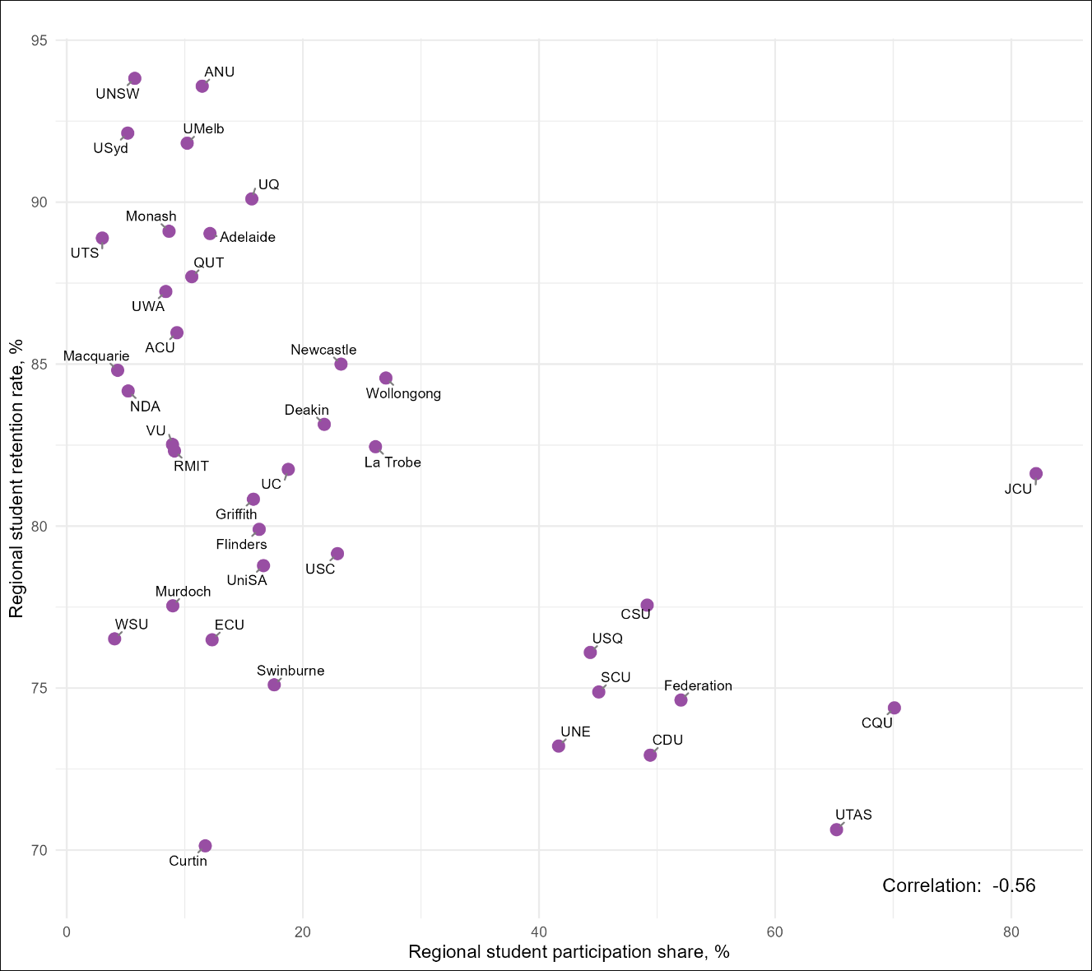

There was a negative correlation between retention rates and participation share for students from remote areas
Figure 18: Relationship between institutional participation rate and retention rate for students from remote areas. Each dot represents the Table A institution,
as labelled.
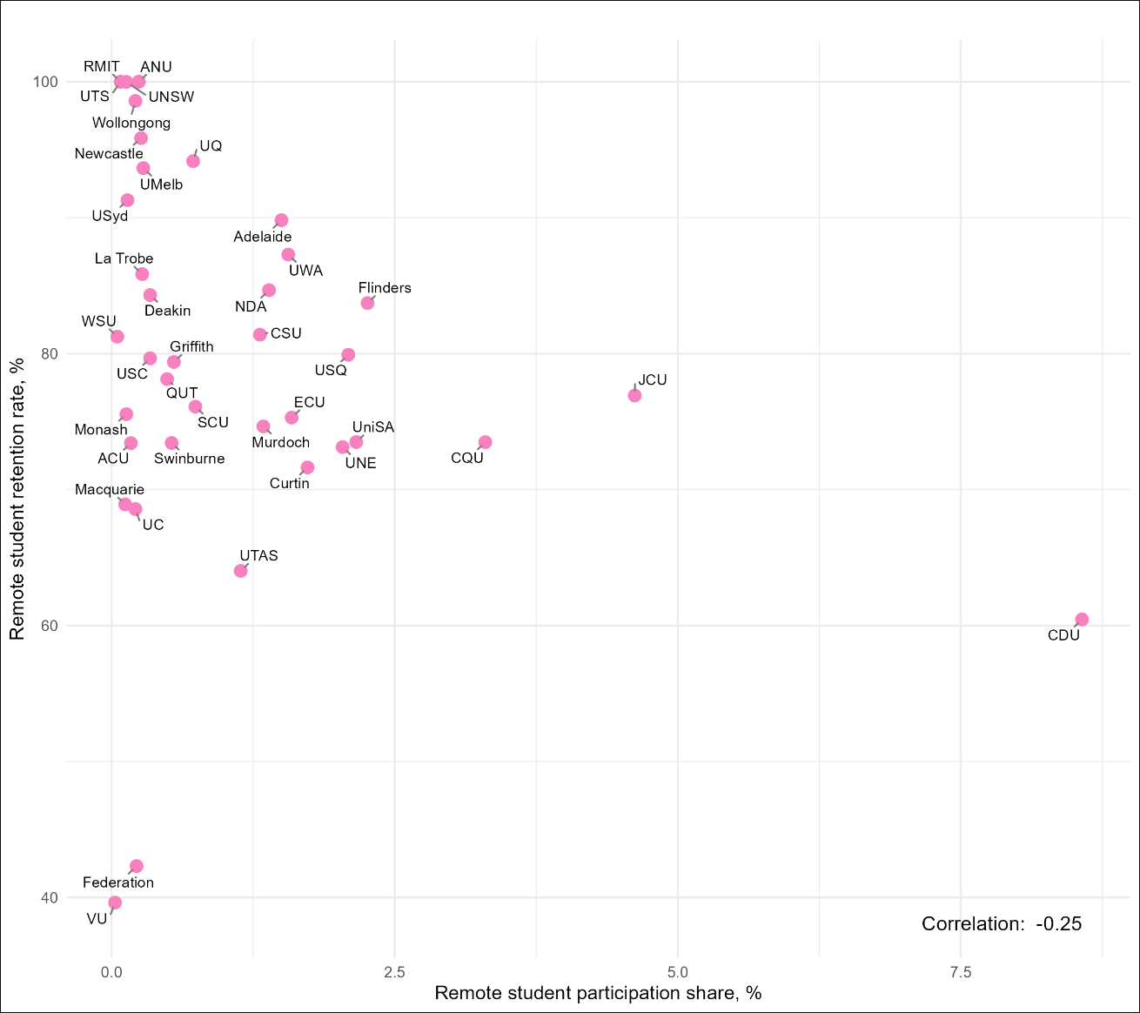

References
- Australian Government Department of Education (2025). Selected Higher Education Statistics – 2022 Student data. https://www.education.gov.au/higher-education-statistics/student-data/selected-higher-education-statistics-2022-student-data
- Li, IW & Carroll DR. (2019): Factors influencing dropout and academic performance: an Australian higher education equity perspective, Journal of Higher Education Policy and Management.
- National Centre for Student Equity in Higher Education (NCSEHE). (2016). Exploring the Retention and Success of Students with Disability. Retrieved from https://www.ncsehe.edu.au/app/uploads/2016/05/Exploring-the-Retention-and-Success-of-Students-with-Disability.pdf
- Tertiary Education Quality and Standards Agency (TEQSA). (2020). Good Practice Note: Improving retention and completion of students in Australian higher education. Retrieved from https://www.teqsa.gov.au/sites/default/files/good-practice-note-improving-retention-completion-students-v2-0.pdf
- Universities Australia. (2017). 2017 Universities Australia Student Finances Survey. Retrieved from https://universitiesaustralia.edu.au/wp-content/uploads/2019/06/180713-2017-UA-Student-Finance-Survey-Report.pdf

Please see Student Equity Data Guide: Defining Equity Groups for further information.
Equity Group Statistics, Private Request (October 2024). Canberra: Department of Education.
https://www.tcsisupport.gov.au/glossary/glossaryterm/Retention%20rate
https://www.education.gov.au/heppp

