Students with disability in Australian higher education: An overview

  - ACSES Data Insights Series, Report 1

Acknowledgements
This report was prepared by Gemma Cadby, Tim Pitman, and Paul Koshy of the Australian Centre for Student Equity and Success (ACSES) at Curtin University.
The authors would like to acknowledge the staff at ACSES for their comments and assistance in the production of this publication and extend thanks to the Australian Government Department of Education for the provision of student equity data.
The report may be cited as: Cadby, G., Pitman, T., & Koshy, P. (2024). Students with disability in Australian higher education: an overview. Australian Centre for Student Equity and Success (ACSES), Perth: Curtin University.
This report focuses on recent developments in participation among domestic undergraduate students with disability over the past decade, considering the impact of changes in the collection of data on disability status in higher education during 2020-21. For further information on various aspects of students with disability performance, and those of equity students more generally—access; participation; success; retention; six- and nine-year cohort completion—please see the ACSES Student Equity Data Program webpage: https://www.acses.edu.au/data/interactive-tool/
Copyright ownership of this material resides with ACSES.
ISBN - R978-0-646-70241-4

The Australian Centre for Student Equity and Success Data Insights Series
The Australian Centre for Student Equity and Success (ACSES) is an evidence-based research and public policy centre based at Curtin University and funded by the Australian Government Department of Education (‘the Department’). ACSES is committed to providing the higher education sector with tangible proof of what works to improve the quality and impact of student equity practices in higher education.
The ACSES Data Insights Series reports on equity student participation and outcomes in Australian higher education. It focuses on trends among identified equity groups in domestic undergraduate enrolments in Australia, including, but not limited to:
- Low socio-economic status (‘Low SES’) students
- Students with Disability
- First Nations (Aboriginal and Torres Strait Islander) Australian students
- Regional students
- Remote students

For further information on ACSES, please visit www.acses.edu.au

Data Explanatory Notes
All student data reported in this document are sourced from a customised request to the Australian Government Department of Education (Australian Government Department of Education, 2024a).
In preparation of this report:
- For the purposes of aggregation and presentation and results, cell counts of less than 5 were replaced with
the value ‘2’.
- Higher education institutions were identified but have been anonymised in this report.
- Analysis was restricted to Table A institutions (Higher Education Support Act 2003).
- Some longitudinal analysis is provided, but the focus is on the most recent data available, which is for 2022.

Readers should know that the Department of Education released the following note about the 2020 equity data collection:
A Note about 2020 Higher Education Equity and Equity Performance Data
During the transition to the Tertiary Collection of Student Information (TCSI) System, enrolment numbers for students with disability were substantially under-reported in the case of several universities. This issue affects data in Section 11, Section 16 and some Visual Analytics products. Caution should be taken when using the 2020 enrolment data points for students with disability. All other time points are unaffected. (Australian Government Department of Education, 2024b).
This caveat applies to data sourced via the Department’s official site and customised requests. For this reason, caution should be exercised in reporting and analysing data on disability from 2020.
In addition, caution must always be exercised in analysing data on students with disability:
- As not all students with disability choose to identify for personal reasons, it is a reasonable assumption that the raw numbers in this report under-report the actual instance of students with disability.
- The extent of underreporting may also differ across institutions.
- As explained further in this report, the disability categories were updated in 2020. This has effectively caused a break in series, meaning any comparative analyses of categories of disability that use both pre- and post-2020 categories are problematic.

Defining and measuring disability in the context of Australian higher education
Disability has long been recognised as an equity issue in Australian higher education policy. For example, the 1992 student equity framework for higher education, A Fair Chance for All, noted that ‘achieving equality of opportunity in higher education is an important Government objective for people with disabilities.’ (Department of Employment, Education and Training, 1992, p. 40). Over the ensuing decades, there has been a continued commitment to improving access, support, and success for students with disability. A critical foundation for action is the Disability Discrimination Act (1992), which amongst other things makes it unlawful for an educational authority to discriminate against a person on the ground of the person’s disability by refusing to accept their application, denying or limiting access, or delivering content that is inaccessible. Another key document is the Disability Standards for Education (2005), which provides greater detail and clarification on the rights of students and the responsibilities of higher education providers.
Individual higher education providers are responsible for providing and promoting an opportunity for students to identify as having a disability, usually at enrolment. Self-identification serves both a primary and secondary purpose. The primary purpose is to provide direct and relevant support to students in accordance with the institution’s responsibilities. A secondary purpose is to collect better data to inform research, policy, and practice. For both the primary and secondary purposes, disability is defined broadly and includes disability, impairment, or a long‑term medical condition. A more detailed description is provided in the Disability Standards for Education (2005).
To enhance the quality of data collected and attain a degree of nuance, students are asked to provide the category or classification of their disability (noting that students can nominate more than one category of disability). Until 2020, the categories of disability were:
- Medical disability
- Visual disability
- Mobility disability
- Hearing disability
- Learning disability
- Other disability
From 2020, the categories were changed to provide even greater detail. The new categories are:
- Hard of Hearing/deaf/Deaf
- Physical disability
- Intellectual disability
- Specific Learning Disability (SLD)
- Mental health condition
- Acquired brain injury (ABI)
- Low Vision/Blind
- Medical condition
- Neurological condition
- Other disability
Descriptions of each of these categories are available on the Tertiary Collection of Student Information (TCSI) website (Tertiary Collection of Student Information, 2024).
As already noted, students self-identify and self-categorise, i.e. it is for the individual student to decide whether they want to identify as having a disability, whether they want to categorise their disability and, if so, which category or categories to select. For this reason, the data collected contains a degree of personal interpretation.

Overall representation of students with disability in higher education
The enrolment of domestic undergraduate students with disability has increased significantly since 2011. In that year, 30,334 students identified as having a disability, equating to 5% of the undergraduate headcount. By 2019, this had risen to 58,451, or around 7.7% of the population. In other words, both the raw number and proportional representation of students with disability has risen, year by year, over this period. From 2020 to 2022, the percentage of students reporting disability increased at an even higher rate, rising from 8.1% in 2020 to 10.3% in 2021, and then to 11.6% in 2022.
In terms of domestic undergraduate enrolments, this represents an increase of 185.6% between 2011 and 2022 (from 30,334 to 86,644). In proportional terms, this represents an increase of 132% (from 5.0% to 11.6%).
Although the reasons for these significant increases cannot be stated definitively, several factors present themselves as likely contributors:
- Greater understanding and acceptance of disability issues in the wider community may be encouraging more students to identify as having a disability.
- Improved institutional processes – for example students being able to manage their enrolment online – may result in the better collection and reporting of data.
- The definitional change in disability categories may have had a positive effect on reporting. Most notably, the creation of a specific ‘Mental health condition’ category may have resulted in some students now identifying as having a disability, whereas previously they may have not realised a mental health condition was an official disability category.
- Relatedly, Australian society at large has experienced a rise in the incidence of mental health issues post COVID-19.

Figure 1: Students with disability as a percentage share of enrolments (%), 2011 to 2022. Percentage is calculated as the total number of domestic undergraduate students reporting at least one disability in each year divided by the total number of domestic undergraduate students enrolled at Table A Providers in that year.

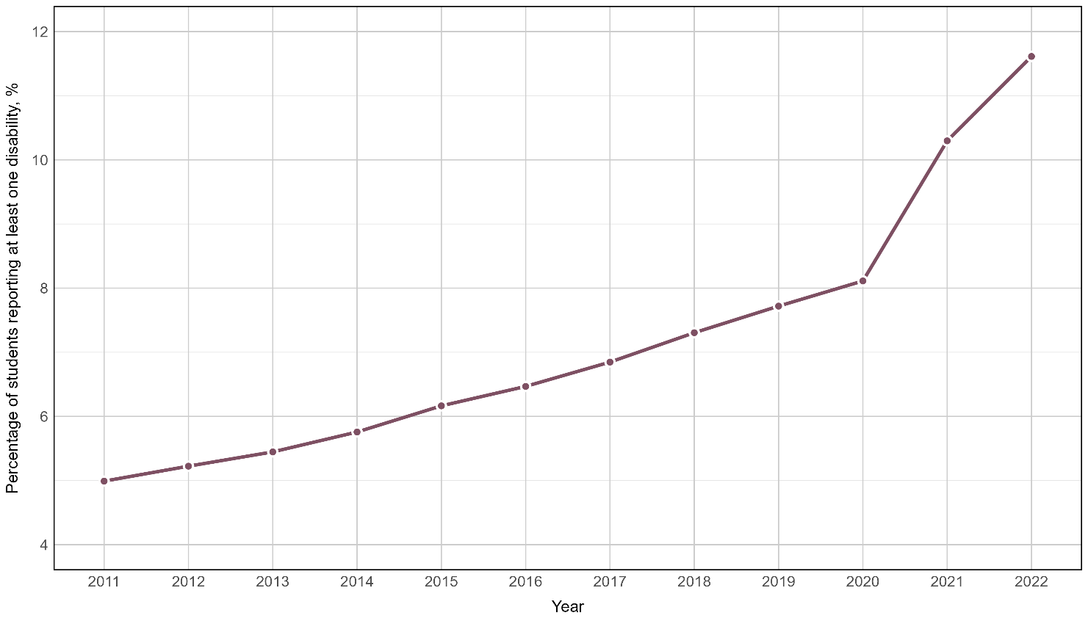

The representation of students with disability across the sector
Trends across institutional groupings and states and territories indicate that the increase in representation by students with disability has been broadly based.
Two observations can be made.
Among institutional groupings, universities in the Innovative Research Universities (IRU) and non-aligned providers now tend to have lower rates of disability participation compared to other groups. Since 2017, their increases in participation have been smaller relative to other groupings. For instance, in 2017, the IRU as a group had a disability participation rate of 7.1%, which was higher than that seen in the Group of Eight (Go8) at 6.6% and Australian Technology Network (ATN) at 6.7%. However, by 2022, both the Go8 and ATN groupings had substantially higher participation rates – 12.9% and 13.7% – compared to the IRU (9.9%).
There are noticeable differences between the states and territories in terms of overall participation rates – for instance, South Australia’s relatively high participation share (15.0% participation rate in 2022) – which are likely to reflect some combination of demographic factors and local factors affecting student recruitment.

Table 1: Students with Disability, percentage share of enrolments (%), by Institutional Groupings and State and Territory, Table A Providers, 2017–22. These percentages have been calculated by summing the number of students with disability within each of the groupings or states/territories and dividing by the total number of students within each of the groupings or states/territories.
 | 2017 | 2018 | 2019 | 2020* | 2021 | 2022
National — Table A Providers | 6.9 | 7.3 | 7.7 | 8.1 | 10.3 | 11.6
Group of Eight (Go8) | 6.6 | 7.0 | 7.7 | 9.7 | 11.3 | 12.9
Australian Technology Network (ATN) | 6.7 | 7.2 | 7.7 | 8.0 | 12.4 | 13.7
Innovative Research Universities (IRU) | 7.1 | 7.4 | 7.9 | 8.0 | 8.8 | 9.9
Regional University Network (RUN) | 7.5 | 8.0 | 8.5 | 7.9 | 11.3 | 12.6
Non-aligned | 6.7 | 7.2 | 7.3 | 7.0 | 8.2 | 9.4
New South Wales | 7.0 | 7.4 | 7.8 | 7.4 | 9.9 | 11.1
Victoria | 6.8 | 7.3 | 7.9 | 7.5 | 10.7 | 11.9
Queensland | 5.5 | 6.0 | 6.4 | 8.6 | 9.9 | 11.1
Western Australia | 6.5 | 7.1 | 7.4 | 7.8 | 9.1 | 11.5
South Australia | 9.9 | 10.3 | 10.7 | 12.7 | 14.0 | 15.0
Tasmania | 7.6 | 7.5 | 7.4 | 7.0 | 8.0 | 10.9
Northern Territory | 5.5 | 5.8 | 7.4 | 5.0 | 10.6 | 12.8
Australian Capital Territory | 9.1 | 9.8 | 10.3 | 10.1 | 12.8 | 13.2
Multi-State | 6.9 | 7.6 | 7.5 | 7.3 | 8.0 | 9.2
Note:* The figures for 2020 are subject to some degree of under-reporting.

Types of disability reported by higher education students: 2011-2019
From 2011 to 2019, under the old categories of disability, three categories (‘Hearing’, ‘Mobility’, and ‘Vision disability’) remained constant, at approximately 0.4%, 0.5%, and 0.7% of the student cohort, respectively, as the reported numbers of students with disability increased.
The other three categories (‘Learning’, ‘Medical’, and ‘Other disability’) did, however, see proportional rises. The rise was most significant for the ‘Other disability’ category, which saw an increase in share from 1.5% in 2011 to 3.5% in 2019, more than doubling in nine years. In 2019, of the 58,451 students reporting a disability, 26,801 (45.9%) were classified in the ‘Other disability’ category.
As illustrated in Figure 2, the shifts in the ‘Medical disability’ and ‘Other disability’ categories are the most striking. Again, a definitive answer cannot be provided as to why these shifts took place. One explanation is that given the increasingly nuanced discussion of disability, students selected the ‘Other disability’ category because other categories did not represent their lived experience. This would also align with a reported increase in mental health conditions being reported (Tuck et al., 2022) i.e., more students experiencing mental health conditions as a disability and choosing ‘Other disability’ as the nearest fit in terms of a category.
For the ‘Medical disability’ category, a rise in Mental health conditions might also be an explanation, with some students equating mental health with a medical disability. However, other factors could play a part; for example, the increasing incidence of reporting autism in the wider community and students aligning this with the ‘Medical disability’ category.

Figure 2: Percentage of students with each disability type, from 2011 to 2019. Percentage is calculated as the number of students reporting each disability category across all providers, divided by the total number of students enrolled at all providers.
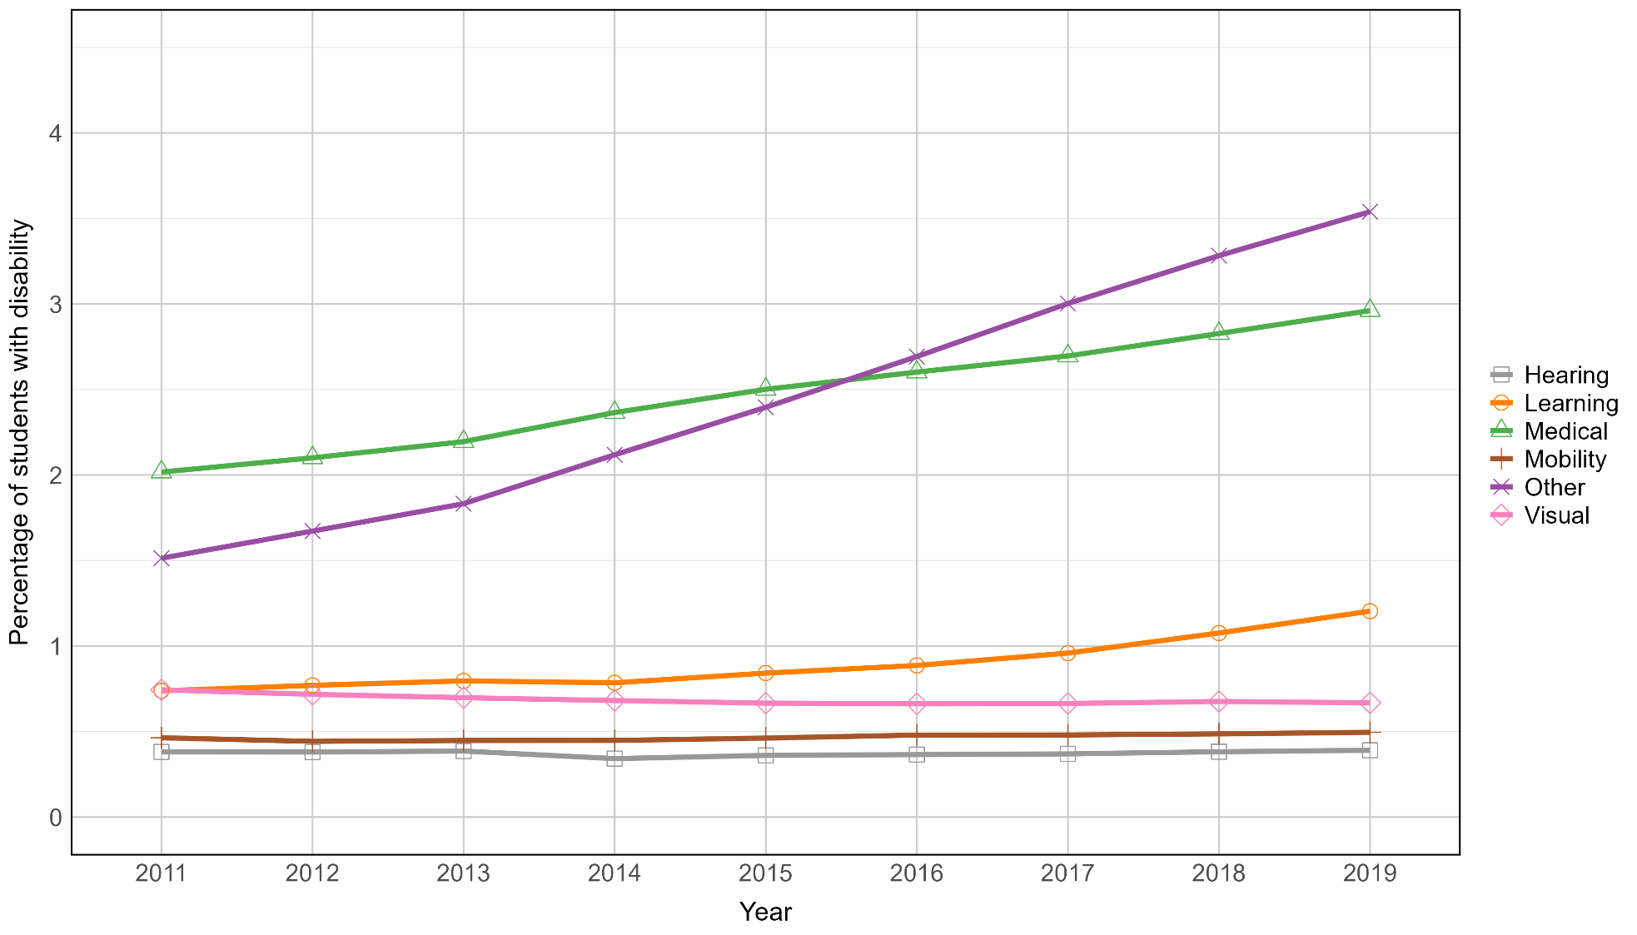

Types of disability reported by higher education students: 2022
In 2022, the 86,664 students identified as having disabilities collectively reported 120,149 categories of disability, an average of 1.4 categories per student (see Figure 3). Listing a ‘Mental health condition’ was the most common form of disability disclosed (40,344 cases), being listed by almost half of all students with disability (46.6%). More than a quarter of students with disability reported a ‘Medical condition’ (23,616 or 27.3%).
It is noteworthy that almost one in five students reporting a disability still used the ‘Other disability’ category (15,789 or 18.2%). Whilst this is down markedly from the 45.9% figure reported under the older categories of disability, it is still a significant proportion of students. This may indicate either that the new categories are still not sufficient to accurately report types of disability or that institutional reporting mechanisms remain confusing to many students with disability.

Figure 3: Count of disability category reported, 2022. The left most bar (darkest bar) is the total number of disabilities reported and is larger than the total student population reporting any disability as students can report more than one disability. The second bar from the left is the total number of students reporting disability (where a student has reported more than one disability, in this count they will appear only once).
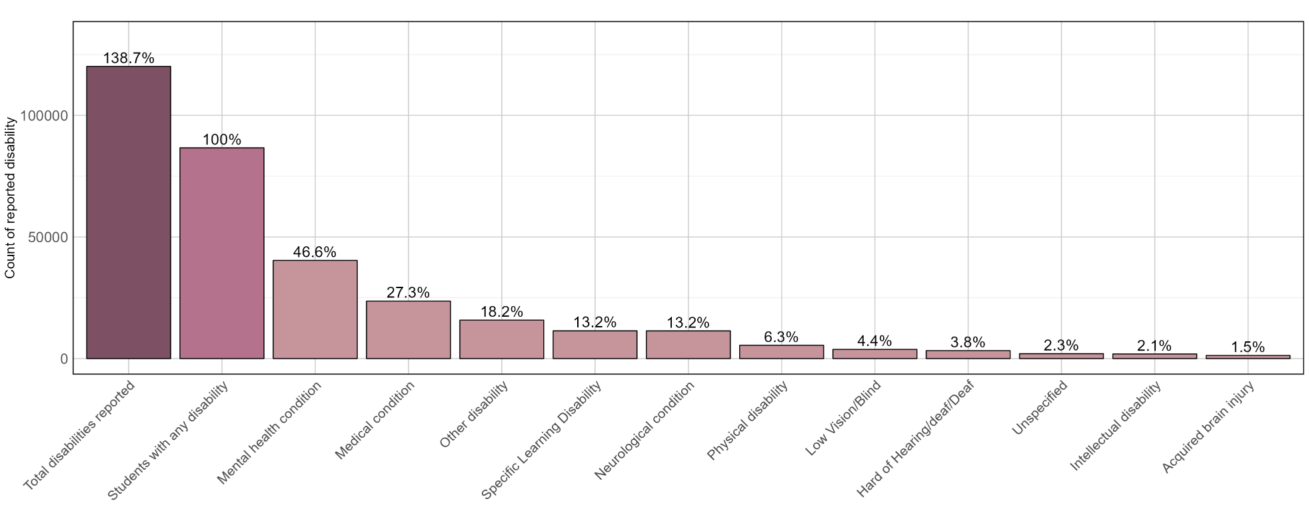

Further, these sector-wide rates hide a significant degree of variance at the institutional level, as illustrated by Figure 4. This shows clearly that there is substantial variation in the percentage of students from each institution that reported an overall disability, and for each type of disability. For example:
- Overall, in 2022, 11.6% of undergraduate students reported having a disability. However, this percentage varied across institutions, with the range spanning from as low as 5.2% to as high as 20.3% of the student cohort.
- The largest variability (range) in institutional rates across disability types was for students reporting a ‘Mental health condition’, with estimates ranging from 0.9% to 12.8% across institutions.
- There was also significant variability (range) in the ‘Other disability’ category, with estimates ranging from 0.8% to 6.0% across institutions.
- The smallest variability (range) was in the ‘Hard of Hearing/deaf/Deaf’ category, with estimates ranging from 0.2% to 1.1% across institutions.
One interpretation of the data is that the demographic profile varies significantly across institutions. Another is that the collection and reporting of data varies, rather than the students. Without further investigation it is not possible to say, definitively, the reason for the variance. However, this is an area of inquiry that is deserving of attention, for example:
- If the variance is explained by actual difference in student profile, then is this because certain institutions are known as exemplars in supporting particular types of disability requirements or for other (e.g. external) factors?
- If the variance is a consequence of differences in how data are reported or differences in institutional processes, then this would almost certainly be unbeneficial to wider efforts to support students with disability.

Figure 4: Percentage of students with each disability type in 2022, showing institutional spread. Dots represent individual institutions, while the black line represents the weighted average percentage of students with each disability type across all institutions. The weighted incorporates institution size, meaning that the percentage from a larger institution contributes more to the weighted average than that from a smaller institution.

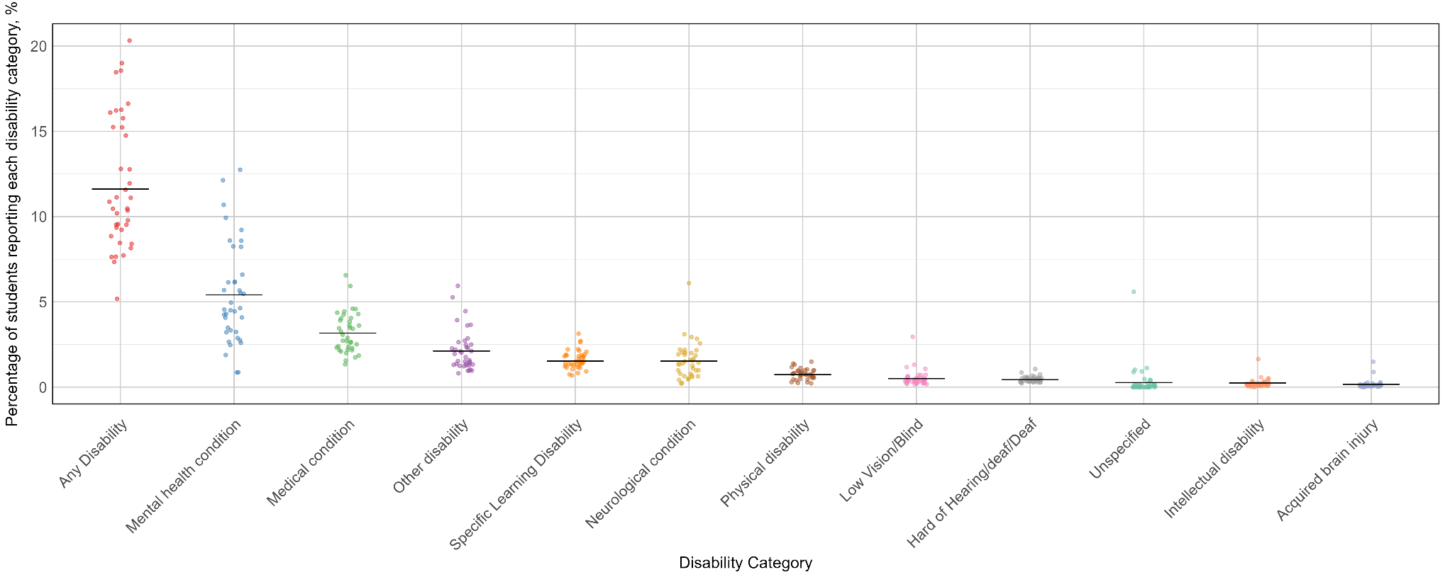

References
Australian Government (1992) Disability Discrimination Act 1992. https://www.legislation.gov.au/C2004A04426/latest/text
Australian Government (2003) Higher Education Support Act 2003. https://www.legislation.gov.au/C2004A01234/asmade/text
Australian Government (2005) Disability Standards for Education 2005. https://www.legislation.gov.au/F2005L00767/latest/text
Australian Government Department of Education (2024a). Equity Group Statistics, Private Request (April 2024). Canberra: Department of Education.
Australian Government Department of Education (2024b). Selected Higher Education Statistics – 2022 Student data. https://www.education.gov.au/higher-education-statistics/student-data/selected-higher-education-statistics-2022-student-data
Australia Department of Employment, Education and Training 1990, A fair chance for all: national and institutional planning for equity in higher education: a discussion paper, Australian Government Publishing Service, Canberra.
Tertiary Collection of Student Information (TCSI). (2024). Disability. https://www.tcsisupport.gov.au/node/7816
Tuck D, Wiley J, Patlamazoglou L & Berger E. (2022). Distress of tertiary education students in Australia during the COVID-19 pandemic. J Clin Psych, 79 (3), 818-834. https://doi.org/10.1002/jclp.23445

Appendix

Institutional groupings
Australian Technology Network (ATN): The University of Newcastle, University of Technology Sydney, University of South Australia, Deakin University, RMIT University, Curtin University.
Group of Eight (Go8): The Australian National University, University of New South Wales, The University of Sydney, The University of Queensland, The University of Adelaide, Monash University, The University of Melbourne, The University of Western Australia.
Innovative Research Universities (IRU): University of Canberra, Western Sydney University, James Cook University, Griffith University, Flinders University, La Trobe University, Murdoch University.
Regional Universities Network (RUN): Charles Sturt University, Southern Cross University, The University of New England, CQ University, University of Southern Queensland, University of the Sunshine Coast, Federation University Australia.
Non-aligned: Australian Catholic University, University of Wollongong, Macquarie University, Charles Darwin University, Queensland University of Technology, University of Tasmania, Swinburne University of Technology, Victoria University, Edith Cowan University, The University of Notre Dame Australia.

However as previously caveated, the figures for 2020 are believed to under-report actual numbers.

