The Academic Performance of First Year Students at Victoria University by Entry Score and SES, 2009-2013

George Messinis and Peter Sheehan

Victoria Institute of Strategic Economic Studies
Melbourne

1 May 2015



The authors would like to acknowledge funding from the National Centre for Student Equity in Higher Education (NCSEHE) at Curtin University and express our gratitude to John Phillimore and Mike Dockery from NCSEHE, and Peter Dawkins and Kerri-Lee Krause from Victoria University for valuable comments on earlier drafts. We also wish to thank Vicki Gunn and Sandra Thompson of Victoria University’s Government Reporting and Systems Support Unit in providing the basic data for the project. Further, we are most grateful to Steven Parker for excellent data support, Margarita Kumnick for editorial assistance, and to Peter Davenport for the geo-coding and matching of ABS SEIFA indicators to VU student data, for about 60,000 unique addresses. The usual caveat applies for remaining errors.

© 2015
National Centre for Student Equity in Higher Education
Curtin University,

Victoria Institute of Strategic Economic Studies
Victoria University
PO Box 14428
Melbourne VIC 8001

Contact for further information:
George Messinis
george.messinis@vu.edu.au

Table of Contents
List of Tables 4
List of Charts 4
Key Points 5
Executive Summary 6
1. Background 11
2. Data and Characteristics of Victoria University Students 12
The VU database 12
Definition of socio-economic status 12
Students characteristics and SES at Victoria University 13
ATAR scores and students performance 15
3. Multivariate Analysis: Quantile Regressions 18
4. Matched Quantile Regression 21
5. Discussion and Future Work 28
References 29
Data Appendix 30

List of Tables
Table 1. First-year VU Student characteristics, low SES group 14
Table 2. First-year VU Student characteristics, high SES group 14
Table 3. Academic performance of first-year VU students and SES officially defined 19
Table 4. Academic performance of first-year VU students and school-adjusted SES 20
Table 5. Mahalanobis matching of ATAR scores 22
Table 6. Matched ATAR scores, academic performance and school-adjusted SES 24
Table 7. Matched ATAR scores and academic performance, 2009-2011 & 2003 27

List of Charts
Chart ES 1. Median decile conditional predictions of student performance by ATAR 8
Chart ES 2. Median decile predictions of student performance by SES group 9
Chart 1. Student performance by ATAR score and SES, VU students, 2009-2013 16
Chart 2. Predicted student performance by ATAR score and SES, VU students, 2009-2013 16
Chart 3. School rankings and ATAR scores, VU students, 2009-2013 17
Chart 4. School rankings and student performance, VU students, 2009-2013 17
Chart 5. ATAR propensity scores by ATAR group, unmatched, 2009-2013 22
Chart 6. ATAR propensity scores matched by SES, re-weighted 2009-2013 23
Chart 7. Median decile conditional predictions of student performance by ATAR 25
Chart 8. Median decile predictions of student performance by SES group 26

Key Points
This report examines the impact of tertiary entry scores, socio-economic status and other factors on the first year performance of higher education students at Victoria University in Melbourne. Victoria University has diverse entry paths and substantial numbers of students from low socio-economic status (SES) and/or non-English speaking backgrounds (NESB). The key findings are noted below.
- On average, students with higher prior achievement, as measured by the Australian Tertiary Admission Rank (ATAR) scores, achieve higher marks in their first year courses; this is a statistically significant relationship.
- Other factors such as age, gender, socioeconomic status (SES) and non-English speaking background (NESB) also have significant effects on first year performance.
- However, even when adding these other explanatory variables, there is a large amount of variance unexplained; many lower ATAR students get high first year scores and substantial numbers of high ATAR students get low first year marks. Thus, we account for the potential for a varying relationship between ATAR scores and academic performance across the mark distribution.

- A new measure of SES is developed which is considered to be superior to the standard definition used in higher education. Using this newly developed measure we find that, controlling for other explanatory variables, low SES students perform better than high SES students for a given ATAR score in their first year results.

- When we allow for all observable factors, predicted mean marks for high SES students are better than those for low SES students. This shows the extent to which factors other than ATAR scores pull down marks for low SES students. But across the ATAR range marks rise more rapidly with ATAR for low SES than for high SES students.

- School quality (as measured by median school VCE score) has a small influence on first year performance. Again, controlling for other variables, VU students from lower performing schools seem to perform better than their peers from elite schools.

- ATAR scores play a very different role in different enrolment paths. Only a little more than half of VU’s first year students enter direct from high school. For those entering from a VET award course or from another institution, performance since their initial ATAR score may be a more important factors in securing admission than the original ATAR score itself.

- There is preliminary evidence of discernible changes in student performance by ATAR scores, age, gender, NESB, field of study and school rank over time. In particular, there are signs that the NESB disadvantage has been reduced for the 2013 cohort.

Executive Summary
Introduction
This report examines the impact of tertiary entry scores and socio-economic status (SES), together with other factors, on the performance of first year higher education students at Victoria University (VU) in Melbourne, over the period 2009-2013. This issue is important both for national education policy and in terms of the educational strategies of individual universities. Victoria University provides a unique base for studying these issues, because it draws students from many sections of the Victorian community, with a significant component of students from low socio-economic families and many with non-English speaking backgrounds.
The analysis is based on unit record data on first year students at VU. In common with other institutions, VU has a diverse set of pathways to entry, so that an ATAR score cannot be identified for all students. Even when there is an ATAR score, the role of that score in the admission process may differ for different pathways. Just over 50% of first year degree students at VU enter directly from high school, with most of the other students entering via a higher education course at another institution or a VET award course. In the latter cases, performance since achieving the ATAR score may be a more important factor in securing admission than the original ATAR score. For example, students entering through a VET award course have low average ATAR scores. The analysis is confined to first year students for which an ATAR score is available, about 20,000 students over the 2009-2013 period.
Victoria University has its main campuses in the western region of Melbourne, and its student population includes a strong representation from lower SES groups and from recent migrant families. For the first year students studied here: over 55% are female; the mean ATAR score is less than 60; about a fifth were born in non-English speaking countries and for about one third of the students English is not the language spoken at home; and over 80% come from either Government or Catholic schools. In spite of some of the challenges that this diversity poses, VU is thus an important case study for the impact of entry score and SES on student performance. It provides a distinctive laboratory in which to study the role of socio-economic and other factors in student performance.
There has been considerable debate about how SES status should best be measured. For this study, the addresses of the entering students have been geocoded to the 2011 Census at the Census Collector District (CCD) level, allowing the socio-economic information from the Census at that level to be linked to each student. It is recognised that there can be significant variations in SES status within the CCD level, which may be particularly relevant for analysis of educational issues. Here we adopt a hybrid measure of SES status, dividing the students into two groups, low and high SES. Low SES is defined as being those from the lower 50% of the distribution of CCDs on the ABS Index of Socio-Economic Advantage and Disadvantage for 2011 who attended government or Catholic schools, while all other students are classified as high SES. Thus we do not treat SES as a variable applying to each student in the regression analysis, but run the analysis separately for the low SES and high SES groups. However, the sensitivity of our results to this particular choice of SES measure is examined by also using a more traditional SES measure. We also make use of school rankings from the Better Education web site, which ranks schools in terms of the median Victorian Certificate of Education (VCE) score.
Methods
Our research strategy begins with a simple bivariate analysis of the link between ATAR scores and first-year academic performance. Chat ES1 is a scatter plot of these two variables which shows that, although on average the relationship between ATAR scores and students outcomes seems to be positive, there is wide variation in outcomes for a given ATAR score; i.e., many students with low ATAR scores achieve strong academic results while others with high ATAR scores underperform.
Chart ES1. Student performance by ATAR score and SES, VU students, 2010-2013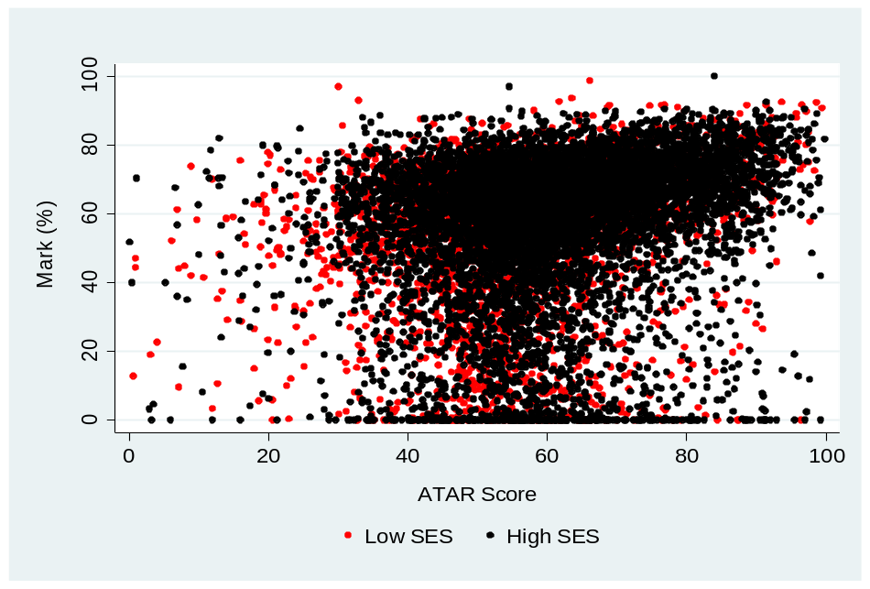
In view of this wide range of outcomes, this study analysis goes beyond the ‘typical’ student to allow for variation in the relationship between ATAR scores and student performance across the distribution of average marks. Thus, we employ quantile regression analysis, by examining quantile segments by mark for both the high and low SES groups, and undertaking a regression analysis of each of those quantiles, with the mean student mark as the dependent variable and with a wide range of other explanatory variables in addition to ATAR score. This allows us to analyse the performance of different SES groups of students separately, as well as to incorporate the impact of other factors.
This application of standard quantile regression still depends on the assumption that the explanatory variables are independent of one another, and in particular that ATAR is independent of the set of other explanatory variables used. Overall, this assumption seems to be satisfied, but some segments do not overlap. To correct for this dependency, matching estimators are employed that can identify common support factors and re-balance the ATAR distribution using the estimated weights. Quantile regressions are again estimated on re-weighted ATAR scores and the other performance variables. The details of the application of these methods are provided in the body of the paper, and the results summarised below.

Results
First, in the many regressions undertaken here, there is a significant positive relationship between ATAR scores and first year marks for the two SES groups. This confirms the standard finding in the literature of a positive correlation between entry score and first year performance.
Secondly, for any given ATAR score there is a wide variation in marks, for both high SES and low SES students. This indicates the importance of both the broad characteristics of students and of unidentifiable individual factors in shaping student outcomes. This diversity of outcomes should be clearly recognised in policy discussions.
Thirdly, in these regressions, the other important factors explaining student first year marks include age and gender (with older students and women both performing better), with NES country of birth (COB_NES) and NESB (i.e., students who report a language other than English is spoken at home or have a parent born in a non-English speaking country) having a negative impact. There were also some significant differences across faculties, with a negative effect for Business/Law and Engineering/Science students and mixed effects for the Health, Nursing and Sport faculty, as compared to the reference group of Arts, Psychology and Education.
Fourthly, the ATAR/mark relationship is a complex and interesting one having regard to both the difference between low and high SES students and the role of these other factors. There are three important aspects of this relationship.
Chart ES2. Median decile conditional predictions of student performance by ATAR, 2010-2013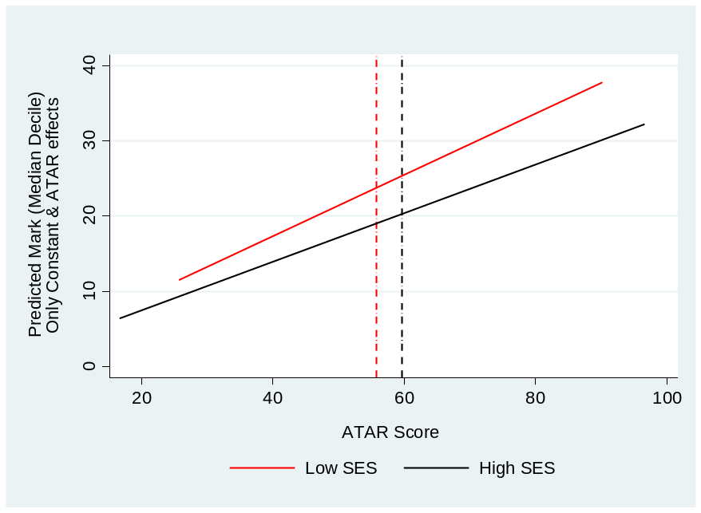

The ‘pure’ ATAR/mark relationship is estimated for the median outcomes group (i.e., the median decile of marks) implied by the matched data for the two SES groups, by conditioning on the other identified factors that shape outcomes (that is, by setting other things equal). The results are shown in Chart ES2. They show that, on this basis, low SES students achieve higher mean marks for a given ATAR score than high SES students. This discrepancy tends to increase as the entry score rises, with the gap being particularly marked for higher ATAR scores. In other words, Chart ES2 shows that, if the identified factors are equal, low SES students tend to get higher first year marks for a given ATAR score than students from high SES backgrounds.
On the other hand, Chart ES3 illustrates the relationship between ATAR scores and marks for the median groups on the basis of including rather than controlling for the other factors and hence allowing student characteristics to influence total outcomes for the two SES groups. The 95% confidence intervals are shown by the dotted lines around the central solid lines and the vertical dotted lines indicate the median ATAR score for the two SES groups. This chart again indicates a significant positive ATAR gradient in the final results but a better overall performance by the high SES group for most of the students in the median group.
Taken together, Charts ES2 and ES3 show that, after controlling for the modelled factors affecting student performance, low SES students tend to get better marks for a given ATAR score than high SESE students, but that this no longer holds if the effect of the other factors on performance is included.
It is noticeable also that both charts show that there is a stronger positive gradient between ATAR score and first year mark for low SES than for high SES students. Moving along the ATAR range, one extra ATAR point for low SES students tends to result in a bigger increment in academic performance than for high SES students.
Chart ES3. Median decile predictions of student performance by SES group, 2010-2013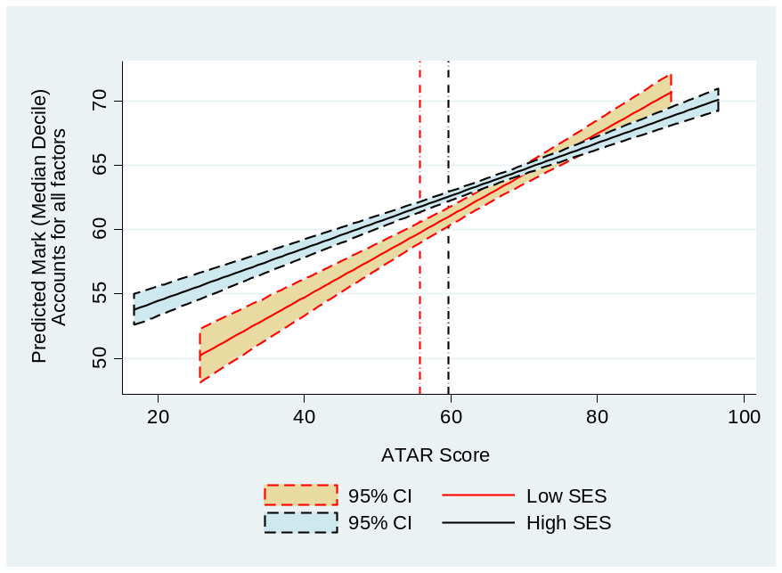

For robustness, a more standard measure of low SES (i.e., the lowest 25% of the SEIFA index at the postcode and national level) is also used to distinguish between low and high SES. The results are similar except that the significant difference in the ATAR gradient between low and high SES students disappears and the unexplained variation in performance increases. This result provides some support for a hybrid measure of low SES in future research.
Finally, while high SES students on average get better marks than low SES students, there is little evidence that this difference varies with school quality.
Conclusions
This matched quantile analysis supports many of the conclusions of the simpler analyses undertaken, while putting it in a more rigorous and complete context. First, there is again evidence of a positive and statistically significant relationship between ATAR and mean first year marks, but other factors such as age, gender and NES status, are also important in explaining first year outcomes. Secondly, the ATAR gradient is still higher for low SES than for high SES students.
Evidence from this study indicates that low SES students who achieved relatively high ATAR scores, in spite of their disadvantaged backgrounds, tend to outperform their high SES peers in their first year of study, other things being equal. Also, the findings of this study reinforce the importance of ensuring that universities continue to provide enhanced support to low SES students with low ATAR scores, in order to assist them to succeed in their studies.
There is also evidence that academic outcomes differ across the faculties of Victoria University, do not relate closely to school quality, and are stronger for females, mature-aged students and those born overseas from a NES country. Yet, linguistic diversity at home seems to be a disadvantage, with students where English is not the language spoken at home tending to have lower first year marks, although the importance of this factor seems to have reduced over time.
Further, a potential limitation of this study may concern the measurement of the hybrid low SES indicator that may have wrongly assigned some students in the wrong SES group, as it is often the case with new hybrid and multi-dimensional indicators in social sciences. This possibility, as well as the scope for refinement of the measure, needs to be investigated further in the future.
Finally, although ATAR scores age, gender, NESB, field of study and school quality all play a role in explaining student outcomes at VU, there is much left unexplained in this study. Future work ought to examine additional factors, such as tertiary teaching quality, diversity in student cohorts and attrition, and the role of diverse entry pathways to higher education.

1. Background
This study uses data from Victoria University on domestic students entering higher education from 2009-2013 to examine the role of entry scores and socio-economic status (SES), among other factors, in shaping student performance in their first year of university. The 2009-2013 period should be of interest because policy, institutional and input variables have changed significantly over this time.
A key issue for this study is how the effects of low SES interact with low entry scores. Is there a different relationship between entry score and performance for different SES groups? If low entry scores mainly reflect the impact of SES rather than ability, ability might reassert itself with good university performance. But if high SES does not distort entry scores relative to ability, lower performance might be expected to be correlated with low entry scores. These issues may be becoming more important if the distribution of education and physical resources across schools is becoming more unequal.
The recent Review of the Demand Driven Funding System for the Australian Government (Kemp and Norton 2014) has confirmed both the importance of, and the lack of knowledge about, these issues. The Review noted that the Australian Tertiary Admission Rank (ATAR) score is not a measure of inherent academic ability, and reported strong evidence that a student with a lower-ATAR score can achieve academic success, but pointed to lower completion rates for such a student. On this basis, it rejected proposals for an ATAR cap, but called for more information about likely outcomes for lower-ATAR students and better dissemination of it to potential students.
In terms of SES access issues, the Review noted the strong variation in the relationship between ATAR scores with SES level. They also drew upon some ‘older’ research which showed that for a given ATAR score, low and high SES applicants had similar rates of application to university, but noted that this finding had not been replicated with more recent data. The Review recommended abolishing the target of 20% low SES higher education enrolments at the undergraduate level by 2020, set by the previous Government on the advice of the Bradley committee. This decision was reached because ATAR score attainment by low SES students was seen as the critical problem, and because universities should be free to make offers on a case-by-case basis, without the constraints of an imposed target.
This Review illustrates both the importance of the issues being addressed in this project to higher education policy in Australia, and the constraints on policy formulation imposed by inadequate information about them.
Victoria University has a strong representation from lower SES groups and from recent migrant families. For the first year students studying here: over 55% are female; the mean ATAR score is less than 60; about a fifth were born in non-English speaking countries and for about one third of the students English is not the language spoken at home; and over 90% come from either Government or Catholic schools. In spite of some of the challenges that this diversity poses, VU is thus an important case study for the impact of entry score and SES on student performance. It provides a distinctive laboratory in which to study the role of socio-economic and other factors in student performance.

2. Data and Characteristics of Victoria University Students

The VU database
This report utilises student statistical information provided to us by the Government Reporting and Systems Support unit at Victoria University. This database maintains basic demographic information such as home address, country of birth (COB), non-English speaking background (NESB), high school attended, course details, Equivalent National Tertiary Entrance Ranking score (ENTER) also known as ATAR score, and academic achievement (mark) for each course unit enrolled. The information is collected as part of reporting requirements for the Australian Federal government, and for the University’s own management purposes. Around 2009, the unit adopted a new reporting system and database structure. As a result of this migration, the database ceased to record some data that was no longer deemed necessary while starting to collect new data.
The new database was checked for consistency and cleaned. One area of continuing concern was the number of missing values in the marks variable, especially around the migration period. These data were input by the lecturers themselves (into a central database) and were transferred to the reporting team, but there was a significant number of zeroes besides missing values. Also of concern was the large number of missing values for ATAR score due to student or administrative omissions.
For each year and student, the VU dataset also includes records of multiple study units undertaken and the final marks awarded for each unit. The average mark of each student in each year was used for analysis. Still, 2.5% of students obtained an average mark of 0 and 5.5% recorded an average mark below 10, with or without the missing observations for ATAR scores. Closer inspection revealed that many students leave the university without submitting the required paperwork to defer studies. Therefore, they are still in the system and receive zeros or low marks, depending on how much they have accomplished. Given the lack of any more information, these low marks are also included in the analysis below, as they remain an indicator of the student’s performance in the subject studied.
Longitudinal information was used to identify the first year students. Further, due to an ambiguity regarding year level for part-time students, this group was excluded from the analysis. Thus, the study is confined to first year, full-time, domestic fee students enrolled in a bachelor’s degree.

Definition of socio-economic status
Home addresses in the VU database facilitate geocoding and the linking of each student to the ABS Census 2011 indexes of socio-economic status (SES), SEIFA, which is a weighted average of indicators such as income, unemployment, education and occupation. However, both the home address and the ABS SEIFA indicators are problematic since the former could be the student’s residence address and not the home/parental address, while the latter can mask much heterogeneity within the statistical unit and is only updated every five (Census) years.
It has been suggested that parental education is an important dimension of SES. Yet, the lack of such data is a major limitation of the VU database. As a remedy one could explore students’ school background and link this to resources and performance of schools attended by VU students. We pursued this avenue with the Australian Curriculum, Assessment and Reporting Authority (ACARA) and secured access to data. However, these data were far from complete. It is worthy of mention that most high-fee independent schools were missing from the ACARA data. Given this selectivity bias, the ACARA indicators of SES were omitted from analysis. Note also that it is debatable whether the exclusive use of school background or parental education could be robust indicators of SES (Gale 2008).
Thus, we settled on a hybrid approach to identifying SES using both the ABS indicators at the CCD level and a broad classification of schools by government, Catholic and independent schools. It is generally the rule that the vast majority of low SES students typically go to government schools (Gale and Parker 2013), but Catholic schools have a significantly higher proportion of students from low SES than other non-government schools, especially in Victoria. Going by tuition fees, there is a sharp difference between government and independent schools, but there are also marked disparities between Catholic and private schools. Although there is substantial variation in fees and school resources within independent schools, we treat here both government and Catholic schools as the main pool of students from relatively low socio-economic status. Note that religious and Catholic schools are not exclusive on the basis of socio-economic background and are, thus, expected to include students from low SES and Catholic denomination. Some support for restricting this to government and Catholic schools comes from 2001 Census unpublished data used in Sheehan (2004) examining school enrolments by school type and father’s occupation at CCD level. According to these data, 13.1% of students in government secondary schools had a father whose occupation was very low skills (i.e., elementary clerical, sales & service or labourers or related workers). The corresponding figures for Catholic and other non-government schools were 10.8% and 4.7%. These suggest that government and Catholic schools have comparable representation of students from low SES. Hence, we consider students who attended government or Catholic schools and whose home address associates with values below the Victorian median of the ABS Census 2011 SEIFA Index of socio-economic advantage and disadvantage (SAD_2011) to constitute the low SES group (SES_LOW) of students at VU. All other students are included in the high SES group.

Students characteristics and SES at Victoria University
The VU data set for 2009-2013, involving over 55,690 unique Australian addresses, has been geo-coded to link to the ABS Census 2011 at the CCD level. As noted earlier, the analysis below concerns first year, full-time and domestic students enrolled in a bachelor’s degree at Victoria University, excluding international students and the small number of full-fee paying students, over the period 2009-2013.
Tables 1 and 2 provide insights into recent trends in VU student characteristics by SES group, although caution is required in interpreting these data in the light of the data limitations discussed above. Arts, Psychology or Education students make up about one-third of the domestic student population, slightly increasing their share over time. Business and Law students have seen their share decline from 28.6% in 2009 to 19.8% in 2013.

Table 1. First-year VU Student characteristics, low SES group
 | 2009 | 2010 | 2011 | 2012 | 2013 | All
All (numbers) | 809 | 868 | 1098 | 1461 | 1868 | 6104
Arts_Psyche_Education (%) | 35.2 | 40.1 | 39.1 | 37.4 | 38.7 | 38.2
Business_Law (%) | 28.9 | 23.9 | 26.2 | 24.7 | 20.3 | 24.1
Engineering_Science (%) | 12.2 | 16.8 | 18.8 | 17.2 | 16.6 | 16.6
Health_Nursing_Sport (%) | 23.6 | 19.1 | 15.9 | 20.7 | 24.4 | 21.1
Age (mean) | 23.2 | 22.7 | 22.9 | 23.2 | 23.5 | 23.2
Female (%) | 61.2 | 60.7 | 56.5 | 57.2 | 57.0 | 58.1
ATAR (mean) | 54.2 | 59.7 | 59.9 | 56.9 | 54.2 | 56.8
ATAR (median) | 56.9 | 60.8 | 59.4 | 56.3 | 53.0 | 56.6
COB_NES (%) | 25.9 | 26.0 | 23.8 | 24.6 | 25.0 | 25.2
NESB (%) | 40.7 | 35.4 | 36.6 | 37.0 | 44.0 | 39.2
SAD_25% (national) | 40.7 | 33.6 | 39.1 | 37.6 | 37.9 | 37.8
School_Govt. (%) | 67.9 | 68.7 | 65.2 | 67.2 | 69.2 | 67.7
School_Catholic (%) | 32.1 | 31.3 | 34.8 | 32.8 | 30.8 | 32.3
School_Rank (mean) | 268.1 | 273.0 | 266.5 | 271.3 | 287.8 | 275.2
Mark (mean) | 58.8 | 58.6 | 57.8 | 52.9 | 53.1 | 55.5
Mark (median) | 64.2 | 63.0 | 62.9 | 59.5 | 59.0 | 61.5
Table 2. First-year VU Student characteristics, high SES group
 | 2009 | 2010 | 2011 | 2012 | 2013 | All
All (numbers) | 1881 | 2144 | 2447 | 3462 | 3902 | 13836
Arts_Psyche_Education (%) | 32.6 | 36.7 | 38.8 | 33.3 | 34.8 | 35.1
Business_Law (%) | 28.3 | 25.5 | 24.2 | 23.9 | 19.5 | 23.6
Engineering_Science (%) | 15.0 | 13.1 | 15.8 | 17.8 | 16.9 | 16.1
Health_Nursing_Sport (%) | 24.1 | 24.7 | 21.2 | 25.0 | 28.7 | 25.2
Age (mean) | 22.5 | 22.9 | 22.6 | 22.9 | 23.5 | 22.9
Female (%) | 60.5 | 60.5 | 57.2 | 55.3 | 54.2 | 56.8
ATAR (mean) | 59.4 | 63.4 | 62.6 | 61.1 | 58.0 | 60.7
ATAR (median) | 60.1 | 63.1 | 61.9 | 59.6 | 56.6 | 59.9
COB_NES (%) | 13.8 | 16.1 | 12.2 | 13.9 | 14.5 | 14.1
NESB (%) | 22.0 | 20.9 | 17.9 | 21.5 | 28.3 | 22.8
SAD_25% (National) | 6.1 | 6.7 | 5.0 | 6.1 | 5.7 | 5.9
School_Govt. (%) | 52.1 | 51.2 | 48.4 | 49.5 | 48.9 | 49.8
School_Catholic (%) | 24.6 | 23.5 | 27.6 | 25.6 | 26.8 | 25.8
School_Rank (mean) | 233.5 | 234.3 | 234.1 | 239.1 | 230.2 | 234.2
Mark (mean) | 60.6 | 59.4 | 59.9 | 56.4 | 56.0 | 58.1
Mark (median) | 65.2 | 64.7 | 64.9 | 62.4 | 62.0 | 63.8

The share of Health, Nursing and Sport students has bottomed in 2011 at 19.6%, but has recovered to 27.8% in the most recent year. The number of females has been substantially higher than males, but their share has declined to 54.3% in 2013. Students from non-English speaking backgrounds (NESB) seem to have increased, relatively speaking. Also, the share of students from government schools has marginally declined and mainly been replaced by from students from Catholic schools.
Table 1 suggests that 2010 and 2011 were turning points for low SES students in terms of course orientation, ATAR scores, NESB, school background and academic performance. Since 2010 or 2011, these students have moved away from Business and Law and towards Arts, Psychology and Education or Engineering and Science disciplines. Also, an increasing proportion of them are from NESB or born overseas in NES countries. Further, they have increasingly been drawn from schools with lower mean VCE scores (lower rankings) and their academic performance (i.e., mean or median mark) has declined substantially when compared to 2009.
Our definition of SES results in 30.6% of all first year students at VU being low SES. Compared to their high SES counterparts, they tend to be more concentrated in the Arts, Psychology and Education, to have a lower ATAR score, to have a much higher proportion of NESB students, but as expected, they have attended schools of relatively lower VCE rankings in 2010.
Note, this share of low SES is much higher than that corresponding to a standard definition of low SES using SEIFA indicators only. Going by the latter definition, the low SES group constitutes 18.9% of all domestic students and 16.1% of full-time, higher education students at VU. The former figure seems close to the 21.3% figure reported by Koshy (2011) for all VU students (i.e., TAFE students included) for 2008-2009.
Similar trends are evident for high SES students since 2011 (Table 2), with a shift away from Business and Law to other faculties, an increasing proportion of students from NES backgrounds, and a decline in ATAR scores and academic performance. These trends are in good part indicators of the impact on VU of the major changes that have occurred in Australian higher education in recent years, especially the introduction of the demand-driven approach to funding higher education places from 2012.

ATAR scores and students performance
Charts 1 and 2 below are scatter plots for full-time, first year bachelor degree students at VU, for the years 2009-2013 combined. The ATAR scores are shown for all entry types, even if entry was via a pathway program or TAFE course. Note also, as a result of diverse pathways to entry, ATAR scores are missing for 65% of full-time students, and these students are excluded. Chart 1 shows average first year marks on the vertical axis, and the ATAR scores on the horizontal axis for each SES group.
Chart 2 includes the same information as Chart 1 except that it hides the individual marks and focuses on the estimated OLS linear regression between Mark and ATAR score in solid lines. These linear predictions are mean estimates for each SES group as a whole. They suggest an upward sloping relationship for both SES groups suggesting a positive relationship between ATAR scores and academic performance. These data also indicate that low SES students marginally underperform when ATAR scores are below 65. Yet, Chart 1 makes it abundantly clear the absence of a tight relationship between ATAR scores and students outcomes.
Chart 1. Student performance by ATAR score and SES, VU students, 2009-2013
Chart 2. Predicted student performance by ATAR score and SES, VU students, 2009-2013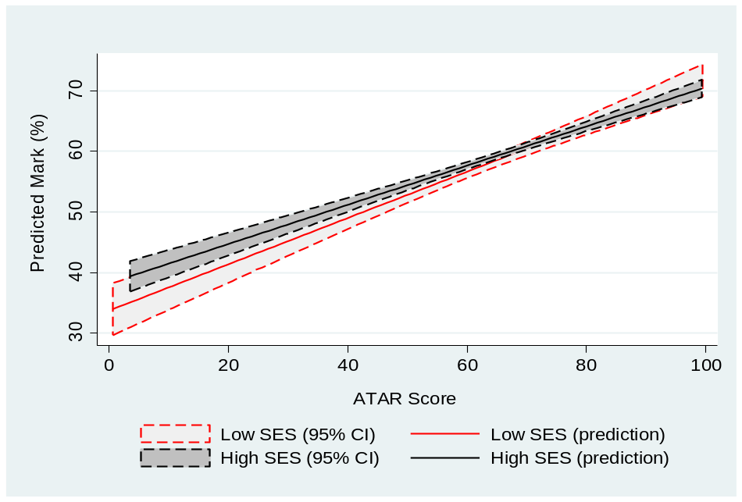
For each SES group, the linear predictions from implicit OLS regressions of Mark against ATAR scores are also accompanied by their corresponding 95% confidence intervals (CI) in dotted line bands. This provides a clearer picture as to statistical significance of the differences in student performance between the two SES groups. The 95% bands seem to suggest that the low SES group disadvantage for low ATAR scores may be statistically significant. This, however, will need to be reviewed in the context of multivariate, quantile analysis in the next section.
Another important feature of the VU data is the different school backgrounds of the two SES groups. Chart 3 provides insights on the relation between school VCE ranking and ATAR scores for the VU student population. As expected, the higher the school rank (i.e., the smaller the value on the x-axis) the higher the ATAR score. It makes a stark contrast between low and high SES groups whereby the former consistently associate with lower ATAR scores at a given school rank. Thus, on average, being in a high VCE ranking school is an advantage for high SES students. School performance, however, does not impact critically on academic performance, especially for the high SES group (Chart 4).
Chart 3. School rankings and ATAR scores, VU students, 2009-2013
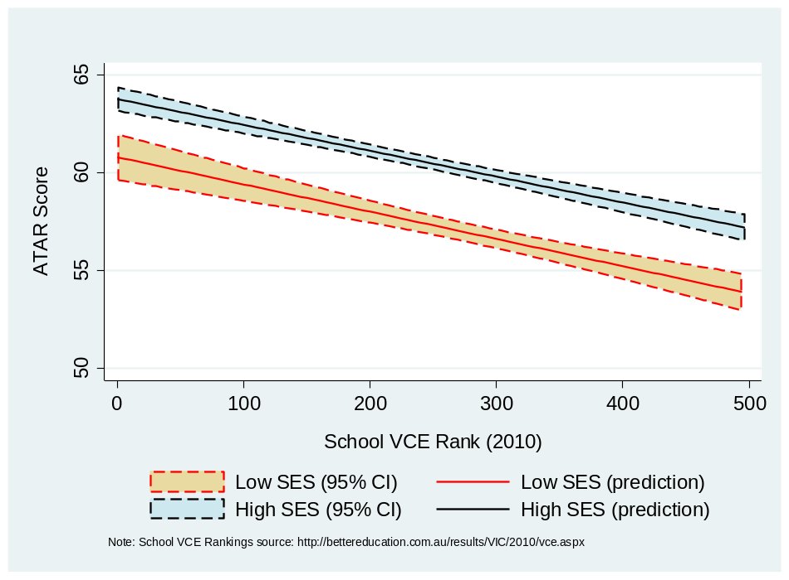
Source: School VCE Rankings: http://bettereducation.com.au/results/VIC/2010/vce.aspx

Chart 4. School rankings and student performance, VU students, 2009-2013
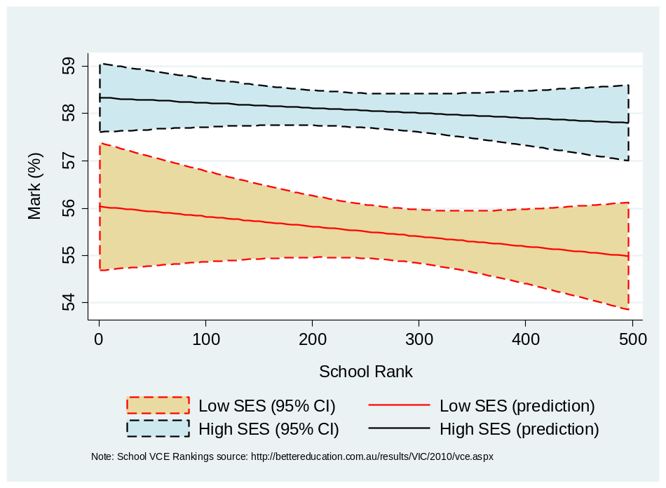
Source: School VCE Rankings: http://bettereducation.com.au/results/VIC/2010/vce.aspx

3. Multivariate Analysis: Quantile Regressions
Although Chart 2 points to a positive relationship between ATAR scores and academic performance, Chat 1 clearly illustrates a huge variation around the linear prediction line; many students with low ATAR scores achieve strong academic results while there are others with high ATAR scores who underperform.
The academic achievement of a particular student can be seen as a function of cumulative inputs by the student, family, peers, friends, teachers and school (Hanushek 1986). The impact of student characteristics, family background, and school or institutional factors on academic performance in first year at university can be measured by a production function of the general form:
Mark_{i} = βZ_{i} + ε_{i}
where Mark_{i} is the average score received by student i, β is a vector of coefficients, Z_{i} is a vector of covariates such as the above factors and ε_{i} is an error term. A covariate of special interest here is the ATAR score, ATAR. Given, however, the range of student performance associated with the diversity of educational inputs, it is important to gain insights on the whole distribution of Mark as the key indicator of student performance. Thus, we follow Birch and Miller (2006) to employ quantile regression techniques. Suppose we are interested in the effect of ATAR score for a particular part of the Mark distribution. The standard approach is to apply the conditional quantile model of Koenker and Bassett (1978), expressed as:
(1)
where q^{θ}(•) is the conditional quantile of Mark_{i} for quantile θ, 0<θ<1, Z_{i} is a vector of covariates that is orthogonal to the error term, ε^{θ}_{i}, ATAR is the tertiary education entry score, X_{i} is a vector of other exogenous covariates, and β^{θ} and δ^{θ} are unknown parameters at quantile θ.
The estimator is defined as the minimisation problem:
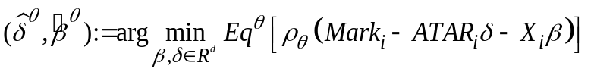 (2)
where ρ_{θ}(u) = (θ – 1(u≤0))u is the check function, and 0<θ<1.
As part of the X_{i} vector, the following covariates are considered: a constant, age and eight indicator variables that take the value of one if the condition applies and zero otherwise. The latter include females, non-English speaking background (NESB), NES country of birth (COB_NES), admitted on the basis of Year 12 completion, admitted on the basis of a higher education course, admitted on the basis of a VET course, a Business or Law student, Engineering or Science students, and Health, Nursing or Sport students (the reference discipline group comprises of Arts, Psychology and Education students). Note, all continuous variables (i.e., ATAR, Age and School Rank) are demeaned to make coefficient estimates more comparable across the SES groups and easier to interpret.
We proceed with quantile estimation by using first a standard measure of low SES that is in line with the official indicator used by the Australian Government (see previous section). Table 3 presents the regression estimates. They indicate that ATAR scores positively and significantly predict academic performance (i.e., the average student mark). More precisely, one extra ATAR point boosts the average mark of students by 0.386 points of low SES at the lowest quantile. The corresponding estimate for the high SES group is similar but higher than the coefficient estimate for the other two quantiles; Wald test statistics confirm these.
Table 3. Academic performance of first-year VU students and SES officially defined, quantile regressions
 | Low SES |  |  | High SES
 | Q25 | Median | Q75 | Q25 | Median | Q75
Constant | 53.856** | 66.033** | 75.828** | 55.421** | 67.899** | 73.876**
 | (5.242) | (1.894) | (1.559) | (2.193) | (0.873) | (0.710)
ATAR (demeaned) | 0.386** | 0.328** | 0.294** | 0.403** | 0.326** | 0.290**
 | (0.067) | (0.024) | (0.020) | (0.026) | (0.011) | (0.009)
Age (demeaned) | 0.499 | 1.982** | 2.503** | 1.557** | 2.389** | 2.715**
 | (1.494) | (0.540) | (0.444) | (0.490) | (0.195) | (0.159)
Age²/100 (demeaned) | 0.398 | -2.356* | -3.088** | -1.480 | -2.935** | -3.457**
 | (2.727) | (0.985) | (0.811) | (0.870) | (0.346) | (0.282)
Female | 3.592 | 2.464** | 1.377* | 5.098** | 2.272** | 1.005**
 | (1.958) | (0.708) | (0.582) | (0.748) | (0.298) | (0.242)
NESB | -4.089* | -1.611* | -1.079 | -2.469* | -1.925** | -1.719**
 | (2.081) | (0.752) | (0.619) | (1.043) | (0.415) | (0.338)
COB_NES | -1.916 | -2.344** | -3.053** | -5.083** | -2.774** | -1.300**
 | (2.486) | (0.898) | (0.739) | (1.373) | (0.546) | (0.445)
Admission: SEdu | -9.285** | -2.531* | -1.484 | -2.815* | -1.284* | -0.770
 | (3.229) | (1.167) | (0.961) | (1.322) | (0.526) | (0.428)
Admission: HEdu | -4.017 | -0.994 | -0.923 | 0.320 | 0.447 | 0.318
 | (2.974) | (1.075) | (0.885) | (1.141) | (0.454) | (0.369)
Admission: VET | -2.421 | -0.754 | -0.727 | 2.155 | 1.678* | 1.142
 | (4.378) | (1.582) | (1.302) | (1.951) | (0.776) | (0.632)
Business_Law | -7.011** | -9.917** | -8.823** | -8.225** | -8.234** | -7.435**
 | (2.411) | (0.871) | (0.717) | (0.977) | (0.389) | (0.316)
Engineering_Science | 0.235 | -2.948** | -3.634** | -0.480 | -3.310** | -3.208**
 | (2.854) | (1.031) | (0.849) | (1.102) | (0.438) | (0.357)
Heatlh_Nursing_Sport | 8.187** | 0.702 | -1.975* | 5.040** | -0.503 | -1.833**
 | (2.630) | (0.950) | (0.782) | (0.982) | (0.391) | (0.318)
School Rank (demeaned) | -0.001 | -0.001 | -0.001 | 0.003 | 0.005** | 0.003**
 | (0.007) | (0.003) | (0.002) | (0.003) | (0.001) | (0.001)
Observations | 2,243 | 2,243 | 2,243 | 9,166 | 9,166 | 9,166
Pseudo R² | 0.088 | 0.114 | 0.131 | 0.098 | 0.111 | 0.134
Note: Standard errors are in parentheses, * and ** denote 5% and 1% levels of significance respectively. Time effects
are included but not reported. School type indicators were also included but proved to be statistically insignificant.
The estimates suggest that academic performance positively associates with age, females and Health, Nursing and Sports disciplines in the lower end of the outcomes distribution. Conversely, NESB and COB_NES students, Year 12 based admissions and students in Business/Law or Engineering/Science underperform. Also, Health, Nursing and Sports students in the upper end of the distribution also underperform in comparison to Arts, Psychology and Education students. Thus, implicit here is the superior performance of Arts, Psychology and Education students at the top end of the outcomes distribution. Surprisingly, school ranking inversely associates with student outcomes for high SES students amongst the relatively strong performers. The latter may be due to VU success in attracting more able students from low performing schools for high SES students.
Table 4. Academic performance of first-year VU students and school-adjusted SES, quantile regressions
 | Low SES |  |  | High SES
 | Q25 | Median | Q75 | Q25 | Median | Q75
Constant | 53.813** | 67.775** | 73.921** | 55.258** | 67.278** | 74.000**
 | (4.007) | (1.679) | (1.259) | (2.369) | (0.900) | (0.764)
ATAR (demeaned) | 0.442** | 0.359** | 0.316** | 0.387** | 0.313** | 0.280**
 | (0.049) | (0.021) | (0.016) | (0.029) | (0.011) | (0.009)
Age (demeaned) | 0.668 | 1.817** | 2.514** | 1.784** | 2.472** | 2.822**
 | (0.996) | (0.418) | (0.313) | (0.539) | (0.205) | (0.174)
Age²/100 (demeaned) | 0.013 | -2.005** | -3.029** | -1.815 | -3.094** | -3.702**
 | (1.788) | (0.749) | (0.561) | (0.961) | (0.365) | (0.310)
Female | 4.567** | 2.006** | 1.215** | 4.993** | 2.273** | 1.085**
 | (1.395) | (0.585) | (0.438) | (0.822) | (0.312) | (0.265)
NESB | -2.323 | -1.662* | -1.067* | -3.504** | -1.900** | -1.726**
 | (1.575) | (0.660) | (0.495) | (1.143) | (0.434) | (0.368)
COB_NES | -2.582 | -2.876** | -2.805** | -4.749** | -2.467** | -1.532**
 | (1.947) | (0.816) | (0.611) | (1.510) | (0.574) | (0.487)
Admission: SEdu | -7.434** | -2.879** | -0.965 | -2.069 | -0.917 | -0.726
 | (2.331) | (0.977) | (0.732) | (1.458) | (0.554) | (0.470)
Admission: HEdu | -4.230* | -0.399 | -0.470 | 0.975 | 0.459 | 0.337
 | (2.063) | (0.864) | (0.648) | (1.267) | (0.482) | (0.409)
Admission: VET | -0.932 | -0.854 | -0.457 | 2.435 | 2.196** | 1.716*
 | (3.246) | (1.360) | (1.020) | (2.152) | (0.818) | (0.694)
Business_Law | -7.249** | -9.464** | -8.407** | -8.214** | -8.296** | -7.320**
 | (1.741) | (0.730) | (0.547) | (1.077) | (0.409) | (0.347)
Engineering_Science | -0.440 | -3.012** | -3.121** | -0.096 | -3.239** | -3.001**
 | (2.032) | (0.852) | (0.638) | (1.213) | (0.461) | (0.391)
Heatlh_Nursing_Sport | 6.024** | -0.464 | -2.437** | 5.392** | -0.331 | -1.482**
 | (1.856) | (0.778) | (0.583) | (1.081) | (0.411) | (0.348)
School Rank (demeaned) | 0.002 | 0.003 | 0.003 | 0.002 | 0.004** | 0.002*
 | (0.005) | (0.002) | (0.002) | (0.003) | (0.001) | (0.001)
Observations | 3,333 | 3,333 | 3,333 | 8,076 | 8,076 | 8,076
Pseudo R² | 0.098 | 0.116 | 0.142 | 0.097 | 0.110 | 0.130
Note: Standard errors are in parentheses, * and ** denote 5% and 1% levels of significance respectively. Time effects
are included but not reported. School type indicators were also included but proved to be statistically insignificant.

Next, we use our school-adjusted definition of low SES and employ again quantile estimation. Table 4 reports the results which are similar to those in Table 3 except that the ATAR effect now is higher in magnitude and statistically greater at the lower quantiles, especially for the low SES group. Also, the coefficient estimates for the low SES group are statistically higher than for the high SES group in the median and upper quantile. Thus, the low SES group disadvantage at low ATAR scores observed in the previous section proves to be a mirage attributed to bivariate analysis that fails to account for other factors. Differences between Tables 3 and 4 allude to the need for more hybrid measures of low SES that add information additional to area-based measures, such as school SES information in Li and Dockery (2014) and household-based data from the HILDA survey in Dockery et al. (2015).

4. Matched Quantile Regression
The above analysis and quantile regression estimation results rest on the assumption of ‘overlapping support’; that is, the key explanatory variable or treatment effect, ATAR, has an explained distribution (propensity scores) that is common or overlapping for both high performing and low performing students. In other words, relative academic performance cannot be explained by the observable characteristics of students; i.e., going by these characteristics, the predicted distribution of ATAR for relatively strong and weak students will be overlapping. Students whose ATAR distribution (propensity scores) are not overlapping are considered to be ‘off support’ and, according to the ‘overlapping support’ assumption, are not permissible in the analysis of ATAR as a treatment effect, unless these are re-balanced.
A treatment effect in the medical literature usually refers to a randomised trial where a group receives a new technology (treatment group), while another group with a similar condition does not (control group). The term has also been extended to observational data where the treatment can be the participation in schooling or a training program.
Although one interpretation of ATAR scores may concern student achievement and ability, it is also intuitive that ATAR scores reflect school resources and higher quality preparation for university entry exams. In that sense, ATAR scores can be viewed as a treatment effect. Further, on the basis of an ATAR score of 70 as a threshold, there are discernible differences in some of the student characteristics. In particular, excluding students without an ATAR score, 56% of those who attended a government school had an ATAR score lower than 70, 26% of NESB, 17% of those admitted to higher education on the basis of a previous higher education course, 40% of Arts, Psychology and Education students, and the mean school VCE ranking was 253. The corresponding figures amongst the group with a higher ATAR score than 70 are: 51%, 19%, 22%, 25% and 223 respectively. Clearly, the NESB, Arts, Psychology and Education students and those from low school rank are over-represented in the lower ATAR group. These results are intuitive and SES is an explaining factor (see Tables 1 and 2).
Hence, the analysis next seeks to account for this partial failure in common support and selectivity in observables. It has become standard practice to use matching estimators that can identify common support and re-weight the propensity scores or ATAR (Messinis 2013; Caliendo & Kopeinig 2008). Here, we classify students with an average ATAR score above 70, ATAR_70, to be the group with the strong ATAR score, leaving the rest to form the weak ATAR group. The former group is the treatment group while the latter is the control group.
Due to the fact that the control group outnumbers the treatment group by a multiple, we seek to undertake Mahalanobis propensity matching. Chart 5 illustrates the distribution of propensity scores of the two ATAR groups for the two SES clusters. Although there is substantial overlap, the distributions are somewhat different and the treatment groups associate with higher propensity scores.
We consider several student characteristics and preferences that may impact on ATAR scores. These are age, gender, NESB (i.e., those with non-English speaking background at home), COB_NES (i.e., those born overseas in a non-English speaking country), school rank, government schooling, non-Catholic schooling, and the binary SES indicator.
Chart 5. ATAR propensity scores by ATAR group, unmatched, 2009-2013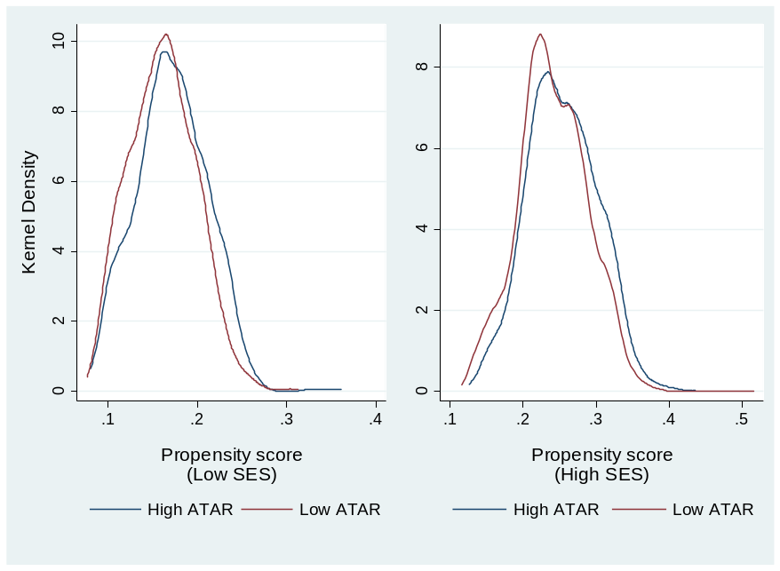
Note: Treated are those with ATAR scores > 70. Propensity scores used the following covariates: Age, Female, COB_NESB, School Rankings and indicators for Government, Catholic schools and SES_LOW. See Data Appendix for variable definitions.

Table 5 has the Mahalanobis matching estimates that constitute the propensity scores for ATAR. Going by statistical significance, age associates positively with high ATAR scores while NESB, school rank, non-Catholic independent schools, and low SES inversely relate to ATAR scores. A visual inspection shows significant overlap.
Chart 6 illustrates the result of propensity score rebalancing using the weights recovered from Mahalanobis matching. Here, the re-weighted propensity scores yield a much better matching of the predicted ATAR distribution.

Table 5. Mahalanobis matching of ATAR scores
Variable | Coefficient |  | Standard errors
Constant | 0.638** |  | (0.037)
Age (demeaned) | 0.011** |  | (0.004)
Female | 0.031 |  | (0.027)
NESB | -0.194** |  | (0.037)
COB_NES | -0.084# |  | (0.048)
School Rank (demeaned) | -0.001** |  | (0.000)
Government School | -0.016 |  | (0.040)
Catholic School | -0.087* |  | (0.041)
Low SES | -0.203** |  | (0.032)
 | Off support | On support |  | Total
Untreated (ATAR <= 70) | 0 | 8,895 |  | 8,895
Treated (ATAR > 70) | 305 | 2,210 |  | 2,515
Total observations | 305 | 11,105 |  | 11,410
Note: Standard errors are in parentheses, #, * and ** denote 10%, 5% and 1% levels of significance respectively.
Chart 6. ATAR propensity scores matched by SES, re-weighted 2009-2013 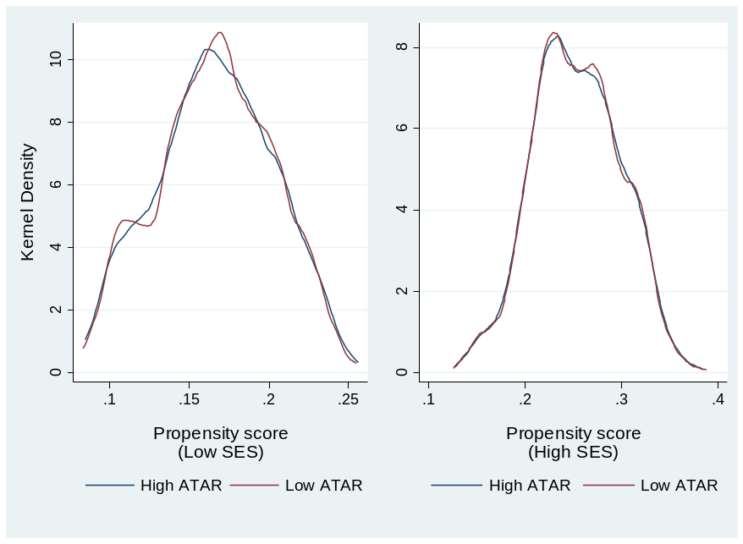
Note: Mahalanobis (epanechnikov) kernel matching used the ‘psmatch2’ Stata module and propensity scores used the following covariates: Age, Female, COP_NES, NESB, School Ranking and indicators for Government, Catholic schools and SES_LOW. Matching here excludes those off support.
Next, we again employ quantile regressions and the estimation results are reported in Table 6. These are comparable to those in Table 4 above except that the quantile regressions are now weighted using the weights from the matching exercise above. The results in Table 6 seem very similar to those in Table 4, and reaffirm the positive and significant effect of ATAR scores on student performance. Still, estimates in Table 6 exhibit two minor differences to those in Table 4. First, the positive age effect become less pervasive, and the negative NESB coefficients now seem larger in magnitude. It is also worth noting that the pseudo R² estimates in Table 6 have improved compared to those in Tables 3 and 4 for the low SES group.
Regarding the ATAR gradient for low SES students, the results here suggest that high ATAR score students of low SES may be more driven/motivated or better prepared for Victoria University (as compared to high SES) in their first year of studies. An alternative explanation may involve the inflation of ATAR scores by elite schools for high SES students (Li and Dockery 2014). Yet another interpretation may concern the potential for mismeasurement of the low SES indicator adopted here, which may assign some high SES students to the low SES group and vice versa, an issue that needs to be addressed in future work.
Table 6. Matched ATAR scores, academic performance and school-adjusted SES: Quantile regressions
 | Low SES |  |  |  | High SES
 | Q25 | Median | Q75 | Q25 |  | Median | Q75
Constant | 64.662** | 66.937** | 74.457** | 54.596** |  | 65.671** | 71.711**
 | (3.654) | (3.124) | (2.436) | (2.600) |  | (0.645) | (1.090)
ATAR (demeaned) | 0.494** | 0.408** | 0.333** | 0.412** |  | 0.323** | 0.300**
 | (0.036) | (0.026) | (0.020) | (0.023) |  | (0.013) | (0.011)
Age (demeaned) | -2.447 | 3.536 | 4.604* | 0.079 |  | 2.202** | 3.172**
 | (2.840) | (2.902) | (2.205) | (1.040) |  | (0.459) | (0.757)
Age²/100 (demeaned) | 6.373 | -6.011 | -8.162 | 1.285 |  | -2.789** | -4.510**
 | (6.134) | (6.745) | (5.059) | (2.139) |  | (0.899) | (1.657)
Female | 3.719** | 2.141** | 0.805 | 4.641** |  | 1.937** | 1.060**
 | (1.238) | (0.754) | (0.684) | (0.672) |  | (0.363) | (0.339)
NESB | -6.228** | -2.415** | -1.689* | -3.606* |  | -1.892* | -1.428*
 | (2.283) | (0.907) | (0.784) | (1.601) |  | (0.750) | (0.650)
COB_NES | 1.841 | -3.732** | -4.424** | -3.666 |  | -2.675* | -0.965
 | (3.279) | (1.202) | (1.048) | (2.720) |  | (1.226) | (1.302)
Admission: SEdu | -5.620 | -2.102 | -0.873 | -2.182 |  | -0.956 | -0.891
 | (3.803) | (1.416) | (1.164) | (1.377) |  | (0.761) | (0.512)
Admission: HEdu | -3.832 | -0.039 | -1.184 | 1.850** |  | 0.692 | 0.517
 | (2.238) | (1.482) | (0.940) | (0.676) |  | (0.458) | (0.414)
Admission: VET | -2.190 | -1.727 | -1.841 | 3.062 |  | 2.821* | 2.963*
 | (5.567) | (1.859) | (1.127) | (2.684) |  | (1.273) | (1.276)
Business_Law | -8.758** | -9.518** | -8.551** | -7.435** |  | -7.987** | -7.257**
 | (2.350) | (0.942) | (0.837) | (1.445) |  | (0.557) | (0.419)
Engineering_Science | -1.663 | -2.305 | -0.932 | 0.639 |  | -2.272** | -1.597**
 | (1.619) | (1.429) | (0.849) | (1.380) |  | (0.536) | (0.515)
Heatlh_Nursing_Sport | 2.678 | -0.890 | -2.182** | 4.950** |  | -0.287 | -1.210**
 | (1.769) | (0.847) | (0.713) | (1.313) |  | (0.431) | (0.376)
School Rank (demeaned) | 0.013** | 0.005 | 0.003 | -0.000 |  | 0.004** | 0.002
 | (0.005) | (0.003) | (0.002) | (0.002) |  | (0.001) | (0.001)
Observations | 2,070 | 2,070 | 2,070 | 6,319 |  | 6,319 | 6,319
Pseudo R² | 0.109 | 0.135 | 0.150 | 0.098 |  | 0.112 | 0.138
Note: Standard errors are in parentheses, * and ** denote 5% and 1% levels of significance respectively. Time effects
are included but not reported. These are available on request.
The results in Table 6 also suggest that student performance is weaker in more technical disciplines such as Engineering and Business. As a caveat, note that in all disciplines there are significant numbers of students with low ATAR scores and relatively high marks, and a significant body of students with low marks or non-completion. All of these issues need to be examined further in the future. Further, in contrast to the bivariate Chart 7, the quantile results in Table 6 show and Wald tests confirm that the ATAR gradient is again higher for the low SES group. Note also, pseudo R² estimates seem low suggesting there is much variation in student outcomes that is left unexplained in this study.
Chart 7 plots the results for the constant and the ATAR score coefficients for the median decile group (i.e., percentiles 45-54) for each SES group. It takes the coefficients estimates for the constant and the ATAR score in Table 6 and provides predictions for a given ATAR score (the bold lines) for only those students in the median decile in the Mark distribution of each SES group. Thus, the Chart reflects the higher constant (i.e., the intercept or the value of Mark when ATAR score is zero) and ATAR coefficient (i.e., the slope or steepness of the line) estimates for the low SES group. Note, there is no predicted value recorded for cases where there is no student in a particular SES groups that records a specific ATAR score on the x-axis.
Chart 7. Median decile conditional predictions of student performance by ATAR, re-weighted, 2010-2013

Chart 7, however, ignores covariates other than ATAR scores and, thus, the total effect of both all coefficient estimates and remaining differences in endowments (i.e., the median of all covariates within the median decile). A more accurate picture is Chart 8 which illustrates the average of the total effect and the associated confidence intervals for the median decile for Marks for each SES group. Put differently, the estimates in Table 6 provide predictions for each student in each group and then an average (the bold lines) is calculated for each SES group. These predictions take into account both the coefficient estimates in Table 6 and the median endowment for each SES group. Hence, Chart 8 accurately summarises the multivariate analysis in Table 6, although still two-dimensional; that is, from the ATAR scores perspective.
The vertical dotted lines indicate the median ATAR score within the median decile for each SES group. It depicts: (a) the lower ATAR score for the low SES group; (b) the positive ATAR gradient for both groups; and (c) the much higher gradient for the low SES groups. Again, the differences between Chart 7 and Chart 8 are due to remaining differences in characteristics that make the overall performance of the typical student (i.e., students with a median ATAR score) higher for the high SES group in this median decile. Again, the difference in the ATAR gradient between the low and high SES groups is visually evident and remains statistically significant as in Table 6. An equivalent illustration to Chart 8 can also be shown for the 2nd and 7th deciles, but these are omitted to conserve space.
Chart 8. Median decile predictions of student performance by SES group, re-weighted, 2009-2013
The above analysis, however, pools all five years of data together and only accounts for year effects. Yet, during this time some major policy changes (e.g., a shift to uncapped, demand-driven system) have taken place. Hence, it is important to consider possible changes in the considered covariate effects over time. Table 7 reports the coefficient estimates for a selected set of covariates. Note, we again re-weight the covariates on the basis of the matching procedure above, but we pool the first two years for the early period due to limited observations for the low SES group in 2009 and 2010. The results in Table 7 indicate that pooled regressions in Table 6 masked significant shifts in coefficient estimates for several covariates. More precisely, the absolute magnitude of the ATAR, age and gender coefficients – the latter only for high SES – have increased substantially from 2009-2011 to 2013. The adverse NESB effect on performance only applies to the earlier period and has become insignificant in 2013. These suggest that the 2013 student cohort and NESB students in particular have achieved better academic outcomes than those in the earlier period of the period. This could be due to several interpretations. First, VU may have drawn from more able students in 2013 or may have improved in its delivery of educational services. Second, students at risk in the 2013 data may have experienced higher withdrawal rates than in previous years. Third, the 2013 students may have had significantly lower ATAR scores in 2013 that makes specific quantiles less comparable. Finally, VU teaching staff may have become more lenient with marking in 2013. Although, there it is not enough information to assess the first two interpretations, data in Tables 1-2 is consistent with the third (i.e., mean ATAR scores have significantly declined from 2010-2011) but is in contradiction with the last as average and median marks have lowered.
Table 7. Matched ATAR scores and academic performance, 2009-2011 and 2003, quantile regressions
 | Low SES |  |  | High SES
 | Q25 | Median | Q75 | Q25 | Median | Q75
2009-2011
Constant | 58.782** | 68.236** | 76.978** | 56.711** | 65.439** | 72.179**
 | (5.467) | (4.229) | (2.882) | (3.477) | (0.842) | (0.780)
ATAR (demeaned) | 0.423** | 0.373** | 0.296** | 0.347** | 0.271** | 0.241**
 | (0.070) | (0.035) | (0.027) | (0.029) | (0.020) | (0.014)
Age (demeaned) | 2.000 | -0.027 | 1.516 | 2.698 | 1.638** | 2.792**
 | (5.522) | (3.430) | (2.490) | (3.258) | (0.415) | (0.295)
Female | 2.364 | 1.444 | 1.002 | 3.083** | 2.128** | 0.738
 | (1.697) | (1.108) | (0.833) | (0.980) | (0.515) | (0.449)
NESB | -6.025* | -2.983* | -3.155** | -3.833** | -3.939** | -1.343
 | (2.380) | (1.317) | (1.218) | (1.079) | (0.884) | (0.930)
Business_Law | -10.916** | -8.739** | -6.334** | -10.952** | -7.133** | -5.014**
 | (2.602) | (1.519) | (1.187) | (1.550) | (0.831) | (0.689)
Health_Nursing_Sport | 1.321 | -1.443 | -3.765** | 1.403 | -1.303* | -1.426**
 | (1.955) | (1.167) | (1.028) | (1.393) | (0.592) | (0.399)
School Rank (demeaned) | 0.008 | 0.004 | 0.005 | 0.001 | 0.002 | 0.001
 | (0.006) | (0.004) | (0.003) | (0.003) | (0.002) | (0.001)
Observations | 865 | 865 | 865 | 2,687 | 2,687 | 2,687
Pseudo R² | 0.122 | 0.143 | 0.159 | 0.089 | 0.093 | 0.115
2013
Constant | 60.560** | 54.636** | 66.582** | 48.034** | 65.806** | 71.646**
 | (20.209) | (2.871) | (3.231) | (3.795) | (1.808) | (1.829)
ATAR (demeaned) | 0.583** | 0.538** | 0.377** | 0.465** | 0.399** | 0.364**
 | (0.113) | (0.057) | (0.034) | (0.055) | (0.025) | (0.022)
Age (demeaned) | -8.536 | 15.907** | 13.920** | 0.865 | 2.821** | 4.615*
 | (19.052) | (4.325) | (3.076) | (2.363) | (1.089) | (1.833)
Female | 3.171 | 1.715 | 1.303 | 8.059** | 3.093** | 1.386*
 | (4.073) | (1.516) | (1.203) | (1.621) | (0.796) | (0.692)
NESB | 2.700 | -0.344 | -0.156 | -5.103 | -2.320 | -0.907
 | (3.269) | (2.380) | (1.080) | (3.609) | (1.484) | (1.009)
Business_Law | -6.011 | -8.856** | -10.292** | -4.370 | -9.726** | -9.580**
 | (3.995) | (2.165) | (1.317) | (3.058) | (1.258) | (0.880)
Health_Nursing_Sport | 7.152 | 1.110 | -1.714 | 9.869** | -0.018 | -1.581
 | (5.110) | (2.133) | (1.437) | (2.535) | (0.960) | (0.831)
School Rank (demeaned) | -0.002 | 0.003 | 0.008* | 0.012* | 0.012** | 0.007**
 | 0.583** | 0.538** | 0.377** | (0.006) | (0.003) | (0.002)
Observations | 654 | 654 | 654 | 1,800 | 1,800 | 1,800
Pseudo R² | 0.075 | 0.151 | 0.179 | 0.115 | 0.153 | 0.185
Note: Standard errors are in parentheses, * and ** denote 5% and 1% levels of significance respectively. Two year
dummies were included together with other covariates that appear in Table 6 but estimates were largely insignificant.

At the field of study level, the results in Table 7 suggest some (deterioration) improvement in outcomes for the (more) less able students in Business and Law, and substantial progress for students in Health, Nursing and Sports. Finally, the negative effect of school quality (i.e., low VCE rank score) mainly concerns the high SES group in the most recent period. Yet, it is important to note that some of the differences between Table 6 and Table 7 may be due to the dramatic reduction in observations that inevitably result in lower precision of estimates. Again, pseudo R² remain low in all regressions suggesting there is substantial variation in student outcomes that is left unexplained.

5. Discussion and Future Work
This report has examined the role of tertiary entry scores on the student performance of first year, domestic, full-time students at Victoria University by socio-economic status (SES) over the period 2009-2013. The study has developed a new, hybrid measure of student SES based on both ABS Census area-based indicators at the CCD level and secondary school data. This new student-specific measure yields different results to those based on a standard definition. It also provides some improvement when explaining variation in student outcomes.
In addition to ATAR scores, the analysis accounts for field of study, gender, age, school quality and NES background. Quantile regression techniques are employed to assess distributional effects on academic performance. More importantly, the analysis has paid particular attention to the potential endogeneity of ATAR scores due to selectivity on the observable characteristics of students. Propensity score matching estimation has permitted a better matching and re-balancing of ATAR scores and more comprehensive quantile estimates.
The overall evidence here suggests that ATAR scores impact significantly on academic performance. Further, the ATAR gradient on performance seems higher for students of low SES. In addition, other factors such as age, gender, NESB, admission basis and study area are important in explaining academic achievement by first year, full-time students at Victoria University. The results also show evolution in student performance over time with respect to ATAR scores, age, gender, NESB, field specialisation and school quality. In the most recent period of study, student experience at VU seems to have become more enabling in terms of academic achievement with disadvantaged groups such as NESB students benefiting most. In particular, the positive ATAR, age and gender effects have strengthened, the NESB disadvantage seems to have disappeared. Yet, challenges remain for students in particular fields of study and with an elite school background, in terms of school VCE rankings.
Future research may consider the role of alternative entry paths to VU that will include students without a record of an ATAR score in the database. Also, further research is required to account for different age cohorts of VU students.
Further, it is important that the results presented here are tested for robustness to alternative definitions of the low SES group adopted. These alternatives may include a more eclectic approach in further refining the identification of the low SES group. One possibility is to further exploit information of school quality or rankings against some benchmarks based on prior knowledge on study choices with respect to study intensity, field of study and entry paths for low SES students.
Finally, although ATAR scores age, gender, NESB, field of study and school quality play a role in explaining student outcomes at VU, there is much left unexplained in this study. Future research ought to examine additional factors, such as tertiary teaching quality, diversity in student cohorts and attrition, as well as the role of diverse entry pathways to higher education.

References
Australian Government, Department of Industry and Science 2014, Postcode to SES Concordance, http://www.innovation.gov.au/highereducation/HigherEducationStatistics/StatisticsPublications/
Pages/Library%20Card/PostcodetoSESconcordance.aspx
Baum, S., Haynes, M., Gellecum, Y. and Han, J.H. 2007, ‘Considering regional socio-economic outcomes in non-metropolitan Australia: A typology building approach’, Papers in Regional Science, 86 (2), 261-286.
Birch, E.R. and Miller, P.W. 2006, ‘Student outcomes at university in Australia: A quantile regression approach’, Australian Economic Papers, 45 (1), 1-17.
Caliendo, M. and Kopeinig, S. 2008, ‘Some practical guidance for the implementation of propensity score matching’, Journal of Economic Surveys, 22 (1), 31-72.
Dockery, A.M., Seymour, R. and Koshy, P. 2015, ‘Promoting low socio-economic participation in higher education: A comparison of area-based and individual measures’, Studies in Higher Education, http://dx.doi.org/10.1080/03075079.2015.1020777
Gale, T. 2008, ‘Going for broke’, Campus Review, 41 (13), http://www.campusreview.com.au/2008/10/going-for-broke/
Gale, T. and Parker, S. 2013, Widening Participation in Australia in Higher Education, Report submitted to the Higher Education Funding Council for England (HEFCE) and the Office for Fair Access (OFFA); CFE (Research and Consulting) Ltd, Leicester, UK and Edge Hill University, Lancashire, UK, at www.deakin.edu.au/arts-ed/efi/pubs/wp-in-australian-he.pdf
Hanushek, E.A. 1986, ‘The economics of schooling: Production and efficiency in public schools’, Journal of Economic Literature, 24, 1141-1177.
Kemp, D. and Norton, A. 2014, Review of the Demand Driven Funding System, Department of Education, Canberra, at http://docs.education.gov.au/node/35537
Koenker, R. and Bassett, G. 1978, ‘Regression quantiles’, Econometrica, 46 (1), 33-50.
Koshy, P. 2011, ‘Targets for low SES participation in Australian higher education: Geographical measures and state boundaries’, The Journal of Contemporary Issues in Business and Government, 17 (2), 45-62.
Li, I.W. and Dockery, A.M. 2014, Socio-economic Status of Schools and University Academic Performance: Implications for Australia’s Higher Education Expansion, Report to National Centre for Student Equity in Higher Education (NCSEHE), Curtin University.
Lim, P. and Gemici, S. 2011, Measuring the Socioeconomic Status of Australian Youth, National Centre for Vocational Education Research (NCVER), Technical Paper.
Messinis, G. 2013, ‘Returns to education and rural migrant wage differentials in China: IV quantile treatment effects’, China Economic Review, 26, 39-55.
Sheehan, P. 2004, The Contribution of Catholic Schools to the Victorian Economy and Community, Report to Catholic Education Commission of Victoria, Centre for Strategic Economic Studies, Victoria University, Melbourne.

Data Appendix
ID | Student Id
Admission: HEdu | Indicator: Admission based on higher education course
Admission: SEdu | Indicator: Admission based on secondary education
Admission: VET | Indicator: Admission based on a VET/TAFE award course
Age | Age in years
Arts_Psyche_Education | Indicator: Arts, Psychology, or Education student
ATAR | Equivalent National Tertiary Entrance Ranking score (ENTER in VU data)
ATAR² | ATAR squared
Business_Law | Indicator: Business or Law student
COB_NES | Indicator: Country of birth is overseas and non-English speaking
Engineering_Science | Indicator: Engineering or Science student
Female | Indicator: Female
Heatlh_Nursing_Sport | Indicator: Health, Nursing or Sports student
Mark | Average mark
NESB | Indicator: Non-English speaking background (home language not English)
SAD_2011 | The Index of Socio-Economic Advantage and Disadvantage (deciles), ABS Census 2011
School_Catholic | Indicator: Catholic secondary school
School_Govt. | Indicator: Government secondary school
School_Other | Indicator: Other non-Catholic secondary school
School_Rank | Rank of school performance, Better Education VCE Rankings 2010
SAD_25% | Indicator: SAD_2011 (postcode) <= 25th percentile at the national level
SES_LOW | Indicator: SAD_2011 (CCD) < 50th percentile and Government or Catholic school
Year | Study year

According to Koshy (2011), 21% of all VU students are of low SES on the basis of the official SES measure.
Although there are several ABS SEIFA indicators of SES, such as the Index of Economic Resources (IER) and the Index of Education and Occupation (IEO), these are strongly correlated. Here, we select the Index of Socio-economic Advantage and Disadvantage (SAD) that summarises income, education and occupation.
The School_Rank variable is based on the 2010 rankings of the better education website http://bettereducation.com.au/results/VIC/2010/vce.aspx. Lower values indicate higher ranking.
That is, the lowest 25% of the ABS SEIFA index by postcode. Note, the official measure used by the Australian Government, Department of Industry and Science (2014) focuses only on education and occupation.
The reference group is several classes of which the most prevalent are: (a) mature aged special entry, (b) professions qualification, and (c) unspecified other.
This is relative to the following respective reference groups: English speaking, those born in an English speaking country, students with entry paths to higher education other than Year 12, a higher education course or VET, and Arts, Psychology and Education students.
Earlier drafts also experimented with a quadratic term for ATAR which was much less significant statistically. The Wald test statistic failed to reject the null hypothesis of a zero coefficient for the quadratic term.
For comparison, 23%, 16.3% and 21% of students in Business & Law, Engineering & Science and Health, Nursing and Sports are observed amongst the lower ATAR group. The respective averages amongst the higher ATAR group are 28%, 18% and 28%. The lowest VCE ranking score was 496.
There are 16.3% of low SES students in the high ATAR group, compared to 24.4% for the high SES students. A Pearson’s χ² test rejects the hypothesis that these two variables are independent.
Note, higher school rank values indicate a lower ranking in terms of VCE school performance.
For propensity score matching and re-weighting, the ‘psmatch2’ STATA 13 procedure was employed with the following covariates: age, female, NESB, NES country of birth, school rank, government and non-Catholic independent schools. Mahalanobis matching used all these covariates, kernel matching, common support and 1% trimming of extreme propensity scores.
Recall, the matching of characteristics was based on all students in each separate SES group. Here, Table 6 estimates and Chart 8 reflect remaining differences in characteristics within this specific decile.

